March 27, 2019
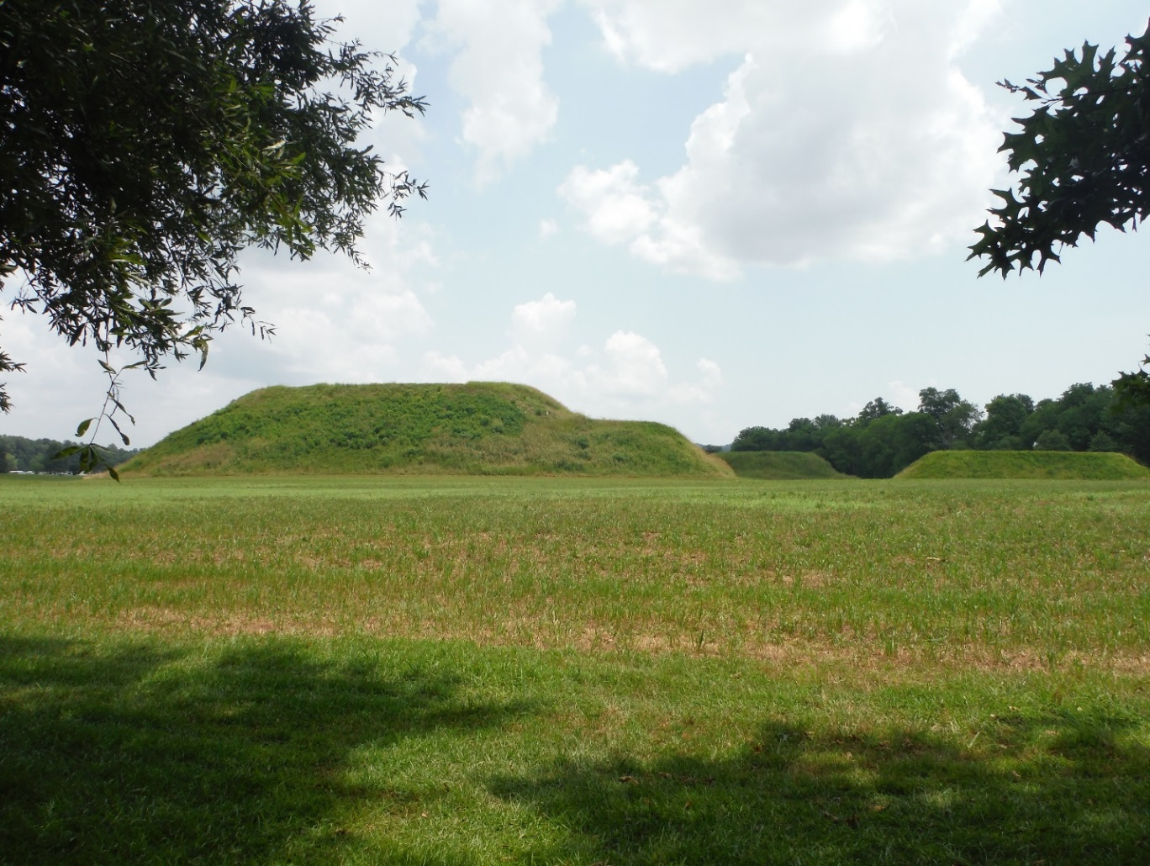
At Etowah Mounds State Historic Site visitors can behold the historic landscape that drew the Native Americans of the Mississippian Culture to this location where they developed a high level of artistry and craftsmanship, built a ceremonial complex of ritual and burial mounds, hunted, farmed, fished, and controlled trade along the Etowah River.
Etowah Indian Mounds State Historic Site
Interpretation & Recreation Plans

_________________________________________________________________________________________
Table of Contents

- Site Significance and Interpretation
- Recreational Resources
- Potential & Current Audiences
- Nearby Services Serving Similar Audiences/Potential Partners
- Appendix A: Park Facilities: Site Map and List of Program Locations and Trails
- Appendix B: Contact Information (Audiences, Nearby Sites & Potential Partners)
- Appendix: C: References that Address your Sites Unique Resources
- Appendix D: Media Contacts

Etowah Mounds State Historic Site

Interpretation & Recreation Plans march 2019

Purpose:
This plan is intended to provide guidance to site staff in planning interpretive programs, exhibits, and recreational opportunities at Etowah Mounds State Historic Site over the next five years. Programs are the Division’s most effective means of generating public support and should be a high priority when making planning and budget decisions for the park.
Date Established: 1953
Original Acreage: 54
Current Acreage: 68
Home to several thousand Native Americans from 1000 A.D. to 1550 A.D., this site protects six earthen mounds, a plaza, village site, borrow pits and defensive ditch. Etowah Mounds is the most intact Mississippian Culture site in the Southeast. Artifacts in the museum show how natives of this political and religious center decorated themselves with shell beads, paint, complicated hairdos, feathers and copper ear ornaments. Hand-carved stone effigies weighing 125 pounds still bear some original pigments. Objects made of wood, seashells and stone are also displayed.
Visitors can follow a nature trail along the Etowah River where they can view a v-shaped fish trap used for catching fish. The trail also highlights how early civilizations used native trees for food and medicine.
While only nine percent of this site has been excavated, examination at Mound C and surrounding artifacts revealed much about the people who lived here. They were a society rich in ritual. Towering over the community, the 63-foot earthen knoll was likely used as a platform for the home of the priest-chief. In another mound, the nobilities were buried in elaborate costumes accompanied by items they would need in their after-lives.

Site Significance:

The significance of the site resources includes:

- Site has the second tallest mound from the Mississippian Culture in the United States – Tallest Mound in the Southeast
- Site was named a National Historic Landmark in 1964
- There at least six recognizable mounds on site
- Stone Fish Weir is in the original location in the river and is visible from the site
- The two large marble effigy statues are considered national treasures and the other artifacts on display are some of the best examples of Mississippian culture
- Site has large rare American Elm trees on site

Overarching Interpretive Theme:
At Etowah Mounds State Historic Site visitors can behold the historic landscape that drew the Native Americans of the Mississippian Culture to this location where they developed a high level of artistry and craftsmanship, built a ceremonial complex of ritual and burial mounds, hunted, farmed, fished, and controlled trade along the Etowah River.

Interpretive Media that Relate to the Site’s Significance and Retail Suggestions
Topic | Potential Storylines | Personal Interpretation | Non-Personal Interpretation | Suggested Retail
historic landscape | Human habitation at the site from appr. 850 AD to the current era.  Geography/Geology of the region (ridge and valley) along the Cartersville-Knoxville fault attracted Native Americans for natural resources and trade.  Etowah River has a large diversity of fish making it attractive as a food source | Guided Site Tours  History Talks – Symposiums  Nature Walks  Orienteering and compass use programs  Resource management interpretation (invasive species, native grasses, animal habitats) | Museum Exhibits  Interpretive Panels  Site Video  Site Literature | Books on Geography/Geology  postcards
Native Americans of the Mississippian Culture | The site has a reproduction wattle and daub hut for exhibit and demonstrations  Etowah people were connected with other sites throughout the Mississippian Period | Guided Site Tours  History Talks  Native American/Skills of the Past programs  Junior Ranger programs  Wattle and Daub demonstrations | Museum Exhibits  Interpretive Panels  Site Video  Site Literature | Books  Maps  Prints  Postcards  Mugs  T-shirts
high level of artistry and craftsmanship | The people at Etowah created human and animal effigies  The pottery at Etowah has a variety of types indicating a sophisticated production and trade | Guided Site Tours  Museum talks  Pottery/crafts class  Weaving and textile programs | Museum Exhibits  Interpretive Panels  Site Video  Site Literature | Books  Replica effigies  Jewelry  Flutes  Hiking stick medallions  patches
ceremonial complex of ritual and burial mounds | Etowah has the largest platform mound in the southeast (63 feet tall, 3 acres wide)  The archaeology and the research of Etowah is of major significance in understanding the Mississippian culture  6 identified mounds – at least one burial mound (mound c) and maybe others  There were different burial rituals practiced at Etowah  The plaza was used for a trade/bazaar, rituals and as a gaming field | Guided Site Tours  Archaeology programs  Artifact ID programs  Symposium  Native American Games programs | Museum Exhibits  Interpretive Panels  Site Video  Site Literature | Plush toys  Books
Hunted, farmed, fished, and controlled trade along the Etowah River. | Native Americans at Etowah used a variety of Tools in their daily lives.  Fishing by use of a fish weir  Etowah has the remnants of a moat or ditch that was built as part of the village defense and public works  The Etowah people farmed a variety of plants for medicine and food.  They used weapons such as the atlatl, bow and arrow, and others for defense and hunting.  The Etowah people traded goods with other villages along the river and beyond  The fish weir on site is in its original location as it was used by the Native Americans | Guided site tours  Tools and weapons demonstrations  Fishing demonstrations (how a weir works)  Cooking demonstrations  Corn grinding programs  Maintaining garden plots  Medicinal and edible herbs programs  Rope making programs  Trade goods programs  History talks  Archery Programs | Museum exhibits  Interpretive panels  Site literature  Site trail information | Books  Crafts  Tool reproductions  Arrowheads/ projectile point replicas  furs

School Programs
Etowah Mounds State Historic Site does provide school programs that meet a variety of the Georgia Performance Standards for students k-12. Current standards can be found at:
https://www.georgiastandards.org/Standards/Pages/BrowseStandards/BrowseGPS.aspx

potential & current Audiences
This plan includes Bartow, Cobb, and Cherokee Counties.
Contact information listed in Appendix B
Special Interest Groups
- Scout groups
- Nature Enthusiasts

Day Visitors
- History and archaeology enthusiasts
- I-75 travelers
- International visitors to the Atlanta Metro Area
- Visitors attending games at Lake Point and other attractions
- Overnight campers and visitors from Red Top and other locations

Current Program Participants

- Public Programs: attended by day use visitors from a wide area including metro Atlanta.
- Special Events: attended by general public from within a 100-mile radius
- Group Programs: Senior groups, special needs groups, youth groups
    - Outreach Programs: Civic groups, public library
    - School Groups: Bartow County and Metro Atlanta, some from North Carolina, Alabama and Tennessee

Who is NOT coming that we would like to engage?

- Local people from the Cartersville area
- Would like to see more Latin American and international visitation
- Partner more with Tellus, Booth Western Museum and Bartow History Museum
- Would like to engage more pre-k age patrons

Community

- Churches:
  - There are 100 churches listed in Bartow County
  - There are 208 churches listed in Cobb County
  - There are 134 churches listed in Cherokee County
- Civic Organizations, Tourism Organizations:
- Atlanta Area Council Boy Scouts of America
- Bartow County Kiwanis Club
- Bartow County Lions Club
- Bartow County Rotary Club
- Bartow County Senior Center
- Boys and Girls club of Bartow co.
- Boys and Girls club of Cherokee co.
- Canton Lions Club
- Cartersville -Bartow County Chamber of Commerce
- Cartersville-Bartow County Convention & Visitors Bureau
- Cherokee County Chamber of Commerce
- Cherokee County Historical Society
- Cobb County Chamber of Commerce
- Cobb County Convention & Visitors Bureau
- Cobb County Landmarks and Historical Society
- East Cobb Lions Club
- Friends of Etowah Indian Mounds
- James T. Anderson Boys and Girls club of Cobb co.
- Kiwanis Club of Marietta
- Lost Mountain Kiwanis
- Michael A Grant Boys and Girls club of Cobb co.
- Northwest Georgia Council Boy Scouts of America
- Rotary Club of Cherokee County
- Rotary Club of Marietta
- Rotary Club of North Cobb
- South Cobb Rotary Club
- Libraries: Bartow, Cobb, and Cherokee County Library
- Area Businesses that could be targeted as partners or potential sponsors include: New Beginning Signs & Graphics, Dick’s Sporting Goods, Cabela’s, Academy Sports & Outdoors, Hobby Lobby, Cartersville Ace Hardware, The Home Depot, Lowe’s Home Improvement, Ladd’s Farm Supply, Staples, Domino’s Pizza, Subway

- Schools: K-12, Colleges and Daycare Centers
- Public Schools
- There are 14 Elementary Schools, 5 Middle School, and 4 High School in Bartow County.
- There are 76 Elementary Schools, 26 Middle School, and 11 High Schools in Cobb County.
- There are 22 Elementary School, 6 Middle School, and 5 High School in Cherokee County
- Private Schools –
  - Excel Christian Academy
  - Futah Preparatory School,
  - Grace Christian Academy
  - Living Way Christian Academy
  - Montessori: (Life song, Casa Dei Bambini, Covered Bridge, Brookstone, Riverstone)
  - Noonday Christian Academy
- Homeschool –
  - Bartow County Homeschoolers
  - CHAT- Christian Homeschoolers Assembling Together
  - Covenant Christian Homeschoolers
  - K12 Online School
  - STAC- Space, Time and Community,
http://localhs.com/?Cobb,GA :
http://localhs.com/?Cherokee,GA
http://localhs.com/?Bartow,GA
- Colleges – There are 43 Colleges within 50 miles of the Site
  - Agnes Scott College
  - American Intercontinental University of Atlanta
  - Atlanta Metropolitan College
  - Berry College
  - Beulah Heights College
  - Brown Mackie College Atlanta
  - Carver Bible College
  - Chattahoochee Technical college
  - Clark Atlanta University
  - Clayton State University
  - Dalton State College
  - DeVry University Georgia
  - Emory University
  - Fortis College
  - Georgia Gwinnett College
  - Georgia Highlands college
  - Georgia Institute of Technology
  - Georgia Military College Atlanta Campus
  - Georgia Northwestern Technical College
  - Georgia Perimeter College
  - Georgia Piedmont Technical College
  - Georgia State University
  - Gupton Jones College of Funeral service
  - Gwinnett College Lilburn
  - Gwinnett Technical College
  - Herzing University Atlanta
  - Interactive College of Technology Chamblee
  - Kennesaw State University
  - Life University
  - Morehouse College
  - Oglethorpe College
  - Point University
  - Reinhardt University
  - Shorter University
  - Shorter University College of Adult and Professional Programs
  - Southern Polytechnic State University
  - Spelman College
  - University of Phoenix Atlanta
  - University of West Georgia
  - West Georgia Technical College
https://www.collegesimply.com/colleges-near/georgia/cartersville/

- Day-care Centers
  - There are 7 Day-Care/Preschool Centers in Bartow County. https://childcarecenter.us/county/bartow_ga
  - There are 16 Day-Care/Preschool Centers in Cobb County https://childcarecenter.us/county/cobb_ga
  - There are 7 Day-Care/Preschool Centers in Cherokee County. https://childcarecenter.us/county/cherokee_ga

Nearby Sites that serve a Similar Audience/Potential Partners
Contact information listed in Appendix B

Arts, Music, Heritage, Farm organizations:

- Spring Place Pottery & Artists’ Gallery

Nature/Museums/Visitor Centers:

- Bartow History Museum
- Booth Western Art Museum
- Cartersville Depot
- Coopers Furnace Day Use Area
- Corps of Engineers Visitor Center - at Allatoona Dam
- Euharlee Covered Bridge and History Museum
- Roselawn Museum
- Tellus Science Museum
- The Margaret and Luke Pettit Environmental Preserve

Non-profit/Professional and Special Interest Group Organizations:

- Atlanta Audubon Society
- Coosa River Basin Initiative
- Friends of Georgia State Parks
Geocaching/Orienteering partnerships:
- Geocaching.com

Other Government Partnerships/Contacts:

- Bartow County Extension Office
- Bartow County Government Office
- City of Cartersville
- Council on American Indian Concerns
- Georgia Forestry Commission
- Native Americans associated with the site
- Pickett’s Mill Battlefield State Historic Site
- Red Top Mountain State Park

Parks & Campgrounds:

- Army Corps of Engineers Recreation Area
- Bartow Carver Park
- Dillenger Park
- Kennesaw Mountain National Battlefield
- Lake Allatoona
- Pickett’s Mill Battlefield State Historic Site
- Pine Mountain Recreation Area
- Red Top Mountain State Park
- Sam Smith Park
- Wildlife Management Areas:
  - Allatoona WMA
  - Arrowhead WMA
  - Berry College WMA
  - John’s mountain WMA
  - Pine Log WMA

Appendix A Park MaP & Facilities, LIst of Programming locations and trails
Park Facilities: This 68 Acre historic site has a museum, gift shop, 20 picnic tables, 6 prehistoric earthen mounds, and more than 2.8 miles of trails.
PARK MAP
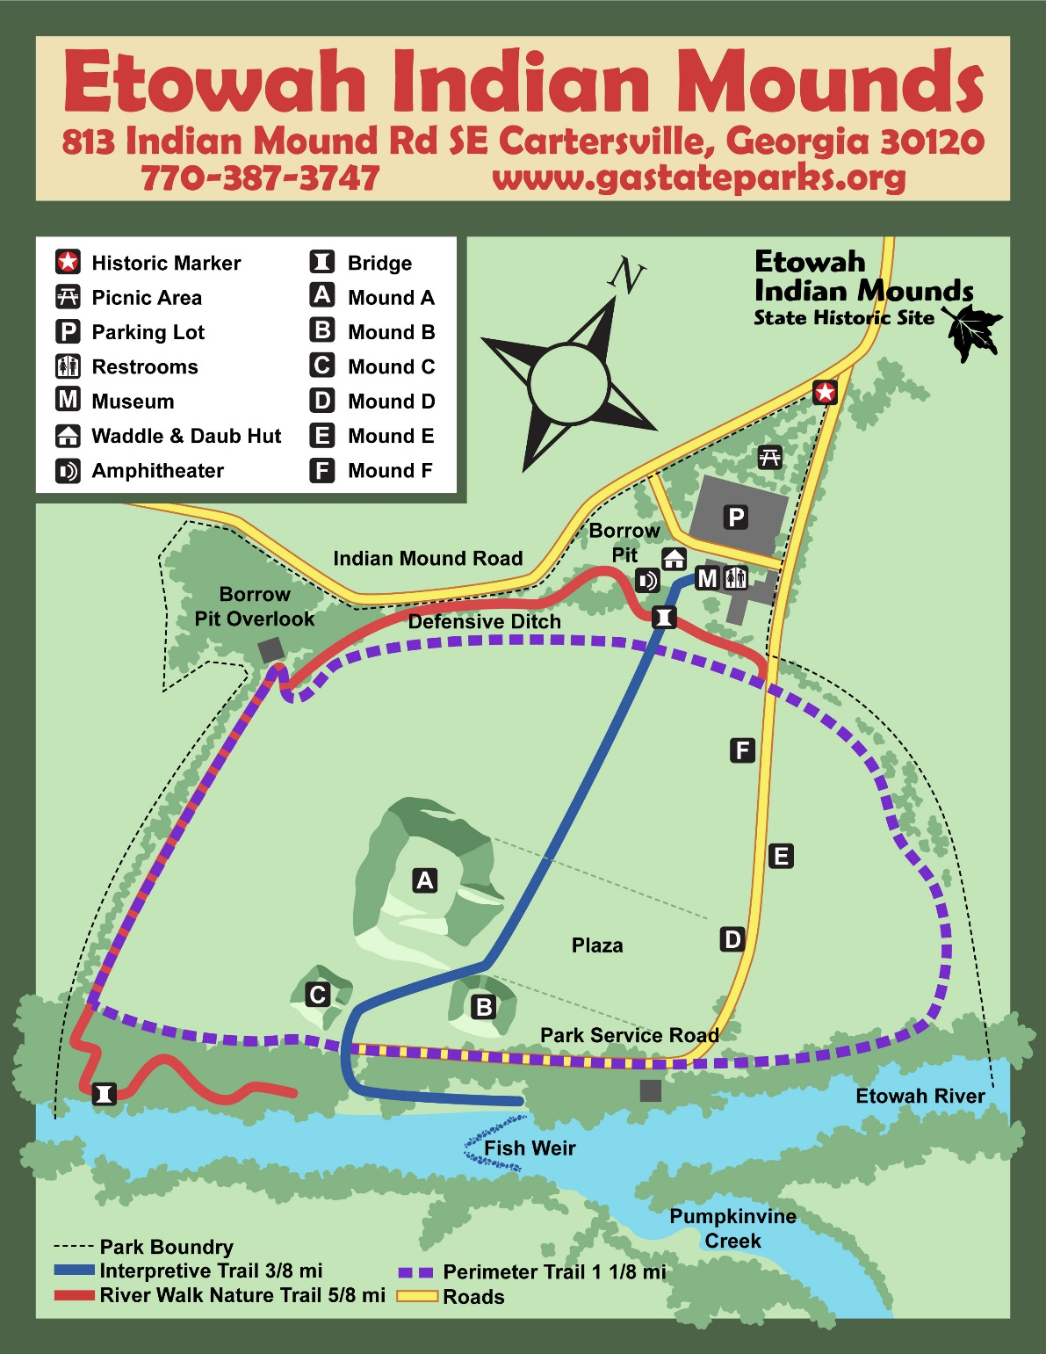
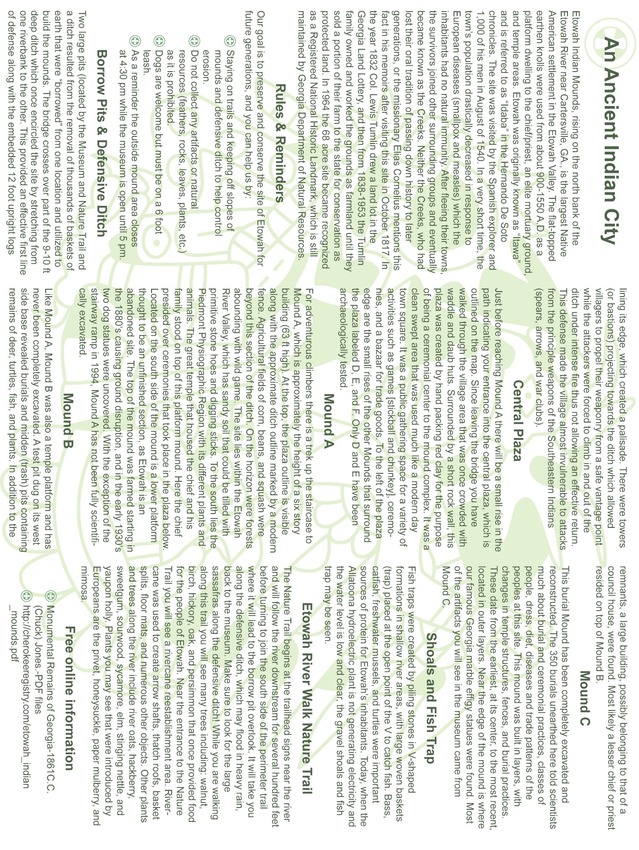

Existing Programming Locations:
Museum
Theater
Amphitheater
Museum Back yard
Campfire Ring
River Side
Picnic Area
Defensive ditch and barrow Pits

Along the Interpretive trail and mound tops: certain types of programming prohibited due to cultural sensitivity

Potential Programming Locations:
No allowable locations at present

Hiking Trails
Interpretive Trail
River walk Nature Trail
Perimeter Trail

Potential Trails:
N/A

Appendix B Nearby Sites that serve similar audiences, Resources & PotentiAl partnerS

Special Interest Groups
Scout Organizations:

Boy Scouts:
http://www.atlantabsa.org/
www.nwgabsa.org

Girl Scouts:
https://www.girlscoutsatl.org

Nature Enthusiasts:

Atlanta Audubon Society
4055 Roswell Road
Atlanta, GA 30342
Phone: (678) 973-2437
http://www.atlantaaudubon.org/

Georgia Ornithological Society
http://www.gos.org/home
Community

Churches:
There are 100 churches listed in Bartow County: https://georgia.hometownlocator.com/features/cultural,class,church,scfips,13015.cfm
There are 208 churches listed in Cobb County: https://georgia.hometownlocator.com/features/cultural,class,church,scfips,13067.cfm
There are 134 churches listed in Cherokee County: https://georgia.hometownlocator.com/features/cultural,class,church,scfips,13057.cfm

Civic Organizations & Tourism:

Atlanta Area Council Boy Scouts of America
1800 Circle 75 Parkway SE
Atlanta, GA 30339
Office Phone: (770) 989-8820
Faye Hammands, Director of Scoutreach/Assistant Director of Field Service
Email: Fhammands@atlantabsa.org
Phone: (770) 956-3189
Jason Baldridge Director of Safe Scouting & Support
Email: JBaldridge@atlantabsa.org
Phone: (770) 956-3173

Bartow County Kiwanis Club
Email: bartowkiwanis@gmail.com
South Cobb Rotary Club
2985 Powder Springs Rd.
Marietta, Ga 30064
Phone: (770) 891-5373
Email: blackstone.wayne@gmail.com

Bartow County Lions Club
Phone: (404) 428-7227

Bartow County Rotary Club
PO Box 1293
Cartersville, GA 30120
Phone: (678) 605-6600

Bartow County Senior Center
33 Beavers Drive,
Cartersville, GA 30120
Phone: (770) 387-5134
Email: crawfordc@bartowga.org

Boys and Girls Club of Bartow County
P.O. Box 455
Cartersville, Georgia 30120
Adairsville Phone: (770) 773-7333
Cartersville Phone: (770) 382-2552
Central Office Phone: (770) 382-5500
Email: info@bgcofbc.org

Boys and Girls Club of Cherokee County
8 Glenwood St
Canton, Georgia 30114
Phone: (770) 720-7712

Canton Lions Club
Phone: (404) 465-1622

Cartersville-Bartow County Chamber of Commerce
122 W. Main Street
PO Box 307
Cartersville, GA 30120
Phone: (770) 382-1466
Fax: (770) 382-2704
Email: reception@cartersvillechamber.com

Cartersville-Bartow County Convention & Visitors Bureau
Physical Address:
Clarence Brown Conference Center
5450 GA Hwy 20,
Cartersville GA 30121
Mailing Address:
PO Box 200397,
Cartersville GA 30120
Phone: (770) 387-1357
http://visitcartersvillega.org/

Cherokee County Historical Society
PO Box 1287
Canton, GA 30169
Phone: (770) 345-3288
Fax: (770)345-3289
Stefanie Joyner, Executive Director sjoyner@rockbarn.org
Meghan Quinlan, Program Manager mquinlan@rockbarn.org

Cherokee County Chamber of Commerce
Physical Address:
3605 Marietta Highway
Canton, GA 30114
Mailing Address:
P.O. Box 4998
Canton, GA 30114
Phone: (770) 345- 0400
Fax: (770) 345- 0030
https://cherokeechamber.com

Cobb County Chamber of Commerce
Physical Address:
240 Interstate North Parkway
Atlanta, GA 30339
Mailing Address:
P. O. Box 671868
Marietta, GA 30006-0032
Phone: (770) 980-2000
Fax: (770) 980-9510
info@cobbchamber.org

Cobb County Convention & Visitors Bureau
1 Galleria Parkway
Atlanta, GA
Phone: (678) 303-2622
Fax: (678) 303-2625
Marketing Director, Lindsey Burruss lburruss@travelcobb.org
Director of Trade Show & Sales, Chris Colbert ccolbert@travelcobb.org
Director of Finance & Administration, Christina McCurdy cmccurdy@travelcobb.org
Chief Executive Officer, Holly A. Bass hbass@travelcobb.org

Cobb County Landmarks and Historical Society
80 N Marietta Parkway NW
Marietta, GA 30060
Phone: (678)594-4994
Email: executive.director@cobblandmarks.com

East Cobb Lions Club
Email: eastcobblions@gmail.com

Friends of Etowah Indian Mounds
813 Indian Mound Rd SE
Cartersville, Georgia 30120
Phone: (770) 387-3747

Friends of Georgia State Parks
199 South Erwin Street, Suite 100
Cartersville, GA 30120
Phone: (770) 383-8900 or (888) 948-2092
Fax: (770) 383-8920
Email: info@friendsofgastateparks.org

James T. Anderson Boys and Girls club of Cobb County
1275 Peachtree Street NE
Suite 500
Atlanta, GA 30309
Phone: (404) 527-7100
Fax: (404) 653-0035

Kiwanis Club of Marietta
P.O. Box 3191
Marietta, GA 30061

Lost Mountain Kiwanis Club
https://lostmountainkiwanis.org

Michael A. Grant Boys and Girls Club of Cobb County
1275 Peachtree Street NE
Suite 500
Atlanta, GA 30309
Phone: (404) 527-7100
Fax: (404) 653-0035

Northwest Georgia Council Boy Scouts of America
Dalton Service Center
202 S. Hamilton Street
Dalton, GA 30720
Phone: (706) 272-7111
Fax: (706) 370-4111

Rome Service Center
100 E. 2nd Ave., Suite 20
Rome, GA 30161
Phone: (706) 235-5545
Fax: (706) 290-1765

Rotary Club of Cherokee County
PO Box 4275
Canton, GA 30114-0016
Email: rcofcc@gmail.com

Rotary Club of Marietta
P.O. Box 711
Marietta, GA 30061
Email: marla@skeltonblackstone.com

Rotary Club of North Cobb
Phone: (678) 414-0430
Email: northcobb@rotary6900.org

Libraries:

Bartow County Libraries (3):

Cartersville Public Library
429 West Main Street
Cartersville, GA 30120
Phone: (770)382-4203
info@bartowlibrary.org

Adairsville Public Library
202 North Main Street
Adairsville, GA 30103
Phone: (770) 769-9200
info@bartowlibrary.org

Emmie Nelson Public Library
116 Covered Bridge Road
Euharlee, GA 30120
Phone: (770) 382-2057
info@bartowlibrary.org

Cobb County Libraries (17):

Switzer Library
266 Roswell Street
Marietta, GA 30060
Phone: (770) 528-2320
www.cobbcat.org

Acworth Library
4569 Dallas Street,
Acworth, GA 30101
Phone: (770) 917-5165
www.cobbcat.org

East Cobb Library
4880 Lower Roswell Road
Marietta, GA 30068
Phone: (770) 509-2730
www.cobbcat.org

Gritters Library
880 Shaw Park Road
Marietta, GA 30066
Phone: (770) 528-2524
www.cobbcat.org

Kemp Memorial Library
4029 Due West Road
Marietta GA 30064
Phone: (770) 528-2527
www.cobbcat.org

Kennesaw Library
2250 Lewis Street,
Kennesaw, GA 30144
Phone: (770) 528-2529
www.cobbcat.org

Lewis A. Ray Library
4500 Oakdale Road
Smyrna, GA 30080
Phone: (770) 801-5335
www.cobbcat.org

Mountain View Regional Library
3320 Sandy Plains Road
Marietta, GA 30066
Phone: (770) 509-2725
www.cobbcat.org

Powder Springs Library
4181 Atlanta Street, Bldg. 1
Powder Springs, GA 30127
Phone: (770) 439-3600
www.cobbcat.org

Sewell Mill Library & Cultural Center
2051 Lower Roswell Road
Marietta, GA 30068
Phone: (770) 509-2711
www.cobbcat.org

Sibley Library 1539
South Cobb Drive
Marietta, GA 30060
Phone: (770) 528-2520
www.cobbcat.org

South Cobb Regional Library
805 Clay Road,
Mableton, GA 30126
Phone: (678) 398-5828
www.cobbcat.org

Stratton Library
1100 Powder Springs Rd SW
Marietta, GA 30064
Phone: (770) 528-2522
www.cobbcat.org

Sweetwater Library
5000 Austell-Powder Springs Road Suite 123
Austell, GA 30106
Phone: (770) 819-3290
www.cobbcat.org

Vinings Library
4290 Paces Ferry Road
Atlanta, GA 30339
Phone: (770) 801-5330
www.cobbcat.org

West Cobb Regional Library
1750 Dennis Kemp Lane
Kennesaw, GA 30152
Phone: (770) 528-4699
www.cobbcat.org

Windy Hill Community Center Library
1885 Roswell Street
Smyrna, GA 30080
Phone: (770) 528-2562
www.cobbcat.org

Cherokee County Libraries (5):

Ball Ground Public Library
435 Old Canton Road
Ball Ground, GA 30107
Phone: (770) 735-2025
Fax: (770) 735-6050
https://www.georgialibraries.org/directories/publibs/countysearch.php?countyname=Cherokee

Hickory Flat Public Library
2740 East Cherokee Drive
Canton, GA 30115
Phone: (770) 345-7565
Fax: (770) 345-7660
https://www.georgialibraries.org/directories/publibs/countysearch.php?countyname=Cherokee

R.T. Jones Memorial Library
116 Brown Industrial Parkway
Canton, GA 30114
Phone: (770) 479-3090
Fax: (770) 479-3069
https://www.georgialibraries.org/directories/publibs/countysearch.php?countyname=Cherokee

Rose Creek Public Library
4476 Towne Lake Parkway
Woodstock, GA 30189
Phone: (770) 591-1491
Fax: (770) 591-1693
https://www.georgialibraries.org/directories/publibs/countysearch.php?countyname=Cherokee

Woodstock Public Library
7735 Main Street
Woodstock, GA 30188
Phone: (770) 926-5859
Fax: (770) 591-8476
https://www.georgialibraries.org/directories/publibs/countysearch.php?countyname=Cherokee

Businesses/Community Services:

New Beginning Signs & Graphics
5 S. Gilmer Street
Cartersville, GA 30120
Phone: (770) 387-1720
Email: tim@nbsigns.com
http://nbsigns.com

Dick’s Sporting Goods
667 Ernest W Barrett Pkwy NW Ave.
Kennesaw, GA 30144
Phone: (770) 281-0200
https://stores.dickssportinggoods.com/ga/kennesaw/4625/

Cabela’s
152 Northpoint Pkwy.
Acworth, GA 30102
Phone: (470) 315-7500
https://www.cabelas.com/stores/Georgia/Acworth/057.jsp

Academy Sports & Outdoors
453 E Main St.
Cartersville, GA 30121
Phone: (770) 607-6020
https://stores.academy.com/ga/cartersville/453-e--main-st.html

Hobby Lobby
180 Market Square
Cartersville, GA 30120
Phone: (770) 386-8777
https://www.hobbylobby.com/

Cartersville Ace Hardware
924 West Ave,
Cartersville, GA 30120
Phone: (770) 382-1298
http://cartersvilleacehardware.net/

The Home Depot
100 Gentilly Blvd.
Cartersville, GA 30120
Phone: (770) 606-0298
https://www.homedepot.com/l/Cartersville/GA/Cartersville/30120/133
Lowe's Home Improvement
301 Market Pl Blvd.
Cartersville, GA 30120
Phone: (770) 382-9500
https://www.lowes.com/store/GA-Cartersville/0190?cm_mmc=YEXT-GO-_-SiteLink-_-190-_-Lowes

Ladd’s Farm Supply
10 Euharlee Rd SW
Cartersville, GA 30120
Phone: (770) 382-4042
www.laddsfarmsupplycartersville.com/

Staples
155 Cherokee Pl.
Cartersville, GA 30121
Phone: (770) 386-9100
https://stores.staples.com/ga/cartersville/155-cherokee-place?cmpid=st_ll_goo&cid=LS:RETAIL:G

Domino’s Pizza
851B Joe Frank Harris Pkwy SE
Cartersville, GA 30120
Phone: (770) 386-4100
https://www.dominos.com

Subway
807 West Ave A.
Cartersville, GA 30120
Phone: (770) 606-1054
https://order.subway.com/

Public Schools, Private Schools, Colleges & Daycare Centers
Public Schools in Cobb County:

http://www.cobb.k12.ga.us/
Allatoona High School
Campbell High School
Cobb High School
Harrison High School
Hillgrove High School
Kell High School
Kennesaw Mountain High School
Lassiter High School
McEachern High School
North Cobb High School
Osborne High School
Pebblebrook High School
Pope High School
South Cobb High School
Sprayberry High School
Walton High School
Wheeler High School
Awtrey Middle School
Barber Middle School
Campbell Middle School
Cooper Middle School
Daniell Middle School
Dickerson Middle School
Dodgen Middle School
Durham Middle School
East Cobb Middle School
Floyd Middle School
Garrett Middle School
Griffin Middle School
Hightower Middle School
Trail Middle School
Lindley Middle School
Lindley 6th Grade Academy
Lost Mountain Middle School
Lovinggood Middle School
Mabry Middle School
McCleskey Middle School
McClure Middle School
Palmer Middle School
Pine Middle School
Mountain Middle School
Simpson Middle School
Smitha Middle School
Tapp Middle School
Acworth Elementary School
Addison Elementary School
Argyle Elementary School
Austell Elementary School
Baker Elementary School
Bells Ferry Elementary School
Belmont Hills Elementary School
Big Shanty Elementary School
Birney Elementary School
Blackwell Elementary School
Brumby Elementary School
Bryant Elementary School
Bullard Elementary School
Chalker Elementary School
Cheatham Hill Elementary School
Clarkdale Elementary School
Clay Elementary School
Compton Elementary School
Davis Elementary School
Dowell Elementary School
Due West Elementary School
East Side Elementary School
Eastvalley Elementary School
Fair Oaks Elementary School
Ford Elementary School
Frey Elementary School
Garrison Mill Elementary School
Green Acres Elementary School
Harmony Leland Elementary School
Hayes Elementary School
Hendricks Elementary School
Hollydale Elementary School
Keheley Elementary School
Kemp Elementary School
Elementary School Kennesaw
Kincaid Elementary School
King Springs 2-5 Elementary School
King Springs K-1 Elementary School
LaBelle Elementary School
Lewis Elementary School
Mableton Elementary School
McCall Elementary School
Milford Elementary School
Mount Bethel Elementary School
Mountain View Elementary School
Murdock Elementary School
Nicholson Elementary School
Nickajack Elementary School
Norton Park Elementary School
Pickett's Mill Elementary School
Pitner Elementary School
Powder Springs Elementary School
Powers Ferry Elementary School
Riverside Intermediate Elementary School
Riverside Primary Elementary School
Rocky Mount Elementary School
Russell Elementary School
Sanders Elementary School
Sedalia Park Elementary School
Shallowford Falls Elementary School
Smyrna Elementary School
Sope Creek Elementary School
Still Elementary School
Teasley Elementary School
Timber Ridge Elementary School
Tritt Elementary School
Varner Elementary School
Vaughan Elementary School
Campbell High School International Baccalaureate Program
Kennesaw Mountain High School Academy of Mathematics, Science, and Technology
North Cobb School for International Studies
Pebblebrook High School Center for Excellence in the Performing Arts
South Cobb High School Academy of Research and Medical Sciences
Wheeler HS Center for Advanced Studies in Science, Mathematics, & Technology
Kennesaw Charter School
Walton Charter School

Public School in Cherokee County:

https://www.cherokeek12.net/
Arnold Mill Elementary School
Avery Elementary School
Ball Ground Elementary School STEM Academy
Bascomb Elementary School
Boston Elementary School
Carmel Elementary School
Clark Creek Elementary School STEM Academy
Clayton Elementary School
Free Home Elementary School
Hasty Elementary School Fine Arts Academy
Hickory Flat Elementary School
Holly Springs Elementary School STEM Academy
Indian Knoll Elementary School
Johnston Elementary School
Knox Elementary School STEM Academy
Liberty Elementary School
Little River Elementary School
Macedonia Elementary School
Mountain Road Elementary School
Oak Grove Elementary School Fine Arts Academy
R.M. Moore Elementary School STEM Academy
Sixes Elementary School
Woodstock Elementary School
Creekland Middle School
Dean Rusk Middle School
E.T. Booth Middle School
Freedom Middle School
Mill Creek Middle School
Teasley Middle School
Woodstock Middle School
Cherokee High School
Creekview High School
Etowah High School
River Ridge High School
Sequoyah High School
Woodstock High School
ACE Academy
Polaris Evening Program
Tippens Education Center

Public Schools in Bartow County:

https://www.bartow.k12.ga.us/
Adairsville High School
Cass High School
Woodland High School
Adairsville Middle School
Cass Middle School
South Central Middle School
Woodland Middle School ﻿
Adairsville Elementary School
Allatoona Elementary School
Clear Creek Elementary School
Cloverleaf Elementary School
Emerson Elementary School
Euharlee Elementary School
Hamilton Crossing Elementary School
Kingston Elementary School
Mission Road Elementary School
Pine Log Elementary School
Taylorsville Elementary School
White Elementary School
Bartow County College and Career Academy
Bartow County School System Transitional Academy

Private schools:
Excel Christian Academy
54 7th Street
Emerson, GA 30137
and
325 Old Mill Rd.
Cartersville, Ga 30120
MS/HS Phone: (770)382-9488
Elem Phone: (770)607-6616
http://excelca.org/

Furtah Preparatory School
5496 Hwy 92
Acworth, GA 30102
Phone: (678) 574-6488
http://www.furtahprep.org/

Grace Christian Academy
477 Old Cassville White Rd NW
Cartersville, GA 30121
Phone: (770) 382-6652
http://graceacademylions.org/

Living Way Christian Academy
118 E George Ste. E
Adairsville, GA 30103
Phone: (770) 877-3600
https://www.greatschools.org/georgia/adairsville/2374-Living-Way-Christian-Academy/

Noonday Christian Academy
4121 Canton Rd.
Marietta, GA 30066
Phone: (770) 926-8891 http://www.noondaychristianacademy.com/

Brookstone Montessori School
1680 Brookstone Walk NW
Acworth, GA 30101
Phone: (855)351-2170

Casa Dei Bambini Montessori School
150 Powers Ferry Rd.
Marietta, GA 30067
Phone: (770) 973-2731

Covered Bridge Montessori School
488 Hurt Rd SW
Smyrna, GA 30082
Phone: (770)801-8292
Life Song Montessori School
324 W Cherokee Ave.
Cartersville, GA 30120

River Stone Montessori School
455 Casteel Rd.
Marietta, GA 30064
Phone: (770) 422-9194

Homeschool Groups:
Covenant Christian Homeschoolers http://www.ghea.org/pages/resources/supportGroups/search.php?ID=221

CHAT- Christian Homeschoolers Assembling Together
20 Parmeter St.
Cartersville, GA 30120
Phone: (678) 986-9413

Bartow County Homeschoolers
https://www.facebook.com/pages/Bartow-County-Homeschoolers/178602272206296

K12 Online School
http://www.k12.com/

STAC- Space, Time and Community,
http://localhs.com/?Cobb,GA
http://localhs.com/?Cherokee,GA
http://localhs.com/?Bartow,GA

Colleges:

Kennesaw State University
Kennesaw Campus:
1000 Chastain Road
Kennesaw, GA 30144
Phone: (470) 578-6000
http://www.kennesaw.edu

Marietta Campus:
1100 South Marietta Pkwy.
Marietta, GA 30060
Phone: (470) 578-6000
http://www.kennesaw.edu

Reinhardt University
7300 Reinhardt Circle
Waleska, GA 30183-2981
Phone (770) 720-5600
Fax (770) 720-5602
http://www.reinhardt.edu

Chattahoochee Technical College (9 campuses)
North Metro Campus
5198 Ross Road
Acworth, GA 30102
Phone: (470) 361-2822
http://www.chattahoocheetech.edu/contact-us/

Georgia Northwestern Technical College
1 Maurice Culberson Drive
Rome, GA 30161
Phone: (866) 983-4682
http://www.gntc.edu/

Berry College
2277 Martha Berry Hwy NW,
Mount Berry, GA 30149
Phone: (706) 232- 5374
https://www.berry.edu/

Georgia Highlands College (5 campuses)
5441 Highway 20NE,
Cartersville, GA 30121
Phone: (678) 872-8000
Fax: (706) 295-6341
Site contact numbers (678) 872-8014 and (678) 872-8250
https://www.highlands.edu

Life University
1269 Barclay Cir,
Marietta, GA 30060
Phone: (770) 426-2600
https://www.life.edu/

Southern Polytechnic State University
1100 South Marietta Pkwy SE
Marietta, GA 30060
Phone: (470) 578-6000
http://www.kennesaw.edu/

Shorter University
315 Shorter Ave.
Rome, GA 30165
Phone: (706) 291-2121
http://www.shorter.edu/

Fortis College
2140 S Cobb Dr. SE
Smyrna, GA 30080
Phone: (770) 980-0002
https://www.fortis.edu/

Shorter University College of Adult and Professional Programs
315 Shorter Ave NW
Rome, GA 30165
Phone: (800) 868-6980
http://www.shorter.edu

American Intercontinental University of Atlanta
Embassy Row Northeast,
500 Peachtree Dunwoody Rd.
Atlanta, GA 30328
Phone: (404) 965-6500
https://www.aiuniv.edu/

Brown Mackie College
370 Peachtree Rd NE
Atlanta, GA 30319
https://www.brownmackie.edu/

University of Phoenix Atlanta
859 Mount Vernon Hwy NE
Atlanta, GA 30328
Phone: (678) 731-0555
https://www.phoenix.edu/campus-locations/ga/atlanta-campus.html?channel=socm&init=yext&campus=AtlantaCampus

Herzing University Atlanta
50 Hurt Plaza SE #400
Atlanta, GA 30303
Phone: (404) 586-4265
https://www.herzing.edu/atlanta

Carver Bible College
3870 Cascade Rd.
Atlanta, GA 30331
Phone: (404) 527-4520
http://www.carver.edu/

Interactive College of Technology Chamblee
5303 New Peachtree Rd.
Chamblee, GA 30341
Phone: (770) 216-2960
https://www.ict.edu/

Oglethorpe College
4484 Peachtree Rd NE
Atlanta, GA 30319
Phone: (404) 261-1441
https://oglethorpe.edu/

Clark Atlanta University
223 James P Brawley Dr. SW
Atlanta, GA 30314
Phone: (404) 880-8000
http://www.cau.edu/

Georgia Institute of Technology
North Ave NW
Atlanta, GA 30332
Phone: (404) 894-2000
https://www.gatech.edu/

Emory University
201 Dowman Dr.
Atlanta, GA 30322
Phone: (404) 727-6123
http://www.emory.edu/home/index.html

Georgia State University
Atlanta, GA 30302
Phone: (404) 413-2000
https://www.gsu.edu/

Morehouse College
830 Westview Dr. SW
Atlanta, GA 30314
Phone: (470) 639-0999
http://www.morehouse.edu/

Spelman College
350 Spelman Ln,
Atlanta, GA 30314
Phone: (404) 681-3643
https://www.spelman.edu/

Point University
507 West 10th St.
West Point, GA 31833
Phone: (706) 385-1000
https://point.edu/

Agnes Scott College
141 E College Ave.
Decatur, GA 30030
Phone: (404) 471-6000
https://www.agnesscott.edu/

Atlanta Metropolitan College
1630 Metropolitan Pkwy SW
Atlanta, GA 30310
Phone: (404) 756-4000
http://www.atlm.edu/

Beulah Heights College
892 Berne St. SE
Atlanta, GA 30316
Phone: (404) 627-2681
https://www.beulah.edu/

DeVry University Georgia (5 campuses)
100 Galleria Pkwy. SE
Suite 100
​Atlanta, GA 30339
Phone: (866) 338-7934
http://www.devryuniversity.org/atlanta

West Georgia Technical College
1 College Circle, 1302 Orchard Hill Rd.
LaGrange, GA 30240
Phone: (706) 845-4323
https://www.westgatech.edu/

Georgia Military College Atlanta Campus, Fairburn (14campuses)
320 NW Broad Street
Suite 200
Fairburn, GA 30213
Phone: (678) 379-1414
Fax: (770) 306-6406
https://www.gmc.edu/

Georgia Piedmont Technical College
95 N Indian Creek Dr.
Clarkston, GA 30021
Phone: (404) 297-9522
https://www.gptc.edu

Dalton State College
650 College Dr.
Dalton, GA 30720
Phone: (706) 272-4436
https://www.daltonstate.edu/

Gwinnett College Lilburn
4230 US-29 Suite 11
Lilburn, GA 30047
http://www.gwinnettcollege.edu/

Georgia Perimeter College
3251 Panthersville Road
Decatur, GA 30034
Phone: (678) 891-2300
https://perimeter.gsu.edu/

Gwinnett Technical College
5150 Sugarloaf Pkwy.
Lawrenceville, GA 30043
Phone: (404)679-4500
https://www.gwinnetttech.edu/

University of West Georgia
1601 Maple St.
Carrollton, GA 30118
Phone: (678) 839-5000
https://www.westga.edu/

Clayton State University
2000 Clayton State Blvd.
Morrow, GA 30260
Phone: (678) 466-4000
http://www.clayton.edu/

Georgia Gwinnett College
1000 University Center Ln.
Lawrenceville, GA 30043
Phone: (678) 407-5000
http://www.ggc.edu/

Gupton-Jones College of Funeral Service
5141 Snapfinger Woods Dr.
Decatur, GA 30035
Phone: (770) 593-2257
https://www.gupton-jones.edu/

Daycare Centers:
- Bartow
Bartow Head Start
15 Felton Place
Cartersville GA 30120
Phone: (770) 386-2156

Kids and Company Community Pre-K
323 South Erwin Street
Cartersville GA 30120
Phone: (678) 535-6330

Rollins Child Development Center
676 Henderson Dr.
Cartersville GA 30120
Phone: (678) 535-5200

The Gingerbread House
96 W. Felton Road
Cartersville, GA 30120
Phone: (770) 386-4568

Tomorrow's Child Learning & Dev. Center Inc.
48 Stone Mill Drive
Cartersville GA 30121
Phone: (770) 386-9192

Cartersville Child Care Inc.
325 Old Mill Road,
Cartersville GA 30120
Phone: (770) 387-0649

Kids' Stop Learning Center
533 Grassdale Rd.,
Cartersville GA 30120
Phone: (706) 295-7867

- Cobb
A Child's Night Out
1360 Powers Ferry Road
Suite B-255
Marietta GA 30067
Phone: (770) 952-9824

Childcare Network #32
2877 Woodruff Dr.
Smyrna GA 30080
Phone: (866) 721-3010

Cambridge Academy of Austell
3890 Floyd Road
Austell GA 30106
Phone: (770) 872-0941

Childcare Network #229
2265 Cooper Lake SE
Smyrna GA 30080
Phone: (866) 721-3010

Children's Nest
3950 Austell Road
Austell GA 30106
Phone: (770) 732-6500

Compass Academy
2820 Cobb Lane
Smyrna GA 30082
Phone: (678) 424-1671

Foundations for the Future
1500 Stanley Road NW
Kennesaw GA 30152
Phone: (770) 429-4799

Show Me Love Learning Academy
1233 Old Powder Springs Rd.
Mableton GA 30126
Phone: (770) 944-9100

Sunbrook Academy at Legacy Park
3871 Jiles Rd NW
Kennesaw GA 30144
Phone: (770) 428-1144

Sunbrook Academy at Stilesboro
5181 Stilesboro Road NW
Kennesaw GA 30152
Phone: (770) 794-0234

Better Chance Preschool A
Wyntuck Circle
Kennesaw GA 30152
Phone: (770) 428-5021

Bright Beginnings Learning Center
782 Franklin Road
Marietta GA 30067
Phone: (678) 401-4454

Children's Corner Child Care
1330 North Cobb Parkway
Marietta GA 30062
Phone: (770) 427-0783

Elite Children Learning Center
3875 Austell Road
Austell GA 30106
Phone: (678) 403-1432
Javits Academy Learning Center
1240 Johnson Ferry Rd
Marietta GA 30068
Phone: (770) 321-8484

- Cherokee

Kids 'R' Kids of Woodstock
407 Springfield Drive
Woodstock GA 30188
Phone: (770) 591-0900

Sunbrook Academy at Trickum
3305 Trickum Road
Woodstock GA 30188
Phone: (770) 928-9969

The Goddard School
3115 Parkbrooke Circle
Woodstock GA 30189
Phone: (770) 516-0880

Top Notch Kids Care
9914 Highway 92
Woodstock GA 30188
Phone: (678) 903-5837

Bells Ferry Learning Center
6761 Highway 92
Woodstock GA 30189
Phone: (770) 591-1100

Kids Haven
5480 Bells Ferry Rd.
Acworth GA 30102
Phone: (770) 926-4937

Little People's Corner Day Care
2938 Lower Union Hill Rd.
Canton GA 30115
Phone: (770) 475-1844

Arts, Music, Heritage, organizations:

Spring Place Pottery & Artists’ Gallery
http://springplacepottery.com/

Nature/Museums/Visitor Centers:

Corps of Engineers Visitor Center
Lake Allatoona
1128 State Rt. 20 Spur NE
Cartersville, GA 30121
Phone: (678) 721-6700

Bartow History Museum
4 East Church Street
Cartersville GA 30120
Phone: (770) 382-3818
Email: charityc@bartowhistorymuseum.org
http://bartowhistorymuseum.org/

Booth Western Art Museum
501 Museum Dr.
Cartersville GA 30120
Phone: (770) 387-1300
http://boothmuseum.org/

Tellus Science Museum
100 Tellus Drive
Cartersville GA 30120
Phone: (770) 606-5700
http://tellusmuseum.org/

The Margaret and Luke Pettit Environmental Preserve
P.O. Box 2843
Cartersville, GA 30120
Phone: (678) 446-5611
http://pettitpreserve.org/index.php

Etowah Valley Historic Society
115 West Cherokee Avenue
Cartersville, GA 30120
Phone: (706) 606-8862
Email: evhs@evhsonline.org
http://evhsonline.org/

Cartersville Depot
http://www.roadsidegeorgia.com/site/cvilledepot.html.

Roselawn Museum
224 West Cherokee Avenue,
Cartersville, GA 30120
Phone: (770) 387-5162
Email: roselawnga@comcast.net
http://www.roselawnmuseum.com/

Euharlee Covered Bridge and History Museum
118 Covered Bridge Rd,
Euharlee GA 30120
Phone: (770)607-2017
E-mail kodom@euharlee.com
http://www.euharleehistory.org/

Cooper's Furnace Day Use Area
1052 Old River Rd SE,
Cartersville, GA 30121
Phone: (678) 721-6700

Non-profit/Professional and Special Interest Group Organizations:

Atlanta Audubon Society
4055 Roswell Rd.
Atlanta, GA 30342
Phone: (678) 973-2437
https://www.atlantaaudubon.org/

Coosa River Basin Initiative
5 Broad Street
Rome, GA 30161
Phone: (706) 232-2724
https://coosa.org
http://www.etowahwatertrail.org/

Friends of Georgia State Parks
199 S. Erwin St.
Suite 100
Cartersville, GA 30120
Phone: (706) 383-8900
www.friendsofgastateparks.org

Geocaching/Orienteering partnerships:

History cache page for Etowah Indian Mounds State Historic Site
https://www.geocaching.com/geocache/GC2T12A_etowah-indian-mounds-state-historic-site

Other Government Partnerships/Contacts:

Bartow County Extension Office
320 W Cherokee Ave #112
Cartersville, GA 30120
Phone: (770) 387-5142
Email: uge1015@uga.edu
http://extension.uga.edu/county-offices/bartow.html

Bartow County Government Offices
Frank Moore Administration & Judicial Center
135 West Cherokee Avenue
Cartersville, GA 30120
http://www.bartowga.org/index.php

City of Cartersville
1 N Erwin Street
P.O. Box 1390
Cartersville, GA 30120
https://www.cityofcartersville.org

Council on American Indian Concerns
Georgia Department of Natural Resources
2610 GA Hwy 155, SW
Stockbridge, GA 30281
Phone: (770) 389-7864
https://www.georgiaindiancouncil.com
or
254 Washington Street SW, ground Floor
Atlanta, GA 30334
Phone: (404) 651-8630
https://georgia.gov/agencies/council-american-indian-concerns

Native Americans associated with the site:
  - Alabama-Quassarte Tribal Town of the Creek Nation of Oklahoma
  - Cherokee Nation of Oklahoma
  - Eastern Band of Cherokee Indians
  - Kialegee Tribal Town of the Creek Indians of Oklahoma
  - Muscogee (Creek) Nation of Oklahoma
  - Poarch Bank of Creek Indians
  - Thlopthlocco Tribal Town of the Creek Indians of Oklahoma
  - United Keetoowah Band of Cherokee Indians
Contact via the Council on American Indian Concerns
Georgia Forestry Commission
Cartersville, GA
(770) 387-3750 (note- moving to Pine Log)
Pickett’s Mill Battlefield State Historic Site
4432 Mount Tabor Church Road
Dallas, GA 30157
Phone: (770) 443-7850
https://gastateparks.org/PickettsMillBattlefield

Red Top Mountain State Park
50 Lodge Road SE
Acworth, GA 30102
Phone: (770) 975-0055
https://gastateparks.org/RedTopMountain

Parks & Campgrounds:

Lake Allatoona
http://www.allatoonalake.org/

Army Corp of Engineers Recreation Area http://corpslakes.usace.army.mil/visitors/projects.cfm?Id=K500220
Lake Point Sports Complex
755 Highway 293
Emerson, GA 30137
Phone: (855) 525-3764
Email: general@lakepointsports.com
http://www.lakepointsports.com/

Pine Mountain Recreation Area
100 Pine Grove Rd.
Cartersville, GA 30120
Phone: (770) 387-5626
http://www.cityofcartersville.org/index.aspx?NID=459
http://www.cityofcartersville.org/DocumentCenter/Home/View/570

Bartow Carver Park
Phone: (770) 974-6053
http://www.allatoonalake.org/parks/bartow-carver-park.html

Dillinger Park
100 Pine Grove Rd.
Cartersville, GA 30120
Phone: (770)387-5626
http://www.cityofcartersville.org/index.aspx?NID=72
http://www.cityofcartersville.org/DocumentCenter/Home/View/392

Sam Smith Park
1155 Douthit Ferry Rd.
Cartersville, GA 30120
Phone: (770) 387-5626
http://cartersville.patch.com/listings/sam-smith-park

Kennesaw Mountain National Battlefield Park
900 Kennesaw Mountain Dr.
Kennesaw, GA 30152
Phone: (770) 427-4686
http://www.nationalparks.org/explore-parks/kennesaw-mountain-national-battlefield-park
http://www.kennesaw.com/attractions/kennesaw-mountain/

Wildlife Management Areas:

Allatoona WMA
White, GA 30184
Region Office Phone: (706) 295-6041
https://georgiawildlife.com/allatoona-wma

Arrowhead WMA
Armuchee, GA 30105
Region Office Phone: (706) 295-6041
https://georgiawildlife.com/arrowhead-wma

Berry College WMA
Rome, GA 30165
Region Office Phone: (706) 295-6041
https://georgiawildlife.com/johns-mountain-wma

John’s Mountain WMA
Armuchee, GA 30105
Region Office Phone: (706) 295-6041
https://georgiawildlife.com/johns-mountain-wma
Pine Log WMA
White, GA 30184
Region Office Phone: (706) 295-6041
https://georgiawildlife.com/pine-log-wma

Appendix C REFERENCES THAT RELATE TO THE SITES UNIQUE RESOURCES
Business Plan for Etowah Indian Mounds State Historic Site: http://explore.gastateparks.org/D15-Resources
Cultural Resource Management Plan: http://explore.gastateparks.org/content/Georgia/parks/staff_resources/AnnualReport2010-CulturalResourcesl.pdf
Etowah the Political history of a chiefdom Society by Adam King
Etowah Wild Flower Inventory of the Native Plant Garden at Etowah, Excel spreadsheet identifying the wild flowers and signs in the outdoor exhibit.
Grave Intentions Historic Preservation Division; Georgia department of Natural resources
Library Book Inventory for Etowah Staff Library, Excel Spreadsheet stored on main office Computer
Resource Management Plan (2014) http://explore.gastateparks.org/Staff/Plans/ResourceManagement-2012.pdf
The Natural Communities of Georgia by Leslie Edwards, Jonathan Ambrose, Katherine Kirkman and Hugh Nourse
Roadside Geology of Georgia Pamela J. Gore and William Witherspoon

Appendix d Media contacts for surrounding Area
Site uses a Facebook pages to promote programs and plans to pursue other social media sites: Twitter, Instagram, YouTube, etc.

MUST BLIND COPY email | Media Outlet | First Name | Last Name | Phone | Address | City | State | Zip Code
alennon@calhountimes.com | Calhoun Times | Abbey | Lennon |  | 215 West Line Street | Calhoun | GA | 30701
features@daily-tribune.com | Cartersville Daily Tribune-news | Marie | Nesmith | (770) 382-4545 | P.O. Box 70 | Cartersville | GA | 30120
earcher@notatlanta.org | Cartersville- Bartow County CVB | Ellen | Archer | 770-387-1357 | PO Box 200397 | Cartersville | GA | 30120
cvb@notatlanta.org | Cartersville- Bartow County CVB |  |  | 770-387-1357 | PO Box 200397 | Cartersville | GA | 30120
rwheeler@cartersvillebartowcvb.org | Cartersville- Bartow County CVB | Regina | Wheeler |  |  | Cartersville | GA | 30120
david@cartersvilleuncut.com | Cartersville Uncut cable show | David | Paul |  |  | Cartersville | GA | 30120
Catoosacountynews@catoosanews.com | Catoosa county news | Elliot | Volkman | 706-935-2621 | P.O. Box 40 | Ringgold | GA | 30736
Lorri.harrison@chatsworthtimes.com | Chatsworth Times | Lorri | Harrison |  | P.O. Box 130 | Chatsworth | GA | 30705
MUST BLIND COPY email | Media Outlet | First Name | Last Name | Phone | Address | City | State | Zip Code
news@chatsworthtimes.com | Chatsworth Times | Gary | Tanner | (706) 695-4646 | P.O. Box 130 | Chatsworth | GA | 30705
News@timesfreepress.com | Chattanooga Times free Press | Chris | Vass |  | 400 East 11th Street | Chattanooga | TN | 37403
Weekend@timesfreepress.com | Chattanooga Times free Press |  |  |  | 400 East 11th Street | Chattanooga | TN | 37403
webmaster@mdjonline.com | Cherokee Tribune |  |  |  | 521 East Main Street | Canton | GA | 30114
robinfordwallace@tvn.net | Dade County Sentinel | Robin | Ford Wallace |  | 385 Church St | Trenton | GA | 30752-2311
matthamilton@daltoncitizen.com | Daily Citizen | Matt | Hamilton |  | PO Box 1167 | Dalton | GA | 30722-1167
jamiejones@daltoncitizen.com | Daily Citizen | Jamie | Jones | (706) 272-7723 | PO Box 1167 | Dalton | GA | 30722-1167
markmillican@daltoncitizen.com | Dalton Citizen | Mark | Millican |  | PO Box 1167 | Dalton | GA | 30722-1167
adrep@timescourier.com | Ellijay Times-Courier | Kathy | Aker | (706) 635-4313 | P.O. Box 1076 | Ellijay | GA | 30540
jahackett@tds.net | Fannin County Chamber of Commerce | Janet | Hackett | 706-632-5680 | 3990 Appalachian Highway | Blue Ridge | GA | 30513
cady.schulman@gmail.com | Historic High Country | Cady | Schulman |  |  | Cartersville | GA
MUST BLIND COPY email | Media Outlet | First Name | Last Name | Phone | Address | City | State | Zip Code
amandaray2133@yahoo.com | HometownPickens.com | Amanda | Ray |  | PO Box 247 | Ball Ground | GA | 30107
mari@knowpickens.com | KnowPickens and DiscoverDawson | Mari | Livsey |  |  | Ballground | GA
news@nooga.com | nooga.com |  |  |  |  | Chattanooga | TN
canton-ga@patch.com | Patch.com Canton |  |  |  |  | Canton | GA
cartersville@patch.com | Patch.com Cartersville |  |  |  |  | Cartersville | GA
brande.poulnot@patch.com | Patch.com Cartersville | Brande | Poulnot | 770-547-1957 |  | Cartersville | GA
dlocklin89@gmail.com | Patch.com Woodstock | Dee | Locklin | 404-353-4922 |  | Woodstock | GA
lisa@romegeorgia.org | Rome CVB | Lisa | Smith | 706-295-5576 | 402 Civic Center Drive | Rome | GA | 30161
vcreel@rn-t.com | Rome News-Tribune | Valarie | Creel | (06-290-5268 | P.O. Box 1633 | Rome | GA | 30162-1633
dwalker@rn-t.com | Rome News-Tribune | Doug | Walker | 706-290-5272 | P.O. Box 1633 | Rome | GA | 30162-1633
romenewstribune@rn-t.com | Rome News-Tribune | John | Bailey | 706-290-5252 | 305 E 6th Ave | Rome | GA | 30161
news@thenewsobserver.com | The News Observer | Georgia | Davis | 706-632-2019 | 5748 Appalachian Hwy | Blue Ridge | GA | 30513-4240
MUST BLIND COPY email | Media Outlet | First Name | Last Name | Phone | Address | City | State | Zip Code
news@timescourier.com | Times-Courier Ellijay | Mark | Millican | 706-635-4313 | 47 River Street | Ellijay | GA | 30540
subscription@timescourier.com | Times-Courier Ellijay | Rhesa | Chastain | 706-635-4313 | P.O. Box 1076 | Elliay | GA | 30540
eyjones@wbhfradio.org | WBHF 100.3FM & AM1450 | Ernestine | Young-Jones | 770-386-1450 | 7 N Wall St | Cartersville | GA
matts@wbhfradio.org | WBHF-AM | Matt | Santini | 770-386-1450 | 7 N Wall St | Cartersville | GA
neller@south107.com | WRGA 98.7FM & 1470AM | Nelle | Reagan | 706-291-8088 | 20 John Davenport Dr NW | Rome | GA | 30165-2536
chuck@newstalk1270.com | WYXC 1270AM | Chuck | Shiflett | 770-382-9992 | 1410 Highway 411 NE | Cartersville | GA | 30120
mtthw_youngblood@yahoo.com | WYYZ 1490AM & 102.7FM - The Croc | Matt | Youngblood | 706-692-4100 | 268 Hood Road | Jasper | GA | 30143
natsimms@bellsouth.net | Hometownheadlines.com | Natalie | Simms | 706 295 0533 |  | Rome | GA
mcmillanl@bartowga.org | Georgiabartowga.org |  |  |  | 135 West Cherokee Avenue | Cartersville | GA
druck@hometownheadlines.com | Bartow Headlines | John C. | Druckenmiller |  |  |  | GA
bartow@neighbornewspapers.com | Bartow Neighbor Newspaper | Tom | Spigolon | 770-445-9401 |  |  | GA
MUST BLIND COPY email | Media Outlet | First Name | Last Name | Phone | Address | City | State | Zip Code
bartowtrader@gmail.com | Bartow Trader |  |  | 770-548-0468 | P.O. Box 3911 | Cartersville | GA
catoosacountynews@catoosanews.com | Walker county Messenger/The Coosa County News |  |  | 706-935-2621 | 7513 Nashville St | Ringgold | GA | 30737
tdean@cherokeeherald.com | Cherokee Herald newspaper | T | Dean |  |  | Center | AL
rjohnston@cherokeetribune.com | Cherokee tribune | R | Johnston
webmaster@coosavalleynews.com | Coosa Valley News |  |  |  | 510 Ave A | Rome | GA | 30165
weschance@daltoncitizen.com | Dalton Citizen  Daily Citizen | Wes | Chance | 706-217-6397 | 308 S Thorton Ave | Dalton | GA | 30720
editor@ledgernews.com | Ledger news
julia@appenmediagroup.com | Alpharetta Roswell Herald | Julia | Grochowski | 770-442-3278 | 319 North Main Street | Alpharetta | GA | 30009
ray@northfulton.com  ray@appenmediagroup.com | North Fulton | Ray | Appen | 770-442-3278 ex.101 | 319 North Main Street | Alpharetta | GA | 30009
MUST BLIND COPY email | Media Outlet | First Name | Last Name | Phone | Address | City | State | Zip Code
Paulding@NeighborNewspapers.com | Paulding Neighbor | Tom | Spigolon | 770-445-9401 |  |  | GA
rhines@usnation.net | US National News |  | Rhines
gtanner@cherokeetribune.com | Cherokee Tribune & Ledger-News | Gary | Tanner | 770-479-1441 | 521 East Main Street | Canton | GA | 30114
brightnews@aol.com | brightsidenews.com |  |  | 770-851-5469 | P O Box 935, | Kennesaw | GA | 30156
csantee@thenortheastgeorgian.com | The Northeast Georgian | Christina | Santee | 706-778-4215 | 2440 Old Athens Hwy | Cornelia | GA
douglas@neighbornewspapers.com | Douglas Neighbor, Paulding Neighbor, Bartow Neighbor | Tom | Spigolon | 770-445-9401
nside@neighbornewspapers.com | Northside Neighbor, Sandy Springs Neighbor, Vinings Neighbor | Everett | Catts | 404-256-3100 | 5290 Roswell Rd., N.W., Suite M, | Atlanta | GA | 30342
calhountimes@calhountimes.com | Calhoun Times |  |  | 706-629-2231 | 301 South Park Avenue | Calhoun | GA | 30701
bclark@neighbornewspapers.com | Neighbor Newspapers, Inc. | Brian T | Clark | 770-993-7400 | 625 West Crossville Road, Suite 200, | Roswell | GA | 30075
MUST BLIND COPY email | Media Outlet | First Name | Last Name | Phone | Address | City | State | Zip Code
Ladonna.mears@loves.com | Loves Truck Stop Sleep Inn and Main Stay Suites | LaDonna | Mears | 770-607-3005 | 146 Old Allatoona Rd SE | Cartersville | GA | 30121
Randy.Parker@daily-tribune.com | Staff photographer | Randy | Parker | 770-608-1844 | 251 S Tennessee St | Cartersville | GA | 30120
smetro@neighbornewspapers.com | South Fulton Neighbor, Henry Neighbor | Noreen | Cochran | 404-363-8484 | 625 West Crossville Road, Suite 200, | Roswell | GA | 30075
nfulton@neighbornewspapers.com | Roswell Neighbor, Alpharetta Neighbor, Milton Neighbor | Rachel | Kellogg | 770-993-7400 | 625 West Crossville Road, Suite 200, | Roswell | GA | 30075
dekalb@neighbornewspapers.com | Dekalb Neighbor | Christine | Fonville | 770-454-9388 | 625 West Crossville Road, Suite 200, | Roswell | GA | 30075
mindy.salamon@daily-tribune.com | The Daily Tribune News | Mindy | Salamon | 770-382-4545 | 251 S. Tennessee St | Cartersville | GA | 30120
joe@appenmediagroup.com | Milton Herald | Joe | Parker | 770- 442-3278 | 319 North Main Street | Alpharetta | GA | 30009

Listings for field trips that Etowah Indian Mounds can contact for listings:

http://www.homeschoolbuyersco-op.org/field-trips/homeschooling-georgia/

http://www.classtrips.com/region-landing/2589/school-field-trips-in-atlanta

http://www.thehomeschoolmom.com/homeschooling-in-georgia/field-trips/

https://www.pinterest.com/georgiadoe/georgia-field-trip-ideas/

http://fieldtripswithsue.com/

https://www.ghea.org

