August 28, 2019
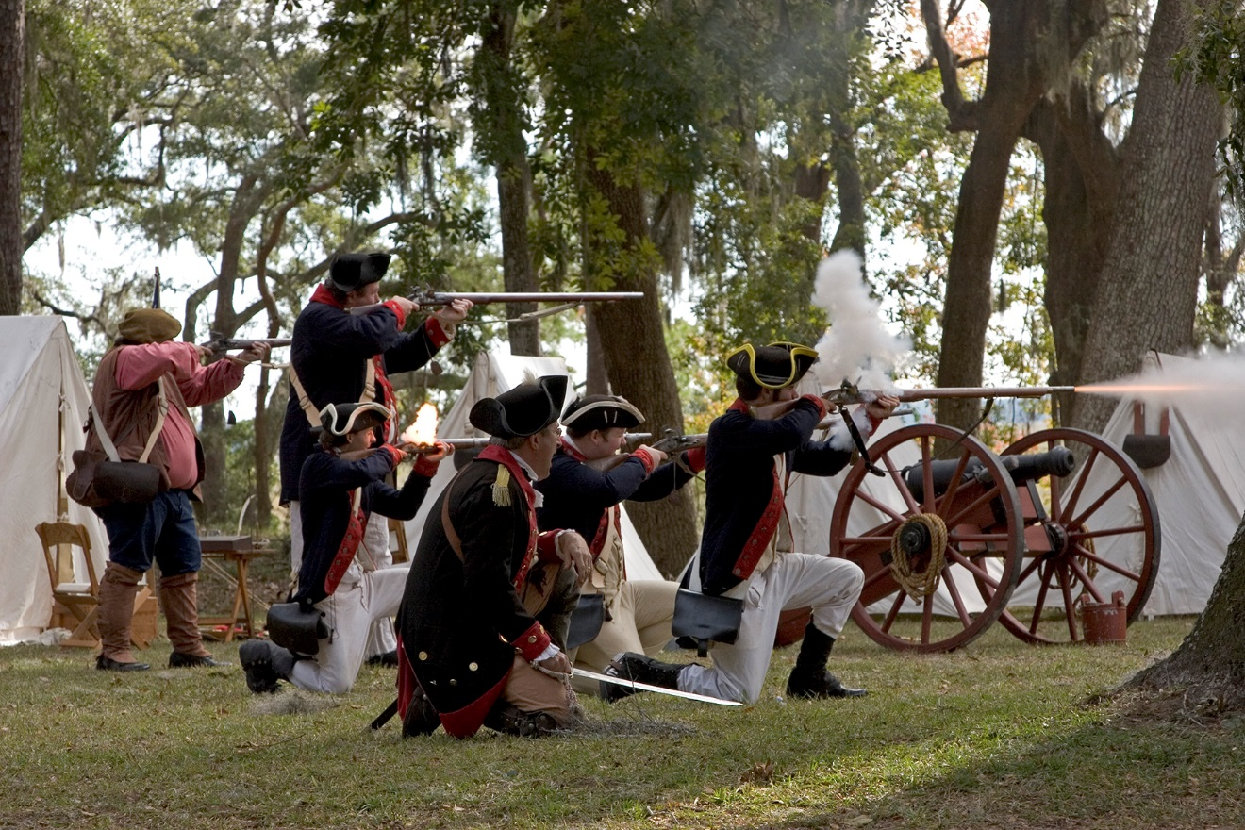

Visitors to Fort Morris State Historic Site can the hear whispers of the past as they gaze into the panoramic vista of the coastal environment while traversing the well preserved original earthworks that served as a bastion of liberty and defiance while defending the commercial seaport of Sunbury and the strategic Medway River during the American Revolution and War of 1812.

Fort Morris State Historic Site
Interpretation & Recreation Plans

_________________________________________________________________________________________
Table of Contents

- Site Significance and Interpretation
- Recreational Resources
- Potential & Current Audiences
- Nearby Services Serving Similar Audiences/Potential Partners
- Appendix A: Park Facilities: Site Map and List of Program Locations and Trails
- Appendix B: Contact Information (Audiences, Nearby Sites & Potential Partners)
- Appendix: C: References that Address your Sites Unique Resources
- Appendix D: Media Contacts

FORT Morris State historic Site

Interpretation & Recreation Plans september 2019

PURPOSE:
This plan is intended to provide guidance to site staff in planning interpretive programs, exhibits, and recreational opportunities Fort Morris State Historic Site over the next five years. Programs are the Division’s most effective means of generating public support and should be a high priority when making planning and budget decisions for these facilities.
WHY THE PARK WAS CREATED:

Liberty County Previous Site Name: Sunbury Historic Site
Date Established: 1968
Original Acreage: 66
Current Acreage: 66

Fort Morris was acquired as the Revolutionary War Fort Morris site. Research revealed the site was more significant than originally believed. The original land to establish Fort Morris Historic Site was purchased on June 14, 1968 from the Liberty County Commissioners. The surrounding area was being subdivided for development, creating a need for preservation of the site. With the help of local citizens, land purchases and acquisitions continued into the 1980s ending with a total of 66 acres. Governor Zell Miller designated 56 of the acres as a Heritage Preserve on November 6, 1998. The manager’s residence was built in 1975 and the museum/visitor’s center and maintenance barn were built in 1976. The site is representative of the coastal defense of Georgia as far back as the 1750s, the American Revolution, the War of 1812 and the War Between the States. In 1756 a battery was erected at Sunbury. From this time to the American Revolution, defenses were prepared to protect the site whether it was against the Native Americans, privateers, the British or the Union Army. During the American Revolution defenses were known as Sunbury Fort or the Fort at Sunbury. There were three expeditions against the British-held Florida that were all based out of Sunbury, with the fort being attacked at least twice: once by Lieutenant Colonel L. V. Fuser in November 1778 who, when requested to surrender the fort, gave the laconic reply, “…come and take it,” and once by Colonel John McIntosh. It was during this event that the fort became known as Fort Morris. In January 1779, British General Augustine Prevost captured the rebel fort and renamed it Fort George in honor of the king. Fort Morris was the last patriot post in Georgia to fall to the British and thus the whole state was brought back under Royal Rule. Visitors are made aware of these historically significant events through a film, the museum, exhibits, special events and programs. The walking tour allows the public to be within the fragile earthwork remains of the fortifications from times past. The magnificent vistas of the saltwater marsh, Medway River, coastal wildlife and St. Catherine’s Sound are also a fragile bonus. The heritage and nature of this site are truly priceless and in need of preservation, interpretation and promotion.

Site Significance:

The significance of the site resources includes:

- Best preserved earthworks from the American Revolution in Georgia
- Sunbury was once Georgia’s second largest seaport
- “Come and Take It!” letter
- Fort Morris was captured by the British in 1779
- George Walton, Button Gwinnett, Lyman Hall, Georgia’s signers of the Declaration of Independence had connections to Sunbury
- Sunbury is a “dead” town but is seeing new prosperity
- St. Catherine’s Sound is a natural deep-water harbor
- Old Sunbury Road begins/ends in Sunbury.
- First Masonic Lodge meeting in Georgia was held in Sunbury environs

Overarching Interpretive Theme:
Visitors to Fort Morris State Historic Site can the hear whispers of the past as they gaze into the panoramic vista of the coastal environment while traversing the well preserved original earthworks that served as a bastion of liberty and defiance while defending the commercial seaport of Sunbury and the strategic Medway River during the American Revolution and War of 1812.

Interpretive Media that Relate to the Site’s Significance and Retail Suggestions
Topic | Potential Storylines | Personal Interpretation | Non-Personal Interpretation | Suggested Retail
coastal environment | Exploration of Salt Marsh  The rich ecosystem diversity found in the park  Diverse wildlife species from the coastal waters  Historic flora and crops (indigo, mulberry, rice)  Canoe and Kayak programs  Astronomy | Tidal river - aquatic life, erosion  Salt marsh ecology  Agricultural history  Plant species such as oaks, myrtles, bay, pine and other maritime forest species as well as the coastal salt marsh.  Types of crops grown for subsistence and profit  Guided interpretive hikes or nature quest  Rare & endangered species such as bald eagles, diamondback terrapins, wood storks, etc.  Guided canoe/kayak programs  Astronomy programs  Birding/butterflies  Wildflower hikes/ID  Native, non-native and invasive plants  Photography and artist workshops  Citizen science activities related to birds and the environment (example: Christmas Bird Count)  Prescribed Burns – hike/walk, why we do it, etc. | Self-guided trail brochures –Nature Trail  Eco Boxes  Interpretive Panels to interpret flora and fauna throughout the park near public use areas  Checklist of birds, wildflowers, etc.  Nature Photography  Information on bulletin boards about plants and wildlife | Field guides to wildlife, plants, trees, birds, etc.  Books on canoeing/kayaking Georgia  Toys, t-shirts, souvenirs, gifts and logo branded items that reflect the park’s natural & cultural resources.  Nature journal specific to the park  Bird Song CD’s  Hiking sticks, medallions, patches  Nature study resources for families with children – kids binoculars, books, bug boxes, magnifiers, etc.
preserved original earthworks | Building of the battery and the fort  Changes to the fort over time (reconfiguration)  Fort nomenclature and engineering | Walking tours of the fort  Fort terminology talks  Archaeology and Artifact ID programs | Self-guided tour of the fort  Eco Boxes  Museum exhibits  Interpretive panels  Geo-cache boxes | t-shirts, mugs, souvenirs, etc.  Walking sticks, stick medallions  Books on Sunbury, fort architecture.

Topic | Potential Storylines | Personal Interpretation | Non-Personal Interpretation | Suggested Retail
commercial seaport of Sunbury and the strategic Medway River | Shipping/ deep water harbor  Transportation  Town layout and history  Hurricanes and natural disasters  Old Sunbury Road  Declaration signers  “Dead” town  British Occupation  Sunbury in the Civil War | Town and cemetery history talks/walks  Living History programs (blacksmithing, spinning, cooking, colonial games, butter churning, candle dipping, soap making, Outdoor and Dutch oven cooking, sailor life, storytelling, basket making, natural dyes etc.)  Programs/talks about Sunbury’s role in the history of Georgia  Programs related to Sunbury’s “demise” and modern recovery | Museum exhibits  Self-guided tour  Interpretive panels  Eco boxes  Site Video | Books on Sunbury and colonial Georgia  Books about Ships and transportation in the 1700-1800s.  t-shirts, mugs, souvenirs, etc.
the American Revolution and War of 1812 | Siege and capture of the fort  “Come and Take It!”  Naval Activity in the War of 1812  War of 1812 activity along the Georgia Coast  Artillery programs | Walking tours of the fort  Revolutionary war/War of 1812/Civil War Living History programs (soldier life, camp life, period military drills, cannon firings)  Revolutionary War History and Anniversary events  War of 1812 Anniversary events  Other Black powder programs  Lectures, symposiums, book signings, etc. | Self-guided tour or quest of the fort  Museum exhibits  Interpretive panels  Eco boxes  Site Video | t-shirts, mugs, souvenirs, etc.  Books on the Revolution and War of 1812, artillery, uniforms, weaponry, etc.

potential & current Audiences
Contact information listed in Appendix B
Special Interest Groups
- American Revolution/ military history enthusiasts
- Military personnel
- Tourists off I-95
- Geocaching and orienteering enthusiasts
- Bird Watching Enthusiasts

Community (Bryan, Chatham, McIntosh and Liberty County)
https://georgia.hometownlocator.com/counties/

- Churches:
- 48 Churches in Bryan County
- 322 Churches in Chatham County
- 49 Churches in McIntosh County
- 74 Churches in Liberty County

- Civic Organizations, Tourism Organizations:
- American Legion
- Darien/McIntosh Visitor Center
- Chatham Chamber of Commerce
- Coastal Georgia Botanical Gardens at the Historic Bamboo Farm
- Habersham House
- Hinesville Rotary
- Jenkins Boys Club
- Liberty County CVB
- Liberty County Historical Society
- Lions Club of Savannah
- Marsh View Senior Living
- Richmond Hill Convention and Visitor’s Bureau
- Rotary Club of Richmond Hill
- Rotary Club of Savannah
- Savannah Area Chamber of Commerce
- Savannah Botanical Gardens
- Savannah Newcomers Club
- Savannah’s Secret Gardens
- Senior Citizen’s Center, Town of Thunderbolt
- Skidaway Island Rotary Club
- SmartSenior Program at St. Joseph’s Candler
- Southeast GA Friends of Ft. Stewart & Hunter

- Libraries:
- 2 Libraries in Bryan County
- 15 Libraries in Chatham County
- 1 Library in McIntosh County
- 4 Libraries in Liberty County

- Area Businesses that could be targeted as partners or potential sponsors include:
- Bass Pro Shops (Savannah),
- Coastal Center for Developmental Studies
- Foley House Inn,
- Jumping Jacks
- Memorial Health
- Publix store 522
- Savannah Mall,
- Savannah Walmart Supercenter
- Southern Sweets Café & Bakery
- SSA Cooper
- Target (Savannah)
- YMCA of Costal Georgia

- Schools: K-12, Colleges and Daycare Centers
- Public Schools
  - Bryan County: There are 4 elementary schools, 3 middle schools, 2 high schools
  - Chatham County: There are 23 elementary schools, 8 K-8th, 8 middle schools, 11 High Schools, 5 charter schools
  - McIntosh County: There are 1 Elementary School, 1 Intermediate School, 1 Middle School and 1 High School.
  - Liberty County: There are 8 elementary schools, 3 middle schools, 2 high schools
- Private Schools:
  - Bryan County: There are 2 private schools
- Day Care Centers:
    - Bryan County: There are 8 Day-Care Centers
- Regional Homeschool Associations:
    - There are 4 regional homeschool associations

- Regional College and Universities:
    - Emory-Riddle University
    - Georgia Southern University
    - Georgia Southern University – Armstrong and Liberty Campuses
    - Savannah Law School
    - Savannah State University
    - Savannah Technical College
    - SCAD
    - South University

Day Visitors

- Most the day use visitors are from McIntosh, Bryan, Liberty, and Chatham counties.
- Fort tourists
- Visitors off I-95

Overnight Guests

Fort Morris has a Primitive Camp area designed for organized groups with advance reservations.

Current Program Participants

- Public Programs: Are attended by local, as well visitors from Interstate-95.
- Special Events: Most participants are predominately from the Hinesville, Brunswick, Savannah, and Fort Stewart areas.
- Group Programs: boy scouts, Fort Stewart military personnel, church groups, family reunions, meet-up groups.
- School field trips from: Bryan County School System, Liberty County School System, Mcintosh County School system, Richmond Hill City School System, Savanah City School System, as well as School groups from other Georgia schools and Groups from outside the state.
- Outreach Programs: Bryan County School System, Liberty County School System, Mcintosh County School system, Richmond Hill City School System, Fort Stewart, Bass Pro Shop Savannah.

Who is NOT coming that we would like to engage?

- Diverse populations
- Local community from surrounding counties
- Hunter Army Air-Field personnel, local Industrial Park work force (Target, Tire Rack, ALCOA)

Nearby Sites that serve a Similar Audience/Potential Partners
Contact information listed in Appendix B

Parks & Campgrounds:

- Fort King George State Historic Site
- Fort McAllister State Historic Park
- Lake Harmony RV Park
- Savannah South KOA
- South Newport Campground
- McIntosh Lake RV Park
- Skidaway Island State Park
- Wormsloe State Historic Site

Other Government Partnerships/Contacts:

- DNR–Fisheries Management Richmond Hill Hatchery & Office
- Georgia 4-H
- Georgia Ports Authority
- U.S.F.S. Fort Stewart
- UGA Extension Offices
- Harris Neck National Wildlife Refuge
- Fort Frederica National Monument

Nature Centers/Museums/Visitor Centers:
- Dorchester Academy National Historic Site
- Fort Stewart Military Museum
- Jepson Center for the Arts
- Mighty Eighth Air Force Museum
- Ralph Mark Gilbert Civil Rights Museum
- Richmond Hill History Museum
- Savannah Children’s Museum
- Savannah History Museum
- SCAD Museum of Art
- Telfair Academy

Arts, Music, Heritage, Farm organizations:

- Bee’s Creations
- Daughters of the American Colonists
- Daughters of the American Revolution
- Dunham Farms
- Hinesville Area Arts Council
- Jepson Center for the Arts
- Yvette’s Art for the Soul
- Sons of the American Revolution
- Springfield Plantation

Non-profit/Professional Organizations:

- Coastal Center for Developmental Services, Inc.
- Goodwill Industries of the Coastal Empire
- United Way of Liberty County

Special Interest:

- Geocaching/Orienteering
- Georgia Geocachers Association
- Georgia Orienteering Club

- Sons/Daughters/Children of the American Revolution

- Scout Organizations:
- Costal Empire Council, Scouts of America
- Girl Scout Council- Savannah

Appendix A Park MaP & Facilities, LIst of Programming locations and trails
Park Facilities: This 66-acre park has original American Revolution/ War of 1812 earthen fort, visitor center, museum, gift shop, 10 minute interpretive video, 7 picnic sites, 1 mile nature trail, primitive group camp, bus parking. Is part of the Colonial Coast Birding Trail with views of the Medway River and Saint Catherine’s Sound.

PARK MAP
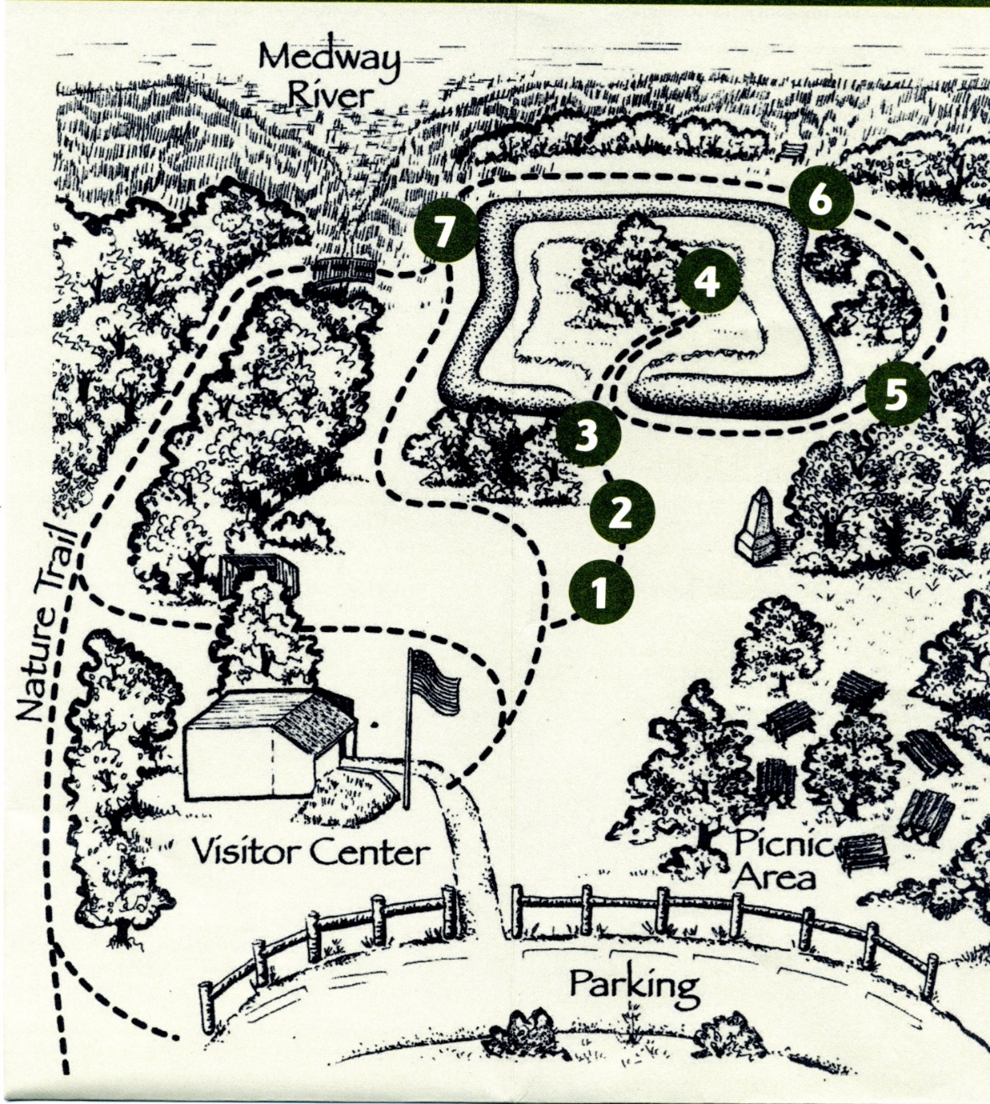
Existing Programming Locations:
AV Room
Blacksmith Shop
Fort
Museum
Medway River
Nature Trail
Parking Lot
Pioneer Camp

Potential Programming Locations:
Sunbury Public Boat Ramp-Newly purchased DNR building located at Sunbury Public Dock

Appendix B Nearby Sites that serve similar audiences, Resources & PotentiAl partnerS

Arts, Music, Heritage Organizations:

Bee’s Creations
229 W. General Screven Way, Suite 14
Hinesville, GA 31313
(912) 368-4774
http://business.libertycounty.org/list?moduleversion=3

Daughters of the American Colonists
2205 Massachusetts Ave. NW
Washington, DC 20008
(202) 667-3076
www.nsdac.org

Daughters of the American Revolution
1776 D Street NW
Washingotn, DC 20006
(202) 628-1776
www.dar.org

Dunham Farms
5836 Islands Hwy.
Midway, GA 31320
(912) 880-4500
www.dunhamfarms.com

Hinesville Area Arts Council
102 Commerce Street
Hinesville, GA 31313
(912) 368-4445
http://business.libertycounty.org/list?moduleversion=3

Liberty County Historical Society
100 S. Commerce Street
Hinesville, GA 31313
(912) 977-3282
http://business.libertycounty.org/list?moduleversion=3

Sons of the American Revolution
809 W. Main St.
Louisville, KY 40202
(502) 589-1779
www.nssar.org

Springfield Plantation
5836 Islands Hwy.
Midway, GA 31320
(912) 884-5450

Yvette’s Art for the Soul
Hinesville, GA 31313
(912) 312-4289
http://business.libertycounty.org/list?moduleversion=3
Non-profit/Professional Organizations:

Coastal Center for Developmental Services
1249 Eisenhower Dr.
Savannah, GA 31406
(912) 644-7500

Goodwill Industries
7220 Sallie Mood Dr.
Savannah, GA 31406
www.Goodwillsega.org

United Way of Liberty County
301 Fair Hope Lane
Hinesville, GA 31313
(912) 368-4282
https://uwce.org

Businesses/Community Services

Bass Pro Shops – Savannah
14045 Abercorn Street
Savannah, GA 31419
(912) 961-4200
http://www.basspro.com/webapp/wcs/stores/servlet/CFPageC?storeId=10151&catalogId=10051&langId=-1&appID=94&tab=3&storeID=29

Coastal Center for Developmental Services, Inc 1249 Eisenhower Drive Savannah, GA 31406 (912) 644-7500 http://www.effinghamcounty.com/Membership-Directory.72.0.html
Foley House Inn
14 West Hull Street
Savannah, GA 31401
(800) 647-3708
http://www.foleyinn.com/

Jumping Jacks
5918 Ogeechee Road
Savannah, GA 31419
(912) 920-2474
http://business.libertycounty.org/list?moduleversion=3

Memorial Health
4700 Waters Avenue
Savannah, GA 31404
(912) 350-8000
http://www.memorialhealth.com/

Publix (store 522)
5500 Abercorn Street Suite 2
Savannah, GA 31405-6913
(912)353-1260
http://www.publix.com/

Savannah Mall
14045 Abercorn Street
Savannah, GA 31419
(912) 927-7467
http://www.savannahmall.com/

Savannah Walmart Supercenter 1955 E. Montgomery Road Savannah, GA 31406 (912) 354-0335 http://www.walmart.com/store/605/whats-new

Southern Sweets Café & Bakery
1 Sherwood Drive
Hinesville, GA 31313
(912) 332-7555
http://business.libertycounty.org/list?moduleversion=3

SSA Cooper
27 Chatham Center Suite # A
Savannah, GA 31405
(912) 652-0599
http://www.ssamarine.com/

Target
14065 Abercorn Street
Savannah, GA 31419-1964
(912) 925-2667
http://www.target.com/sl/Savannah--Target-Store/1910

YMCA of Coastal Georgia 201 Marylou Drive Hinesville, GA 31313 (912) 368-9622 http://www.ymcaofcoastalga.org/
Civic Organizations & Tourism

American Legion Post 168
1121 W. Oglethorpe Hwy.
Hinesville, GA 31313
(912) 876-0168

Darien/McIntosh Visitor Center
PO Box 1497
Darien, Georgia 31305
(912) 437-6684
https://www.visitdarien.com/

Coastal Georgia Botanical Gardens at the Historic Bamboo Farm
2 Canebrake Road
Savannah, GA 31419
(912) 921-5460
http://www.coastalgeorgiabg.org/

Habersham House
5200 Habersham Street
Savannah, GA 31405
(912) 352-0070
https://www.fivestarseniorliving.com/communities/ga/savannah/habersham-house

Hinesville Rotary
Hinesville, GA 31313
(912) 401-1387
http://www.effinghamcounty.com/Membership-Directory.72.0.html

Jenkins Boys Club
Billy Covington - Executive Director
6408 Waters Avenue
Savannah, GA 31406
(912) 352-0964
http://www.jenkinsboysclub.com/

Liberty County CVB
208 E. Court St.
Hinesville, GA 31313
(912) 368-3580
www.libertycounty.org

Liberty County Historical Society
100 S. Commerce Street
Hinesville, GA 31313
(912) 977-3282
http://business.libertycounty.org/list?moduleversion=3

Lions Club of Savannah
P.O. Box 16916
Savannah, GA 31416-3616
(912) 354-4242
http://lionsclubofsavannah.com/

Marsh View Senior Living
7410 Skidaway Road
Savannah, GA 31406
(912) 354-6185
https://www.fivestarseniorliving.com/communities/ga/savannah/marsh-view-senior-living

Richmond Hill Convention and Visitors Bureau
2591 Hwy 17
Richmond Hill, GA 31324
www.richmondhillvisit.com

Rotary Club of Richmond Hill
520 Cedar St.
Richmond Hill, GA 31324
http://www.savrotary.org/index.php

Rotary Club of Savannah
P.O. Box 11105
Savannah, Georgia 31412
(912) 272-9711
http://www.savrotary.org/index.php

Savannah Area Chamber of Commerce
101 East Bay Street
Savannah, Georgia 31401
(912) 644-6400
http://www.savannahchamber.com/

Savannah Botanical Gardens
1388 Eisenhower Drive
Savannah, Ga. 31406
(912) 355-3883
http://www.savannahbotanical.org/

Savannah Newcomers Club
http://www.savannahnewcomers.com/

Savannah’s Secret Gardens
5657 Ogeechee Road.
Savannah, Ga 31405
(912)341-8002
http://savannahsecretgardens.blogspot.com/

Senior Citizens, Inc.
3025 Bull Street
Savannah, GA 31405
Phone: (912) 236-0363
(866) 579-2116
http://www.seniorcitizensinc.org/

Senior Citizen’s Center, Town of Thunderbolt
Linda Swanson - Director
3236 Russell Street
Savannah, GA 31404
(912) 352-4846
http://www.thunderboltga.org/Community/Senior-Citizens-Center

Skidaway Island Rotary Club
The Plantation Club at The Landings
1 Cottonwood Lane
Savannah, GA 31411
http://www.skidawayrotary.org/

SmartSenior Program at St. Joseph’s Candler
#8 Medical Arts Center
Savannah, GA 31405
(912) 352-4405
http://www.sjchs.org/in-the-community/smartsenior

Southeast GA Friends of Ft. Stewart & Hunter
Hinesville, GA 31313
(912)408-6225
http://www.effinghamcounty.com/Membership-Directory.72.0.html

Churches

There are 48 Churches in Bryan County, GA:
http://georgia.hometownlocator.com/features/cultural,class,church,scfips,13029.cfm

There are 322 Churches in Chatham County, GA:
http://georgia.hometownlocator.com/features/cultural,class,church,scfips,13051.cfm

There are 49 churches in McIntosh County, Georgia:
http://georgia.hometownlocator.com/features/cultural,class,church,scfips,13191.cfm

There are 74 Churches in Liberty County, GA:
http://georgia.hometownlocator.com/features/cultural,class,church,scfips,13103.cfm

Libraries

Ida Hilton Public Library
1105 North Way
PO Box 1227
Darien, GA 31305
(912) 437-2124
https://threeriverslibraries.org/wordpress-dev/library-locations/ida-hilton public-library/

ADA Community Library
106 W 76th Street
Savannah, GA 31405
(208) 362-0181
http://www.adalib.org

Asa H Gordon Library
2300 College Street
Savannah, GA 31404
(912) 356-2183
http://library.savannahstate.edu/

Bull Street Library
2002 Bull Street
Savannah, GA 31401
(912) 652-3600
http://www.liveoakpl.org/

Carnegie Library
537 East Henry Street
Savannah, GA 31401
(912) 652-3660
http://www.liveoakpl.org/

Forest City Library 1501 Stiles Avenue Savannah, GA 31415 (912) 238-0614 http://www.liveoakpl.org/

Islands Library
50 Johnny Mercer Boulevard
Savannah, GA 31410
(912) 897-6233
http://www.liveoakpl.org/

Jen Library
201 E. Broughton Street
Savannah, GA 31401
(912) 525-4700
http://library.scad.edu/

Law Library
415 W. Broughton Street Suite # 112
Savannah, GA 31401
(912) 652-7336
http://liveoakpl.org/

Liberty County Library
236 Memorial Drive
Hinesville, GA 31313
(912) 368-4003
http://www.liveoakpl.org/

Library for the Blind
2708 Mechanics Avenue
Savannah, GA 31404
(912) 925-8305
http://www.liveoakpl.org/

Liberty County Law Library 100 S. Main Street Hinesville, GA 31313 (912) 368-5111 http://www.libertycountyga.com/

Midway-Riceboro Library
9397 E. Oglethorpe Highway
Midway, GA 31320
(912) 884-5742
http://www.liveoakpl.org/

Oglethorpe Mall Library
7 Mall Annex
Savannah, GA 31406
(912) 925-5432
http://www.liveoakpl.org/

Ola Wyeth Library
4 East Bay Street
Savannah, GA 31401
(912) 232-5488
http://www.liveoakpl.org/

Pembroke Public Library
1018 Camelia Drive
Pembroke, GA 31321
(912) 653-2822
http://www.pembrokepubliclibrary.org/

Port City Library
3501 Houlihan Avenue
Savannah, GA 31408
(912) 964-8013
http://www.liveoakpl.org/

Port Wentworth Library
102 Aberfeldy Street
Savannah, GA 31408
(912) 964-0371
http://www.liveoakpl.org/

Richmond Hill Public Library 9607 Ford Avenue Richmond Hill, GA 31324 (912)756-3580 Savannah Newcomers Club
http://www.savannahnewcomers.com/

Southwest Chatham Library 14097 Abercorn Street
Savannah, GA 31419
(912) 925-8305 http://www.liveoakpl.org/

West Broad Library
1110 May Street
Savannah, GA 31415
(912) 232-6395
http://liveoakpl.org/

West Chatham Library
216 South Rogers Street
Pooler, GA 31322
(912) 748-0471
http://liveoakpl.org/

Yamacraw Reading Center
260 W. Bryan Street
Savannah, GA 31401
(912) 232-4656

Nature Centers/Museums/Visitor Centers:

Dorchester Academy National Historic Site
GA 38/US 84
Hinesville, GA 31313
(912) 884-2347
http://www.discoverourtown.com/GA/Hinesville/Attractions/dorchester-academy-national-historic-site/114564.html

Fort Stewart Military Museum 158 W. 1st Street Fort Stewart, GA 31314 (912) 767-7885 http://www.stewart.army.mil/info/?id=417
Jepson Center for the Arts
207 W. York Lane
Savannah, GA 31401
(912) 790-8800
http://www.telfair.org/visit/jepson/

Mighty Eighth Air Force Museum
175 Bourne Avenue
Pooler, GA 31332
(912)748-8888
http://mightyeighth.org/

Ralph Mark Gilbert Civil Rights Museum
460 Martin Luther King Jr Boulevard
Savannah, GA 31401
(912) 231-8900
http://www.visit-historic-savannah.com/

Richmond Hill Historical Society and Museum
11460 Ford Avenue
Richmond Hill, GA 31324
(912) 756-3697
http://www.richmondhillhistoricalsociety.com/

Sapelo Island Visitor Center/
Sapelo Island Wildlife Management Area
1766 Landing Rd,
Darien, GA 31305
(912) 437-3224
https://sapelonerr.org/

Savannah Children’s Museum
655 Louisville Road
Savannah, GA 31401
(912) 651-4292
http://chsgeorgia.org/

Savannah History Museum
303 Martin Luther King Jr Boulevard
Savannah, GA 31401
(912) 651-6825
http://www.chsgeorgia.org/

SCAD Museum of Art
601 Turner Boulevard
Savannah, GA 31401
(912) 525-7191
http://www.scadmoa.org/

Telfair Academy 121 Barnard Street Savannah, GA 31401 (912) 790-8800 http://www.telfair.org/

Other Government Partnerships/Contacts:

Fort Frederica National Monument
6515 Frederica Rd.
SSI, GA 31522
(912) 638-3639
www.nps.gov/fofr

Georgia Department of Natural Resource Division
Richmond Hill Fish Hatchery
110 Hatchery Dr.
Richmond Hill, GA 31324
(912) 727-2112
https://georgiawildlife.com/richmond-hill-fish-hatchery

Georgia 4-H
17 Minus Ave.
Garden City, GA 31408
(912) 652-7981
Uge3051@uga.edu

Georgia Ports Authority
2 Main Street
Savannah, GA 31407
(912) 964-3907
http://www.gaports.com/PortofSavannah.aspx

Harris Neck National Wildlife Refuge
5000 Wildlife Dr. NW
Townsend, GA 31331
(912) 832-4608
www.fws.gov/refuge/harris_neck

USFS Ft. Stewart
5000 Wildlife Dr.
Townsend, GA 31331
(912) 832-4608
www.Fws.gov

UGA Extension Office
17 Minus Ave.
Garden City, GA 31408
(912) 652-7981
Uge3051@uga.edu

Parks & Campgrounds:

Fort King George State Historic Site
302 Mcintosh Road SE
Darien, GA 31305
(912) 437-4770
https://gastateparks.org/FortKingGeorge

Fort McAllister State Historic Park
3894 Fort McAllister Road
Richmond Hill, GA 31324
(912) 727-2339
https://gastateparks.org/FortMcAllister

Lake Harmony RV Park
1088 Lake Harmony Dr. SW
Townsend, GA 31331
(912) 832-4338
www.lakeharmonypark.com

McIntosh Lake RV Park
1045 McIntosh Lake Ln. SW
Townsend, GA 31331
(912) 224-6236
www.mcintoshlakervpark.com

Savannah South KOA
4915 Hwy-17
Richmond Hill, GA 31324
(912) 756-3396
www.koa.com

Skidaway Island State Park
52 Diamond Causeway
Savannah, GA 31411
(912) 598-2300
https://gastateparks.org/SkidawayIsland

South Newport Campground
21782 US-17 North
Townsend, GA 31331
(912) 617-7750

Wormsloe State Historic Site
7601 Skidaway Road
Savannah, GA 31406
(912) 353-3023
https://gastateparks.org/Wormsloe

Public Schools, Private Schools, Colleges & Daycare Centers

Public Schools:
Bryan County Public Schools
8810 Highway 280
Black Creek, GA 31308
(912) 851-4000
http://www.bryan.k12.ga.us/

Chatham County Public Schools
208 Bull Street
Savannah, GA 31401
(912) 395-5600
http://internet.savannah.chatham.k12.ga.us/default.aspx

McIntosh County Board of Education
200 Pine St.
Darien, GA 31305
(912) 437-6645
http://mcintosh.schooldesk.net/

Liberty County Public Schools
200 Bradwell Street
Hinesville, GA 31313
(912) 876-2161
http://www.liberty.k12.ga.us/

Private Schools:

First Christian Academy
9184 Ford Ave.
Richmond Hill, GA 31324
(912)756-3407
www.fceagles.com

Calvary Christian Academy
8933 Ford Ave.
Richmond Hill, GA 31324
(912)756-3553

Colleges:

Emory-Riddle University
135 Canal St.
Pooler, GA 31322
(912) 450-0073
www.erau.edu

Georgia Southern University
1 Burnette BLVD.
Savannah, GA 31419
(912) 961-8303
www.georgiasouthern.edu

Georgia Southern University - Armstrong and Liberty Campuses
11935 Abercorn St,
Savannah, GA 31419
(800) 633-2349 | (912) 344-2576
https://www.armstrong.edu/

Savannah Law School
7426 Hodgeson Memorial Dr.
Savannah, GA 31404
(912) 525-3900
www.savannahlawschool.com

Savannah Technical College
5717 White Bluff Rd.
Savannah, GA 31401
(912) 443-5700
https://www.savannahtech.edu/

Savannah State University
3219 College St.
Savannah, GA 31404
(912) 358-4778
www.savannahstate.edu

SCAD
618 Drayton St.
Savannah, GA 31401
(912) 525-5200
www.scad.edu

South University
709 Mall Blvd.
Savannah, GA 31404
(912) 201-8000
www.south.edu

Day Care Centers:

Richmond Hill Playing
465 Harris Trail Rd.
Richmond Hill, GA 31324
(912)756-7257
www.richmondhillpals.com

Ford Academy
10730 Ford Ave.
Richmond Hill, GA 31324
(912) 756-2524
www.thefordacademy.com

The Children’s Village
2641 US-17
Richmond Hill, GA 31324
(912) 756-8688
www.Tcvkids.com

Early Learning Childcare Center 1962 US-17 Richmond Hill, GA 31324 (912) 756-0105
Richmond Hill YMCA
154 Thunderbird Dr.
Richmond Hill, GA 31324
(912) 756-5856
www.ymcaofcoastalga.org

Richmond Hill Montessori
2933 US-17
Richmond Hill, GA 31324
(912) 756-4554
www.richmondhillmontessori.com

Village on the Hill Learning Center
3766 US-17 #301
Richmond Hill, GA 31324
(912) 445-0160

First Christian Academy
9184 Ford Ave.
Richmond Hill, GA 31324
(912) 756-3407
www.Fceagles.com

Homeschool Organizations:

Classical Conversations
c/o Silk Hope Baptist Church
4929 Pineland Drive
Savannah, GA 31405
(912) 233-8424
www.classicalconversations.com

The Independent Learning Network
7160 Hodgeson Memorial Dr. Suite 101
Savannah, GA 31401
(912)355-7557

Kingdom Builders Homeschool Co-Op
kbchomeschool@gmail.com

Special Interest

Geocaching/Orienteering partnerships:

Georgia Geocachers Association:
Karen & Mark Lougee
geeocaching@gmail.com
(404) 353-4896
http://www.geocaching.com/geocache/GC26FHX_fort-yargo-state-park?guid=e1784e43-0da9-4fe7-9afd-587f8505e400

Georgia Orienteering Club
http://www.gaorienteering.org/

Scout Organizations:

Coastal Empire Council, Boy Scouts of America
11900 Abercorn Street
Savannah, GA 31419
(912) 927-7272

Girl Scout Council- Savannah
110 Pipemakers Circle #116
Pooler, GA 31322
(912) 236-1571

Appendix C REFERENCES THAT RELATE TO THE SITES UNIQUE RESOURCES

Every year an Annual Action Plan is created (AAP). There is a copy saved on the site computer.
Sunbury On the Medway – John Sheftall
The Struggle For the Georgia Coast- Dr. John E. Worth
Stability & Change in Guale Indian Pottery A.D. 1300-1702
Fort Morris State Historic Site office offers a library on local Colonial history.

Appendix d Media contacts for surrounding Area
Fort Morris State Historic Site is on Facebook.
MUST BLIND COPY Email | Media Outlet | First Name | Last Name | Phone | Address | City | State | Zip Code
jwhitten@bryancountynews.com | Bryan County News | Jeff | Whitten | (813)943-9354 | P.O. Box 1239 | Richmond Hill | GA | 31324
jamie.parker@bryancountynow.com | Bryan County Now | Jamie | Parker | (912) 756-5566 Ext. 102 | P.O. Box 1088 | Savannah | GA | 31402-1088
steve.corrigan@savannahnow.com | Bryan Co Now (Savannah Morning News) | Steve | Corrigan | (912)652-0318 | P.O. Box 1088 | Savannah | GA | 31402
editor@coastalcourier.com | Coastal Courier | Denise | Etheridge | (912)-876-0156 | P.O. Box 498 | Hinesville | GA | 31313
chill@gpb.org | Georgia Public Broadcasting
editor@glennvillesentinel.net | Glennville Sentinel | Pamela | Waters | (912) 654-2515 | 105 W. Barnard St. | Glennville | GA | 30427
calendar@goldenislesarts.org | Golden Isles Arts Assoc. |  |  | (912) 262-6934 | 1530 Newcastle St. | Brunswick | GA | 31520
psa@goldenislesbroadcasting.com | Golden Isles Broadcasting | Joe | Willie | (912) 261-1000 | 185 Benedict Rd. | Brunswick | GA | 31520
periscopekb@comcast.net | Kings Bay Periscope | Bill | Wesselhoff | (912)573-4719 | King's Bay Submarine Base | Kingsland | GA | 31548
Chargrove@Georgia.org | Local Tour Rep. | Cheryl | Hargrove | (404) 971-1559 |  | St. Simons | GA
calendar@savannahnow.com | Savannah Morning News |  |  | (912) 236-9511 | P.O. Box 1088 | Savannah | GA | 31402
eledbetter@statesboroherald.net | Statesboro Herald | Eddie | Ledbetter | (912) 489-9403 | 1 Proctor St. | Statesboro | GA | 30458
mail@tattnalljournal.com | Tattnall Journal |  |  | (912) 557-6761 | 114 B N. Main St. | Reidsville | GA | 30453
kathleen@thedariennews.net | The Darien News | Kathleen | Russell | (912) 437-4251 | P.O. Box 496 | Darien | GA | 31305
tjones@goldenisles.news | The Golden Isles News | Tyler | Jones | (912) 265-8320 | P.O. Box 1557 | Brunswick | GA | 31521
ssislander@bellsouth.net | The Islander | Pamela | Shierling | (912) 265-9654 | 3596 Darien Hwy | Brunswick | GA | 31525-3046
editor1@tds.net | Tribune Georgian |  |  | (912) 882-4927 | P.O. Box 6960 | St. Marys | GA | 31558

Listings for field trips that Fort Morris State Historic Site can contact for listings:

http://www.homeschoolbuyersco-op.org/field-trips/homeschooling-georgia/

http://www.thehomeschoolmom.com/homeschooling-in-georgia/field-trips/

http://a2zhomeschooling.com/regional/us/georgia/georgia_home_school_field_trips/

http://fieldtripswithsue.com/

http://www.thetravelstore.us.com/

