November 10, 2014
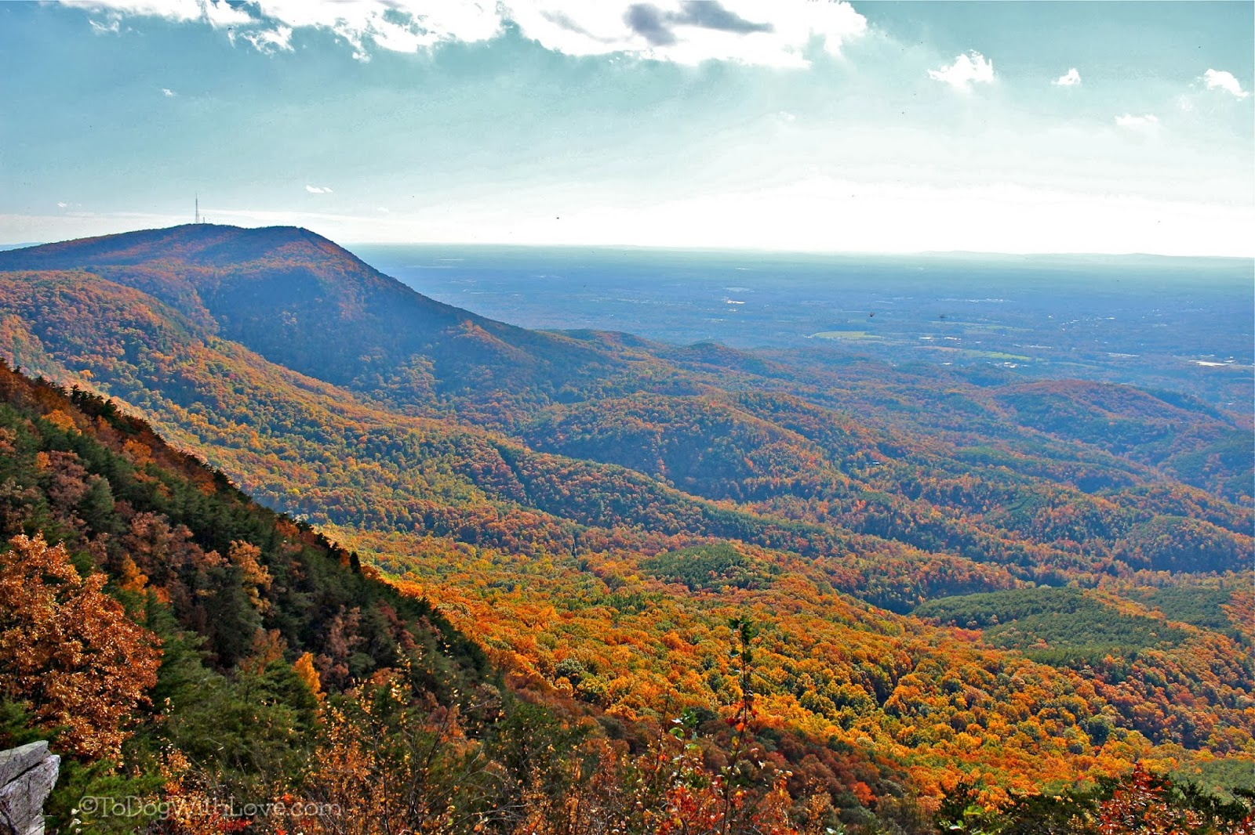
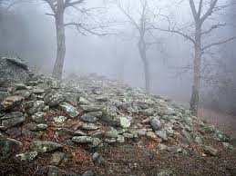

Mystery shrouds the ancient stone wall of Fort Mountain State Park, located near the Cohutta Wilderness, offering you a look back in time to the previous inhabitants, as you discover 60 miles of recreational trails and majestic overlooks.
Fort Mountain State Park
Interpretation & Recreation Plans

_________________________________________________________________________________________
Table of Contents

- Site Significance and Interpretation
- Recreational Resources
- Potential & Current Audiences
- Nearby Services Serving Similar Audiences/Potential Partners
- Appendix A: Park Facilities: Site Map and List of Program Locations and Trails
- Appendix B: Contact Information (Audiences, Nearby Sites & Potential Partners)
- Appendix: C: References that Address your Sites Unique Resources
- Appendix D: Media Contacts

fort mountain State Park

Interpretation & Recreation Plan november 2014

Purpose:
This plan is intended to provide guidance to site staff in planning interpretive programs, exhibits, and recreational opportunities at Fort Mountain State Park over the next five years. Programs are the Division’s most effective means of generating public support and should be a high priority when making planning and budget decisions for the park.
Why THE PARK was Created
Date Established: 1938 Original Acreage: 1,930 Current Acreage: 3,712
Fort Mountain State Park was established in 1938 after Ivan Allen donated the initial acreage to the state, ensuring the unique cultural and natural resources atop Fort Mountain would be protected for future generations. The original property included campgrounds, a 17-acre lake, day-use area, trails, and later, rental cottages.
In the late 1990s, through federal and state funding, the park expanded its boundaries to include 3,712 acres. This expansion has helped protect the park from the booming mountain realty developments and provided more recreational opportunities. The park has a premier trail system that is second to none in Georgia, including hiking, mountain biking, and horseback riding trails. In 2014 the horse trails were closed due to no one maintaining and operating the stables.
Fort Mountain has many unique resources, including the old fort wall that is estimated to be between 500 and 2,000 years old; its origins are an unsolved mystery even to this day. The CCC constructed many facilities in the park, including the stone fire tower, trails, the lake, and some park buildings. Fort Mountain is home to rare or unusual species such as the Tennessee Leafcup, Yellow and Pink Ladyslippers, Rafinesque’s Big-eared Bat, and the Eastern Small-footed Bat.
Site Significance:

The significance of the site resources include:

- Different theories about the mystery of how the “fort”/wall was build or why it is here. Speculation regarding the builders and their purpose cover a wide range. It includes references to sun-worship and last-ditch defense by prehistoric white people, bloody warfare between rival Indian tribes, defense fortifications for Spanish conquistadores hunting gold and a honeymoon haven for Cherokee Indian newlyweds. Nobody knows which of the many legends and theories is true and which is false. The true answer still lies buried somewhere in antiquity and may never be unearthed.

- There are many structures as well as the lake and roads that were built by the Civilian Conservation Corps during the Great Depression, with the fire tower being one of the unique features at Fort Mountain.

- Due to the location of the park in the Southern Appalachians, near the Cohutta Wilderness, Cohutta Wildlife Management Area, and Chattahoochee National Forest there are many wildlife species found in the region.

- Pink lady slippers and Turks cap lilies are just a few of the unique plant species that can be found along the trail system as well as many rock outcrops and small cascading waterfalls.

- The park has more miles of trail system than any other Georgia State Park.

- Elevation of the park and the highway leading to the park allows for scenic overlooks and many recreational opportunities such as hiking, biking, boating and swimming and attracts overnight guests in the backcountry campsites, walk-in sites, pioneer campground, and power-water sites with cable, and cottages. Note that 10 of the cottages are newly renovated.

Overarching Interpretive Theme:
Mystery shrouds the ancient stone wall of Fort Mountain State Park, located near the Cohutta Wilderness, offers you a look back in time to the previous builders, as you discover 60 miles of recreational trails and majestic overlooks.

Interpretive Media that Relate to the Site’s Significance and Retail Suggestions
Topic | Potential Storylines | Personal Interpretation | Non-Personal Interpretation | Suggested Retail
The ancient stone wall | Different theories about the mystery of how the “fort”/wall was build or why it is here. | Guided hike to wall  Mention wall in park intro programs  Multiple theories: explorers, American Indians, etc. | Self-guide brochure/trail interpreting the wall  Interpretive panel at the wall  Information in the cottage binders | Toys, t-shirts, magnets and other logo branded items that reflect the stone wall.  Books
Located near the Cohutta Wilderness  Majestic overlooks | Nestled within State/Forest lands there are multiple plant and animal species. | Wildlife programs, tracks & signs etc. specifically black bears  Weather  Plant, wildflower, tree, mushrooms ID, etc.  Birds – owls, vultures, hawks, songbirds, etc.  Reptiles & amphibians  Invasive species – hemlock wooly adelgid, Japanese hornets, etc.  Threatened and rare species – pink lady slippers, American Chestnut, Turks Cap Lily, etc. | Wildlife displays in the Visitor Center  Plant and animal interpretive panels along the trails  Tree ID guide and trails  Checklists: wildflower, bird, shrubs, etc.  Scavenger hunts and educational quests  Information in cottage binders | Field guides to trees, wildflowers, birds, mushrooms, scat & tracks, butterflies, mammals, etc.  Maps of the Cohutta Wilderness & Chattahoochee National Forest  Toys - Plush animals, rubber snakes, etc.  Nature study resources for families with children – kids binoculars, books, bug boxes, magnifiers etc.  Survival kits
Previous builders | There are many structures as well as the lake and roads that were built by the Civilian Conservation Corps.  Ivan Allen donated property that is a portion of the existing park. | Fire Tower guided hike/tour  CCC History and Anniversary events  Include Ivan Allen in park overview | Self-guided tour of CCC structures  CCC plaques identifying the structures  Information in cottage binders | t-shirts, souvenirs “built by the CCC”

Recreational Activities Suited to the Site and Retail Suggestions
Recreational Offerings/Facilities | Staff/Partnership-led Programs | Self-Directed Activities/Resources | Retail Suggestions
Fishing | Fishing 101 Programs: introduce inexperienced guests to fishing  Kayak fishing | Interpretive flyers on types of fish on bulletin boards  Fishing loaner program | Fishing gear – poles, stringers, bobbers, weights, etc.  Bait – worms and artificial lures, etc.  Books and fishing guides
Canoeing, Kayaking, Jon Boats, SUP, Pedal Boats & Aqua Cycles | Canoe clinics/101  Guided canoe/kayak programs  Twighlight Paddles | Boat rentals | Books on canoe/kayaking Georgia  Sunglasses, sunscreen, bug repellent, sun hats, visors, flashlights  Dry gear & cell phone bags  License/Keychain floats
Miniature Golf | Miniature Golf Tournaments | Equipment rentals
Astronomy | Astronomy 101 programs  Night time photography | Star gazing (use of mobile apps) | Planespheres, guide books
Geocaching | Geocaching  GPS or Map & Compass “how to” | GPS loaner program | Compasses  Trinkets for the cache, notebooks
Campfires | S’mores & stories  Storytelling  Outdoor cooking  Fire building |  | Marshmallow sticks  S’mores supplies  Outdoor Cooking, Dutch Oven, Campfire Cook Books  Firewood & fat lighter  Lighters, matches, etc.
Wagon Rides | Wagon ride program (transportation, storytelling, songs, etc.)  Wagon ride and hike
Arts & Crafts & Music Programs | Kids nature crafts  Holiday/seasonal crafts  Visiting Artists/Art in the Park  Music Concerts |  | Crayons, markers, etc.  Coloring books  Stickers
Trails & Fitness | Biking clinics  Ranger led Tons of Fun trail exercises (Animal Olympics)  Yoga or Thai Chi | Hiking, Jogging, dog-walking, biking, fitness elements/trails | Leashes & collars  Walking sticks, stick medallions  Related clothing items
Yard games – Bag Toss, Four Square in the Air, etc.  Board games | “Recreation Station”/yard games | Recreational equipment rentals  Board game in cottages | Frisbees, board games, cards, etc.
Beach and swimming | Sandcastle building contest  Treasure hunt with hidden treasure  Water relays/balloon toss |  | Sunscreen, PFD’s, floats  Sand toys, sunglasses, flip flops, towels

Equestrian stable and trails | Concessionaire guided rides | Trail rides | Horse decorations, t-shirts, souvenirs, etc.
School Programs
Fort Mountain State Park currently does not have programs that meet the Georgia Performance Standards.

potential & current Audiences
Contact information listed in Appendix B
Special Interest Groups
- Trail users – hikers, mountain bike riders. runners, backpackers
- Local community to use the day use areas: swimming beach, picnicking, etc.
- Nature Enthusiasts – birders, nature photographers, day hikers, botanists or individuals searching for rare plant species.
- Family Reunion groups
- First Time Campers

Community
- Global Youth Ministries
- Churches:
- There are 54 churches listed in Gilmer County, GA
- There are 48 churches listed in Murray County, GA
- There are 102 churches listed in Whitfield County, GA
- Civic Organizations, Tourism Organizations:
- Big Brothers Big Sisters of Northwest Georgia Mountains
- Boy Scouts of America/NWGA Co.
- Boys and Girls Clubs of Chattooga, Gordon, Murray & Whitfield Counties
- Cartecay Optimist Club
- Chatsworth Lions Club
- Dalton Chamber of Commerce
- Dalton Elks Lodge/B.P.O.E. #1267
- Dalton Whitfield Senior Center
- Dalton’s Noon Lions Club
- Ellijay Lions Club
- Ellijay Mountain Bike Association
- Gilmer County Senior Center
- Gilmer, Murray & Whitfield County Commissioner’s Office
- Girl Scouts of Greater Atlanta
- Keep Chatsworth-Murray Beautiful
- Kiwanis Club of Dalton
- Murray County Chamber of Commerce
- Murray County Senior Center
- Rotary Club of Dalton
- Whitfield Family Connection-Children & Families First
- Whitfield-Murray Historical Society
- Women’s Enrichment Center
- Libraries: Gilmer County Public Library, Chatsworth-Murray Library,
Dalton-Whitfield Library
- Area Businesses that could be targeted as partners or potential sponsors include: Friends of Fort Mountain State Park, Apple Orchards (PM look up), Carter’s Lake, Cartecay Bike Shop, Academy Sports (Dalton), Chatsworth Sporting Goods, Overlook Inn, The Martyn House, Mulberry Gap Mountain Bike Get-a-way
- Schools: K-12, Colleges and Daycare Centers
- Public Schools:
- There are 3 Elementary Schools, 1 Primary School, 2 Middle Schools, 1 High School in Gilmer County.
- There are 6 Elementary Schools, 2 Middle Schools, 2 High Schools and one K-12 Academy in Murray County.
- There are 12 Elementary Schools, 6 Middle Schools, 3 High Schools and one K-12 Academy in Whitfield County.
- Homeschool – North West Georgia Home Educators, North GA Christian Home Education Association, Gilmer Home Educators, Catoosa Home Education Association. Also available is the Virtual K-12/Georgia Cyber Academy program.
- Private Schools – Canaanland Christian School, North Georgia Christian Academy, Josephine Edwards Christian Academy, Christian Heritage School, Learning Tree Elementary School, Cedar Valley Christian Academy
- Day-care Centers – There are 15 Day-care Centers in Gilmer, Murray and Whitfield Counties.
- Colleges – Dalton State College

Day Visitors
- Local community visiting for day use recreation: swimming, picnicking, playgrounds, and day-hikes.

Overnight Guests
- Families from North Atlanta, Chattanooga, TN, and Florida.

Current Program Participants

- Public Programs: attended by the campground and cottage guests
- Special Events: attended by community members and guests who come specifically for the event theme (ex. runners)
- Group Programs: First Time Campers, Scouts, Ellijay Primary School and Whitfield Junior High school groups, 4-H groups, C.H.A.M.P., and church groups.
    - Outreach Programs: Apple Festival Parade in Ellijay, Christmas Parade in Chatsworth

Who is NOT coming that we would like to engage?

- Day users from the local community are not coming to park programs.
- School groups from the region for group programs.
Nearby Sites that serve a Similar Audience/Potential Partners
Contact information listed in Appendix B

Parks, Recreation & Campgrounds:

- Amicalola State Park
- Carter’s Lake Marina & Resort
- Chattachoochee National Forest
- Cohutta Wilderness
- Dalton State Athletics Club, Inc.
- Diamond Lure RV Park & Campground
- Doll Mountain Campground
- Harris Branch Beach & Campground
- Lake Conasauga
- Mulberry Gap Mountain Bike Get-a-way
- Parks & Recreation – Gilmer, Murray, & Whitfield County Parks & Recreation
- Plum Nelly Campground
- Public Fishing Areas – none nearby see lake resources
- Vogel State Park
- Wildlife Management Areas –Cohutta WMA, Rock Creek WMA
- Woodring Branch Campground

Other Government Partnerships/Contacts:

- Other DNR Division Staff nearby – Law Enforcement Division, Wildlife Resources Division: Game Management Section, Fisheries Management Section
- Gilmer, Murray, & Whitfield County Cooperative Extension
- U.S.F.S. Regional Office in Chatsworth
- Georgia Forestry Commission: Dalton, Ellijay and Chatsworth offices

Nature Centers/Museums/Visitor Centers:

- Blunt House
- Chickamauga and Chattanooga National Military Park
- Chief Vann House Historic Site
- Dalton Convention and Visitors Bureau
- Dalton Depot
- Dalton Freight Depot Visitor Center
- Dug Gap Battle Park
- Ellijay Downtown Welcome Center
- Hamilton House
- Murray County Historical Society
- Murray County Museum
- New Echota Historic Site
- Prater’s Mill
- Tabor House & Civil War Museum
- Tunnel Hill Heritage Center
- Wildlife Rehab Sanctuary

Arts, Music, Heritage, Farm organizations:

- Artistic Civic
- Burt’s Pumpkin Farm & Corn Maze
- Creative Arts Guild
- Dalton Arts Project
- Dalton Little Theater
- Dance Theater of Dalton
- Gilmer Arts & Heritage Association
- Go Murray Arts – Eton Studios
- Heartworks
- Murray Arts Council/MAC
- Whitfield-Murray County Historical Society

Appendix A Park MaP & Facilities, LIst of Programming locations and trails

Park Facilities: This 3,712 acre park has 15 cottages, 80 tent, trailer, RV campsites , 10 walk-in campsites, 6 platform campsites, 3 pioneer campsites, 4 backcountry campistes, 17-acre lake with swimming beach, 1 group shelter, 7 picnic shelters, Naturalist Room and Naturalist Area/Fire ring, miniature golf course, fire tower, over 60 miles of recreational trails.
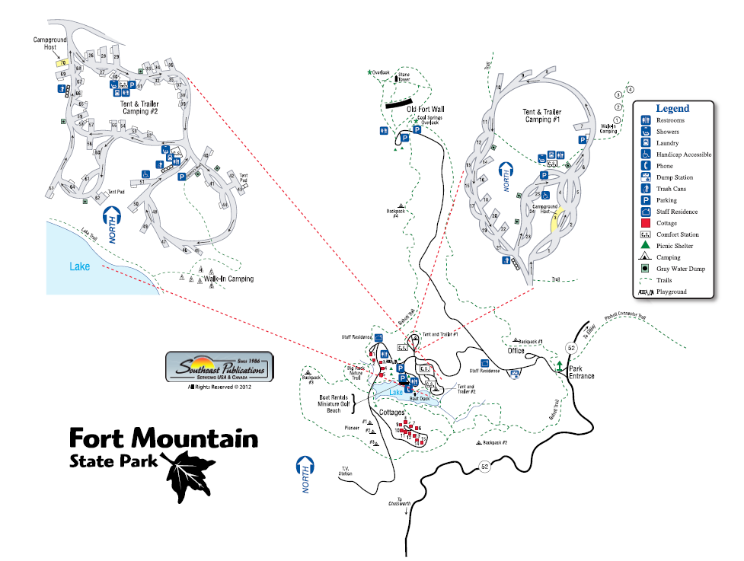
PARK MAP

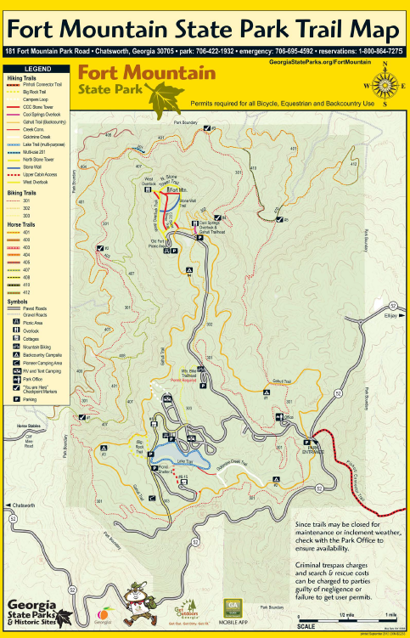
Existing Programming Locations:
Naturalist Room in basement of the Group Shelter
Naturalist Area by lake/Campfire Ring
Picnic Shelter (7)
Group Shelter (1)
Campground (Roving Ranger)
Miniature Golf Course
Beach
Fire Tower
Overlooks
Grassy Area by the Comfort Station 3

Potential Programming Location:
N/A

Trails
Gahuti Trail
Tower/Stone Wall Trail
Goldmine Creek Trail
Lake Loop Trail
Big Rock Trail
Campground Loop Trail
Pinhoti Connector Trail
Cool Springs Overlook Trail
Bike Trails: 301, 302, 303
Equestrian Trails: 400, 401, 403, 404, 405, 407, 408, 410, 412

Potential Trails:
Mountain Bike Trail expansion

Appendix B Nearby Sites that serve similar audiences, Resources & PotentiAl partnerS
Arts, Music, Heritage Organizations:

Artistic Civic Theatre
907 Gaston St.
Dalton GA 30720
http://www.actdalton.org/
706-278-4796

Burt's Farm
5 Burt’s Pumpkin Farm Rd, Dawsonville, GA 30534
http://www.burtsfarm.com/
(706) 265-3701

Creative Arts Guild
520 W Waugh St
Dalton, GA
www.creativeartsguild.org
706-278-0168

Dalton Arts Project
Physical: 411 North Park Drive
Dalton, GA 30720.
Mailing: PO Box 447
Dalton, GA 30722-0447
www.daltonartsproject.org/
706-529-ARTS(2787)

Dalton Little Theater
210 Pentz St.
P. O. Box 841
Dalton, GA 30722-0841
http://daltonlittletheatre.com/
(706) 226-6618

Dance Theater of Dalton
411 North Park Drive
PO Box 447
Dalton, GA 30720
http://www.dancetheatreofdalton.com/
706-529-5664

Gilmer Arts and Heritage Association
207 Dalton St.
Ellijay, GA 30540
http://www.gilmerarts.org/
706-635-5606

Go Murray Arts- Eton Studios
73 Old CCC Camp Rd.
Eton, GA 30724
Contact: Christian, John, gomurrayarts@yahoo.com
https://www.facebook.com/gomurrayarts
770-380-0420

Heartworks
100 W Waugh St
Dalton, GA
www.heartworksclass.com
706-529-427

Murray Arts Council/MAC
121 East Market Street
Chatsworth, GA 30705
Contact: Jones, Jennifer, murrayartscouncil@gmail.com
http://www.murray-arts.com
706-537-2502

Whitfield-Murray Historical Society
712 Chattanooga Avenue
Dalton, GA 30722-6180
Contact: Detweiller, Jennifer, wmhs@optilink.us
http://www.whitfield-murrayhistoricalsociety.org/
Multiple properties: http://www.whitfield-murrayhistoricalsociety.org/historicproperties.html
706-278-0217

Businesses/Community Services

Academy Sports
865 Shugart Rd, Dalton, GA 30720
http://www.academy.com/
(706) 270-6160

Cartecay River Bicycle Shop
N Main St.
Ellijay, GA 30540
http://www.cartecaybikes.com/
(706) 635-2453

Chatsworth Pawn & Sporting Goods
300 S 3rd Ave
Chatsworth, GA
https://www.facebook.com/pages/Chatsworth-Pawn-Sporting-Goods/117197361674881
(706) 695-8106

Friends of Fort Mountain State Park
181 Fort Mountain Park Road
Chatsworth, GA 30705
Contact: Keith, Kenneth, fortmountian1938@gmail.com
http://www.friendsoffortmountain.com/
706-422-1932

The Overlook Inn
9440 Georgia 52
Chatsworth, GA 30705
http://www.theoverlookinn.com/
706-517-0300

The Martyn House
912 Flat Branch Rd B&B
Ellijay, GA 30540
http://themartynhouse.com/
706-635-4759

Mulberry Gap Mountain Bike Get-a-way
400 Mulberry Gap Rd
Ellijay, GA 30540
http://www.mulberrygap.com/
706-698-2865

Apple Orchards: http://www.georgiaapplefestival.org/orchards.aspx

Aron Family Orchards
8350 Georgia 52
Ellijay, GA 30536
http://www.aaronfamilyorchards.com/
(706) 273-3180

Hudson’s Apple House
8036 Georgia 52
Ellijay, GA 30536
(706) 273-3160

Mack Aaron’s Apple House
8955 Georgia 52
Ellijay, GA 30536
https://sites.google.com/site/mackaaronsapplehouse/home
(706) 273-3600

Penland’s Apple House
41 Talona Spur
Ellijay, GA 30540
http://www.pickyourown.org/gaapenlands.php

Seller’s Apple House
255 Parks Dr.
Ellijay, GA 30536
https://www.facebook.com/pages/Sellers-Apple-House/149031328456457
(706) 273-3026

Panorama Orchards & Farm Market
Hwy 515 South
63 Talona Spur
Ellijay, GA 30540
http://www.panoramaorchards.com/ContactUs.shtml
(706) 276-3813

Hillcrest Orchards
9696 Hwy. 52 E.
Ellijay, Georgia 30536
706-273-3838 - Fax 706-273-3888
applelan@ellijay.com
http://www.hillcrestorchards.net/contact.htm
B.J. Reece Orchards
9131 Highway 52 East
Ellijay, Georgia 30536
phone: 706-276-3048
ReeceOrchards@ellijay.com
http://www.reeceorchards.com/wp/

Red Apple Barn
Tailscreek Road
Ellijay, Georgia 30540
http://www.redapplebarn.com/contact.htm
706-635-5898 or 706-635-7674

R&A Orchards
5505 Hwy. 52 East
Ellijay, GA 30536
http://randaorchards.com/index.html
apples@randaorchards.com
706-273-3821

Civic Organizations & Tourism

Big Brothers Big Sisters of Northwest Georgia Mountains
209 W. Morris St.
P. O. Box 417
Dalton, GA 30722-0417
http://www.bbbsnwgm.org/
706-278-0702

Boys and Girls Clubs of Chattooga, Gordon, Murray & Whitfield Counties
1013 Underwood St.
P. O. Box 309
Dalton, GA 30722-0309
http://www.bgcgmw.org/
706-529-5032

Cartecay Optimist Club
Ellijay, GA 30540-3054
https://plus.google.com/112094901342521484014/about?gl=us&hl=en
706-273-2078

Chatsworth Lions Club
P.O. Box 1211
Chatsworth, GA 30705
Contact: Penland, Dan
http://www.chatsworthlionsclub.com
706-695-2368

Dalton Chamber of Commerce
100 S Hamilton St, Dalton, GA 30720
http://www.daltonchamber.org/
706-278-7373

Dalton Elks Lodge/B.P.O.E. #1267
1300 Elkwood Drive
P. O. Box 1586
Dalton, GA 30722-1586
http://www.daltonelks.org/
706-278-6565

Dalton Whitfield Senior Center
302 Cappes St, Dalton, GA 30720
http://www.mydprd.com/page/show/979343-dalton-whitfield-senior-center
(706) 278-3700

Dalton Noon Lions Club
Western Sizzlin
Legion Dr.
Dalton, GA 30721
http://www.e-clubhouse.org/sites/daltonnoon/
https://www.facebook.com/dalton.noonlions

Ellijay Lions Club
1729 S Main St
Ellijay, GA 30540
http://www.ellijaylionsclub.com/
706-276-9910

Ellijay Mountain Bike Association
http://ellijaymountainbike.org/home/

Gilmer County Senior Center
111 N Gilmer St, Ellijay, GA 30540
706-636-4753

Gilmer County Board of Commissioners
1 Broad St #106
Ellijay, GA 30540
http://www.gilmercounty-ga.gov/commissioners.aspx
706-635-4361

Keep Chatsworth-Murray Beautiful, Inc.
302 East Market Street
Chatsworth, GA 30705
Contact: Adams, Sandi
http://www.keepchatsworth-murraybeautiful.org
706-517-0222

Kiwanis Club of Dalton
P. O. Box 65
Dalton, GA 30722-0065
http://www.kiwanisclubofdalton.org/
706-226-2194

Murray County Chamber of Commerce
126 North Third Avenue
Chatsworth, GA 30705
http://www.murraycountychamber.org
706-695-6060

Murray County Senior Center
820 G.I. Maddox Pkwy.
Chatsworth, GA 30705
Joan Dooley, Senior Center Director
http://www.murraycountyga.org/index.aspx?NID=177
706-695-2713

Murray County Commissioners
Brittany Pittman
121 N 4th Ave #101
Chatsworth, GA 30705
http://www.murraycountyga.org/index.aspx?nid=73
706-695-3423

Rotary Club of Dalton
P. O. Box 713
Dalton, GA 30722-0713
706-529-1226

Whitfield Family Connection-Children & Families First
Dalton High School Room 237
P. O. Box 1023
Dalton, GA 30722-1023
http://whitfield.gafcp.org/
706-876-4910

Whitfield-Murray Historical Society
715 Chattanooga Ave.
P. O. Box 6180
Dalton, GA 30722-6180
http://www.whitfield-murrayhistoricalsociety.org/
706-278-0217

Women’s Enrichment Center
109 West Gordon Street
Dalton, GA 30720
706-278-1050
http://www.wecdalton.org/

Whitfield County Board of Commissioners
Board Of Commissioners
301 W Crawford St.
Dalton, GA 30720
http://whitfieldcountyga.com/
706-275-7500

Churches

There are 54 churches listed in Gilmer County, GA
http://georgia.hometownlocator.com/features/cultural,class,church,scfips,13123.cfm

There are 48 churches listed in Murray County, GA
http://georgia.hometownlocator.com/features/cultural,class,church,scfips,13213.cfm

There are 102 churches listed in Whitfield County, GA
http://georgia.hometownlocator.com/features/cultural,class,church,scfips,13313.cfm

Libraries

Gilmer County Public Library (Sequoyah Regional Library)
268 Calvin Jackson Dr
Ellijay, GA 30540
http://www.sequoyahregionallibrary.org/hours_and_locations.htm
706-635-4528

Chatsworth-Murray Library (Northwest Georgia Regional Library System)
706 Old Dalton Ellijay Rd
Chatsworth, GA 30705
http://ngrl.org/chatsworth/
706-695-4200

Dalton-Whitfield Library
310 Cappes Street
Dalton, GA 30720
http://ngrl.org/dalton/
Phone #: (706) 876-1360

Nature Centers/Museums/Visitor Centers:

Blunt House
506 S. Thornton Avenue
Dalton, 30720
706-278-0217

Chickamauga and Chattanooga National Military Park
3370 LaFayette Road
Fort Oglethorpe, GA 30742
www.nps.gov/chch/index.htm
706-866-9241
Chief Vann House State Historic Site
82 Georgia 225
Chatsworth, GA 30705
http://gastateparks.org/ChiefVannHouse
706-695-2598

Dalton Convention and Visitors Bureau
305 S. Depot St
P.O. Box 6177 Dalton, GA 30722
Toll-free: 800.331.3258 | Direct: 706.270.9960http://www.daltoncvb.com/

Dalton Depot
110 Depot Street
Dalton, 30720
www.thedaltondepot.net
706-226-3160
Dalton Freight Depot Visitor Center
305 South Depot Street
Dalton, GA 30720
http://www.exploregeorgia.org/listing/1264-dalton-freight-depot-visitor-center
706-270-9960 | 800-331-3258

Dug Gap Battle Park
W. Dug Gap Battle Road
Dalton, GA 30720
706-278-0217
Ellijay Downtown Welcome Center
92 Sand St
Ellijay, GA 30540-9038
706-276-7973

Hamilton House
701 Chattanooga Ave.
Dalton, GA 30720

Murray County Museum
Herman McDaniel, Email: murraymuseum@aol.com
http://www.murraycountymuseum.com

New Echota State Historic Site
1211 Georgia 225
Calhoun, GA 30701
http://gastateparks.org/NewEchota
706-624-1321

Prater’s Mill
GA Hwy. 2
P.O. Drawer H
Varnell, GA 30756
www.pratersmill.org
706-694-6455
Tabor House & Civil War Museum
138 Spring St.
Ellijay, GA 30540
http://www.gilmercountyhistoricalsociety.org/
706-276-1861

Tunnel Hill Heritage Center
215 Clisby Austin Road
Tunnel Hill, GA 30755
www.tunnelhillheritagecenter.com

Wildlife Rehab Sanctuary
435 Cougar Ln
Ellijay, GA 30540
http://www.thewildlifesanctuary.com/
706-276-2980

Other Government Partnerships/Contacts:

Georgia Forestry Commission
705 Old Ellijay Road
Chatsworth , GA 30705
Vicky Edge, County Ranger, murrayunit@gfc.state.ga.us
http://www.gfc.state.ga.us/about-us/contact-us/county-units/CountyUnitsShow.cfm?iCounty=Murray
706-695-3422

Georgia Forestry Commission
Gilmer-Pickens County
25 Ellington Rd.
Ellijay , GA 30540
Seth Pierce, Chief Ranger, gilmerunit@gfc.state.ga.us
http://www.gfc.state.ga.us/about-us/contact-us/county-units/CountyUnitsShow.cfm?iCounty=Gilmer
706-635-2363

Georgia Forestry Commission
Whitfield County
2517 Cleveland Hwy, Dalton, GA 30720
Chuck Arnold, Chief Ranger
http://www.gfc.state.ga.us/about-us/contact-us/county-units/CountyUnitsShow.cfm?iCounty=Whitfield
706-272-2943

US Forest Service: Chattahoochee National Forest & Cohutta Trailheads
3941 U.S. 76
Chatsworth, GA 30705
http://www.fs.fed.us/
http://www.fs.usda.gov/main/conf/home
http://www.fs.usda.gov/recarea/conf/recreation/recarea/?recid=10465
706-695-1181

UGA Extension Murray County
664 Highway 52 E
Chatsworth, GA 30705-6648
http://www.caes.uga.edu/extension/murray/
706-695-3031

UGA Extension Gilmer County
1123 Progress Road, Suite A
Ellijay, GA 30540
http://www.caes.uga.edu/extension/gilmer/
706-635-4426

UGA Extension Whitfield County
104 South Thornton Ave.
Dalton, GA 30720
http://www.caes.uga.edu/extension/whitfield/
706-278-8207

Wildlife Resources Division
Region I Law Enforcement Division
P.O. Box 786
Calhoun, GA 30703-0786
Cpl. Casey Jones, Sgt. Jon VanLandingham, Cpl. James Keener
706-624-1367

Wildlife Resources Division
Game Management
Northwest Region I
2592 Floyd Springs Rd.
Armuchee, GA 30105
Chuck Waters, Region Supervisor; Larry Etheridge, Adam Hammond
http://www.georgiawildlife.com/hunting/game-management
(706) 295-6041

Parks, Recreation & Campgrounds:

Amicalola Falls State Park
418 Amicalola Falls Lodge Rd, Dawsonville, GA 30534
http://amicalolafallslodge.com/
http://gastateparks.org/AmicalolaFalls
706-344-1500

Dalton State Athletics Club, Inc.
650 College Drive
Dalton, GA 30720
706-483-5044

Diamond Lure Rv Park & Campground
514 Diamond Lure Rd
Ellijay, GA 30536
706-273-3075

Doll Mountain Campground
1362 Doll Mountain Rd
Ellijay, GA 30540
706-276-4413

Gilmer Parks & Recreation
1561 S Main St
Ellijay, GA
http://www.gilmercounty-ga.gov/departments/parks-recreation.aspx
706-635-7700

Harris Branch Beach & Camp Ground
1300 Harris Branch Rd
Ellijay, GA 30540
706-276-4545

Murray County Parks & Recreation
651 Hyden Tyler Rd
Chatsworth, GA
http://www.murrayrec.com/
-706-695-7359

Plum Nelly Campground
15828 South Highway 515
Ellijay GA 30540
Bill and Deanie Fincher
plumnellycampground@yahoo.com
http://www.plumnellycampground.com/
404-317-2458 & 706-698-7586

Vogel State Park
405 Vogel State Park Rd.
Blairsville, GA 30512
http://gastateparks.org/Vogel
706-745-2628

Whitfield County Parks & Recreation
176 Gillespie Dr.
Dalton, GA 30721
http://www.whitfieldcountyga.com/rec/parkrec.htm
706-226-8341

Woodring Branch Camp Ground
5026 Woodring Branch Rd
Chatsworth, GA 30705
706-276-6050

Wildlife Management Areas:

Cohutta Wildlife Management Area
12142 Old CCC Camp Rd
Ellijay, GA 30540
706-295-6041

Public Schools, Private Schools, Colleges & Daycare Centers

Public Schools in Murray County:
http://www.murray.k12.ga.us/Default.asp?L=0&LMID=&PN=Schools2&DivisionID=&DepartmentID=&SubDepartmentID=&SubP=
Bagley Middle School (14.9 miles)
Chatsworth Elementary School (8.4 miles)
Coker Elementary School (9.9 miles)
Eton Elementary School (12.9 miles)
Gladden Middle School (9.7 miles)
Mountain Creek Academy (9.2 miles)
Murray County High School (9.3 miles)
North Murray High School (14.5 miles)
Northwest Elementary School (18.6 miles)
Spring Place Elementary School (11.0 miles)
Woodlawn Elementary School (15.0 miles)

Schools in Gilmer County:
http://www.gilmerschools.com
Ellijay Elementary School (18.0 miles)
Ellijay Primary School (18.2 miles)
Gilmer Middle School (20.1 miles)
Clear Creek Middle School (24.8 miles)
Oakland Elementary School (31.9 miles)
Mountain View Elementary School (20.3 miles)
Gilmer High School (20.0 miles)

Schools in Whitfield County:
http://wcs.whitfield.k12.ga.us/schools
Antioch Elementary (20.7 miles)
Beaverdale Elementary (27.3 miles)
Cedar Ridge Elementary (16.2 miles)
Cohutta Elementary (31.8 miles)
Dawnville Elementary (19.2 miles)
Dug Gap Elementary (23.8 miles)
Eastside Elementary (18.7 miles)
New Hope Elementary (26.5 miles)
Pleasant Grove Elementary (22.6 miles)
Tunnel Hill Elementary (28.1 miles)
Valley Point Elementary (26.2 miles)
Varnell Elementary (26.9 miles)
Crossroads Academy (Middle School) (20.2 miles)
Eastbrook Middle (19.5 miles)
New Hope Middle (26.7 miles)
North Whitfield Middle (24.5 miles)
Valley Point Middle (26.3 miles)
Westside Middle (27.1 miles)
Coahulla Creek High (25.3 miles)
Northwest Georgia College & Career Academy (High school) (17.4 miles)
Phoenix High School—Southeast Whitfield High (17.4 miles)

Homeschool Groups:

Catoosa Home Education Association
http://www.homeschool-life.com/ga/chea/
Physical address CHEA, PO Box 985, Ringgold, GA 30736 (Catoosa County) catoosahea@yahoo.com

North West Georgia Home Educators
Melissa Mashburn, funnifamly@ellijay.com
https://www.globalstudentnetwork.com/viewgroup.php?id=1923

North GA Christian Home Education Association
Masters@ellijay.com
http://www.ghea.org/pages/resources/supportGroups/legacy.php
706-635-7018

Gilmer Home Educators
http://www.ghea.org/pages/resources/supportGroups/legacy.php
706-635-3771

Virtual K-12/Georgia Cyber Academy program
http://www.k12.com/gca#.UzeILvldWSo

Private Schools:

Canaanland Christian School
7624 Highway 225 S
Chatsworth, GA 30705
info@canaanlandchristianschool.com
http://canaanlandchristianschool.com/
706-629-7430

North Georgia Christian Academy
191 Harold Pritchett Rd
Ellijay, GA
http://www.ngca.net/
706-635-6422

Josephine Edwards Christian Academy
12472 Georgia 515
Ellijay, GA
706-635-2644

Christian Heritage School
1600 Martin Luther King Jr Blvd
Dalton, GA
www.chslions.com
706-277-1198

Learning Tree Elementary School
300 S Tibbs Rd
Dalton, GA
www.learningtreeschool.org
706-278-2736

Cedar Valley Christian Academy
2744 Cleveland Hwy
Dalton, GA
706-259-2822

Day-care Centers:

Childcare Network (10.4 miles)
Chatsworth, GA 30705
http://www.childcarenetwork.com/Georgia-Chatsworth-GA-147

Corner Stone Family Daycare (18.7 miles)
Dalton, GA
Countryside Childcare (15.0 miles)
Chatsworth, GA 30705
First Baptist Church (17.8 miles)
Ellijay, GA 30540
http://fbce.publishpath.com/

Funtime Daycare (14.0 miles)
Chatsworth, GA 30705

Gilmer County Day Care Center (20.2 miles)
Ellijay, GA 30540

Gilmer County Head Start (20.1 miles)
Ellijay, GA 30540

Karen’s Kidz (11.7 miles)
Chatsworth, GA 30705

Kiddie Carousel Daycare (21.5 miles)
Dalton, GA

Kiddie Land Preschool (15.0 miles)
Chatsworth, GA 30705
http://www.kiddielandkids.com/

Little Lambs Learning Center (11.5 miles)
Chatsworth, GA 30705

Mountain Academy (19.7 miles)
Ellijay, GA 30540

Precious Possessions Preschool (22.6 miles)
Dalton, GA

Whitfield County-Dalton Day Cr (21.5 miles)
Dalton, GA
Colleges:

Dalton State College
103 Dalton St, Ellijay, GA 30540
706-635-1260

Special Interest

Beaches or Lake Resources:

Carters Lake Marina & Resort
575 Marina Road
Chatsworth, GA 30705
carterlake@ellijay.com
http://www.carterslake.com/
706-276-4891

Harris Branch Beach & Campground
300 Harris Branch Rd
Ellijay, GA 30540, GA 30540
706-276-4545

Rock Creek Lake
http://www.georgiawildlife.com/node/1307

U.S.F.S. Lake Conasauga
http://www.fs.usda.gov/recarea/conf/recreation/ohv/recarea/?recid=10461&actid=29

Birding Partnerships:

Atlanta Audubon Society
4055 Roswell Road
Atlanta, GA 30342
(678) 973-2437
http://www.atlantaaudubon.org/

Chattanooga Audubon Society
Physical Address: 900 North Sanctuary Rd.
Chattanooga, TN 37421
Mailing Address:
Chattanooga Audubon Society
P.O. Box 21219
Chattanooga, TN 37424
(423) 892-1499 or (423) 892-3690
http://www.chattanoogaaudubon.org/

Geocaching/Orienteering partnerships:

Volunteer steward contact info with the Georgia Geocachers Association:
ELJLyle
ELJLYLE@GMAIL.COM
(706) 273-9232
Live cache page: http://www.geocaching.com/geocache/GC27C84_fort-mountain-state-park?guid=06aae486-05e1-4d08-8291-4d9e556361d0

Georgia Orienteering Club
http://www.gaorienteering.org/

Golf:

Indian Trace Golf Course
730 Mitchell Bridge Road
Chatsworth, GA 30705
http://www.indiantracegolf.com
706-695-7353

Spring Lakes Golf Club
1591 Golf Course Rd
Chatsworth, GA 30705
http://www.springlakesgolfclub.com/
706-695-9300

White Path Golf Course
1156 Shenendoa Dr
Ellijay, GA 30540
http://www.whitepathgolf.com/
706-276-3080

Horse Clubs:

Gilmer County Saddle Club
1727 S Main St.
Ellijay, GA 30540-3054
http://www.gilmercountysaddleclub.com/
706-636-3779

Murray County Saddle Club
560 Hwy 52 East
Chatsworth, GA 30705
Contact: Beth Harper, Gilmercountysaddleclub1@gmail.com
http://www.murraycountysaddleclub.com/

Kennels:

Pet’s Night Out
209 Old Northcutt Rd
Ellijay, GA 30540
forbes2@petsnightout.com
http://www.petsnightout.com/
706-276-3352

Bad Karma Kennels
12345 Georgia 2
Chatsworth, GA 30705
706-847-3316

Pet Shop
453 Log Round Mountain Trail
Ellijay, GA 30540
706-635-8727

Pets Prefer Home Pet Sitting Services
1205 Newport Dr
Ellijay, GA 30540
706-669-5861

Lora Palmer House/Pet Sitting
223 Dalrymple Cir
Ellijay, GA 30540
706-276-3129

Bed & Biscuits Pet Resort
11 Pleasant Gap Cir
Ellijay, GA 30540
https://www.facebook.com/pages/Bed-and-Biscuits-Pet-Resort/264123043722951?sk=info
706-635-7297

VCA Appalachian Animal Hospital
125 Mulberry St
East Ellijay, GA 30540
http://www.vcahospitals.com/appalachian
706-635-7357

Ellijay Animal Hospital
89 Gudger St.
Ellijay, GA 30540
http://www.ellijayah.com/
706-698-7387

Gina's Pets At Home
180 Laurel Ridge Dr
Ellijay, GA 30536
706-276-1528

Paddling partnerships:

Ellijay River Outfitters
88 Holt Bridge Rd.
Ellijay, GA 30536
http://www.tubeellijay.com/
706-889-8697

Scout Organizations:

Boy Scouts of America/NWGA Co.
202 S. Hamilton St.
Dalton, GA 30720
http://www.scouting.org/
(706) 272-7111

Girl Scouts Council-Atlanta
2204 E Walnut Ave
Dalton, GA 30721
706-226-1435

Appendix C REFERENCES THAT RELATE TO THE SITES UNIQUE RESOURCES
Resource Management Plan (2010) – Stored on the shared drive.
Business Plan for Fort Mountain State Park (also called D15 Plan) on park webpage: http://gastateparks.org/Staff/Plans/D15material/Stakeholder/Plans/FortMountainBP_FinalizedApproved_021513.pdf
History of Fort Mountain State Park – http://www.gastateparks.org/item/67911#ftmountain
The Natural Communities of Georgia by Leslie Edwards, Jonathan Ambrose, Katherine Kirkman and Hugh Nourse
Our Mark on this Land, A Guide to the Civilian Conservation Corps in America’s Parks by Ren & Helen Davis

Appendix d Media contacts for Pine Mountain Area
Site uses a Facebook page to promote programs and plans to pursue other social media sites: Twitter, Snapchat, Instagram.etc.

MUST BLIND COPY email | Media Outlet | First Name | Last Name | Phone | Address | City | State | Zip Code
bartow@mdjonline.com | Bartow Neighbor |  |  |  | 143 East Felton Road | Cartersville | GA | 30120
bartow@neighbornewspapers.com | Bartow Neighbor | Bill | Samaras | (770) 386-0872 | 143 E Felton Rd | Cartersville | GA | 30120-2143
jwillis@calhountimes.com | Calhoun Times | John | Willis | (706) 629-2231 | P.O. Box 8 | Calhoun | GA | 30701
alennon@calhountimes.com | Calhoun Times | Abbey | Lennon |  | 215 West Line Street | Calhoun | GA | 30701
features@daily-tribune.com | Cartersville Daily Tribune-News | Marie | Nesmith | (770) 382-4545 | P.O. Box 70 | Cartersville | GA | 30120-0070
earcher@notatlanta.org | Cartersville-Bartow Co. CVB | Ellen Archer |  | (770) 387-1357 | PO Box 200397 | Cartersville | GA | 30120
cvb@notatlanta.org | Cartersville-Bartow County CVB |  |  | (770) 387-1357 | PO Box 200397 | Cartersville | GA | 30120
david@cartersvilleuncut.com | Cartersville Uncut cable show | David | Paul |  |  | Cartersville | GA
catoosacountynews@catoosanews.com | Catoosa County News | Elliot | Volkman | (706) 935-2621 | P.O. Box 40 | Ringgold | GA | 30736
lorri.harrison@chatsworthtimes.com | Chatsworth Times | Lorri | Harrison |  |  | Chatsworth | GA
news@chatsworthtimes.com | Chatsworth Times | Gary | Tanner | (706) 695-4646 | P.O. Box 130 | Chatsworth | GA | 30705
news@timesfreepress.com | Chattanooga Times Free Press | Chris | Vass |  | 400 East 11th St. | Chattanooga | TN | 37403
weekend@timesfreepress.com | Chattanooga Times Free-Press |  |  |  |  | Chattanooga | TN
webmaster@mdjonline.com | Cherokee Tribune |  |  |  | 521 East Main Stree | Canton | GA | 30114
robinfordwallace@tvn.net | Dade County Sentinel | Robin | Ford Wallace | (706) 657-6182 | 385 Church St | Trenton | GA | 30752-2311
matthamilton@daltoncitizen.com | Daily Citizen | Matt | Hamilton | (706) 272-7724 | PO Box 1167 | Dalton | GA | 30722-1167
jamiejones@daltoncitizen.com | Daily Citizen | Jamie | Jones | (706) 272-7723 | PO Box 1167 | Dalton | GA | 30722-1167
markmillican@daltoncitizen.com | Dalton Citizen | Mark | Millican |  |  | Dalton | GA
elinformador@daltoncitizen.com | El Informador |  |  | (706) 272-7725 | 308 S Thornton Ave | Dalton | GA | 30720
adrep@timescourier.com | Elijay Times-Courier | Kathy | Aker | (706) 635-4313 | P.O. Box 1076 | Elijay | GA | 30540
jahackett@tds.net | Fannin County Chamber of Commerce | Janet | Hackett | (706) 632-5680 | 3990 Appalachian Highway | Blue Ridge | GA | 30513
cady.schulman@gmail.com | Historic High Country | Cady | Shulman |  |  | Cartersville | GA
natsimms@bellsouth.net | HometownHeadlines.com | Natalie | Simms | (706) 295-0533 |  | Rome | GA

MUST BLIND COPY email | Media Outlet | First Name | Last Name | Phone | Address | City | State | Zip Code
amandaray2133@yahoo.com | HometownPickens.com | Amanda | Ray | (678) 906-0717 | PO Box 247 | Ball Ground | GA | 30107
mari@knowpickens.com | KnowPickens and DiscoverDawson | Mari | Livsey |  |  | Dawsonville | GA
news@nooga.com | nooga.com |  |  |  |  | Chattanooga | TN
canton-ga@patch.com | Patch.com Canton |  |  |  |  | Canton | GA
cartersville@patch.com | Patch.com Cartersville |  |  |  |  | Cartersville | GA
brande.poulnot@patch.com | Patch.com Cartersville | Brande | Poulnot | (770) 547-1957 |  | Cartersville | GA
dlocklin89@gmail.com | Patch.com Woodstock | Dee | Locklin | (404) 353-4922 |  | Woodstock | GA
lisa@romegeorgia.org | Rome CVB | Lisa | Smith | (706) 295-5576 | 402 Civic Center Drive | Rome | GA | 30161
vcreel@rn-t.com | Rome News-Tribune | Valarie | Creel | (706) 290-5268 | P.O. Box 1633 | Rome | GA | 30162-1633
dwalker@rn-t.com | Rome News-Tribune | Doug | Walker | (706) 290-5272 | P.O. Box 1633 | Rome | GA | 30162-1633
romenewstribune@rn-t.com | Rome News-Tribune | Mike | Colombo | (706) 290-5257 | 305 E 6th Ave | Rome | GA | 30161
news@thenewsobserver.com | The News Observer | Georgia | Davis | (706) 632-2019 | 5748 Appalachian Hwy | Blue Ridge | GA | 30513-4240
news@timescourier.com | Times-Courier Ellijay |  |  |  |  | Ellijay | GA
subscription@timescourier.com | Times-Courier Ellijay | Rhesa | Chastain | (706) 635-4313 | P.O. Box 1076 | Ellijay | GA | 30540
eyjones@wbhfradio.org | WBHF-AM | Ernestine | Young-Jones | (770) 386-4618 | 7 N Wall St | Cartersville | GA | 30120
matts@wbhfradio.org | WBHF-AM | Matt | Santini | (770) 386-4618 | 7 N Wall St | Cartersville | GA | 30120
neller@south107.com | WRGA-AM | Nelle | Reagan | (706) 291-8088 | 20 John Davenport Dr NW | Rome | GA | 30165-2536
chuck@newstalk1270.com | WYXC-AM | Chuck | Shiflett | (770) 382-1306 | PO Box 200399 | Cartersville | GA | 30120
mtthw_youngblood@yahoo.com | WYYZ-AM | Matt | Youngblood | (706) 692-4100 | PO Box 1390 | Jasper | GA | 30143

