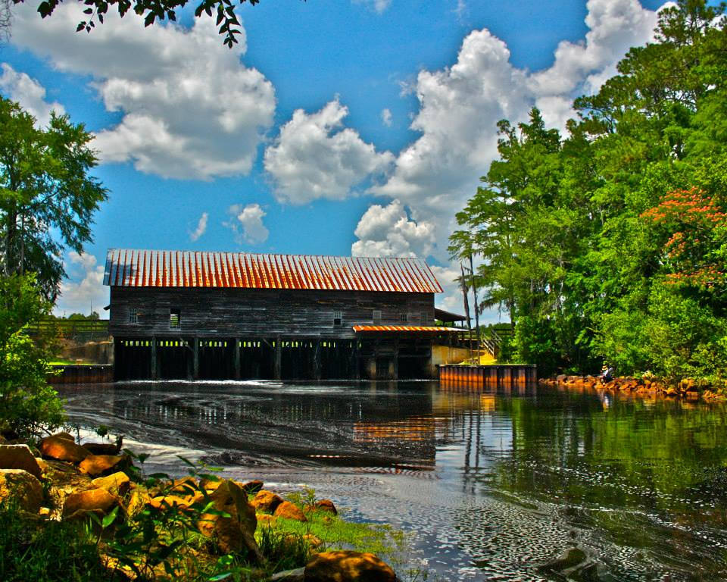
July 16, 2015

The peaceful natural beauty of George L. Smith State Park and the serene, cypress filled water of the mill pond offer you a tranquil escape where a small town, down home atmosphere provides both recreational and historical experiences.
George L. Smith State Park
Interpretation & Recreation Plans

_________________________________________________________________________________________
Table of Contents

- Site Significance and Interpretation
- Recreational Resources
- Potential & Current Audiences
- Nearby Services Serving Similar Audiences/Potential Partners
- Appendix A: Park Facilities: Site Map and List of Program Locations and Trails
- Appendix B: Contact Information (Audiences, Nearby Sites & Potential Partners)
- Appendix: C: References that Address your Sites Unique Resources
- Appendix D: Media Contacts

George l. smith State Park

Interpretation & Recreation Plans july 2015

Purpose:
This plan is intended to provide guidance to site staff in planning interpretive programs, exhibits, and recreational opportunities at George L. Smith State Park over the next five years. Programs are the Division’s most effective means of generating public support and should be a high priority when making planning and budget decisions for the park.
Why THE PARK was Created

Previous name: Parrish Pond Recreation Area, Watson Mill Pond
Date Established: 1975
Original Acreage: 1,355
Current Acreage: 1,634
The land was originally purchased through the Heritage Fund as a historic area and was named Parrish Pond Recreation Area. The name came from the original owner and developer of the land, James Parrish. In 1980, the area became a state park and was named after the local politician, George L. Smith, who was instrumental in purchasing the land for the state. In 1988, 13 additional acres were purchased as a buffer zone from development and to build a house for use as staff residence. In 1997, 266 acres were purchased to expand the park with a boat ramp and parking area, pioneer camping area, three-mile trail, and four additional cottages.
The park interprets Georgia history through the 1880s covered bridge and gristmill. Water recreation is available with boating and fishing in the 412-acre lake/mill pond. Natural recreation is available on the sand ridge trails with the opportunity to see the gopher tortoise.
Site Significance:

The significance of the site resources include:

- Alexander Hendrix and James M. Parrish purchased the land in 1880 and built the dam within a few months that created a man-made lake.

- The covered bridge that has served as a saw mill, a cotton gin, and grist mill has been a crossroad for the community.

- The county road passed through the covered bridge and a post office was located east of the bridge.

- The mill pond water levels are still maintained by gates located within the mill house and it is still used to grind cornmeal and grits.

- The three mile nature loop features the longleaf pine and Sandhill habitat for the State reptile the Gopher Tortoise, Indigo Snake and other threatened species.

- The multitude of bald cypress and tupelo in the mill pond provide beautiful fall colors.

Overarching Interpretive Theme:
The peaceful natural beauty of George L. Smith State Park and the serene, cypress filled water of the mill pond offer you a tranquil escape where a small town, down home atmosphere provides both recreational and historical experiences.

Interpretive Media that Relate to the Site’s Significance and Retail Suggestions
Topic | Potential Storylines | Personal Interpretation | Non-Personal Interpretation | Suggested Retail
peaceful natural beauty | longleaf pine and Sandhill habitat for the State reptile the Gopher Tortoise, Indigo Snake and other threatened species | Guided nature hikes  Birding  Native plants, trees, flowers, etc.  Photography workshops | Self-guided trail guide (virtual)  Interpretive panels on trails  Checklist of birds, mammals, reptiles, etc.  Nature Photography | Field guides specific to state/region: birds, fish, dragonflies, butterflies, trees, wildflowers, mammals, etc.  Hiking sticks, medallions, patches  Nature study resources for families with children – kids binoculars, books, bug boxes, magnifiers etc.
serene, cypress filled water of the mill pond | a man-made mill pond | How lake water levels are maintained  Ichthyology programs (study of fish)  Pond ecology | Interpretive panels on the bridge | Related souvenirs: coffee mugs, t-shirts, caps, magnets, bumper stickers, postcards, with the bridge, etc.  Kid explorer sets: magnifying glass, binoculars, etc.

small town, down home atmosphere | crossroad for the community  rustic trading post  the county road that passed through the covered bridge and the post office | Community farmer’s market  Early settlers: daily life, clothing, etc. | Interpretive panels on the bridge | Local made products – food, arts & crafts, etc.
historical experiences | Alexander Hendrix and James M. Parrish purchased the land in 1880 and built the dam within a few months that created a man-made lake.  The covered bridge that has served as a saw mill, a cotton gin, and grist mill has been a crossroad for the community. | Syrup making  Cornmeal & grits making  Guided bridge/mill house tours  Living History programs | Informational handout about the bridge/mill house  Self-guided bridge/mill house tours | Cornmeal, grits, and syrup made on site

Recreational Activities Suited to the Site and Retail Suggestions
Recreational Offerings/Facilities | Staff/Partnership-led Programs | Self-Directed Activities/Resources | Retail Suggestions
Fishing | Fishing 101 Programs: introduce inexperienced guests to fishing  Cooking Demos on preparing fish | Interpretive sign types of fish | Fishing gear – poles, stringers, bobbers, weights, etc.
Canoeing, Kayaking, Jon Boats, Paddleboards, Aqua Cycle, etc. | Canoe clinics/101  Guided boating programs – including moonlight paddles | water trail maps | Sunglasses, sunscreen, bug repellent, sun hats, visors, ball caps, flashlights  Dry gear & cell phone bags  License/Keychain floats
Astronomy | Astronomy 101 programs  Night time photography | Star gazing (use of mobile apps) | Planespheres, guide books
Geocaching | Geocaching 101 | virtual educational geocaches may be an option using smartphones | Trinkets for the cache, notebooks
Campfires | S’mores & stories  Storytelling  Outdoor cooking  Fire building |  | Marshmallow sticks  S’mores supplies  Firewood & fat lighter  Lighters, matches, etc.
Arts & Crafts | Kids nature crafts  How to: Basket making, natural dyes, candle making, etc.  Holiday/seasonal crafts  Visiting Artists/Art in the Park |  | Crayons, markers, etc.  Coloring books  Stickers

School Programs
George L. Smith State Park currently does not have programs that meet the Georgia Performance Standards.

potential & current Audiences
Contact information listed in Appendix B
Special Interest Groups
- Boaters – to use the recreational boats
- Fishermen – day use to mill pond
- College students doing research on natural resources
- Runners with cross country track meets

Community (Emanuel, Bulloch, Jenkins, Candler)
- Churches: There are 74 churches in Emanuel County; 116 in Bulloch County; 15 in Jenkins County; 7 in Candler County.
- Civic Organizations, Tourism Organizations:
- Boys and Girls Clubs of Bulloch County
- Brooklet Community Development Association, Inc.
- Emanuel Chamber of Commerce
- Emanuel County Senior Center
- Jenkins County Chamber of Commerce
- Metter-Candler Chamber of Commerce
- Rotary Club of Statesboro
- Statesboro Chamber of Commerce
- United Way
- Libraries:
- Candler County Library
- Franklin Memorial Library
- Jenkins County Memorial Library
- Statesboro Regional Library
- Zach S. Henderson Library
- Area Businesses that could be targeted as partners or potential sponsors include: Durden Bank, Mill Pond Trading Post, Stitch n’ Print, Edenfield House Bed & Breakfast, Wal-Mart (Swainsboro & Statesboro), Mill Pond Kayak, Yard Master, Hardware Headquarters, Swainsboro Supply, Lew’s BBQ, Georgia’s Sports Arena
- Schools:
- Public Schools
  - Bulloch County Public Schools – There are 7 elementary schools, 3 middle schools, 1 high school and 1 transitions learning center.
  - Candler County Public Schools – There is 1 elementary, 2 middle schools, and 1 high school.
  - Emanuel County Public Schools - There are 2 elementary, 1 preschool, 1 institute, 1 primary, 1 middle and 1 high school.
  - Jenkins County Public Schools – There is 1 elementary, 1 middle school, and 1 high school.
- Homeschool: Virtual K-12/Georgia Cyber Academy program, and there is a Mennonite Church that may have children who are homeschooled
- Private Schools: Bible Baptist Christian Academy, Bulloch Academy, David Emanuel Academy, Lighthouse Christian Academy, Trinity Christian School
- Daycare Centers: There are 26 daycare centers in Bulloch County; A Child's World Day Care II; Emanuel County Headstart; Kiddie Kampus Learning Center; Kids R Kids Learning Center; Little Treasures Learning Center; Sunshine House Children's Advocacy Center; Wonderland Day Care; Little Sunshine Learning Center; Sunshine House; Wiggles and Giggles Learning Center
- Colleges – East Georgia College, Southeast Technical College, Georgia Southern University, Ogeechee Technical College
Day Visitors
- The day visitors include local families for boating, picnicking and fishing.
- Family reunions, church groups, boy scouts, and weddings come as both day visitors and overnight guests.
Overnight Guests
- The overnight guests come from within a 100-mile radius from the park. In the winter more guests come from out-of-state.
- The majority of the campers are retirees and the boaters are college-age students.

Current Program Participants

- Public Programs: There are few public programs offered currently and the attendees are from the local community.
- Special Events: Most attendees are from the local 4 counties and overnight guests who come here for the event.
- Group Programs: a lot of school groups come from the 4 local counties, college students, and some public/civic organizations
  - Outreach Programs: a few outreach programs have been offered to the community schools

Who is NOT coming that we would like to engage?

- 19-30 year old, college-age population with 5 colleges in the surrounding area
- Multi-cultural population of Emanuel County: the county is divided to be approximately 63% Caucasian, 34% African American, 4.7% Hispanic (http://quickfacts.census.gov/qfd/states/13/13107.html)
- More local family participation

Nearby Sites that serve a Similar Audience/Potential Partners
Contact information listed in Appendix B

Parks & Campgrounds:

- Balls Ferry WMA
- Gordonia-Alatamaha State Park
- Magnolia Springs State Park
- Ohoopee Dunes WMA
- Riverbend WMA

Other Statewide Partnerships/Contacts:

- Bulloch County 4-H
- Candler County 4-H Club
- DNR Law Enforcement Division
- Emanual County 4-H
- Georgia Forestry Commission
- Jenkins County Extension Office
- Wildlife Resources Division, Nongame Conservation

Nature Centers/Museums/Visitor Centers:

- Georgia Southern College museum
- Raptor Center at Georgia Southern
- Twin City Historical Society – pavilion

Arts, Music, Heritage, Farm organizations:

- Bulloch County Historic Society
- Emanuel Arts Council
- Main Street Statesboro Farmers Market

Appendix A Park MaP & Facilities, LIst of Programming locations and trails
Park Facilities: This 1,634 acre park has 8 Cottages, 25 Tent, Trailer, RV Campsites, and 5 Primitive Campsites, 412-Acre Lake/Mill Pond with 10 miles of water trails, Historic Covered Bridge & Mill, 4 Picnic Shelters, Group Shelter, Pioneer Campground, Gift Shop, and 7 miles of trails.
PARK MAP
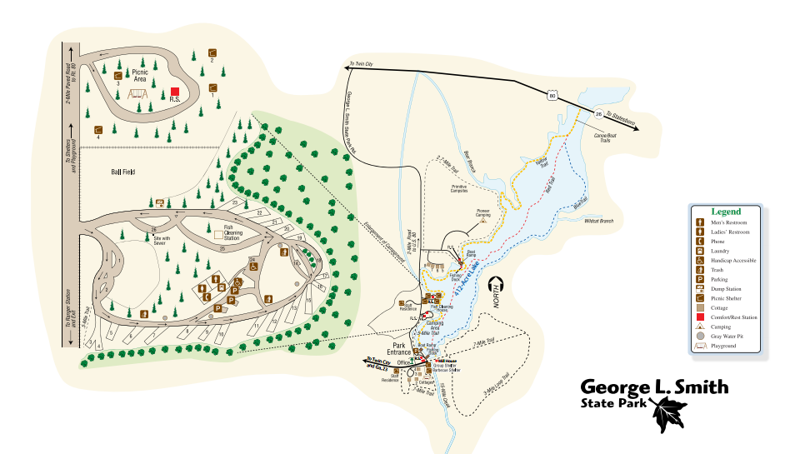

Existing Programming Locations:
Bridge/Mill House
Campground (Roving Ranger)
Dock/Boat Ramp
Field
Floating Dock
Group Shelter (1)
Mill Pond
Park Office
Picnic Shelter (4)
Pier
Pioneer Camp
Syrup Shed

Potential Programming Location:
N/A

Trails
.7-Mile Trail
Blue Water Trail
Brown Thrasher Trail - .5 miles
Deer Run - 3-Mile Loop Trail
Pioneer/Primitive Camping Loop – 2.7 Miles
Red Water Trail
Squirrel Run - .5 mile loop
Yellow Water Trail

Potential Trails:
N/A

Appendix B Nearby Sites that serve similar audiences, Resources & PotentiAl partnerS

Arts, Music, Heritage Organizations:

Bulloch County Historic Society
Victoria Anne Waters
124 South Main Street
Statesboro, GA 30458
(912) 489-8459
http://bullochhistory.com/

Emanuel Arts Council
303 N Green St
Swainsboro, GA
(478) 237-2592
http://emanuelarts.net/

Main Street Statesboro Farmers Market
222 S. Main Street
Statesboro, GA 30458
(800) 568-3301
(912) 764-7227
http://www.visitstatesboroga.com/shopping/mainstreetfarmersmarket/
http://statesborofarmersmarket.com/
https://www.facebook.com/TheMainStreetStatesboroFarmersMarket

Businesses/Community Services

Durden Bank
318 S Main St
Swainsboro, GA
(478) 237-2121
http://www.durdenbc.com/

Edenfield House Bed & Breakfast
426 W Church St
Swainsboro, GA 30401
(478) 237-3007
http://edenfieldhouse.com/

Emanuel Chamber of Commerce
102 S Main St
Swainsboro, GA
(478) 237-6426
http://www.emanuelchamber.org/

Emanuel County Senior Center
42 GA-56 #42
Swainsboro, GA
(478) 237-5434

Georgia’s Sports Arena
1093 GA Hwy 56 South
Swainsboro, GA 30401
(478) 455-0999
georgiasportsarena@gmail.com
www.georgiasportsarena.us
www.georgiasportsarena.com

Hardware Headquarters
521 S Railroad Ave
Twin City, GA 30471
(478) 763-2513

Jenkins County Chamber of Commerce
548 Cotton Ave
Millen, GA 30442
(478) 982-5595
http://www.jenkinscountyga.com/

Lew’s BBQ
407 N Railroad Ave
Twin City, GA 30471
(478) 763-3098
https://www.facebook.com/pages/Lews-Bar-B-que/178080423995

Metter-Candler Chamber of Commerce
1210 S Lewis St
Metter, GA
(912) 685-2159
http://www.metter-candler.com/
https://www.facebook.com/pages/Metter-Candler-Chamber-of-Commerce/404093232943815

Mill Pond Kayak
313 5th Ave
Twin City, GA 30471
(478) 299-6616
http://www.millpondkayak.com/

Mill Pond Trading Post
8 George L Smith State Park Rd
Twin City, GA 30471
(478) 763-4769
https://www.facebook.com/pages/Mill-Pond-Trading-Post/116005395091363

Statesboro Chamber of Commerce
102 S Main St
Statesboro, GA
(912) 764-6111
http://www.statesboro-chamber.org/

Stitch-n-Print
507 5th Ave
Twin City, GA
(478) 763-4183
http://www.snpusa.com/web/
https://www.facebook.com/pages/Stitch-N-Print/128614537221698

Swainsboro Supply
360 E Main St
Swainsboro, GA 30401
(478) 237-8876
https://www.facebook.com/pages/Swainsboro-Supply-Co/1444624359143241

Wal-Mart
147 Northside Dr E
Statesboro, GA
(912) 489-1910
http://www.walmart.com/store/754

Wal-Mart
414 S Main St
Swainsboro, GA
(478) 237-3524
http://www.walmart.com/store/1024/details

YardMaster
633 E Main St, Swainsboro, GA 30401
(478) 237-5444
http://www.theyardmaster.com/

Civic Organizations & Tourism

Boys and Girls Clubs of Bulloch County
Mike Jones, Executive Director
1 Lee Hill Drive
Statesboro, GA 30458
Phone: (912) 764-9696 ext. 223
http://www.bgcbulloch.org/

Boys and Girls Club of Candler County
https://www.facebook.com/boysandgirlsclubcandlerco

Brooklet Community Development Association, Inc.
Randy Newman – Chairman
(912) 682-0759
http://www.brookletcda.org/

Rotary Club of Statesboro
Stephen T. Rushing, President
District 6920
Post Office Box 1399
Statesboro, Georgia 30459
StatesboroRotary@yahoo.com
http://www.statesbororotary.org/

United Way
http://unitedwaysega.org/cms-view-page.php?page=bulloch-county

Churches

There are 116 in Bulloch County:
http://georgia.hometownlocator.com/features/cultural,class,church,scfips,13031.cfm

There are 7 in Candler County:
https://www.google.com/maps/search/churches+in+candler+county+ga/@32.414423,-82.0866119,11z/data=!3m1!4b1

There are 74 churches in Emanuel County:
http://georgia.hometownlocator.com/features/cultural,class,church,scfips,13107.cfm

There are 15 in Jenkins County:
https://www.google.com/maps/search/churches+in+jenkins+county+georgia/@32.7803961,-81.9577424,11z/data=!3m1!4b1

Libraries

Candler County Library
50 S Kennedy St
Metter, GA 30439
(912) 685-2455
http://strl.info/candler-county-library/

Franklin Memorial Library
331 W Main St
Swainsboro, GA 30401
(478) 237-779
http://strl.info/swainsboro-library/

Jenkins County Memorial Library
223 Daniel St
Millen, GA 30442
(478) 982-4244
http://www.sjrls.org/jenkindex.htm

Statesboro Regional Library
124 S Main St
Statesboro, GA
(912) 764-1341
http://strl.info/statesboro-regional-library/
Zach S. Henderson Library
1400 Southern Dr
Statesboro, GA
(912) 478-5115
http://library.georgiasouthern.edu/

Nature Centers/Museums/Visitor Centers:

Georgia Southern University Museum
2142 Southern Dr
Statesboro, GA 30458
(912) 478-5444
http://academics.georgiasouthern.edu/museum/

Twin City Historical Society – pavilion
N College St
Twin City, GA 30471
https://www.facebook.com/HistoricTwinCityGeorgia

Other Government Partnerships/Contacts:

Bulloch County 4-H
Lee Anna Deal or Cathy Deal
(912) 871-6130
http://www.caes.uga.edu/extension/bulloch/4H/index.html

Candler County 4-H Club
1075 East Hiawatha St
Metter, GA 30439
(912) 685-2408
http://www.caes.uga.edu/extension/candler/

Emanual County 4-H
UGA Extension Emanuel County
129 N. Anderson Drive
P. O. Box 770
Swainsboro, GA 30401-0770
Jeffrey Burke or call (478) 237-1226
http://www.caes.uga.edu/extension/emanuel/

Georgia Forestry Commission
3689 GA-15
Vidalia, GA 30474
(912) 537-0479

Jenkins County Extension Office
434 Barney Ave, Millen, GA 30442
(478) 982-4408
http://www.caes.uga.edu/extension/jenkins/

Region VI Georgia DNR Law Enforcement Division
Captain Scott Klingel, Sergeant Don Dasher, Corporal Mike Wilcox, Corporal Shaymus McNeely, and Ranger Randell Meeks
South Central 360 Cedar Street
Metter, GA 30439
(912) 685-2145

Wildlife Resources Division, Nongame Conservation
2065 U.S. Hwy. 278, SE
Social Circle, GA 30025
Matt Elliott, Program Manager (770) 918-6411

Wildlife Resources Division, Nongame Conservation
116 Rum Creek Dr.
Forsyth, GA 31029
Jim Ozier, Program Manager (478) 994-1438

Parks & Campgrounds:

Gordonia-Alatamaha State Park
162 Park Ln
Reidsville, GA 30453
(912) 557-7744
http://gastateparks.org/GordoniaAlatamaha

Magnolia Springs State Park
1053 Magnolias Springs Rd
Millen, GA 30442
(478) 982-1660
http://gastateparks.org/MagnoliaSprings

Ohoopee Dunes WMA
Georgia Wildlife Resources Division
(229) 426-5267
http://www.n-georgia.com/pdf/ohoopee-dunes-wma-mcleods-bridge-tract.pdf

Wildlife Management Areas:

Balls Ferry WMA/State Park
Georgia Wildlife Resources Division
(478) 825-6354
http://www.georgiawildlife.com/maps/hunting/region4
http://www.georgiawildlife.com/sites/default/files/uploads/wildlife/maps/wma/region4/Balls_Ferry_State_Park_Topo.pdf

Riverbend WMA
Georgia Wildlife Resources Division
(229) 426-5267
http://www.riverbendwma.com/
http://www.georgiawildlife.com/sites/default/files/uploads/wildlife/maps/wma/region6/River_Bend_WMA/River_Bend_WMA_South_Tract_Line.pdf

Public Schools, Private Schools, Colleges & Daycare Centers

Public Schools:

Bulloch County Public Schools – There are 7 elementary schools, 3 middle schools, 1 high school and 1 transitions learning center.
http://www.bulloch.k12.ga.us/schools
- Brooklet Elementary
- Julia P. Bryant Elementary
- Langston Chapel Elementary
- Mill Creek Elementary
- Nevils Elementary
- Portal Elementary
- Sallie Zetterower Elementary
- Stilson Elementary
- Langston Chapel Middle
- Southeast Bulloch Middle
- William James Middle
- Southeast Bulloch High
- Transitions Learning Center

Candler County Public Schools
210 South College St
Metter, GA 30439
( 912) 685-5713
http://www.metter.org/schools

Emanuel County Public Schools
201 N Main St
Swainsboro, GA
(478) 237-6674
http://www.emanuel.k12.ga.us/

Jenkins County Public Schools – There is 1 elementary, 1 middle school, and 1 high school.
1152 E Winthrope Ave
Millen, GA 30442
(478) 982-4791
http://www.jenkins.k12.ga.us/

Homeschool Groups:

Metter Mennonite Church
9094 Blanrock Rd, Metter, GA 30439
(912) 685-3909
Virtual K-12/Georgia Cyber Academy program
http://www.k12.com/gca#.UzeILvldWSo

Private Schools:

Bible Baptist Christian Academy
889 Ga Highway 24
Statesboro, GA 30461
(912) 764-5615
email: admin@bbcaraider.com
http://www.bbcaraider.com/

Bulloch Academy
873 Westside Rd
Statesboro, GA 30458
(912) 764-6297
http://www.bullochacademy.com/home/

David Emanuel Academy
602 N Fourth St
Stillmore, GA
(912) 562-4405
http://www.davidemanuelacademy.com/

Lighthouse Christian Academy
1095 Us Highway 1 N
Swainsboro, GA 30401
(478)237-0923
http://www.lcaed.com/

Trinity Christian School
571 E Main St
Statesboro, GA 30461
(912) 489-1375
http://www.tcsstatesboro.org/

Daycare Centers:

There are 26 daycare centers in Bulloch County: http://www.daycarecenterssite.com/BullochCounty-GA.html

Emanual County:

A Child's World Day Care II
493 Old Wadley Rd
Midville, GA 30441
(478) 589-7452
https://www.facebook.com/pages/A-Childs-World-Day-Care-II/160936973930333

Emanuel County Headstart
746 Gumlog Rd
Swainsboro, GA 30401
(478) 237-6135
lpeeples@csraeoaheadstart.org

Kiddie Kampus Learning Center
608 King Circle Dr
Swainsboro, GA 30401
(478) 237-3653
https://www.facebook.com/pages/Kiddie-Kampus-Learning-Center/162105170486353

Kids R Kids Learning Center
314 Happiness Dr
Swainsboro, GA 30401
(478) 237-0087
https://www.facebook.com/pages/Kids-R-Kids-Learning-Center/112420518822120
Little Sunshine Learning Center
508 5th Ave
Twin City, GA 30471
(478) 763-3372
https://www.facebook.com/pages/Little-Sunshine-Learning-Center/150807511628763

Little Treasures Learning Center
330 Stevens Dr
Swainsboro, GA 30401
(478) 237-9440
https://www.facebook.com/pages/Little-Treasures-Learning-Center/105647422834369

Sunshine House Children's Advocacy Center
328 W Main St
Swainsboro, GA 30401
(478) 237-7801
http://www.thesunshinehousecac.com/

Wonderland Day Care
669 Longview Rd
Swainsboro, GA 30401
(478) 289-7279
https://www.facebook.com/pages/Wonderland-Day-Care/165190766833917?rf=221369747882922

Candler County:

Sunshine House
432 N Rountree St
Metter, GA
(912) 685-4260
https://sunshinehouse.com/

Wiggles and Giggles Learning Center
17 N Kennedy St
Metter, GA
(912) 685-2010

Colleges:

East Georgia College
131 College Cir
Swainsboro, GA 30401
(478) 289-2000
http://www.ega.edu/

Georgia Southern University
1332 Southern Dr
Statesboro, GA 30458
(912) 478-4636
http://www.georgiasouthern.edu/

Ogeechee Technical College
1 Joe Kennedy Blvd
Statesboro, GA 30458
(912) 681-5500
http://www.ogeecheetech.edu/

Southeast Technical College - Swainsboro Campus
346 Kite Road
Swainsboro, GA 30401
(478)289-2200
http://www.southeasterntech.edu/about-stc/swainsboro-campus.php

Special Interest

Birding Partnerships:

Briar Creek Bird Club
1982 Burkhalter Rd.
Statesboro, GA 30458
(912) 839-3385

Ogeechee Audubon Society
6 Stone Hewer Lane
Savannah, GA 31411
reedengle@att.net
http://ogeecheeaudubon.org/

Ocmulgee Audubon Society
2742 Hillcrest Ave
Macon, GA 31204
(478)-745-5174
http://ocmulgeeaudubonsociety.blogspot.com/
https://www.facebook.com/OcmulgeeAudubonSociety

Raptor Center at Georgia Southern
1461 Forest Drive
Statesboro, GA
(912) 478-0831
http://academics.georgiasouthern.edu/wildlife/animals/raptors/

Geocaching/Orienteering partnerships:

Volunteer steward contact info with the Georgia Geocachers Association:
Mary Gene Cotton & Fred Williams
marygene@planters.net
(912) 863-4533
Live cache page: http://www.geocaching.com/geocache/GC26F8H_george-l-smith-state-park?guid=63735917-73a0-4bff-a9e7-5b3f934622fd

Georgia Orienteering Club
http://www.gaorienteering.org/

Golf:

Georgia Southern University Golf Courses
1031 Golf Club Rd
Statesboro, GA
(912) 478-4653

Rocky Creek Golf Club
1916 Foxfire Dr
Vidalia, GA 30474
(912) 538-1110
rockycreekgolfclub.com

Willow Lake Golf Club
550 W Willow Lake Dr
Metter, GA
(912) 685-2724
http://www.willowlakegolf.com/

Kennels:

Best Friends Animal Hospital
605 Brannen St
Statesboro, GA 30458
(912) 764-7387

Dogs Live Happy
1679 Akins Anderson Rd
Register, GA 30452
(912) 852-2200
http://www.dogslivehappy.com/

Gateway Animal Hospital
9849 US Highway 301 S
Statesboro, GA 30458
(912) 681-7387
http://www.gatewayvets.com/

Kara's Paw Spa
41 S Rountree St
Metter, GA 30439
(912) 685-7297

Kaycee's Pet Parlor
193 W Main St
Statesboro, GA 30458
(912) 489-1998

Pets & People
609 Brannen St Ste 2
Statesboro, GA 30458
(912) 764-2244

South Paws Dog Resort
2056 Northside Dr E
Statesboro, GA 30458
(912) 681-3647
http://www.southpawsdogresort.com/

Southern Pet Sitters
609 Brannen St Ste 16
Statesboro, GA 30458
(912) 764-4738
http://southernpetsitters.com/

Statesboro Bulloch Regional Vet
23608 US Highway 80 E
Statesboro, GA 30461
(912) 764-1001
http://sbrvet.com/

Tommy's Grooming & Boarding
303 Westside Rd
Statesboro, GA 30458
(912) 764-7693

University Animal Hospital
409 South Zetterower Avenue
Statesboro, GA 30458
(912) 243-9162
http://www.university-animal-hospital.com/

Westside Veterinary Hospital
201 W Main St
Statesboro, GA 30458
(912) 489-1998
http://www.westsidevethospital.com/

Paddling partnerships:

Mill Pond Kayak
13 5th Ave
Twin City, GA 30471
(478) 299-6616
http://www.millpondkayak.com/
https://www.facebook.com/millpondkayak

Scout Organizations:

Boy Scout Troop 205
Twin City, GA
Troop 205 is a small unit whose chartered organization is Twin City United Methodist Church.
http://cubscoutpack99.scoutlander.com/publicsite/unithome.aspx?UID=9656

Girl Scouts of Historic Georgia Corporate Headquarters
6869 Columbus Road
Lizella, GA 31052
(478) 935-2221
https://www.gshg.org/Pages/default.aspx

Appendix C REFERENCES THAT RELATE TO THE SITES UNIQUE RESOURCES
Business Plan for George L. Smith State Park (also called D15 Plan) on park webpage: http://gastateparks.org/Staff/Plans/D15material/Stakeholder/Plans/GeorgeLSmithBP_FinalizedApproved_012913.pdf
History of the park handout – Found on the Park Assistant Manager’s Computer
The Natural Communities of Georgia by Leslie Edwards, Jonathan Ambrose, Katherine Kirkman and Hugh Nourse
Looking for Longleaf: The Fall & Rise of an American Forest by Lawrence S. Earley
Longleaf, Far as the Eye Can See: A New Vision of North America’s Richest Forest by Bill Finch, Beth Maynor Young, Rhett Johnson and John C. Hall.

Appendix d Media contacts for surrounding Area
Site uses a Facebook page to promote programs and are included on state-wide promotions on other social media.
MUST BLIND COPY email | Media Outlet | First Name | Last Name | Phone | Address | City | Zip Code
post events on accessatlanta.com | Atlanta Journal Constitution |  |  | (404) 526-7003 |  | Atlanta
happenings@creativeloafing.com | Creative Loafing |  |  | (404)614-2529 | P.O. Box 54223 | Atlanta | 30308
senseofplacese@gmail.com | Examiner.com Atlanta Nature | Clifford | Blizard |  |  | Atlanta
htnews@bellsouth.net | Hometown News | Dean | Hesse | (770) 493-3003 | 3638 Summitridge Dr | Atlanta | 30340-4147
mami2mommy@yahoo.com | Mami 2 Mommy | Jennifer | Salazar Hutcheson |  |  | Atlanta
occupymyfamily@gmail.com | OccupyMyFamily.com |  |  |  |  | Atlanta
perry.parks@patch.com | Patch.com East Atlanta Region | Perry | Parks |  |  | Atlanta
bgray@georgia.org |  | Brittney | Gray | (678) 640-4338 | 75 Fifth Street NW, Suite 1200 | Atlanta | 30308
ladkison@thebrunswicknews.com | Brunswick News | Lindsey | Adkison | (912) 265-8320 | PO Box 1557 | Brunswick | 31521-1557
hrowland@thebrunswicknews.com | Brunswick News | Hank | Rowland | (912) 265-8320 | P.O. Box 1557 | Brunswick | 31521
terry.dickson@jacksonville.com | Georgia Times Union | Terry | Dickson | (912) 264-0405 ext. 10 | 3675 Community Road | Brunswick | 31520
ssislander@bellsouth.net | Islander |  |  | (912) 265-9654 | 3596 Darien Hwy | Brunswick | 31525-3046
scottryfun@gmail.com | WHFX-FM | Scott | Ryfun | (912) 267-1025 Ext. 112 | 3833 US Highway 82 | Brunswick | 31523-7735
articles@douglasenterprise.net | Douglas Enterprise |  |  | (912) 384-2323 | P.O. Box 750 | Douglas | 31534
dougent@windstream.net | Douglas Enterprise |  |  | (912) 384-2323 | P.O. Box 750 | Douglas | 31534
production@accessatc.net | WOKA-FM |  |  | (912) 384-8153 | 1310 Walker St W | Douglas | 31533
lhennesy@georgia.org | Region Tourism Rep - Magnolia Midlands | Lori | Hennesy | (678) 640-4342 | 902 Center Court | Douglas | 31533
matt.soergel@jacksonville.com | Jacksonville News | Matt | Soergel |  | P.O. Box 1949 | Jacksonville | 32231
jalred@JAXnews.com | Jacksonville News | John | Alred |  | P.O. Box 1949 | Jacksonville | 32231
news@gfrn.net | Georgia Farm Radio Network |  |  | (866) 217-7603 | 1620 Bass Rd | Macon | 31210
awoolen@macon.com | Macon Telegraph | Angela | Woolen | (478) 744-4376 | 120 Broadway | Macon | 31201
adrury@macon.com | Macon Telegraph | Andy | Drury |  | P.O. Box 4167 | Macon | 31208
laurastarlingwden@yahoo.com | WDEN-FM | Laura | Starling | (478) 746-6286 | 544 Mulberry St | Macon | 31201-8258
joe.browning@cumulus.com | WMGB-FM | Joe | Browning | (478) 746-6286 | 544 Mulberry St | Macon | 31201-8258
julie@wpga.tv | WPGA-AM | Julie | Register | (478) 745-5858 | 1691 Forsyth St | Macon | 31201-1407
robertsrci@aol.com | WQMJ-FM | Mike | Roberts | (478) 745-3301 | 6174 Georgia Highway 57 | Macon | 31217
johnlund@clearchannel.com | WVVM-AM | John | Lund | (478) 781-1063 | 7080 Industrial Hwy | Macon | 31216-7538
atcocitizen@mchsi.com | Atkinson County Citizen | Joan | Vickers | (912) 422-3824 | 302 Austin Ave E | Pearson | 31642-9319
gapost@pstel.net | Georgia Post | Mona | Lowe | (478) 836-3195 | P.O. Box 860 | Roberta | 31078
angie.thompson@gaflnews.com | Tifton Gazette |  |  | (229) 382-4321 | P. O. Box 708 | Tifton | 31793
kay.harris@gaflnews.com | Valdosta Daily Times | Kay | Harris | (229) 244-1880 | P.O. Box 968 | Valdosta | 31603
vdt.editorial@gaflnews.com | Valdosta Daily Times |  |  | (229) 244-3400, Ext. 1242 | 201 N. Troup St. | Valdosta | 31601
bill@waft.org | WAFT-FM | William | Tidwell | (229) 244-5180 | 215 Waft Hill Ln | Valdosta | 31602-6512
djkillagroove@yahoo.com | WSTI-FM | James | Walton | (229) 244-8642 | 1711 Ellis Dr | Valdosta | 31601-3573
donmoncrief@warnerrobinspatriot.com | Warner Robins Patriot | Don | Moncrief | (478) 923-3416 | 1350 Radio Loop | Warner Robins | 31088
georgiaeagleproduction@gmail.com | WRWR-TV Ch. 38 / Patriot Ga Jrl | Todd | Wilson | (478) 923-3416 |  | Warner Robins
steve.wheeler@qantumofauburn.com | WCJM-FM | Steve | Wheeler | (706) 645-2991 | 705 4th Ave | West Point | 31833-1594

