September 21, 2018
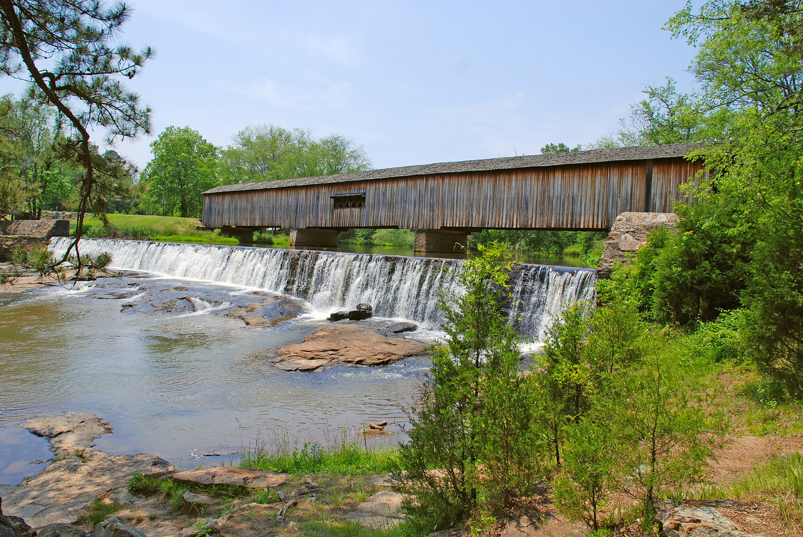

Divided by the winding South Fork River, Watson Mill Bridge State Park boasts Georgia’s longest covered bridge still in use, preserving a link to the culture of a bygone era and opening passageways to outdoor activities, rustic overnight experiences and equestrian adventures.
Watson Mill Bridge State Park
Interpretation & Recreation Plans

_________________________________________________________________________________________
Table of Contents

- Site Significance and Interpretation
- Recreational Resources
- Potential & Current Audiences
- Nearby Services Serving Similar Audiences/Potential Partners
- Appendix A: Park Facilities: Site Map and List of Program Locations and Trails
- Appendix B: Contact Information (Audiences, Nearby Sites & Potential Partners)
- Appendix: C: References that Address your Sites Unique Resources
- Appendix D: Media Contacts

watson mill bridge state Park

Interpretation & Recreation Plans september 2018

Purpose:
This plan is intended to provide guidance to site staff in planning interpretive programs, exhibits, and recreational opportunities at Watson Mill Bridge State Park over the next five years. Programs are the Division’s most effective means of generating public support and should be a high priority when making planning and budget decisions for the park.
Why THE PARK was Created

Date Established: 1969
Original Acreage: 144
Current Acreage: 1,118
The Bryan family, owner of Jefferson Textile Mills, donated the original 135 acres of land to the state of Georgia as the nucleus of a new park. The establishment of the park was a grassroots effort by local citizens and the Bryan family to preserve an old covered bridge and surrounding natural area for future generations. For more than 25 years, the park was focused mainly around the covered bridge, which was placed on the National Register of Historic Places, and provided camping, picnicking, nature trails, and fishing. Seeing the potential for greater natural resource protection and park expansion, the state worked with the Trust for Public Land in 1996 on three phases of land acquisitions. By the end of the decade, the park acreage was at 1,018 acres. In 2006, an additional 100 acres was acquired through DOT land mitigation funds, bringing the total acreage to 1,118.
One of Georgia’s few remaining covered bridges is the focal point of the park, preserving a link to the culture of a bygone era. The bridge crosses a natural flowing river, which is surrounded by rich natural resources of flora and fauna. The biodiversity of this site is varied with different ecosystems. It is one of only three parks in Georgia that operate an equestrian stay-use area. There are presently 21 miles of trails with some designated as horse trails, some as hiking/biking, and some as walking only. With the natural scenic beauty of the site, it is a subject for many artists and photographers in the state.

Site Significance:

The significance of the site resources includes:

- For more than 25 years, the park was focused mainly around the covered bridge, which was placed on the National Register of Historic Places,

- The bridge crosses the South Fork River, which is surrounded by rich natural resources of flora and fauna. The biodiversity of this site is varied with different ecosystems.

- It is the closest park to the city of Athens so it attracts many college students from the University of Georgia.

- Park wildlife includes bobcat, groundhog, raccoon, opossum, rabbit, squirrel, chipmunk, wild turkey, white-tailed deer, red fox, and snakes.

Overarching Interpretive Theme:
Divided by the winding South Fork River, Watson Mill Bridge State Park boasts Georgia’s longest covered bridge still in use, preserving a link to the culture of a bygone era and taking you through a passage to aquatic, overnight and equestrian adventures.

Interpretive Media that Relate to the Site’s Significance and Retail Suggestions
Topic | Potential Storylines | Personal Interpretation | Non-Personal Interpretation | Suggested Retail
Covered Bridge | Georgia’s longest covered bridge still in use  Importance of transportation  preserving a link to the culture of a bygone era | How the bridge was built, preservation of the bridge, etc.  Pioneer Life programs (folk toys, butter churning, candle dipping, etc.) | Interpretive Signs about the bridge  Nature Photography  Information in cottage binder | Souvenirs depicting the bridge: post cards, mugs, hats, shirts, etc.  Old fashioned toys
winding South Fork River | The South Fork River, which is surrounded by rich natural resources of flora and fauna | Wildlife programs: snakes, owls, insects, butterflies, birds of prey, mammals, scats & tracks, etc.  Live animal programs (snakes & turtles)  Guided Hikes: birds, trees,  Mushroom, & wildflower walks/ID  Stream Ecology & creek walks  Prescribed Burns – hike/walk, why we do it (fuel reduction), etc.  Native, non-native and invasive plants | Wildlife displays in the Visitor Center  Interpretive trail signs on trails  Self-guided trail brochures  Scavenger Hunt/Quest (brochure or digital) | Field guides to trees, wildflowers, birds, mushrooms, scat & tracks, butterflies, mammals, etc.  Toys - Plush animals, rubber snakes, etc.  Hiking sticks, medallions, patches  Nature study resources for families with children – kids binoculars, books, bug boxes, magnifiers etc.

Recreational Activities Suited to the Site and Retail Suggestions
Recreational Offerings/Facilities | Staff/Partnership-led Programs | Self-Directed Activities/Resources | Retail Suggestions
Trails & Fitness | Biking clinics  Yoga  Trail races | Hiking, jogging, dog-walking, biking | Leashes & collars  Walking sticks, stick medallions  Sunglasses, sunscreen, bug repellent, sun hats, visors, flashlights, etc.  Related clothing items
Equestrian | N/A – no horses owned by the park | Self-guided rides | Souvenirs depicting horses: post cards, mugs, hats, shirts, etc.
Astronomy | Astronomy 101 programs  Night time photography | Star gazing (use of mobile apps) | Planespheres, guide books
Campfires | S’mores & stories  Storytelling  Outdoor and Dutch oven cooking  Fire building |  | Marshmallow sticks  S’mores supplies  Outdoor Cooking, Dutch Oven, Campfire Cook Books  Firewood & fat lighter  Lighters, matches, etc.

Recreational Offerings/Facilities | Staff/Partnership-led Programs | Self-Directed Activities/Resources | Retail Suggestions
Arts & Crafts | Kids nature crafts  How to: Basket making, natural dyes, candle making, etc.  Holiday/seasonal crafts  Visiting Artists/Art in the Park |  | Crayons, markers, etc.  Coloring books  Stickers
Fishing | Fishing 101 Programs: introduce inexperienced guests to fishing | Fishing loaner program | Fishing gear – poles, stringers, bobbers, weights, artificial lures, etc.
Hayrides | Hayride program (transportation, storytelling, songs, etc.)  Haunted hayrides  Holiday hayrides
Yard games – Murbles, Bocce, Croquet, Frisbee, Ladder Golf, horseshoes, washer toss, bag toss, cat and mouse, etc.  Board games | “Recreation Station”/yard games (croquet, Murbles, Frisbee, etc.)  Group gatherings (birthday parties, family reunion) with ranger led recreation programs | Recreation rental program  Horseshoe pit  Board games in cottages | Frisbees, horseshoes, puzzles, board games, cards, etc.

School Programs
Watson Mill Bridge State Park does not have any programs that correlate to the Georgia Performance Standards.

potential & current Audiences
Contact information listed in Appendix B
Special Interest Groups
- Local residents come for day use to play on the shoals, paddle the river, use trails and visit the iconic bridge.
- Recreational users come to use the horse trails and stables.

Community (Madison and Oglethorpe County)

- Churches:
- 53 Churches in Oglethorpe County
- 61 Churches in Madison County
- Civic Organizations, Tourism Organizations:
  - Carnesville Lions Club
- City of Athens
- City of Comer
- City of Danielsville
- City of Royston
- Franklin County Senior Citizen Center
- Garden Club of Ga
- Kiwanis Club
- Madison County Chamber of Commerce
- Madison County Lions Club
- Madison County Senior Center
- Oglethorpe County Chamber of Commerce
- Oglethorpe County Senior Center
- Oglethorpe Lions Club
- Oglethorpe Rotary Club
- Rotary Club, Royston, GA
- Royston/Franklin Springs Lions Club
- Libraries:
  - Athens Regional Libraries
  - Comer Library
  - Madison County Library (2 branches)
- Area Businesses that could be targeted as partners or potential sponsors include:
- Chief Burger
- Chicken Express
- Deason’s Feed Store
- First Citizens Bank
- First Madison Bank and Trust
- Gina Bell’s
- Ingles Market (2 locations)
- Madison County Ace Hardware
- Maggie’s Café
- Marketplace
- Oglethorpe Hardware
- Papa Ronni’s
- Pig Skins BBQ
- Piggly Wiggly
- Pinnacle Bank (2 locations)
- The Medicine Shoppe
- Wal-Mart (3 locations)
- Schools: K-12, Colleges and Daycare Centers
- Public Schools
  - There are 4 Elementary Schools, 1 Middle Schools, and 1 High School in Madison County.
  - There is 1 Elementary School, 1 Middle School, and 1 High school in Oglethorpe County
- Homeschool – Virtual K-12/Georgia Cyber Academy program.
- Private Schools – Oglethorpe SDA School, Union Christian Academy
- Day-care Centers – There are 8 day care centers near the park
- Colleges – There are 5 Colleges within 40 miles of the Park. Athens Technical College, Emmanuel College, Augusta University College of Nursing Athens Campus, Piedmont College Athens Campus, University of Georgia.

Day Visitors

- Most the day use visitors are from Athens, Franklin, Hart, Madison and Oglethorpe County.
- Most day visitors are recreationalists using the trails for exercise, Equestrian trails, sliding rocks.
- The group shelter is used for large parties and wedding by local visitors.

Overnight Guests

- The campground and equestrian guests are primarily repeat visitors including families from the north Georgia area.
- The bunk houses are used by equestrian groups and organized larger groups that usually rent multiples.

Current Program Participants

- Public Programs: Are limited by staff size.
- Special Events: Most participants are predominately from the surrounding counties.
- Group Programs:
- School field trips from: Madison county schools, Oglethorpe schools
- Outreach Programs: Madison County Rotary Club, UGA Roundtable with Warnell
School Forest Resources.

Who is NOT coming that we would like to engage?

- Seniors are using the park but are not attending ranger-led activities/programs.
- There are a few groups that come for programs but would like to attract more types of groups: school, church, civic organizations, etc.
- Diverse populations are visiting for day use or shelter rentals but not for ranger-led
activities/programs.

Nearby Sites that serve a Similar Audience/Potential Partners
Contact information listed in Appendix B

Parks & Campgrounds:

- Arnold Park
- Bobby Brown State Outdoor Recreation Area
- Broad River Outpost
- Bruce Creek Fishing Park
- Dudley Park
- Franklin County & Stephens County Recreation Department
- Georgia River Recreation Area
- Hart State Outdoor Recreation Area
- Lake Hartwell Parks
- Lake Hartwell State Park (SCSP)
- Poplar Springs Recreation Area
- Sunset Campground
- Victoria Bryant Sate Park

Other Government Partnerships/Contacts:

- Army Corp of Engineers Hart County
- DNR Region II Law Enforcement Division
- DNR Wildlife Resources Division
- Franklin County Cooperative Extension
- Georgia Forestry Commission
- Oglethorpe County
- Franklin County Sherriff’s Office

Nature Centers/Museums/Visitor Centers:

- Comer Travel Museum
- Franklin County Historical Society
- Georgia Museum of Art
- Georgia Museum of Natural History
- Georgia State Botanical Gardens
- Georgia Welcome Center
- Royston Visitor Center
- Sandy Creek Nature Center
- Smithonia Plantation House
- Traveler’s Rest Historic Site

Arts, Music, Heritage, Farm organizations:

- 4-H Youth Development
- Athens Creative Theater
- Comer Farmers Market
- Hart County Community Theater
- Madison Co. Middle School FFA
- Madison County High School FFA
- National Society of Daughters of the American Revolution
- Oglethorpe High school FFA
- Oglethorpe middle school FFA
- The Elbert Theater

Non-profit/Professional Organizations:

- Friends of Watson Mill Bridge State Park
- Outdoor Without Limits

Appendix A Park MaP & Facilities, LIst of Programming locations and trails
Park Facilities: This 1,118 acre park has 3 log cabin bunk houses, 21 Campsites,1 dump station, 1 Group Shelters (seats 80), 3 Pioneer Campgrounds, 3 Picnic Shelters, 11 equestrian Campsites, 22 Horse stables, 9 horse trails, 3 walking trail, 1 hiking and biking trail, a cemetery, Historical Watson mill covered bridge 229 feet long ( 9-foot clearance, 3-ton weight limit)

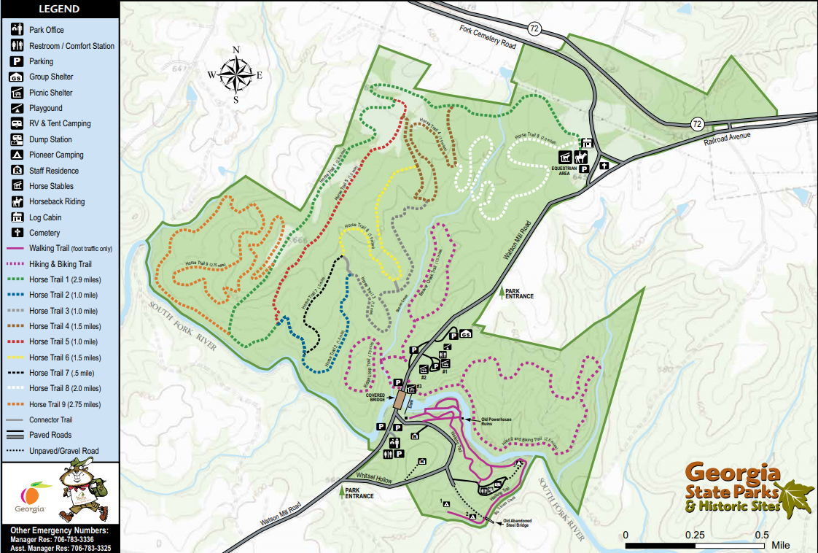

Existing Programming Locations:
Campground
Group shelter
Campfire Ring
Parking Lots
Picnic Shelter
Pioneer Camps
Visitor Center

Potential Programming Locations:
N/A
Hiking Trails

9 horse trails
3 hiking trail
1 hiking and bike trail

Potential Trails:
N/A

Appendix B Nearby Sites that serve similar audiences, Resources & PotentiAl partnerS

Arts, Music, Heritage Organizations:

4-H Youth Development
(706) 795-2281

Athens Creative Theater
195 W Washington St
Athens, GA 30601
(706) 613-3628

Comer Farmers Market
1914 Madison St
Comer, Georgia 30629
https://www.facebook.com/comerfm/

Hart County Community Theater
83 Depot St
Hartwell, GA 30643
(706) 376-5599

National Society of Daughters of the American Revolution
Elijah Clark (Athens Chapter)
http://elijahclarke.georgiastatedar.org/

Madison County High School FFA
https://www.georgiaffa.org/directory/ChapterInfo.aspx?ID=83
(706) 795.2197

Madison Co. Middle School FFA
https://www.georgiaffa.org/directory/ChapterInfo.aspx?ID=324
(706) 795-3341

Oglethorpe middle school FFA
http://ocms.oglethorpe.schooldesk.net/Departments/Clubs-and-Organizations/FFA
(706) 743-8146

Oglethorpe High school FFA
https://www.georgiaffa.org/directory/ChapterInfo.aspx?ID=107
(706) 743-8124

The Elbert Theater
100 S Oliver St
Elberton, GA 30635
(706) 283-1049

Businesses/Community Services

Chief Burger
476 GA-72
Comer, GA 30629
(706) 783-5194

Chicken Express
32 Mama B Dr.
Danielsville, GA 30633
(706) 795-5585

Deason’s Feed Store
Royston, GA
https://www.facebook.com/pages/Deasons-Farm-and-Garden/166410677777
brown648@bellsouth.net
(706) 245-5001

First Citizens Bank
36 Hwy 72 E
Comer, GA 30629
(706) 783-5161

First Madison Bank and Trust
200 General Daniel Ave N # 223
Danielsville, GA 30633
(706) 795-5000

Gina Bell’s
530 General Daniel Ave N
Danielsville, GA 30633
(706) 795-0288

Ingles Market
Commerce Store:
220 Georgia 334
Commerce, GA 30529
(706) 335-7689

Ingles Market
Hull Store:
9161 US-29
Hull, GA 30646
(706) 613-1334

Madison County Ace Hardware
535 General Daniel Ave N
Danielsville, GA 30633
(706) 795-2260

Maggie’s Café
1976 Main St
Comer, GA 30629
maggiescafega.com
(706) 783-3000

Marketplace
291 Sam Groves St
Danielsville, GA 30633
(706) 795-3007

Oglethorpe Hardware
02 Macon St
Oglethorpe, GA 31068
(478) 472-0057

Papa Ronni’s
240 General Daniel Ave N
Danielsville, GA 30633
(706) 795-0237

Pig Skins BBQ
59 Ila-Comer Rd
Danielsville, GA 30633
(706) 795-0356

Piggly Wiggly
101 Macon St
Oglethorpe, GA 31068
(478) 472-6406

Pinnacle Bank
https://www.pinnaclebank.com

Athens Office:
3140 Lexington Road
Athens, GA 30605
(706) 425-2223
Oconee Connector Office:
1081 Parkway Boulevard
Athens, GA 30606
(706) 608-4969

The Medicine Shoppe
7 Johnson Dr
Danielsville, GA 30633
(706) 795-0920

Wal-Mart
https://www.walmart.com
Athens:
East-Side:
4375 Lexington Road
Athens, GA 30605
(706) 355-3966
Commerce:
30983 Highway 441 South
Commerce, GA 30529
(706) 335-7563
West-Side:
3130 Atlanta Highway
Athens, GA 30606
(706) 715-6238

Civic Organizations & Tourism

Carnesville Lions Club
(706) 384-3528 or (404) 405-9991

City of Athens
Athens-Clarke County Unified Government
P.O. Box 1868
Athens, Georgia 30603
https://athensclarkecounty.com/109/City-of-Athens

City of Comer
http://www.cityofcomer.com/

City of Danielsville
https://www.danielsvillega.com/

City of Royston
http://www.cityofroyston.com/

Franklin County Senior Citizen Center
Carnesville, GA
(706) 384-2500

Garden Club of Ga
2450 S Milledge Ave.
Athens, GA 30605
(706) 227-5369

Kiwanis Club
Hartwell, GA
http://www.hartwellkiwanis.org
(706) 377-2432

Madison County Chamber of Commerce
101 Courthouse Sq # 1
Danielsville, GA 30633
(706) 795-3473

Madison County Lions Club
1311 Fairgrounds Rd.3.
Madison, GA 30650
madisongalionsclub@gmail.com

Madison County Senior Center
1265 GA-98
Danielsville, GA 30633
(706) 795-6250

Oglethorpe County Chamber of Commerce
1158 Athens Road
Crawford, GA 30630
(706) 743-3113

Oglethorpe Lions Club
President: Roger Horton Jr.
912 Elberton Road, Lexington GA 30648
kzvulc49@aol.com
(706) 202 7334

Oglethorpe County Senior Center
19 Oglethorpe Drive
Crawford, GA 30630
(706) 743-8848

Oglethorpe Rotary Club
https://www.facebook.com/OglethorpeRotaryClub

Royston/Franklin Springs Lions Club
(706) 245-0591

Rotary Club, Royston, GA
(706) 245-1251

Churches

There are 61 churches listed in Madison County, GA
https://georgia.hometownlocator.com/features/cultural,class,church,scfips,13195.cfm

There are 53 churches in Oglethorpe, Ga
https://georgia.hometownlocator.com/features/cultural,class,church,scfips,13221.cfm

Libraries

Comer Library
2180 Spring Cir, Comer, GA 30629
(706) 783-5308

Library and Community Education Center Pinewoods
1465 US-29 G-10,
Athens, GA 30628
athenslibrary.org
(706) 613-3708

Madison Co. Library
2180 Spring Cir.
Comer, GA 30629
(706) 783-5308

Madison Co. Library
1315 GA-98
Danielsville, GA 30633
athenslibrary.org
(706) 795-5597
Oglethorpe Co. Library
858 Athens Rd. (Hwy 78)
Lexington, Georgia 30648
(706) 743-8817

Winterville Library
115 Marigold Lane
Winterville, Georgia 30683
(706) 742-7735

Nature Centers/Museums/Visitor Centers:

Comer Travel Museum
Comer, GA 30629
https://www.facebook.com/pages/Comer-Travel-Museum/112327752236801

Franklin County Historical Society
Carnesville, GA
(706) 384-4361

Georgia State Botanical Gardens
2450 S Milledge Ave.
Athens, GA 30605
botgarden.uga.edu
(706) 542-1244

Georgia Museum of Art
90 Carlton St
Athens, GA 30602
http://georgiamuseum.org/
(706) 542-4662

Georgia Museum of Natural History
Natural History Bldg.
Athens, GA 30602
http://naturalhistory.uga.edu/index.php
(706) 542-1663

Georgia Welcome Center
938 Co Rd 84
Lavonia, GA 30553
(706) 356-4019

Royston Visitor Center
14 Hartwell St.
Royston, GA 30662
https://www.exploregeorgia.org/city/royston
(706) 245-7577

Sandy Creek Nature Center
205 Old Commerce Rd
Athens, GA 30607
https://www.athensclarkecounty.com/Facilities/Facility/Details/16
(706) 613-3615

Traveler’s Rest Historic Site
4339 Riverdale Rd
Toccoa, GA 30577
https://gastateparks.org/TravelersRest
(706) 886-2256

Smithonia Plantation House
2270 Crawford Smithonia Rd
Colbert, GA 30628
https://www.facebook.com/SmithoniaPlantationHouse/
(706) 424-5400

Non-profit/Professional Organizations:

Friends of Watson Mill Bridge State Park
650 Watson Mill Rd,
Comer, GA 30629
https://friendsofgastateparks.org/parks/watson-mill

Outdoors Without Limits
333 Briarwood Trail
Winterville, GA 30683
https://outdoorswithoutlimits.net/
(803) 480-0167

Other Government Partnerships/Contacts:

Army Corp of Engineers Hart County
5625 Anderson Hwy
Hartwell, GA 30643
http://www.hartcountyga.org/
(888) 893-0678
DNR Region II Law Enforcement Division,
2150 Dawsonville Highway
Gainesville, GA 30501
Ranger First Class Timothy Vickery
(770) 535-5499

DNR, Region II Law Enforcement Division,
2150 Dawsonville Highway
Gainesville, GA 30501
Corporal Craig Fulghum
(770) 535-5499
Ranger First Class Brandon Pierce
(770) 535-5499

Wildlife Resources Division, East Central Region Office (Region 3)
142 Bob Kirk Road NW
Thomson, GA 30824
(706) 595-4222
and
2067 US Highway 278 SE
Social Circle, GA 30025
https://georgiawildlife.com/about/contact
(706) 557-3350

Franklin County Cooperative Extension
PO Box 307, 280 Busha Road, Suite A
Carnesville, GA 30521
http://www.caes.uga.edu/extension/franklin/
(706) 384-2843

Georgia Forestry Commission
3005 Atlanta Hwy
Gainesville GA 30507
(770) 531-6043

Oglethorpe County
District 3 GA forestry Office
302 Buddy Faust Road
Crawford, GA 30630

Franklin County Sherriff’s Office,
1 James Little St
Carnesville, GA 30521
(706) 384-2525

Parks & Campgrounds:

Arnold Park
2627 Arnold Park Dr
Comer, GA 30629
https://www.madcorec.com/page/show/1955553-parks-and-facilities
(706) 783-4552

Bobby Brown State Outdoor Recreation Area
2509 Bobby Brown State Park Rd
Elberton, GA 30635
http://www.bobbybrownpark.com/index.html
(706) 283-5500

Broad River Outpost
7911 Wildcat Bridge Rd
Danielsville, GA 30633
https://www.broadriveroutpost.com/
(706) 795-3242

Bruce Creek Fishing Park
P.O. Box 159
Toccoa, GA 30577
http://www.rentalsonthelake.com/Nearby/BruceCreek/Bruce%20Creek%20Fishing%20Park.htm
Richard Adams, radams@stephenscountyga.com
(706) 886-5101

Dudley Park
100 Dudley Park Rd
Athens, GA 30601
https://www.accgov.com/2954/Dudley-Park
(706) 613-3801

Franklin County & Stephens County Recreation Department
557 Rocky Ford Rd.
Carnesville, GA 30521
http://www.fcrdonline.com
(706) 384-7275
Georgia River Recreation Area
Hart County, GA
http://www.ohranger.com/hartwell-lake/poi/georgia-river-recreation-area

Hart State Outdoor Recreation Area
330 Hart Park Road
Hartwell, GA 30643
http://gastateparks.org/Hart

Lake Hartwell Parks website: http://lakehartwellinsider.com/parks/
Lake Hartwell State Park (SCSP)
19138-A HWY 11 S
Fair Play, SC 29643
http://www.southcarolinaparks.com/lakehartwell/introduction.aspx
(864) 972-3352
lakehartwell@scprt.com

Poplar Springs Recreation Area (Boat Ramp), From Lavonia, Georgia, where GA 328 crosses I-85, go North on GA 328 for 3.5 miles
http://www.ohranger.com/hartwell-lake/poi/poplar-springs-recreation-area

Sunset Campground
17139 Georgia 17
Martin, GA 30557
https://plus.google.com/105040457942445682985/about?gl=us&hl=en
(706) 356-8932

Victoria Bryant Sate Park
1105 Bryant Park Rd
Royston, GA 30662
https://gastateparks.org/VictoriaBryant/
(706) 245-6270

Wildlife Management Areas:

Hart County Wildlife Management
GA Hwy 77 & Cokesbury Hwy
Hartwell, GA 30643
(770) 535-5700

Elbert County Wildlife Management Area
Off GA Hwy 72
Elberton, GA 30635
(706) 595-4222

Hart County Wildlife Management
Off GA Hwy 77 & Cokesbury Hwy
Hartwell, GA 30643
(770) 535-5700

Elbert County Wildlife Management Area
Off GA Hwy 72, Elberton, GA 30635
(706) 595-4222

Richard Russell WMA, between Hartwell and Clarks Hill Lakes

Public Fishing Areas

Poplar Springs Recreation Area (Boat Ramp), From Lavonia, Georgia, where GA 328 crosses I-85, go North on GA 328 for 3.5 miles
http://www.ohranger.com/hartwell-lake/poi/poplar-springs-recreation-area

Georgia River Recreation Area
Hart County, GA
http://www.ohranger.com/hartwell-lake/poi/georgia-river-recreation-area

Sunset Campground
17139 Georgia 17, Martin, GA 30557
https://plus.google.com/105040457942445682985/about?gl=us&hl=en
(706) 356-8932

Public Schools, Private Schools, Colleges & Daycare Centers

Madison County Public Schools:

Broad River Academy
600 Madison Street
Danielsville, GA 30633
(706) 795-2173

Colbert Elementary
255 Colbert School Rd
Colbert, GA 30628
(706) 788-2341

Comer Elementary
565 Gholston St
Comer, GA 30629
(706) 795-2191

Danielsville Elementary
900 Madison St
Danielsville, GA 30633
(706) 795-2181
Hull-Sanford Elementary
9193 Fortson Store Rd
Hull, GA 30646
(706) 353-7888

Madison County High
600 Madison St
Danielsville, GA 30633
(706) 795-2197

Oglethorpe County Public Schools:

Oglethorpe County Primary School
300 Comer Rd, Lexington, GA 30648
(706) 743-8194

Oglethorpe Avenue Elementary School
1150 Oglethorpe Ave, Athens, GA 30606
(706) 549-0762

Oglethorpe County Middle School
270 Buddy Faust Rd, Crawford, GA 30630
(706) 743-8146

Oglethorpe County High School
749 Athens Rd, Lexington, GA 30648
(706) 743-8124

Homeschool Groups:

Virtual K-12/Georgia Cyber Academy program
http://www.k12.com/gca#.UzeILvldWSo

Private Schools:

Oglethorpe SDA School
Hwy. 49 Buckcreek Bypass
Oglethorpe, GA 31068
(478) 472-2388

Union Christian Academy
11720 Nowhere Rd.
Hull, GA 30646
(706) 789.3845

Day-care Centers:

Aaron Child Care
Winterville, GA 30683
(706) 742-8949

Busy Box Day Care Center
4715 Moons Grove Church Rd
Danielsville, GA 30633
(706) 795-2951

Easter Seals North Georgia
85 Rock Quarry Rd
Danielsville, GA 30633
(706) 795-2092

Elite Petite Child Care Center & Pre-K
8050 Highway 106 S,
Hull, GA 30646
(706) 549-1180

First Steps Learning Center
61 Grizzle St
Royston, GA 30662
(706) 245-7170

Little Angles Day Care
895 Oglethorpe Avenue
Athens, GA 30606
(706) 543-2001

Miracle Years of Learning
Address: 223 Colbert School Rd
Colbert, GA 30628
(706) 788-3221

Oglethorpe Children's Academy
1 Callaway Dr
Crawford, GA 30630
(706) 743-7400
Easter Seals North GeorgiaEaster Seals North GeorgiaBottom of Form

Colleges:

Clemson University
Clemson, SC 29634
(864) 656-3311

Emmanuel College
181 Spring St, Franklin Springs, GA 30639
(706) 245-7226

North Georgia Technical College
121 Meeks Ave, Blairsville, GA 30512
(706) 439-6300

Piedmont College
165 Central Ave, Demorest, GA 30535
(706) 778-3000

University of Georgia
Athens, GA 30602
(706) 542-3000

Special Interest

Astronomy partnerships:

Astronomy Clubs in Georgia
http://www.go-astronomy.com/astro-clubs-state.php?State=GA

Atlanta Astronomy Club
http://atlantaastronomy.org/ observing@atlantaastronomy.org,president@atlantaastronomy.org

North Georgia Astronomers, P.O. Box 5103
Gainesville, GA. 30504
http://northgeorgiaastronomers.org/
northgeorgiaastronomers@gmail.com

Beaches or Lake Resources:

Beaches & Ramps map on Lake Hartwell
http://www.lake-hartwell.com/ABOUT/RampsAndRecreationAreas/LakeRecreationAreas.htm

Recreation Sites on Lake Hartwell
http://www.recreation.gov/unifSearchResults.do

Recreation Sites on Lake Richard B. Russell
https://www.recreation.gov/recreationalAreaDetails.do?contractCode=NRSO&parkId=455&recAreaId=455&agencyCode=70902

Birding Partnerships:

Oconee Rivers Audubon Society, Athens, GA
http://www.oconeeriversaudubon.org
Clark Jones, President, president@oconeeriversaudubon.org

Equestrian partnerships:

Currahee Saddle Club
http://www.curraheesaddleclub.com
Abby Walker, President
(770) 355-3793

Georgia Mountain Association of Saddle Clubs
https://gmasc.shutterfly.com
Lorrie Bass
(706) 247-9641
Email: gamtsc2014@gmail.com

Fishing partnerships:

Guided trip partnerships may work by trying to ask several for one program from each per year.

Ricks Guide Service for Lake Hartwell
http://www.ricksguideservice.com/

Capt. Bill’s Fishing Adventures
http://www.lakehartwellfishing.com/

Consider fish habitat improvement partnering with Fisheries Management and with COE approval for any fish attractor plans. This will potentially increase catch rates and improve fishing experience for guests. While this is a resource management improvement, it also will potentially increase the catch rates making fishing more popular at the fishing docks.
Georgia and National Organizations:

Tournament directing organizations
http://www.flwoutdoors.com/
http://www.flwoutdoors.com/bassfishing/bfl/

Geocaching/Orienteering partnerships:

Volunteer steward contact info with the Georgia Geocachers Association:
Live cache page https://www.geocaching.com/geocache/GC27C3F_watson-mill-bridge-state-park?log=y&decrypt=#NumVisits
Joe Fortin “Lakebum”
(404) 423-8466
jfortin@zhone.com

Georgia Orienteering Club: http://www.gaorienteering.org/

Golf:

Black Mountain Golf
(706) 886-3506

Cateechee Golf Club
(706) 856-4653

Chimney Oaks Golf Club
148 Chimney Oaks Drive
Homer, GA 30547
(706) 677-3333

Cross Creek Plantation Golf
(864) 882-8337

Currahee Golf Course
(706) 827-1700

Double Oaks Golf Course
3100 Ila Road
Commerce, GA 30530
(706) 335-8100

Foxwood Hills Golf Course
(864) 647-9503

Hartwell Golf Club
(706) 375-8161

Highland Walk Golf Course
1415 Bryant Park Rd
Royston, GA 30662
(706) 245-6770
Oconee Country Club
(864) 882-8037

The Walker Course
(864) 656-0236

Trails at Chickasaw Point
(864) 972-9623

Kennels:

Affordable Pet-Sitting
(706) 244-0740

Family Companions Pet Grooming
(706) 886-7297

Lakefront Pet Sitting
(864) 784-1497

Lazy S Ranch & Kennel
(706) 206-8787

Ridge Kennels
(706) 245-0700

Royston Animal Hospital
(706) 245-6650

Tugaloo Animal Hospital
(706) 356-1467

Paddling partnerships:

Calm Water Kayak Tours
http://www.calmwaterkayaktours.com/
(864) 221-5607
info@calmwaterkayaktours.com

Paddle Board guides/partnerships:

Linc Stallings owns a business doing guided SUP to offer guided programs/partnership
(706) 970-9053
Email: riverlinc@gmail.com

GASP already partners with REI to host various programs on parks – SUP Paddle Board Races
Daniel Jessee, REI Outdoor School Coordinator
SUP Splash race events; http://supsplashrace.com/
overview at https://www.facebook.com/SUPSplashRaceSeries
(404) 633-6508.

One With The Ride, 2640 Crwe Creek Rd
Sunset, SC 29651 US
http://www.onewiththeride.com/
(864) 868-2040 Website

Scouts Organizations:

Boy scouts of Comer
Troop 377
Comer Lions Club

Northeast Georgia Council 101
Council Number: 101
706-693-2446, Jefferson, GEORGIA, 30549

Boy Scouts of Carnesville
Troop 42
Gainesville St. in Carnesville

Appendix C REFERENCES THAT RELATE TO THE SITES UNIQUE RESOURCES
Roadside Geology of Georgia Pamela J. Gore and William Witherspoon
Covered Bridges of Georgia by.Thomas L. French Jr.
Resource management plan is located on Watson Mill mangers computer, file FY2011
Vanishing Landmarks of Georgia by Joseph Kovarik
Georgia Historic Marker: https://georgiainfo.galileo.usg.edu/topics/historical_markers/county/oglethorpe/watson-mill-bridge

Appendix d Media contacts for surrounding Area
Site uses a Facebook page to promote programs and plans to pursue other social media sites: Instagram. Add extras

MUST BLIND COPY email | Media Outlet | First Name | Last Name | Phone | Address | City | State | Zipcode
pvickery@thehartwellsun.com | Hartwell Sun | Peggy | Vickery | 706-376-8025 | 8 Benson St. | Hartwell | GA | 30643
pvickery@thehartwellsun.com | Hartwell Sun | Peggy | Vickery | 706-376-8025 | 8 Benson St. | Hartwell | GA | 30643
star@elberton.com | Elberton Star | Gary | Jones | 706-283-8500 | 25 N. Public Sq. | Elberton | GA | 30635
Dar8589@bellsouth.net | Athens Banner and GON | Alvin | Richardson |  | 1 Press Place | Athens | GA | 30603
Allison.Floyd@onlineathens.com | Athens Banner Hearld | Allison | Floyd | 706-208-2227 | 1 Press Place | Athens | GA | 30603
April.burkhart@onlineathens.com | Athens Banner-Harald | April | Burkhart |  | PO Box 912 | Athens | GA | 30603
cjones@visitathensga.com | Athens CVB | Chuck | Jones | 706-3574430 | 300 N. Thomas St | Athens | GA | 30603
hsmith@visitathensga.com | Athens CVB | Hannah | Smith | 706-357-4430 | 300 N. Thomas St. | Athens | GA | 30603
Melissatyler@macaronikid.com | Macaroni Kid Athens | Melissa | Tyler |  |  | Athens | GA | 30603
chuck@95rock.com | WCHZ-FM | Chuck | Williams | 706-650-1122 | 4051 Jimmie Dyess Pkwy | Augusta | GA | 30909
harley@wgac.com | WGAC-FM | Harley | Drew | 706-396-7138 | 4051 Jimmie Dyess Pkwy | Augusta | GA | 30909
keith@wgac.com | WGUS-FM | Keith | Beckum | 706-396-7000 | 4051 Jimmie Dyess Pkwy | Augusta | GA | 30909
chuckw@bbgi.com | WHHD-FM | Chuck | Whitaker | 706-396-7138 | 4051 Jimmie Dyess Pkwy | Augusta | GA | 30909
ab@wrdwam.com | WRDW-AM | Ashley | Brown | 706-396-7000 | 4051 Jimmie Dyess Pkwy | Augusta | GA | 30909
makr@markberryman.com | Elberton Star Examiner | Mark | Berryman | 706-283-8500 | 25 N. Public Sq. | Elberton | GA | 30635
gibson@gacaradio.com | WSGC-FM | Sean | Gibson | 706-283-1400 | PO Box 340 | Elberton | GA | 30635
hartwellsun@hartcom.net | Hartwell Sun |  |  |  | 8 Benson St. | Hartwell | GA | 30643
fccitizen@windstream.net | Franklin County Citizen | Mark | Berryman | 706-245-7351 | 12150 Augusta Rd. | Lavonia | GA | 30553
fccsports@windstram.net | Franklin County Citizen/News Leader | Mark | Berryman | 706-498-1236 | PO Box 580 | Lavonia | GA | 30553
journal@nu-z.net | Lincoln Journal | Jacqueline | Johnson | 706-359-3229 | PO Box 399 | Linconlton | GA | 30817
tribstaff@waltontribune.com | Walton Tribune | Wes | Swietek | 770-267-8371 | PO Box 808 | Monroe | GA | 30655
nggaliving@gmail.com | Northeast Georgia Living | Melissa | Herndon | 706-246-0856 | 454 College St. | Royston | GA | 30662
toccoarecord@windstream.net | Toccoa Record | Tom | Law | 706-886-9476 | PO Box 1069 | Toccoa | GA | 30577
cbridges@barrowjournal.com | Barrow Journal—Mainstreet News Group | Chris | Bridges | 770-867-6397 | 77 East May Street | Winder | GA | 30680

Listings for field trips that Watson Mill can contact for listings:

http://www.homeschoolbuyersco-op.org/field-trips/homeschooling-georgia/

http://www.homeschoolbuyersco-op.org/field-trips/homeschooling-georgia/

http://www.classtrips.com/region-landing/2589/school-field-trips-in-atlanta

http://www.thehomeschoolmom.com/homeschooling-in-georgia/field-trips/

https://www.pinterest.com/georgiadoe/georgia-field-trip-ideas/

http://a2zhomeschooling.com/regional/us/georgia/georgia_home_school_field_trips/

http://fieldtripswithsue.com/

https://www.ghea.org/pages/resources/fieldTrips.php

http://www.juniortours.com/atlanta/index.html

http://www.thetravelstore.us.com/

