2012 ANNUAL MONITORING PLAN FOR THE GEORGIA DNR PARKS, RECREATION AND HISTORIC SITES DIVISION (PRHSD)- OPERATED LAKE SWIMMING BEACH AREAS
FOR FECAL COLIFORM BACTERIA
March 28, 2012

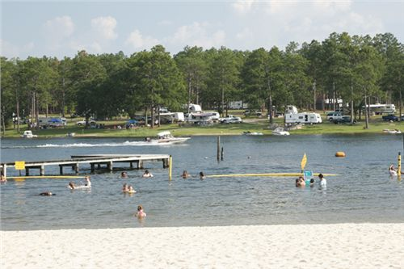
Photograph of Seminole State Park Swimming Beach Courtesy of GADNR Parks Recreation and Historic Sites Division

Georgia Department of Natural Resources
Environmental Protection Division
Watershed Protection Branch
4220 International Parkway, Suite 101
Atlanta, Georgia 30354

REQUEST FOR STUDY RESOURCE AND TECHNICAL ASSISTANCE

The Georgia DNR Parks, Recreation and Historic Sites Division (PRHSD), has requested EPD to provide the resources and technical assistance for annual fecal coliform bacteria monitoring at lake swimming beaches operated by the Division since 1996. Laboratory analysis is conducted by the Environmental Protection Division Watershed Protection Branch for the 5-week bacterial monitoring project beginning in late April through May of each year, with the Watershed Protection Branch providing planning, coordination and reporting. A provision is made for a sixth week of monitoring if needed.

GOAL

Determine the fecal coliform bacteria densities at 28 PRHSD-operated lake swimming beach areas of GADNR State Parks, by sampling and testing weekly for a one-month period (5 contiguous weeks). Results will be assessed by calculating the monthly geometric mean density and comparing that to the state water quality standard for primary contact recreational activities during the months of May through October. During these months the standard is to not exceed a monthly geometric mean of 200 colony forming units (cfu) per 100 mL of sample, based on a minimum of 4 samples collected within a 30-day period, with no samples collected less than 24 hours apart.

OBJECTIVES

- PRHSD staff will collect and deliver samples within 6 hours of collection, to the Environmental Protection Division Laboratory for analysis of fecal coliform bacteria by the Membrane Filtration Method (MF), with confirmation testing.

- PRHSD staff will collect samples weekly for 5 consecutive weeks on the following dates: Monday, April 16, Tuesday April 24, and the Mondays of April 30, May 7 and May 14 (See Table 1). If an unusually high result is obtained, an additional sample(s) may be required. If the fecal coliform 30-day geometric mean is greater than 200 cfu per 100mL after 5 consecutive weeks of monitoring, additional sampling and testing will be accomplished. The schedule will provide the minimum of 4 test results within 30 days for comparison to the water quality standard prior to the busy Memorial Day weekend.

- PRHSD staff collecting sample record on provided sample tag and lab source document the time and date sample was collected, with their name and site information.

- PRHSD staff record additional information including density of swimmer use at beach during previous weekend, weather (most importantly any rainfall), water clarity, and presence of waterfowl (or other significant wildlife), at or near the beach area.

- Watershed Protection Branch, Watershed Planning and Monitoring Program, will report weekly results by e-mail, and a final data report to Parks, Recreational and Historic Sites Division, at the conclusion of the annual monitoring.

SAMPLE SCHEDULE

Samples will be collected by Parks personnel early on the scheduled day of sampling, and delivered by no later than 12 noon to the EPD Laboratory, located at 5804 Peachtree Corners East, Norcross, GA 30092 (See Figure 1 for map showing location). It is critical that Parks staff immediately call the EPD Lab if problems are encountered in meeting the sample delivery time of 12 noon. The EPD Lab phone number is 678-248-7383. Additional sample bottles, tags and source documents may be obtained from Ryan Dent at ryan.dent@dnr.state.ga.us or 404-675-1678.

The 2012 monitoring schedule includes sample collection and delivery on the following dates: April 16, April 24, April 30, May 7, and May 14. The EPA Methods as approved and adopted under the Federal Clean Water Act (CWA) requirements establish maximum holding time and preservation requirements for sample and data validity. For these bacterial analyses, the EPA holding time between sample collection and analysis (test initiation), is 6 hours. The results of this monitoring are to be used by the PRHSD to screen for potential problems at PRHSD-operated swimming beaches. Because of this, all possible and reasonable effort needs to be made to conduct this monitoring such that data produced have the highest possible quality assurance.

TABLE 1: SAMPLING SCHEDULE
2011 FECAL COLIFORM BACTERIA MONITORING AT PRHSD LAKE SWIMMING BEACHES
DATES: |  | April 16  Monday | April 24  Tuesday | April 30  Monday | May 7  Monday | May 14  Monday | 30 Day  Geometric Mean
Sample Station # | State Park Lake Swimming Beach Area | Week  1 | Week  2 | Week  3 | Week  4 | Week  5
1 | Elijah Clark State Park
2 | F.D. Roosevelt State Park: Large Group Camp Beach
3 | F.D. Roosevelt State Park: Small Group Camp Beach
4 | Fort Mountain State Park
5 | Fort Yargo State Park: Group Camp Area  {Monitoring Site Only: Beach Permanently Closed}
6 | Fort Yargo State Park: Day Use Beach
7 | Hard Labor Creek State Park: Camp Rutledge Beach
8 | Hard Labor Cr. State Park: Camp Daniel Morgan Beach
9 | Hard Labor Creek State Park: Day Use Camp Beach
10 | Mistletoe State Park
11 | John Tanner State Park
12 | Red Top Mountain State Park and Lodge
13 | Richard B. Russell State Park
14 | Tugaloo State Park
15 | Vogel State Park
16 | A.H. Stephens State Park Group Camp Beach
17 | Indian Springs State Park Group Camp Beach
18 | Indian Springs State Park Day Use Beach
19 | George T. Bagby State Park and Lodge
20 | Georgia Veterans State Park
21 | Reed Bingham State Park
22 | Seminole State Park
23 | Little Ocmulgee State Lodge Park
24 | Unicoi State Park Day Use Beach
25 | Rocky Mountain Public Fishing Area
26 | Laura Walker State Park
27 | Kolomoki Mounds State Park
28 | High Falls State Park
NM: Not Monitored
Figure 1: EPD Laboratory Location Map 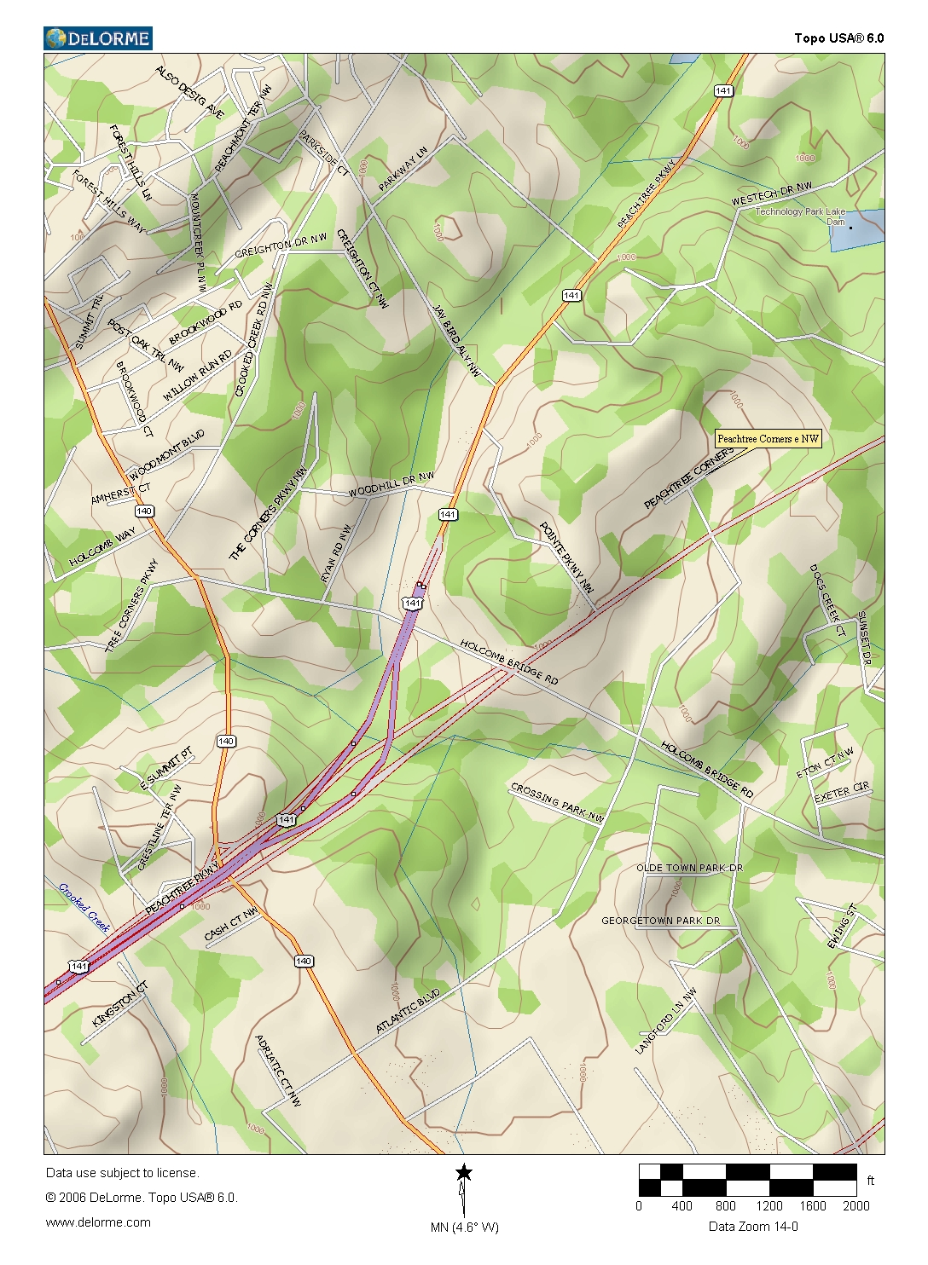

SAMPLE COLLECTION PROCEDURE

The single sampling location used for each beach needs to be where the highest swimmer density typically occurs, so that data will represent the area of greatest exposure. For a crescent-shaped lake beach this would be the middle. The sampling location should be at a location where the total depth is approximately three (3) feet. This depth would be most used by children and adults. Follow the sampling procedures provided below.

- Collecting the sample: Wearing either clean waders or using a boat, wade or paddle to a depth of 3 feet taking care to not disturb bottom sediments. To prevent sample contamination the collector should first clean their hands, and using disposable gloves is also recommended. Remove the sample bottle cap with the covering paper left in place, being careful to not touch the inside of the bottle or cap. Do not lay the cap down or put into a pocket where it may become contaminated. With a single smooth motion of the hand and arm, sweep the bottle, open end first), into the water to a depth of about one foot from the surface and continue the arc until the bottle is out of the water. If there is a noticeable current, fill bottle by moving it in direction against the current. Avoid scooping trash or floating solids from the water surface. An air space is needed to insure sample may be shaken later for homogeneity; pour out any excess sample to a level just below the bottle shoulder. Replace the cap immediately. Screw cap on tightly making sure the paper cover is still attached with rubber band. Place the sample bottle into a clean Ziploc bag and into a cooler with wet ice. It is important that the sample bottle is not immersed in melted ice water as this could introduce contamination. Note collection time. Measure the water clarity with the Secchi disk and note.

- Record sampling information: Using either a pencil or a waterproof ink pen, take the preprinted Sample Tag (See example in Figure 2), and legibly record the date and time of sample collection, and the Secchi transparency reading. If you have not filled out the additional information on the tag before sampling do so after collection, attach to the sample bottle and return it in the Ziploc bag to the ice chest.

Self-explanatory are Park, Lake, Swimming Beach Sampled (some Parks have more than one), Date Collected and the name of the sample Collector. For Time Collected use the 24-hour military-time format (if sample collected 20 minutes after 8 in the morning this would be 0820).

For Weather Today and Previous 3 Days, in general terms, was the weather clear, or were there showers or hard rain (runoff from rain can introduce fecal wastes and the closer to the time of collection this occurs, the test result will be higher). Water clarity (Secchi disk) depth is a measurement of water clarity that can be made with a circular disk 7 7/8” in diameter with alternate black and white quarters. The device can be affixed to a handle or cord. The disk is submerged in the shade without the sampler using sunglasses, until the black and white sections disappear, and then is slowly pulled up until delineation of the black and white sections reappear. This is repeated for a total of 3 times and the average depth from the water surface to that where the disk colors reappeared is recorded. Waterfowl present near or on the beach or bathing area should be noted on the tag as they are a source of fecal material and potentially elevated test results.

- Complete Information on Lab Source Document: Information that must be recorded on this sheet are the collector’s name, date of collection, and time of collection. This year the Site Location, beach name, and sample station numbers (asp per Table 1) are pre-printed on the document. Make sure to use in the document for each week order. This completed form must accompany the sample.

- Transport Sample and Paperwork to EPD Lab: PRHSD will coordinate logistics and transport all samples on the day of collection to the EPD Lab using such that all samples are delivered by 12 noon of that day. Samples will be preserved on wet ice from the time of collection through to delivery to the EPD Lab.

- Chain-of Custody: The sample chain-of-custody is a record of sample possession that documents a sample has a known history and its integrity can be tracked and verified if any question arises on proper holding for quality assurance. The sample collector will sign the first space for “SAMPLE RELINQUISHED BY” including the date (“On”) and time (“AT”), and circling for morning or afternoon. The first receiver signs then entering same information. The sign-off/sign-on process continues with couriers until delivery to the AESL. The back side of the tag can be used if additional space is needed.

Table 2: Sample Tag
PLACE LAB ID STICKER HERE | Sample I.D.# | Park:
PLACE LAB ID STICKER HERE | Lake: | Swimming Beach Area Sampled:
PLACE LAB ID STICKER HERE | Date Collected: | Time Collected: | Collector:
PLACE LAB ID STICKER HERE | Swimming Area Open?: | If Yes, Level of Use (low, med. high?):
PLACE LAB ID STICKER HERE | Weather Today: | Weather Yesterday: | Weather 2 Days Ago:
PLACE LAB ID STICKER HERE | Water Clarity (Secchi): | Water Color: | Other Note?
PLACE LAB ID STICKER HERE | Water Fowl (Geese, Ducks; or other Wildlife), recently near Beach Area? What, How Many?
PLACE LAB ID STICKER HERE | SAMPLE RELINQUISHED BY: | ON: | AT: | A./ P.M.
PLACE LAB ID STICKER HERE | SAMPLE RECEIVED BY: | ON: | AT: | A./ P.M.
PLACE LAB ID STICKER HERE | SAMPLE RELINQUISHED BY: | ON: | AT: | A./ P.M.
PLACE LAB ID STICKER HERE | SAMPLE RECEIVED BY: | ON: | AT: | A./ P.M.
PLACE LAB ID STICKER HERE | Return Completed Tag to WPMP

