

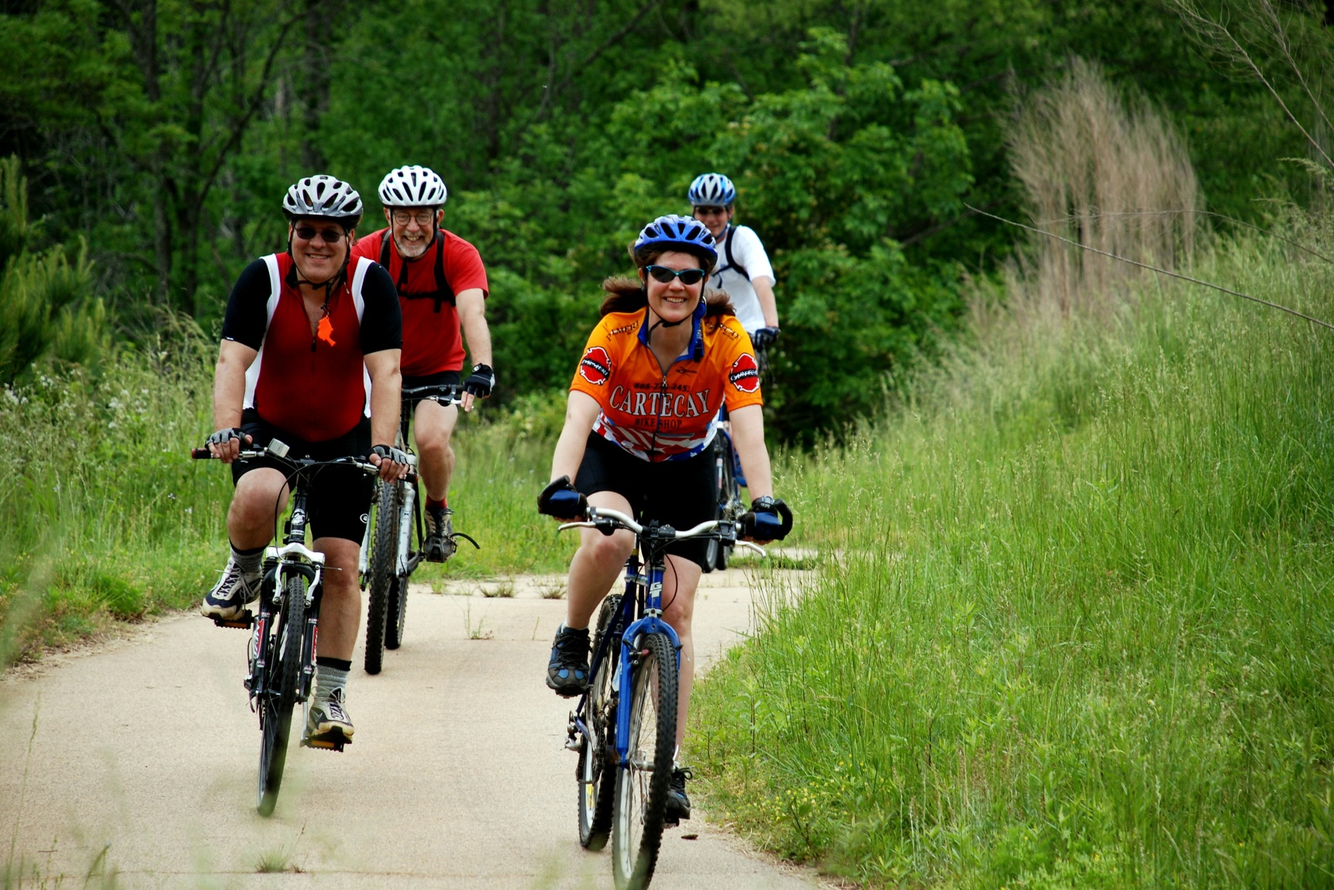
Get out on the trails!
<<Space here to add more information or pricing details>>
Ask at the visitors’ center about the kinds of bikes we have available to rent for your park adventure.
BIKE RENTALS

