Type | Half Hour | Full Hour
Canoe | $x | $x
Kayak | $x | $x
Paddleboard | $x | $x
Aqua Cycle | $x | $x

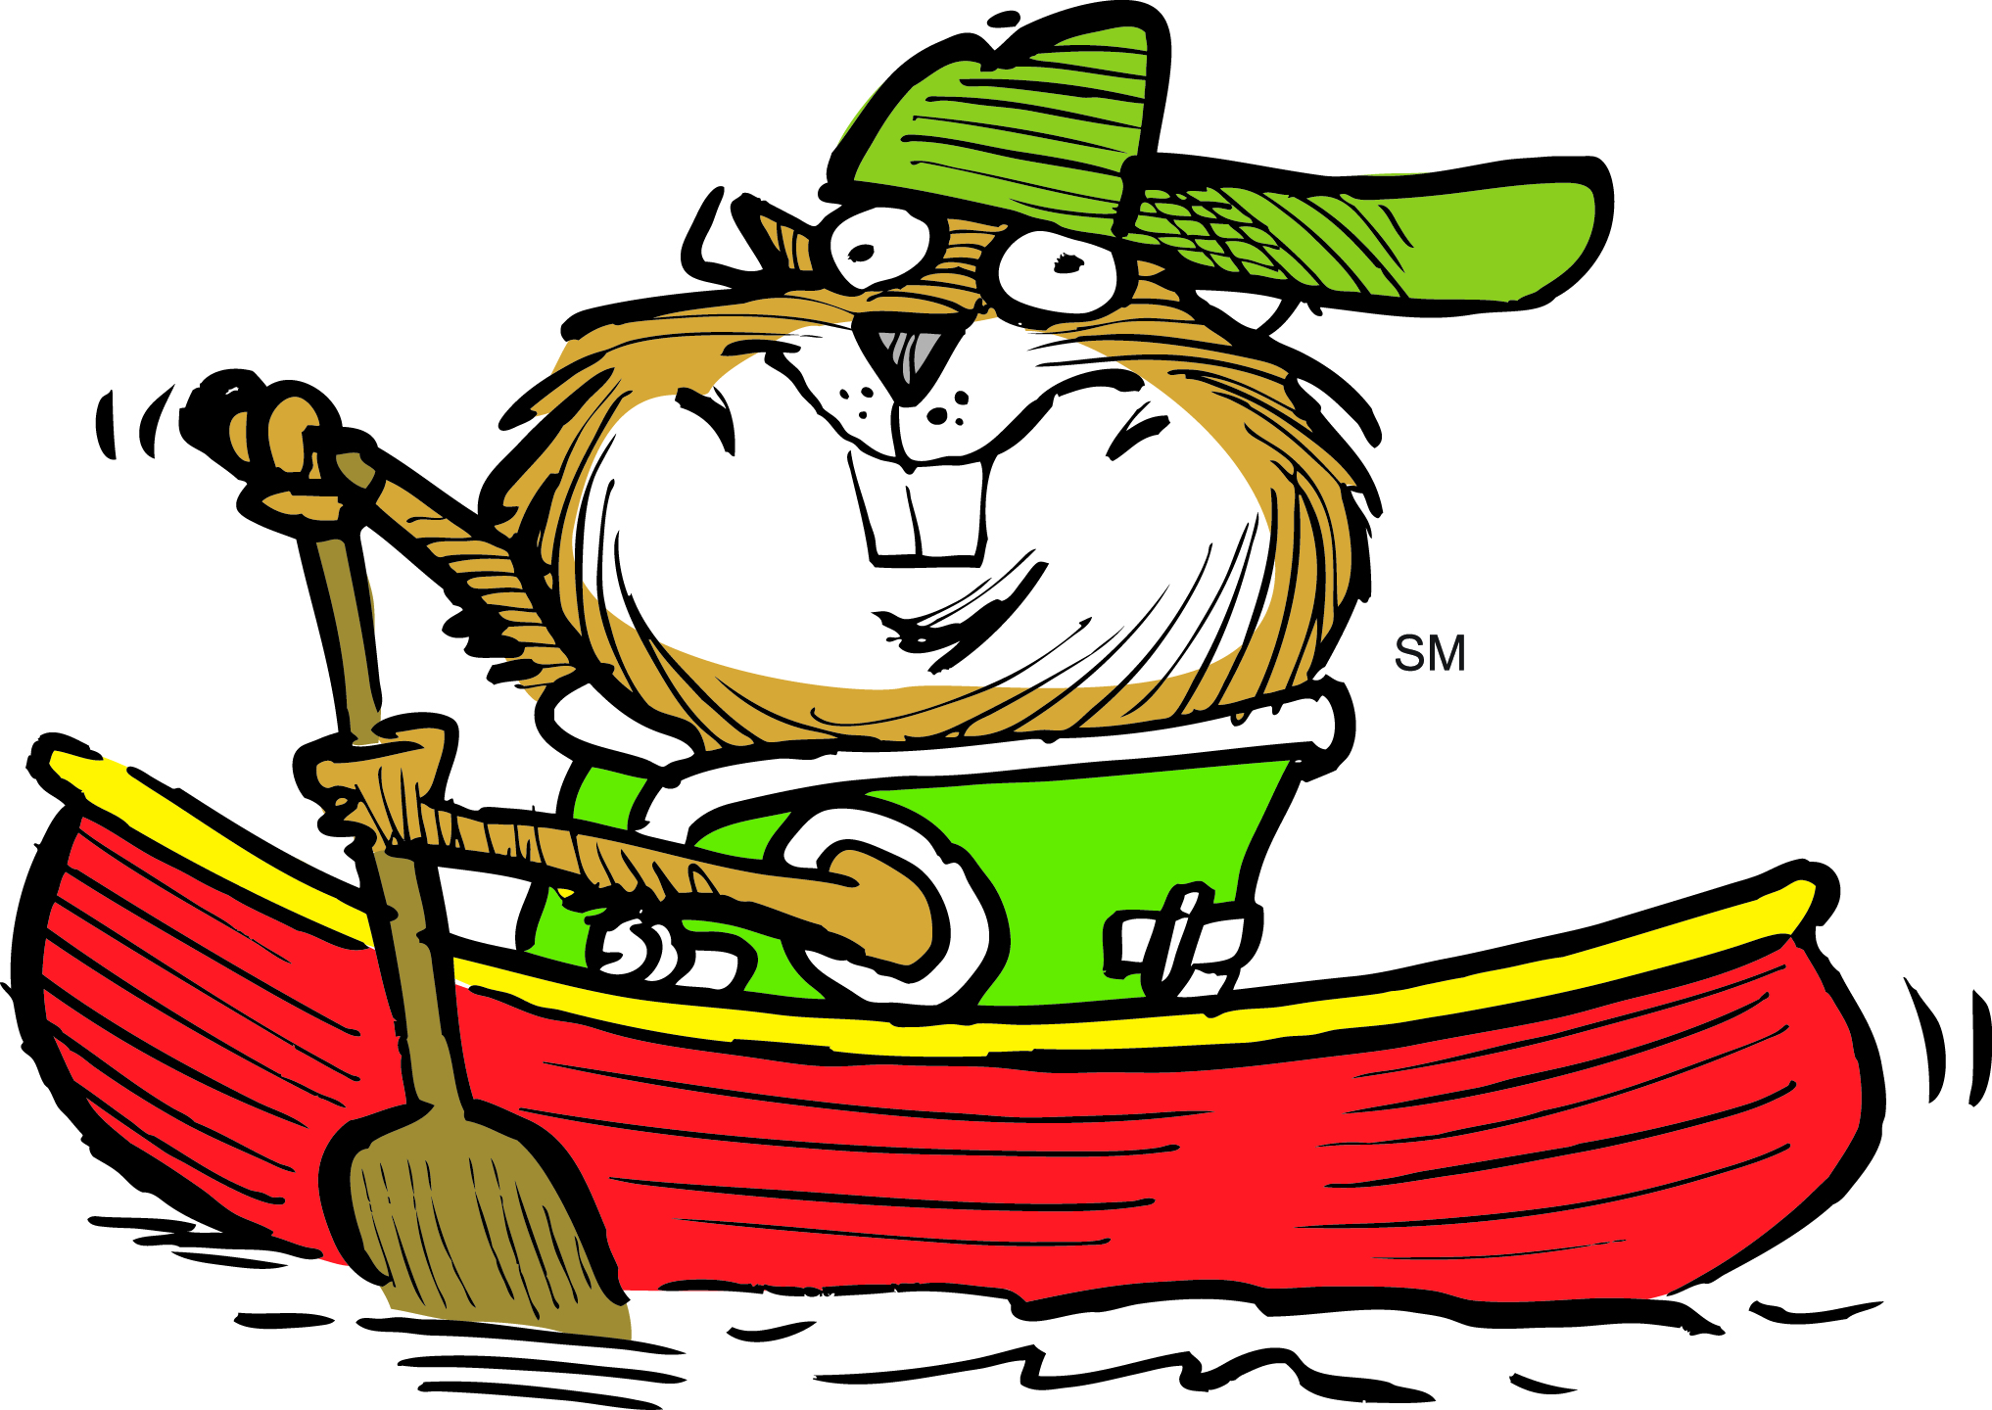
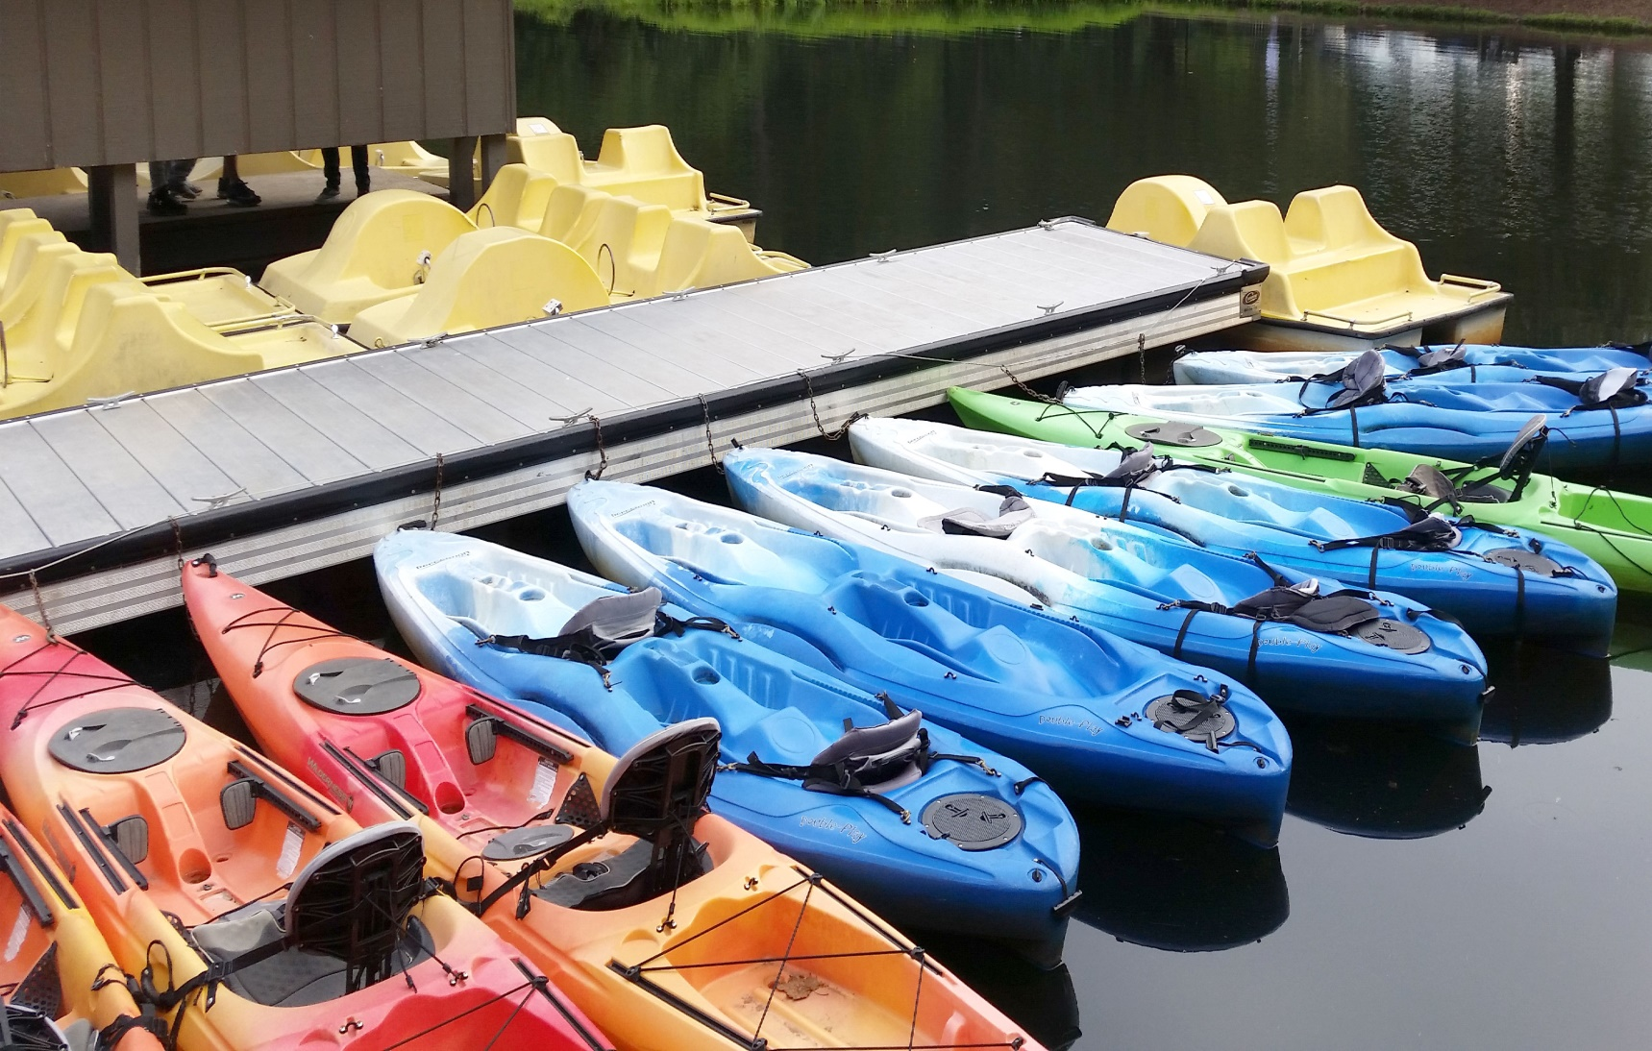
Get out on the water!
Ask at the bait shop about the kinds of boats we have available to rent for your lake adventure.
BOAT RENTALS

