Bike Tours on Sundays

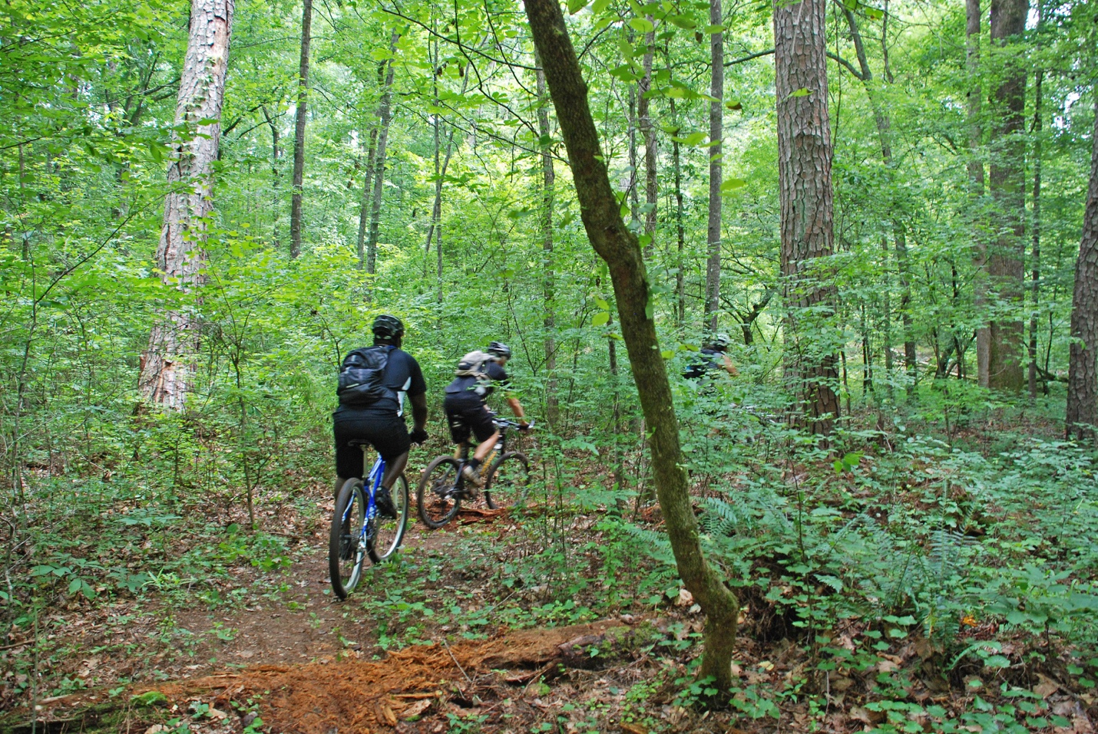

Single-track, contour line trails, loops, jumps: explore the Five Points Recreation Area and Cloudland Connector Trail corridor on mountain bike with the Park Naturalist. Helmets required. Free tours for all guests who rent a mountain bike from the park.

Half-Day Rental: $35/person
Full-Day Rental: $55/person
Tour Price without Bike Rental: $10–$15


706-657-4050


122 Cloudland Canyon Park Road
Rising Fawn, GA 30738

