Title of Your Flyer

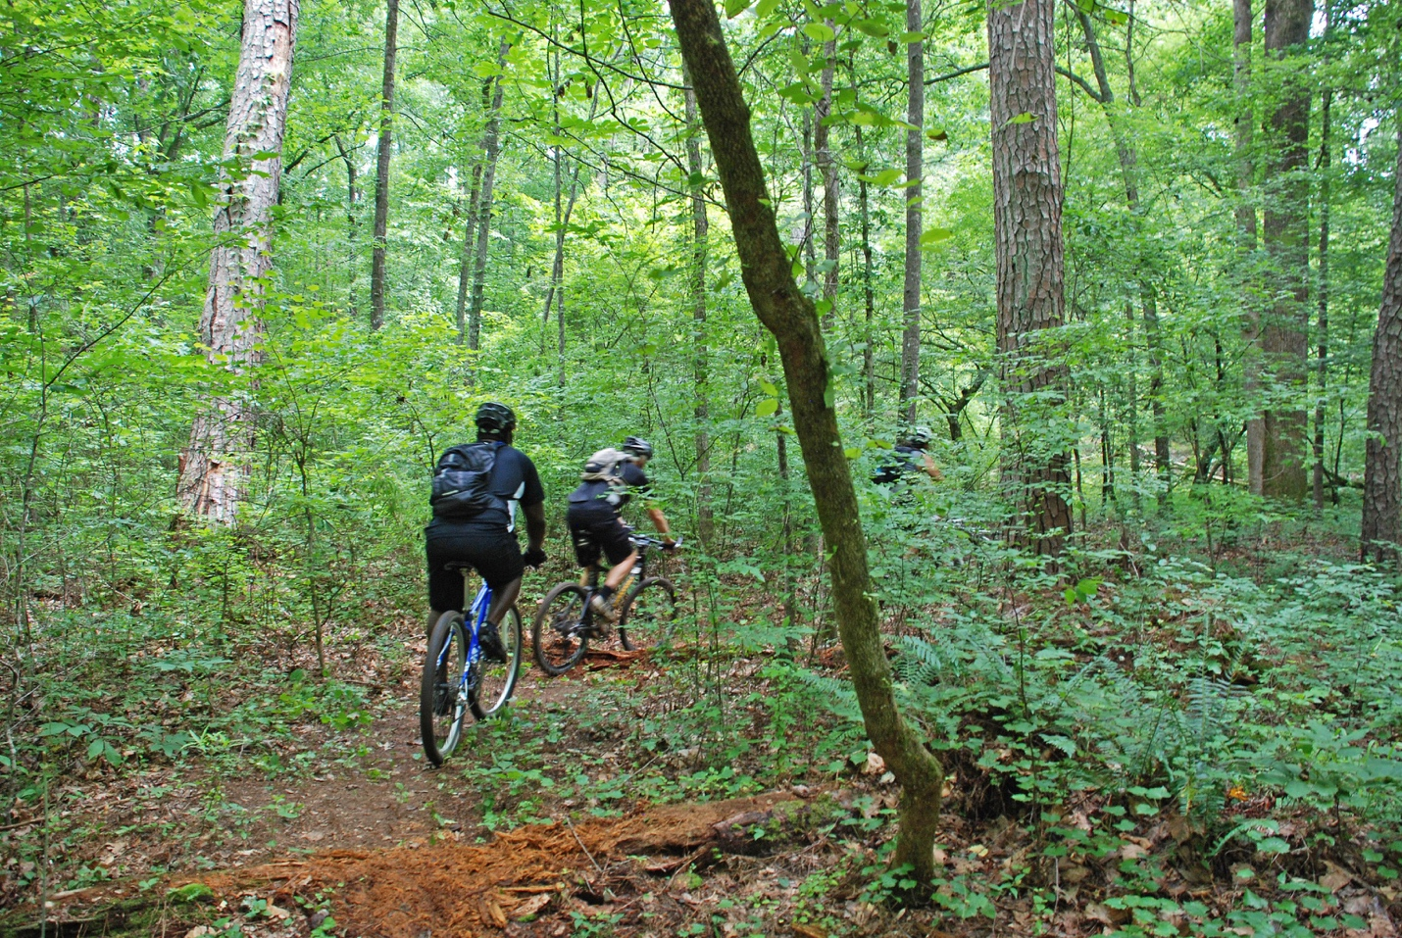

Body of text for flyer. Keep to a maximum of two to three sentences. Have fun and make sure you get your point across! To change the photo (please do not take photos from the web), right click on the photo, and select “Change Picture…”

Day, Date, Year of Event (or rental prices, etc.)

Time of Event (delete if not needed)


Park Phone #


Park Address

