To: Historic Site Mangers
From: Ellen Graham, Chief Naturalist
Date: July 18, 2018
Subject: Historic Site Program Report

We need to have consistent totals between the Program Report and the PeopleSoft “POS Product Sold Summary Report” regarding Historic Site Admission and Program Fee Revenue. There has been some inconsistency and confusion about how to ring up various groups or events in Aspira and also about how to list them on the Program Report. This memo is to clarify this for everyone and to begin a new “baseline” for consistent reporting in FY ’19. It will be important for sites to compare both the PeopleSoft and the Program Report on a monthly basis to ensure they match or reconcile.

Aspira/PeopleSoft Reports: Most revenue in a Historic Sites should be entered in Aspira as Historic Site Admission and should not be rung up as a Program Fee. The only time there should be any revenue showing on either report as Program Revenue is if is a program that is offered “above and beyond” regular site offerings. If Historic Sites charge an additional fee above the regular admission fees or for an outreach/offsite program then it will be listed it under Program Fee Revenue on the Program Report and at the point of sale in Aspira.

Program Report: We use the Program Report to track various types of programs in different categories to track their success. For example, we want to know how many “Parks After Dark” annual theme programs are offered in a year or the total number of scout programs offered. Now that we are offering the Leopold Education Project programs we will be tracking how many programs are offered to Middle and High School students to determine the success of that training and to see if we are reaching a different demographic. These categories are not tracked in Aspira/PeopleSoft Reports so that is why we track that information on the Program Report by different categories. Here are examples for how you should list attendance and revenue on both:

Daily Historic Site Admissions:
- Daily visitor: Any daily visitor who pays admission. This includes a ranger-led site/house tour (A.H. Stephens, Chief Vann House, Hardman Farm, Hofwyl Plantation, Little White House and Wormsloe).
- PeopleSoft Revenue Report: This will be rung up in Aspira as “Historic Site Admission-Taxable” NOT as “Program Fee Revenue”. It will show up on the “POS Product Sold Summary Report” under Product Code 60022 as “Historic Site Admission - Taxable”.
- Program Report: Beginning in FY ’19 on the Program Report you will need to select “Historic Site Admission” and enter the attendance for the whole month as one entry. These numbers should match the attendance and revenue from the “POS Product Sold Summary Report” under “Historic Site Admission - Taxable”.
  - Program Title or Group Name: On the Program Report list this as “Daily Admissions” or “Daily House Tours”.

  - Program Type: There is now a selection for the Historic Site Admission under Program Type in the drop-down box:
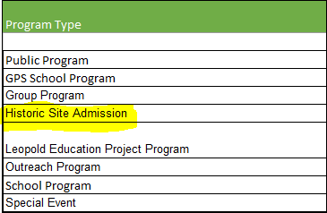
  - Number of Programs: 1
  - For the Program Start Date and the description in Column F list it like this:
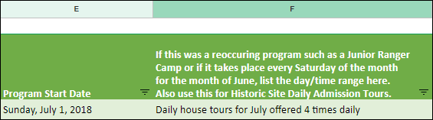
  - Program Attendance: Enter the amount from the “POS Product Sold Summary Report”, under “Historic Site Admission – Taxable” listed as the “Values Sum of Qty Sold.”
  - Historic Site Admission Revenue: Enter the amount from the “POS Product Sold Summary Report”, under “Historic Site Admission – Taxable” listed as the “Sum of Total Amount.”
  - Program Fee Revenue: list “0” as there was no extra program revenue from this.

Special Events listed as Historic Site Admission:
- Special Event Historic Site Admission Example: Molly goes to Hofwyl Plantation during regular hours to a “Deck the Halls” Special Event that has rangers leading programs all day Saturday and all-day Sunday. It is a Christmas themed event so there are craft stations to make ornaments, musicians playing and other program stations in addition to the basic house tour. The site is charging their regular admission fees so her admission is a Youth (6 - 17) rate in Historic Site Admission.
- PeopleSoft Revenue Report: This will be rung up in Aspira as “Historic Site Admission-Taxable” NOT as “Program Fee Revenue”. It will show up on the “POS Product Sold Summary Report” under Product Code 60022 as “Historic Site Admission - Taxable”.
- Program Report: Select “Historic Site Admission” even though it is a Special Event because you are charging the normal daily admission rates.
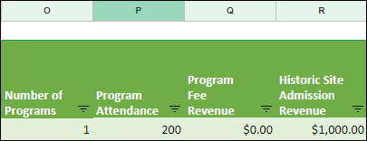

  - Program Title or Group Name: On the Program Report list the event name as “Deck the Halls” Special Event so we know it wasn’t a regular daily admission or tour.
  - Program Type: “Special Event” even though the revenue will show as Historic Site Admission
  - Number of Programs: 1
  - Program Attendance: Enter the amount from the “POS Product Sold Summary Report”, under “Historic Site Admission – Taxable” listed as the “Values Sum of Qty Sold.”
  - Historic Site Admission Revenue: Enter the amount from the “POS Product Sold Summary Report”, under “Historic Site Admission – Taxable” listed as the “Sum of Total Amount.”
  - Program Fee Revenue: list “0” as there was no extra program revenue from this event.

Special Events Upsell as both “Historic Site Admission” AND “Program Fee Revenue”:
- Special Event “Upsell” Example: In the same example above, if the site charges a Program Fee above the regular daily rates, then they would have an additional Program Fee Revenue tied to that special event. For example, the regular daily entry Youth (6 – 17) rate is $5 but they are charging $7/child since it is a special event. All visitors are charged the regular daily rate but the site adds $2 to upsell for the event.
- PeopleSoft Revenue Report: Ring Molly up in Aspira as two transactions, one as “Historic Site Admission” and one as a “Program Fee”. Molly would pay $7 which includes the $5 Youth (6 - 17) Historic Site Admission rate plus an upcharge of $2 more for the program. It will show up on the “POS Product Sold Summary Report” under Product Code 60022 as “Historic Site Admission - Taxable” and that is where the attendance will come from in PeopleSoft. In addition, there will also be revenue will show as under Product Code 60036 as Program Revenue in the “POS Product Sold Summary Report”.
- Program Report: In this example on the Program Report there were 200 people attending and is listed as:
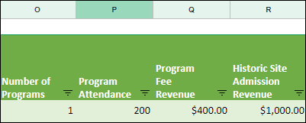
  - Program Title or Group Name: “Deck the Halls”
  - Program Type: “Special Event”
  - Number of Programs: 1
  - Program Attendance: Enter the attendance for the event and that should match the “POS Product Sold Summary Report”, under “Historic Site Admission” listed as the “Values Sum of Qty Sold.”
  - Program Fee Revenue: Enter the total revenue made over the two-day event and this will match with the “POS Product Sold Summary Report”, “Program Fee” as the “Sum of Total Amount.” In this example there was $1,400 made with $1,000 as Historic Site Admission plus the upsell revenue which is listed as $400 as a Program Fee Revenue.
  - Historic Site Admission Revenue: Enter the amount from the “POS Product Sold Summary Report”, under “Historic Site Admission – Taxable” listed as the “Sum of Total Amount.”

Group Program Reporting listed as “Daily Historic Site Admission”:
- Group Program Historic Site Admission Example: Sally’s 3rd grade class go on a house tour at Hofwyl with a group of 20 students from Clarkesville Elementary School. The site is charging their regular admission fees so her admission is a Youth Group (6 - 17) rate in Historic Site Admission.
- PeopleSoft Revenue Report: Ring them up in Aspira as an “Historic Site Admission” for 20 under the Youth Groups (6 - 17) rate. That will show up on the PeopleSoft report to track the attendance and Historic Site Admission Revenue.
- Program Report:
  - Program Title or Group Name: On the Program Report enter the group as “Clarkesville Elementary 3rd grade” so we can track it.
  - Program Type: Select “School Group” even though the revenue will show as Historic Site Admission
  - Number of Programs = 1
  - Program Attendance = 20, and this attendance is included in the total amount from the “POS Product Sold Summary Report”, under “Historic Site Admission – Taxable” listed as the “Values Sum of Qty Sold.”
  - Historic Site Admission Revenue: Enter the amount from the “POS Product Sold Summary Report”, under “Historic Site Admission – Taxable” listed as the “Sum of Total Amount.”
  - Program Fee Revenue: list “0” as there was no extra program revenue from this group.

Group Program “Upsell”, listed as both “Historic Site Admission” AND “Program Fee Revenue”:
- Group Example: “Girl Scout Troop #380” has 20 scouts that visit Hofwyl Plantation and attend Orienteering, Fire Building and Shelter Building programs that have nothing to do with the house tour. Any group program hosted on site should incorporate the Historic Site Admission Fee. In this example there would still be the regular daily entry Youth (6 – 17) rate of $5. If the site charges an additional program fee of $2 then each scout is charged $7/person.
- PeopleSoft Revenue Report: Ring them up in Aspira as two transactions, one as “Historic Site Admission” and one as a “Program Fee”. Each scout would pay $7 which includes the $5 Youth (6 - 17) Historic Site Admission rate plus an upcharge of $2 more for the program. It will show up on the “POS Product Sold Summary Report” under Product Code 60022 as “Historic Site Admission - Taxable” and that is where the attendance will come from in PeopleSoft. In addition, there will also be revenue will show as under Product Code 60036 as Program Revenue in the “POS Product Sold Summary Report”.
- Program Report: On the Program Report this is listed as:
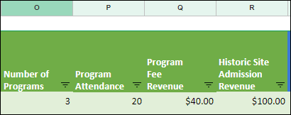
  - Program Title or Group Name: “Girl Scout Troop #380” so we know it was Girl Scouts
  - Program Type: “Group Program”
  - Number of Programs: 3
  - Program Attendance: Enter the attendance 20 for the group and that should match the “POS Product Sold Summary Report”, under “Historic Site Admission” listed as the “Values Sum of Qty Sold.”
  - Program Fee Revenue: $40 ($2/student X 20 scouts) and this will match with the “POS Product Sold Summary Report”, “Program Fee” as the “Sum of Total Amount.” In this example there was $140 made with $100 as Historic Site Admission plus the upsell revenue which is listed as $40 as a Program Fee Revenue.
  - Historic Site Admission Revenue: Enter the amount from the “POS Product Sold Summary Report”, under “Historic Site Admission – Taxable” listed as the “Sum of Total Amount.” In this case it should be $100.

Group or Event “Outreach” “Program Fee Revenue” with NO “Historic Site Admission”:
- Group Example: If there is any group or event hosted off the Historic Site grounds as an “outreach” program where the guests never set foot on the Historic Site, then only the Program Fee Revenue would apply and it should be listed as an “Outreach” Program.
  - A group of college students meet up for a paddling program that launches off site but is hosted by an Historic Site. The students never set foot on the site so there is no Historic Site Admission.
  - An event example would be a “meet up” paddling event that takes place off site but it is hosted by an Historic Site.
  - Another example would be doing outreach at a local school and charging a program fee per student. For this example, we will say the Interpretive Ranger offered a Revolutionary Soldier talk at a local school and charged $2/student and the program was offered as 3 rotations for 60 students.
- PeopleSoft Revenue Report: Ring them up in Aspira as one transaction as a “Program Fee”. Each student is charged $2/student. It will show under Product Code 60036 as Program Revenue in the “POS Product Sold Summary Report”.
- Program Report: On the Program Report this is listed as:
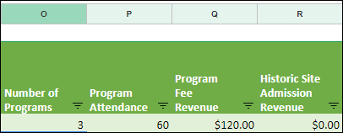
  - Program Title or Group Name: “Todd Grant Elementary” so we know it was Girl Scouts
  - Program Type: “Outreach”
  - Number of Programs: 3 to note that it was offered 3 times
  - Program Attendance: Enter the attendance 60 for the group and that should match “POS Product Sold Summary Report”, under “Program Fees” listed as the “Values Sum of Qty Sold.”
    - NOTE: This is the only time that the PeopleSoft and Program Report may not match exactly. The attendance for Historic Sites is kept under Historic Site Admission on the POS Report as that is the number of people who set foot on a site. The Program Report is going to have the total head count for all of the program attendees which will include these outreach programs. There are very few of these situations.
  - Program Fee Revenue: $120 ($2/student X 60 students) and this will match with the “POS Product Sold Summary Report”, “Program Fee” as the “Sum of Total Amount.”
  - Historic Site Admission Revenue: list “0” as all revenue for this will be listed in Program Fee Revenue.
This reporting process is effective for FY19 so please be sure your July Program Report is completed this way and begin ringing up accordingly in Aspira. Please let me know if you have any questions.
CC: James Hamilton, Assistant Director
Terry Trowbridge, Operations Manager
Kim Lampkins, Business Services Manager
Beverly Terrell, Administrative Operations Manager
Cindy Robinson, Reservation Manager
Judd Smith, Parks Historian
Angie Johnson, Division Training Coordinator
Region Managers
Assistant Region Managers
Region AOM’s

