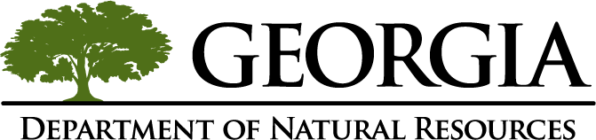

Georgia Department of Natural Resources

Brand Standards Manual

Table of Contents

DNR Logo 3

Approved Versions 3

Usage 4

Size 4

Color 5

Typeface 5

DNR Identity 6

Letterhead 6
Fax Cover Sheet 7
Business Card 8

DNR PowerPoint Template 9

The Georgia Department of Natural Resources Logo

The Georgia Department of Natural Resources’ (DNR) logo is its signature and is the central element of its brand identity.

Approved Versions

While the preferred logo should be used whenever possible, there is also a black version available to accommodate special graphic situations. Versions for each division with distinct icons and colors are available.

Preferred Logo – Full Color Version

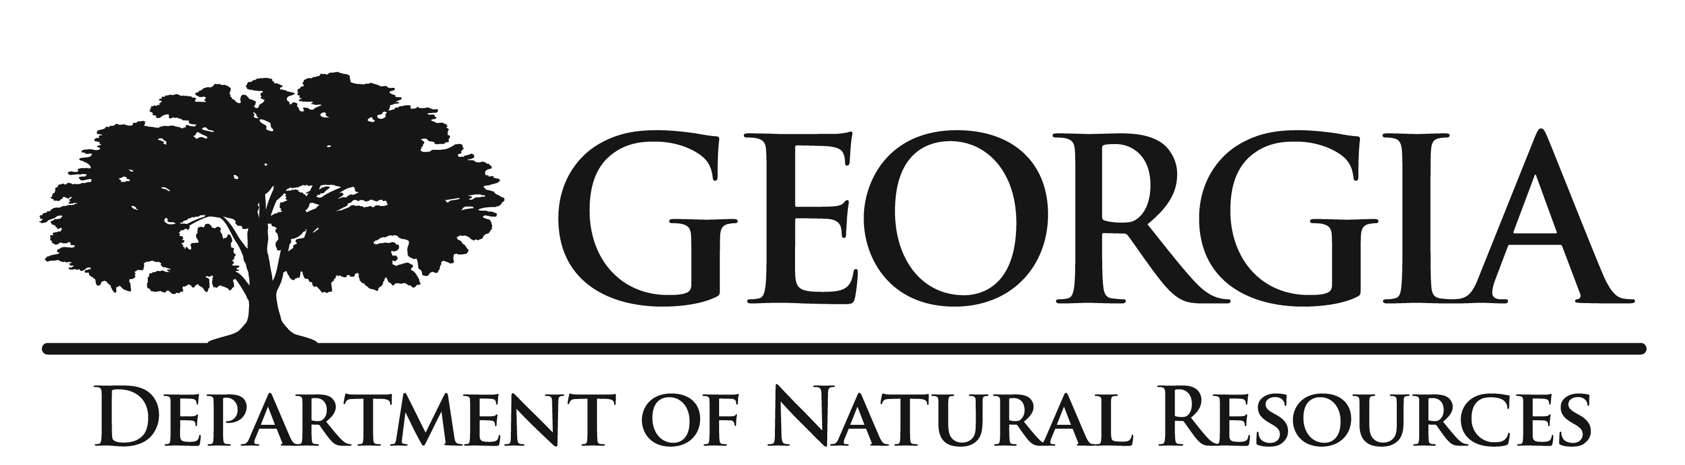

Black Version: For use where black only must be used.

Logo Usage

When the logo is used, the standard position, proportion (aspect ratio) and relative size relationship between the logotype elements must be maintained. This means that no elements of the logo may be larger or smaller in proportion to each other than the example.

- When sizing the logo, in most software applications, you can drag the corner sizing handle when resizing to maintain proportion. This will keep the logo from being stretched out of proportion, becoming either too tall or too wide.
- The elements of the logotype may not be placed closer together or further apart than shown in the example, nor may they be arranged differently from the example.
- The logo should never be tilted or rotated.

Too wide Too tall

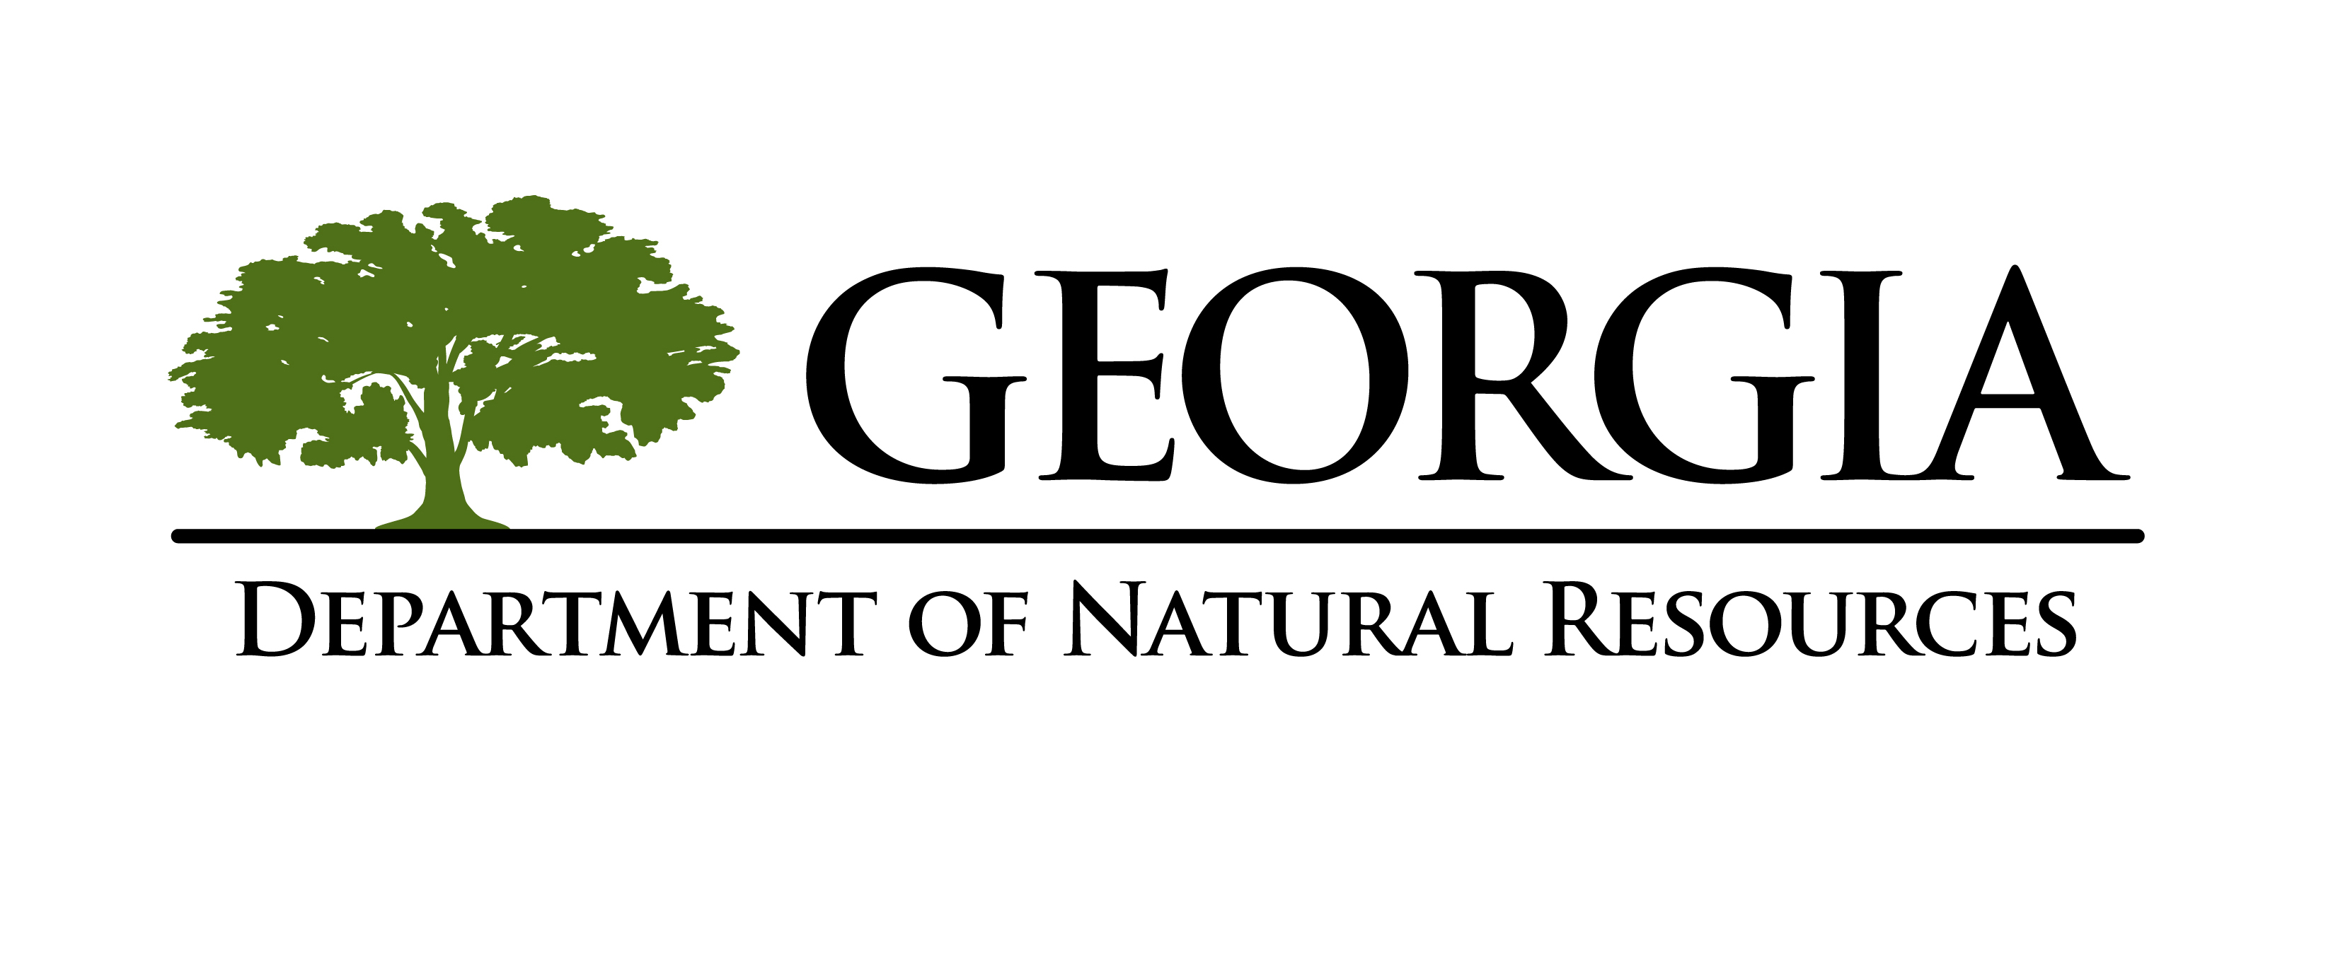
Do not reconfigure elements

Logo Size

Minimum Size Requirement

The logo should never be presented smaller than .5”H on any printed material, as demonstrated below.

Logo Color

Primary Color
The primary DNR color is

PMS 371 (green), R: 86, G: 107, B: 33; Hex: #566B21

- Distinct colors are available for each division.

Logo Typeface

The font used in the DNR logo is Trajan Pro. This font is available for download from the DNR Public and Governmental Affairs Office. For assistance with installing a new font, please visit http://office.microsoft.com/word. Please note, this font only offers caps.

If Trajan Pro is unavailable, or for a corresponding font, please use Garamond.

Trajan Pro
a b c d e f g h i j k l m n o p q r s t u v w x y z
A B C D E F G H I J K L M N O P Q R S T U V W Y Z

Garamond
a b c d e f g h i j k l m n o p q r s t u v w x y z
A B C D E F G H I J K L M N O P Q R S T U V W X Y Z

DNR Identity

Our identity is a key component of our brand look. Bright white paper stock should be used, when available, to convey a clean look.

Letterhead

- The letterhead is available electronically in Microsoft Word so it can easily be inserted into documents and printed as needed.
- The address can be personalized by editing the text in the footer of the Word document.
- While the color option is preferred, a black option is available for those without access to a color printer.
- An electronic version of letterhead is available from the DNR Public and Governmental Affairs Office.
- Distinct versions have been created for each division.

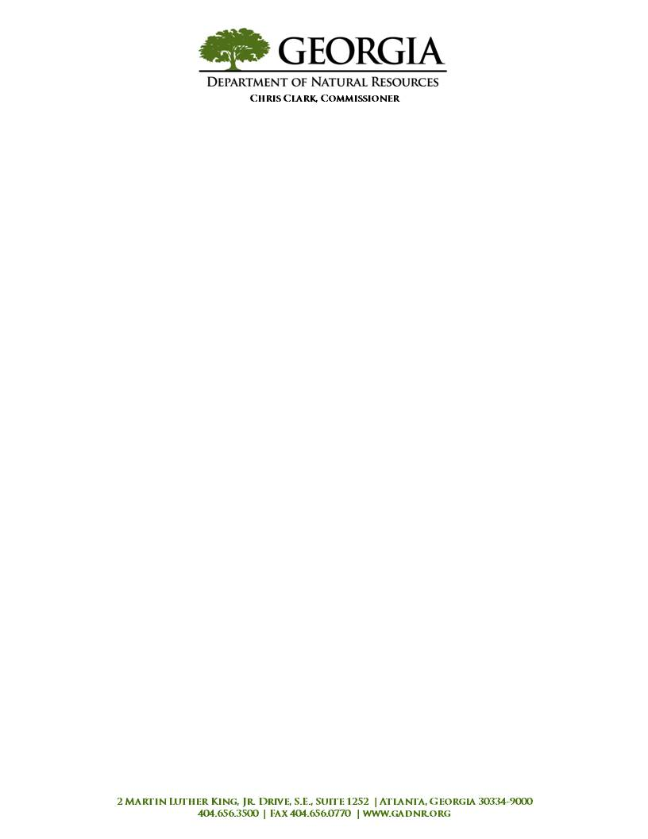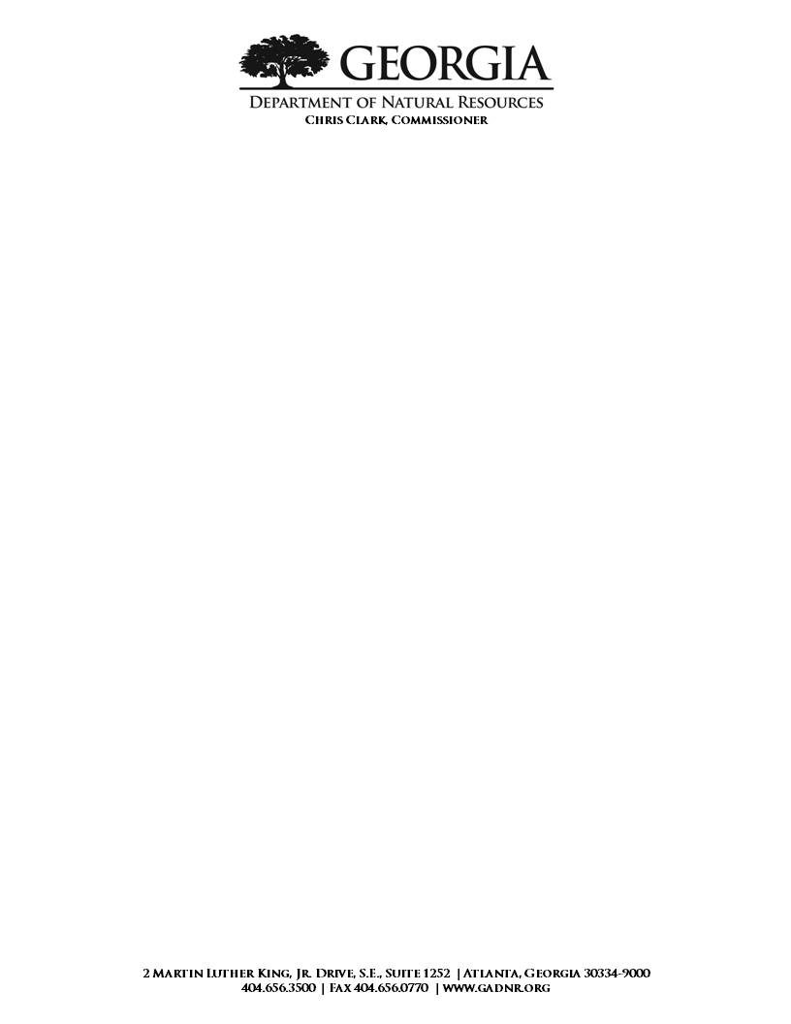

Preferred Version Black Version
Fax Cover Sheet

- The fax cover sheet is available electronically in Microsoft Word so it can be edited and printed as needed.
- The address can be personalized by editing the text in the footer of the Word document.
- An electronic version of letterhead is available from the DNR Public and Governmental Affairs Office.
- Distinct versions have been created for each division.

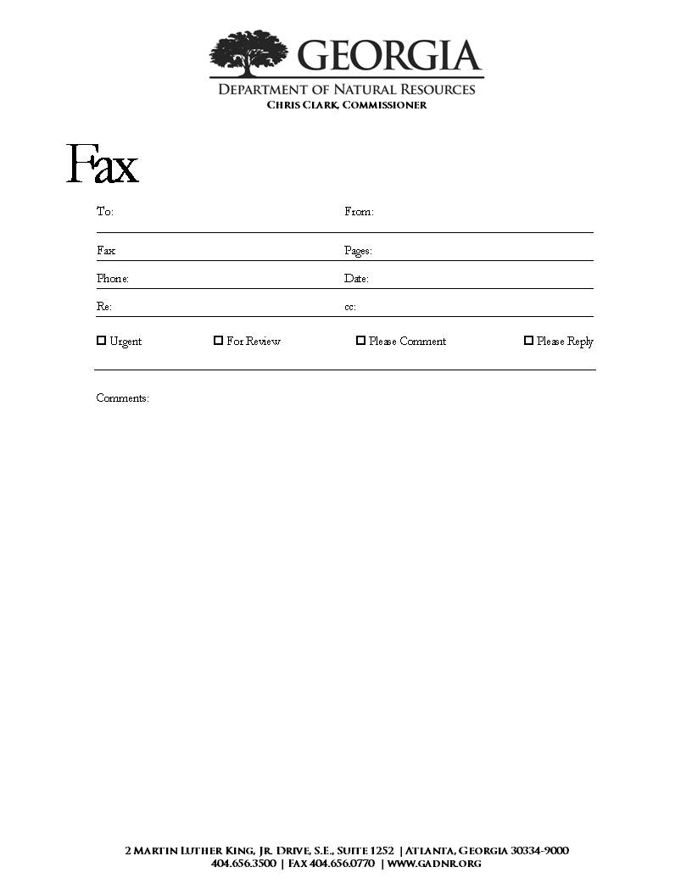

Business Card
- Business card options, shown below, include a color option (preferred) and a black option.
- Departmental programs of your choice can be promoted using the back option when 2-sided printing is available.
- Business card files are available for personalization from the DNR Public and Governmental Affairs Office.
- Distinct versions have been created for each division.

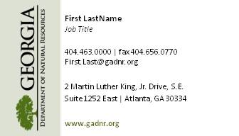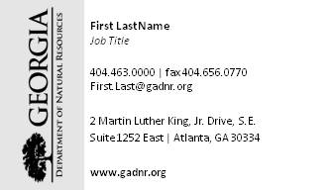

Business Card Front Black Option

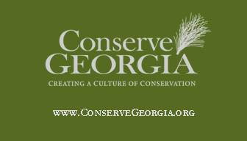

Optional Business Card Back

PowerPoint Template

The DNR PowerPoint template ensures that presentations retain the consistent DNR look.

- Items, including footers, images, and other design elements can only be adjusted in the ‘slide master’ (for tips on editing the ‘slide master’, visit http://office.microsoft.com/powerpoint)
- The look and layout should remain common to all presentations.
- There are several page designs to use, depending on the need for text, graphs or photos.
- Users are welcome to replace the image on the title ‘slide master’ to support their presentation.
- The date and presenter’s name should be personalized by adjusting the ‘slide master.’
- The DNR PowerPoint template can be obtained from the DNR Public and Governmental Affairs Office.
- Two templates are available, one for users with PowerPoint 2000 and one for PowerPoint XP. While both versions should display the same, using the appropriate template for the PowerPoint version will make the template easier to use.
- Distinct PowerPoint templates are available for each division.

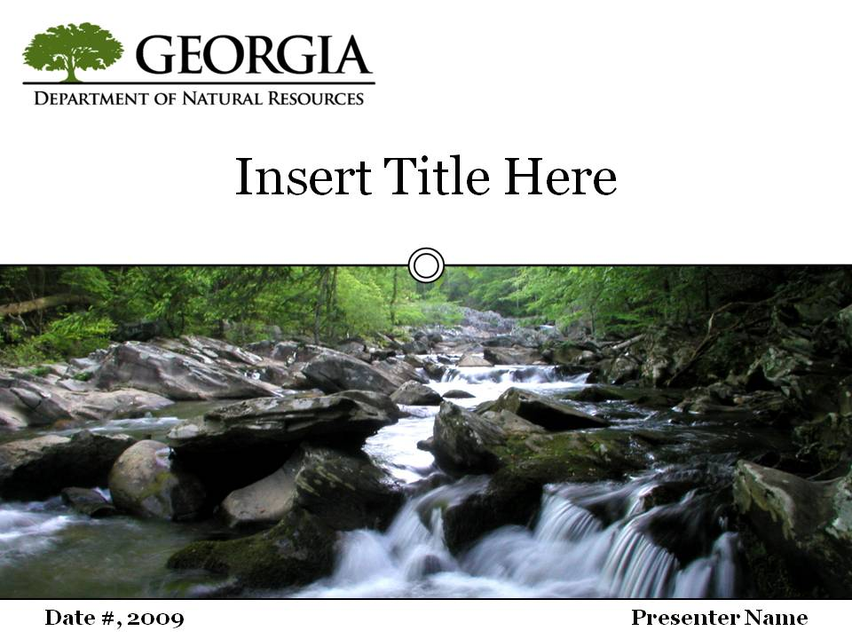
Title Slide
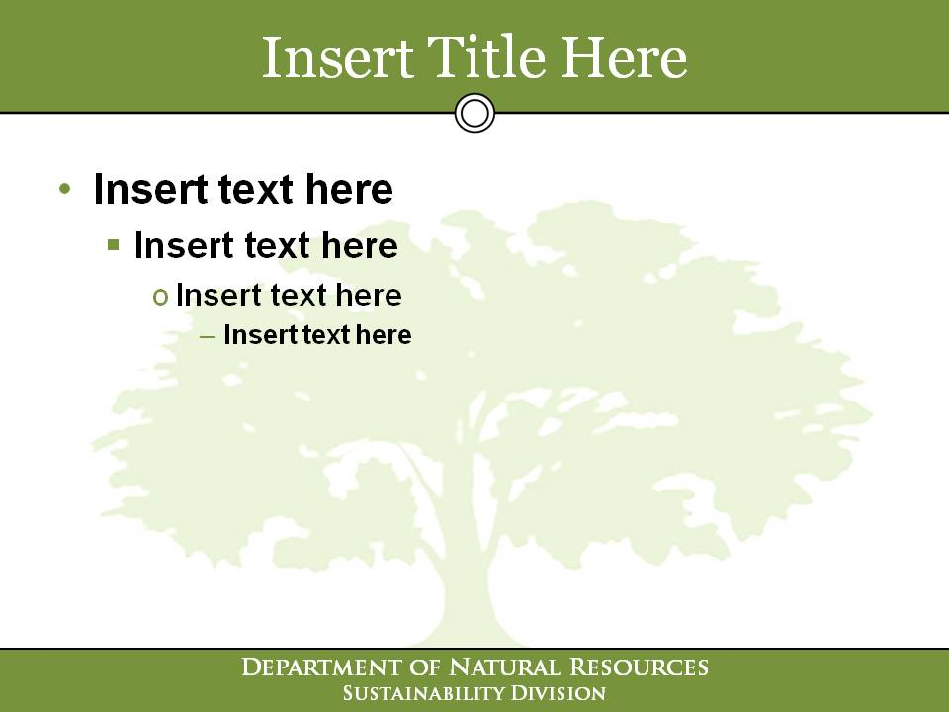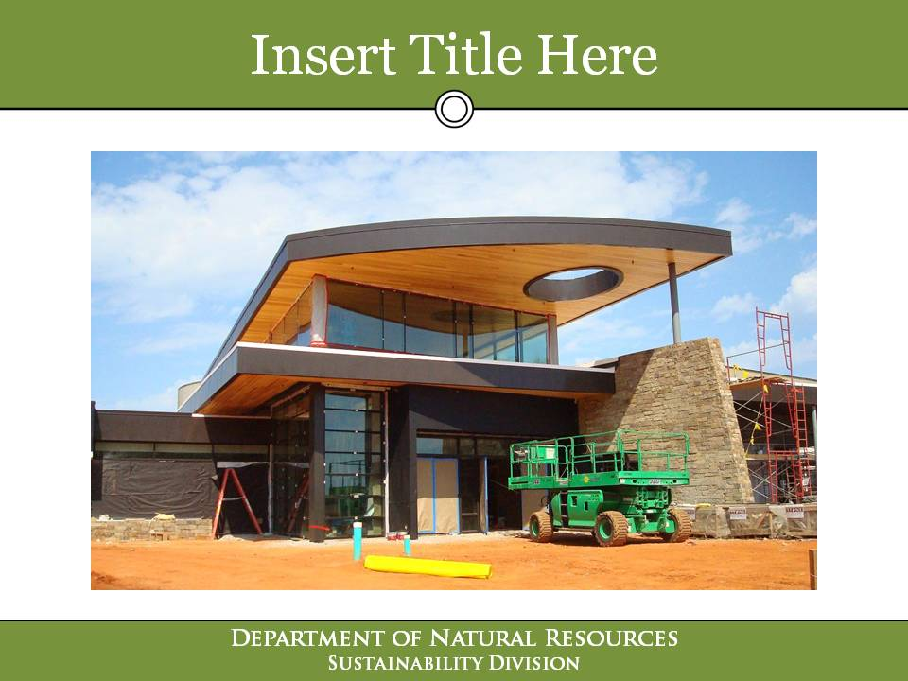
Text Slide Graph/Photo Slide

