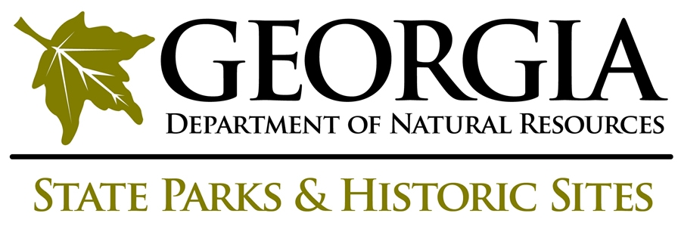

Working with the Media

Do . . .

Return phone calls within one hour whenever possible. (No more than 24 hours.)

Be helpful and honest. You do not want to appear antagonistic.

For sensitive matters, answer only those questions you are asked. Do not volunteer information not asked for.

Admit when you don’t know something and suggest someone who should know.

Admit when you cannot discuss something. Tell them you are not the appropriate person to answer the question, then refer them to our Marketing and Communications Unit.

Get to know your local media. Write them, stop by to drop off a news release, invite them to visit, etc. You may want to offer to write a regular column or be regular guest.

Don’t . . .

Lie. The truth will eventually come out.

Avoid media. They will get the information somehow. It’s better for us to tell DNR’s story than someone else.

Restrict media access to public areas or talking with visitors. Exceptions are made in areas which are under investigation or not public access.

Say “I’m not allowed to speak to reporters” or “No comment.”

Talk off the record. Always assume that anything you say, even in a casual conversation, can be recorded, broadcast or printed. Don’t say anything you would not want to see in the news.

Talk badly about someone, be sarcastic or make flippant remarks -- even jokingly.

Offer your personal opinion. You are always speaking on behalf of DNR.

Ask to approve a story before it’s printed. It is okay to ask a reporter to repeat information during interview to check accuracy.
Appropriate Answers for Difficult Questions

I don’t know, but I’ll help you find the correct person to interview.

I’m not qualified to answer that. You need to ask . . .

The matter is under investigation so the answer isn’t available yet.

That’s not relevant to this situation, so I can’t get involved in that.

I speak only for State Parks and Historic Sites, you need to talk to . . .

