Preliminary Maps for A. H Stephens State Historic Park

Topographic Map
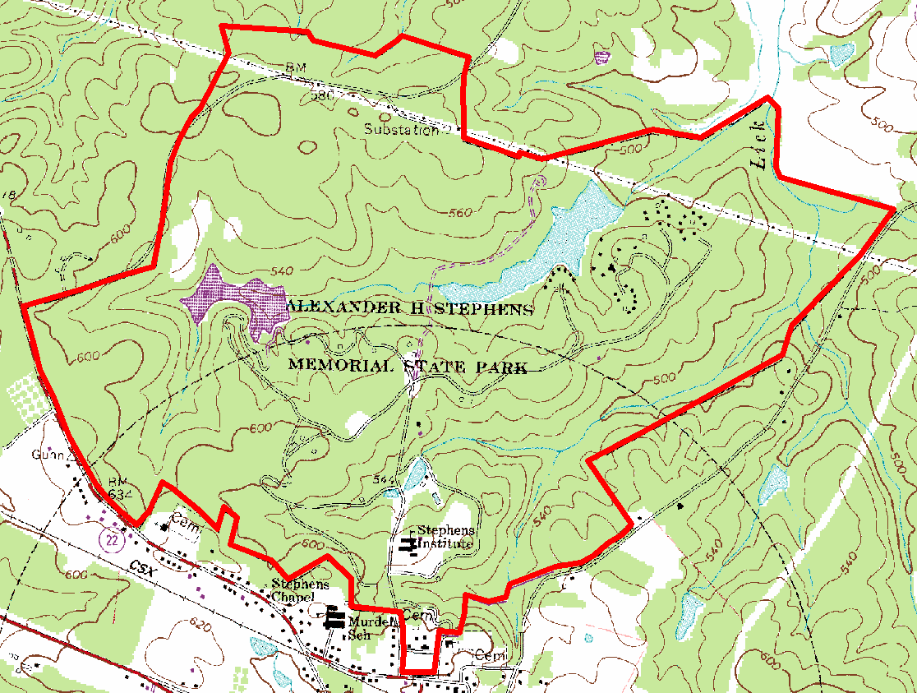

2007 True-Color Leaf-on

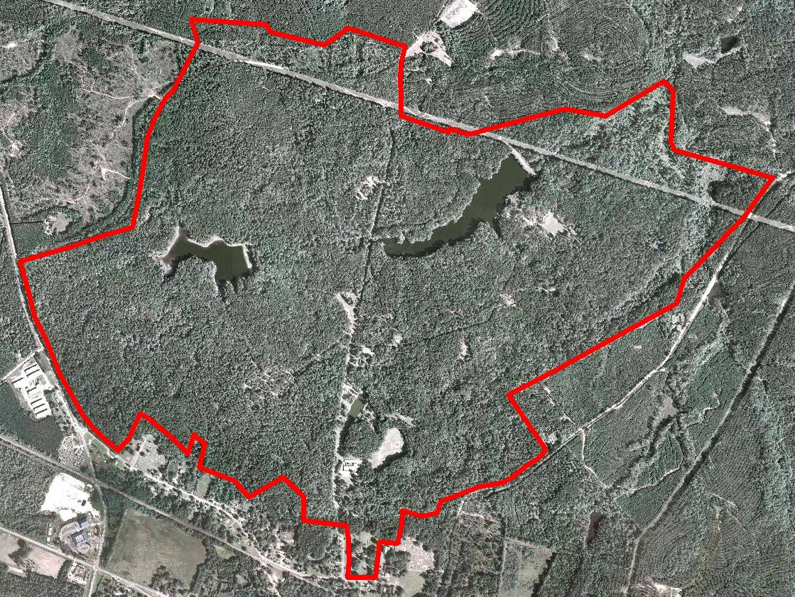

2005 True-Color Leaf-On
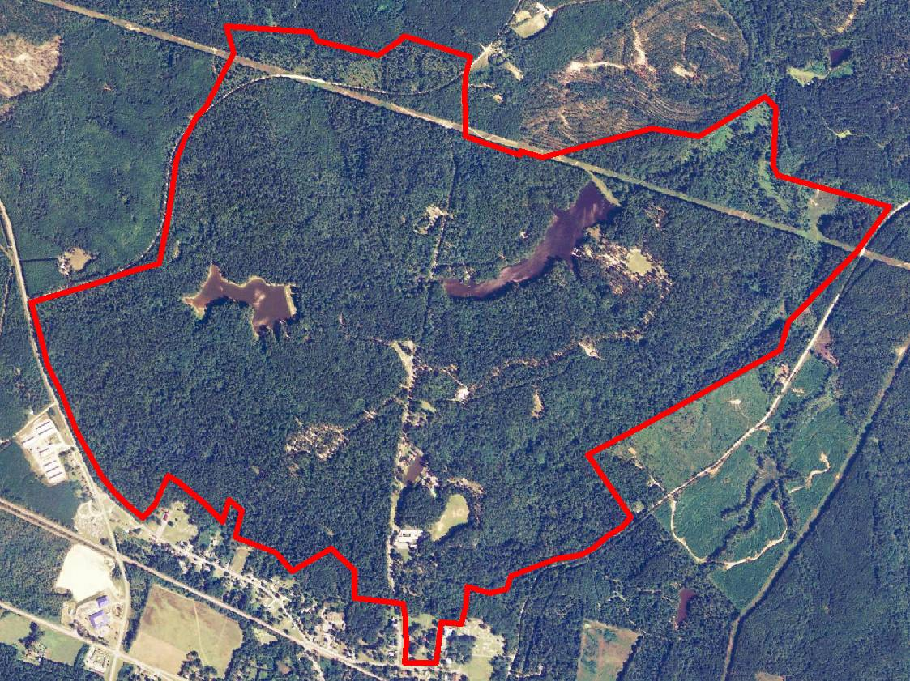

1999 Infra-red Leaf-Off

