Preliminary Maps for Black Rock Mt State Park

Topographic Map
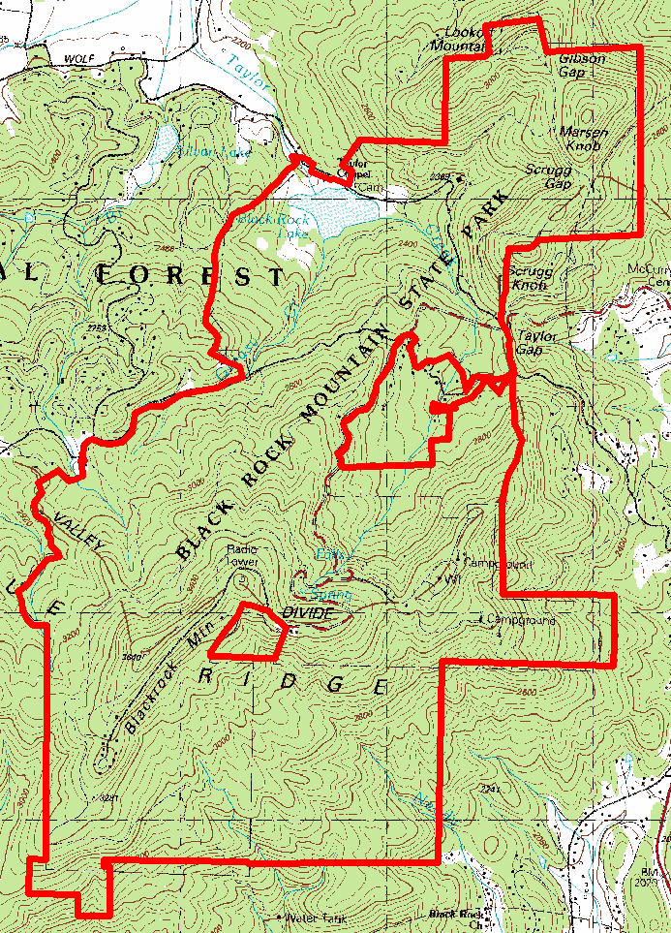

2007 True-Color Leaf-on

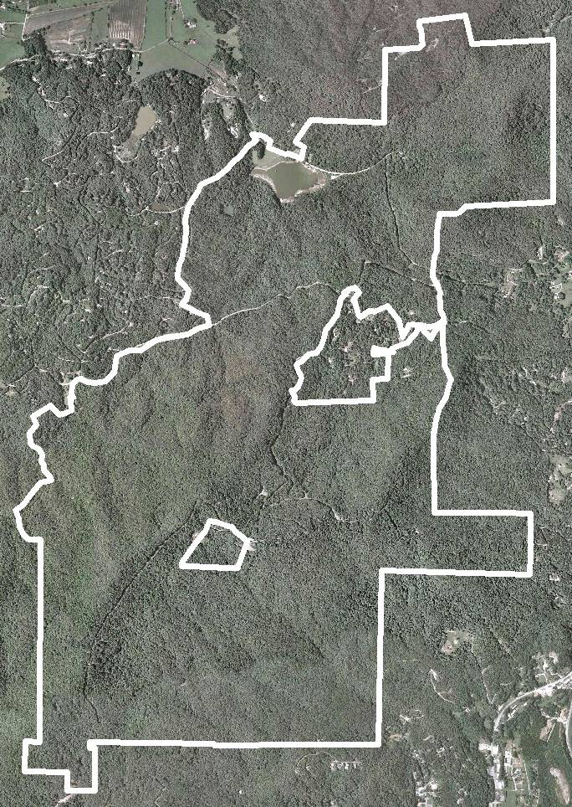

2005 True-Color Leaf-On

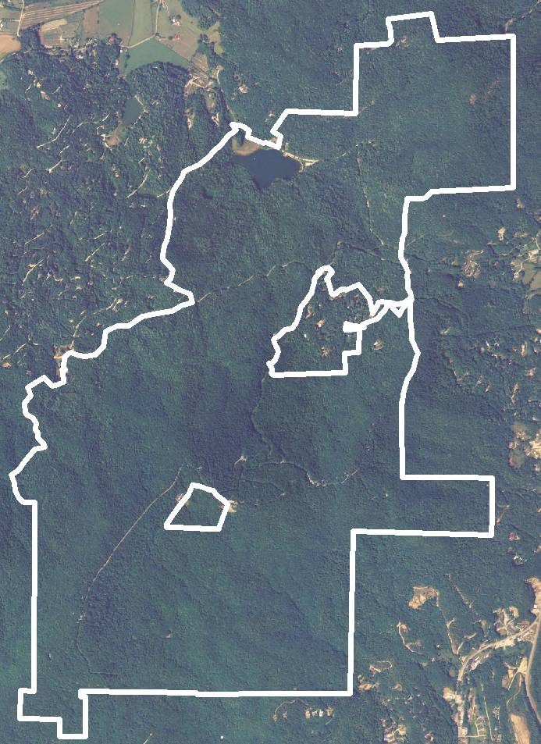

1999 Infra-red Leaf-Off

