Preliminary Maps for Cloudland Canyon State Park

Topographic Map
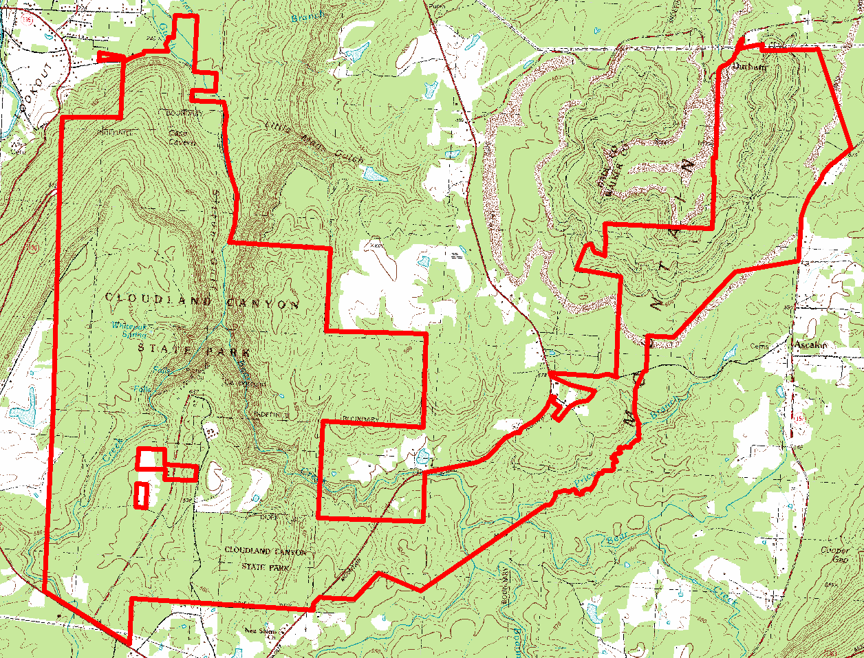

2007 True-Color Leaf-on
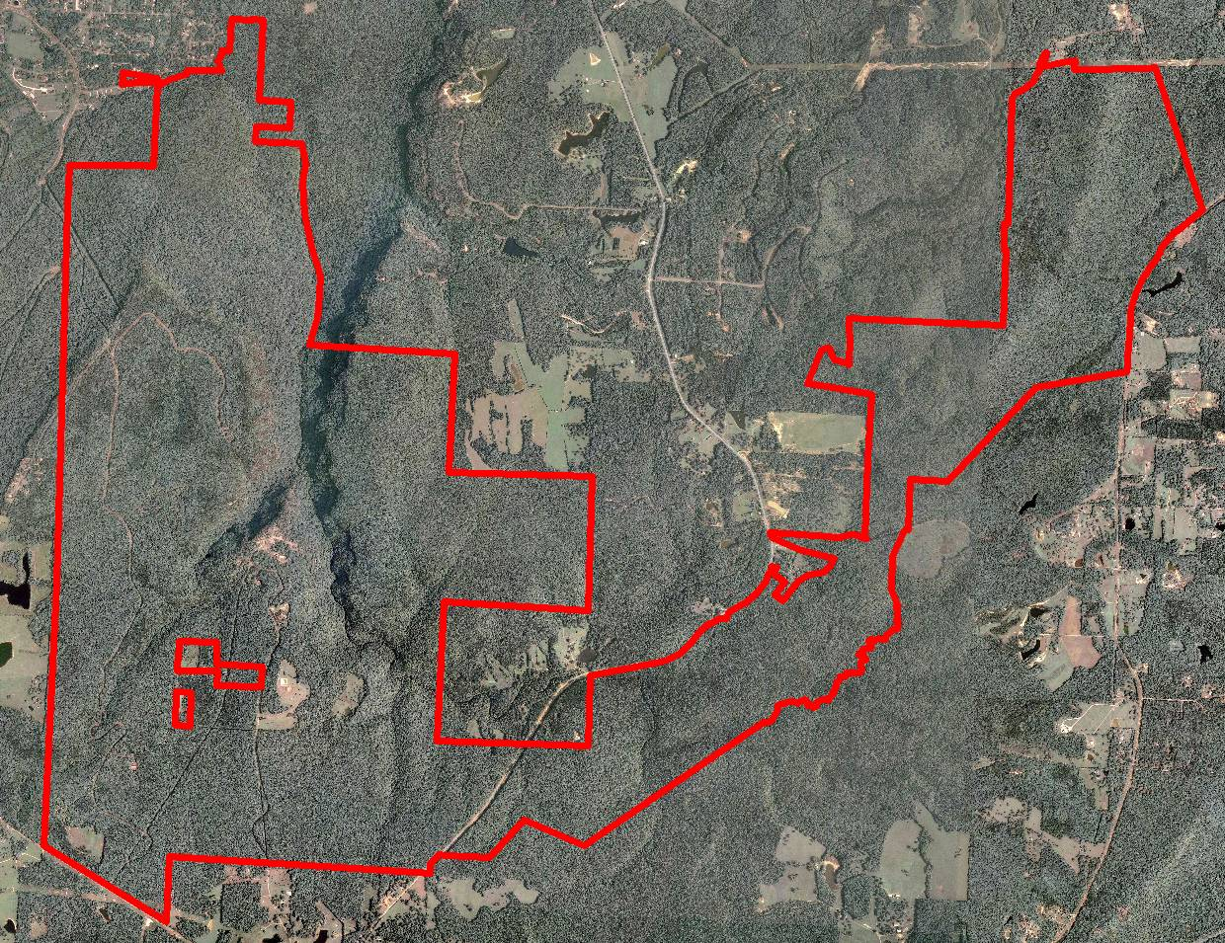

2005 True-Color Leaf-On

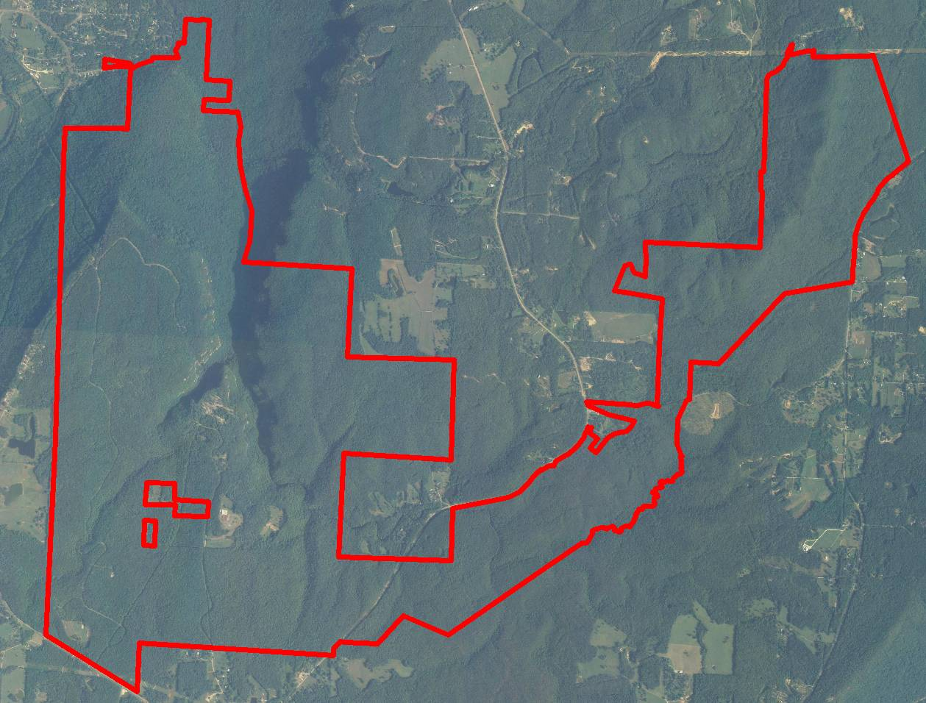

1999 Infra-red Leaf-Off

