Preliminary Maps for F.D. Roosevelt State Park

Topographic Map

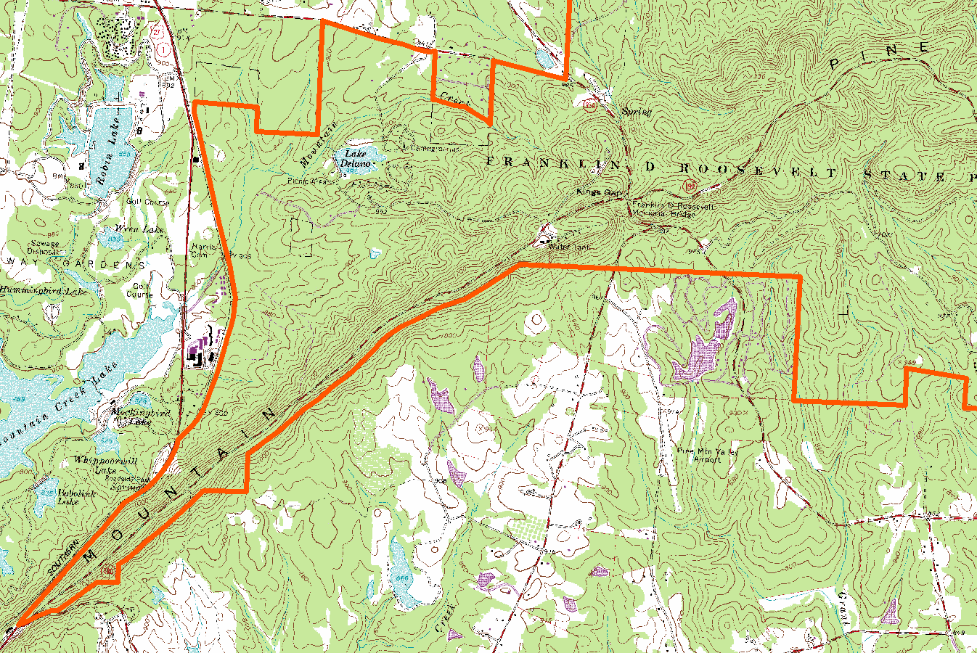

2007 True-Color Leaf-on

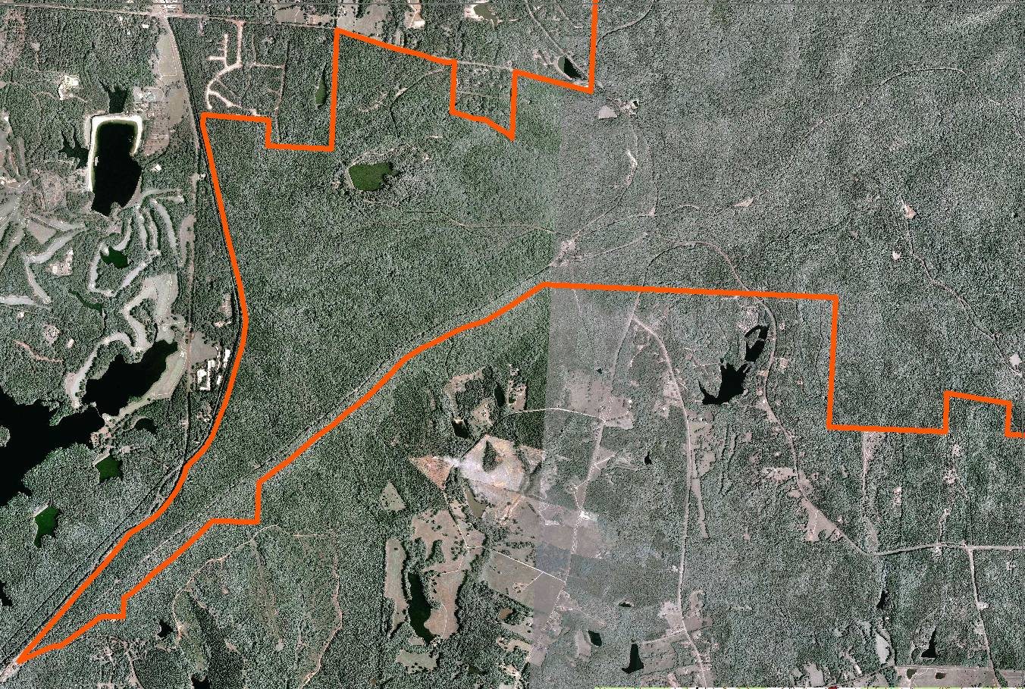

2005 True-Color Leaf-On

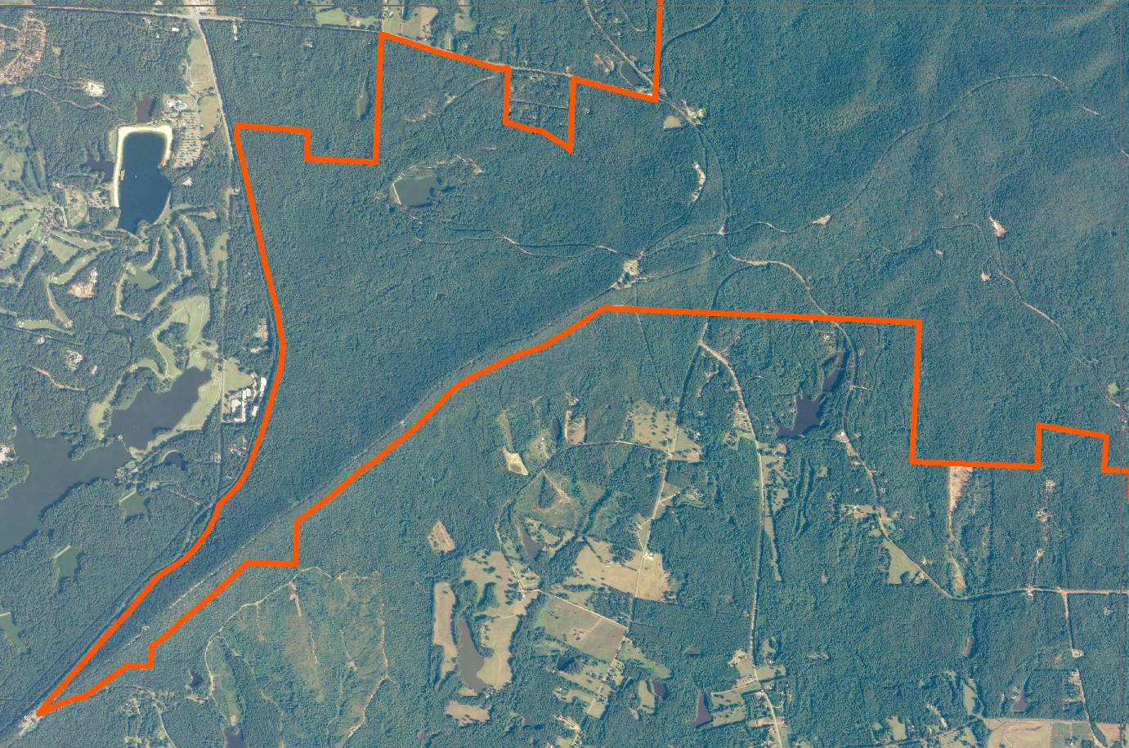

1999 Infra-red Leaf-Off

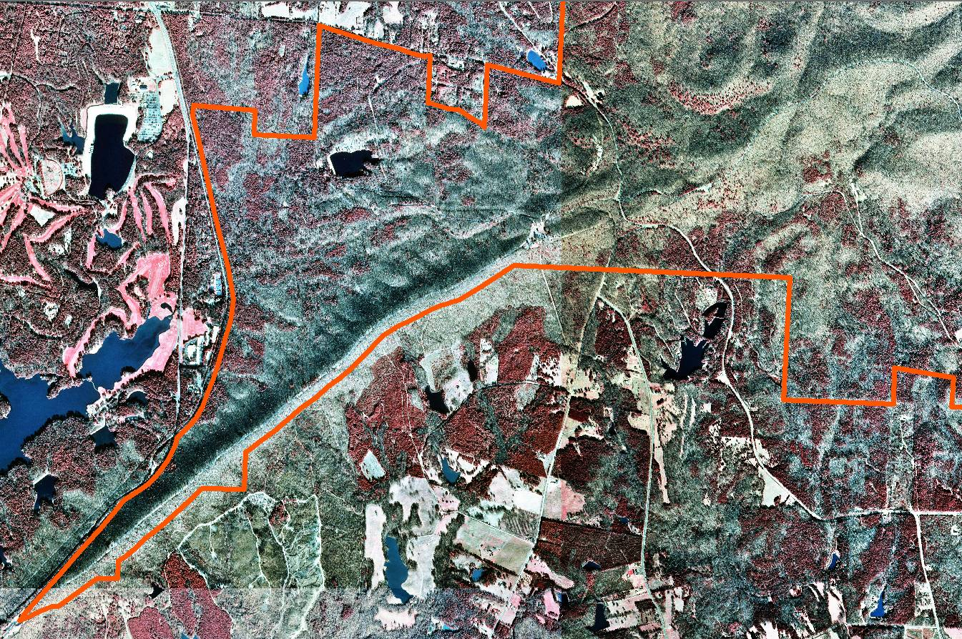

Topographic Map

2007 True-Color Leaf-on

2005 True-Color Leaf-On

1999 Infra-red Leaf-Off

Topographic Map

2007 True-Color Leaf-on

2005 True-Color Leaf-On

1999 Infra-red Leaf-Off

Topographic Map

2007 True-Color Leaf-on

2005 True-Color Leaf-On

1999 Infra-red Leaf-Off

Topographic Map

2007 True-Color Leaf-on

2005 True-Color Leaf-On

1999 Infra-red Leaf-Off

