Preliminary Maps for Florence Marina State Park

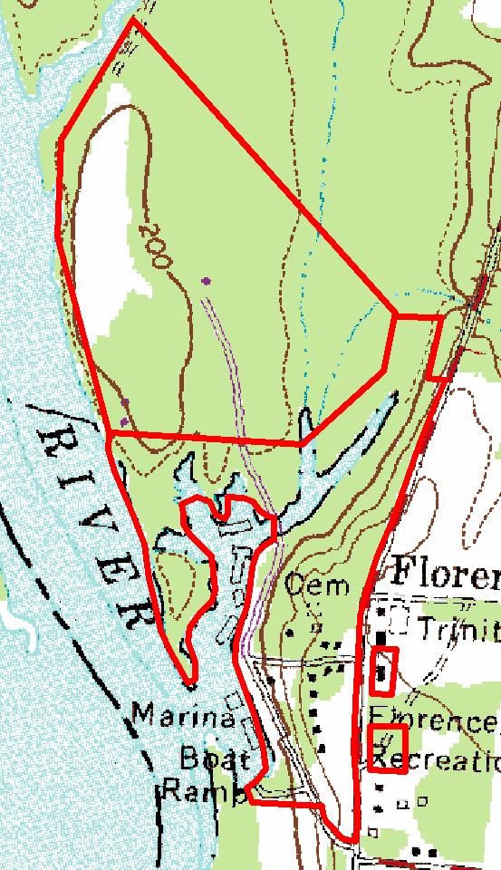
Topographic Map

2007 True-Color Leaf-on

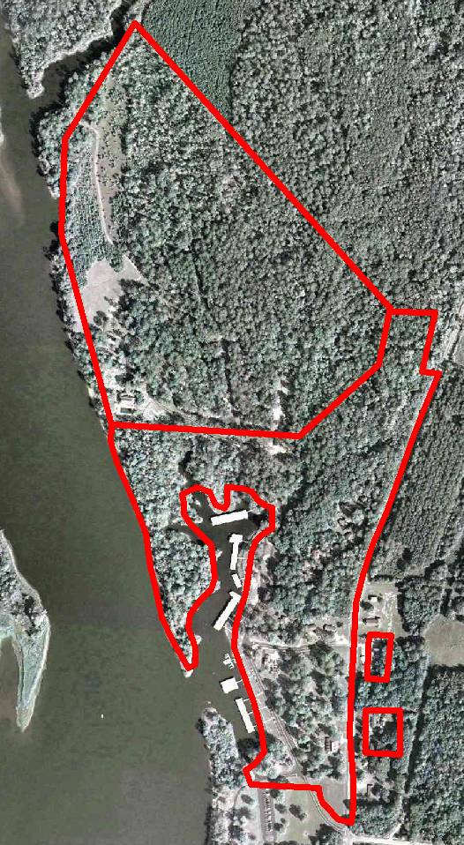

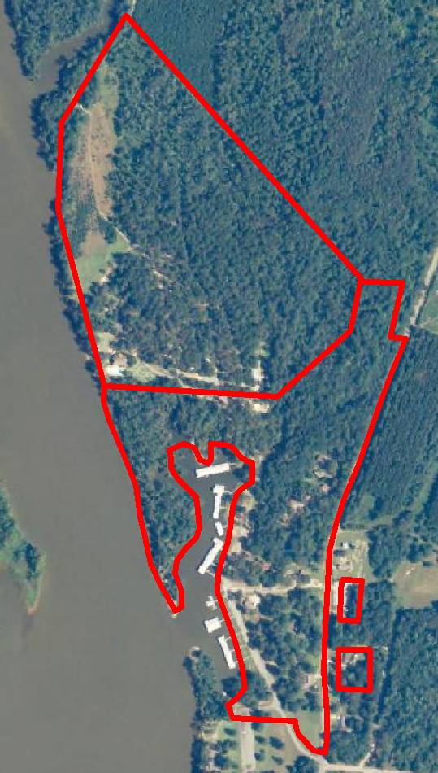
2005 True-Color Leaf-On

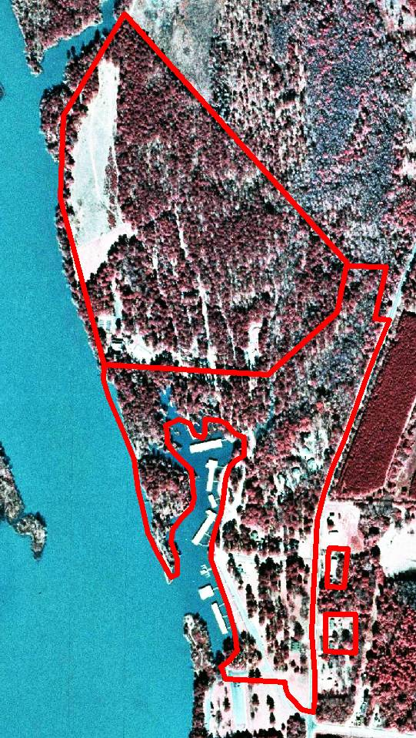
1999 Infra-red Leaf-Off

