Preliminary Maps for Fort McAllister State Park

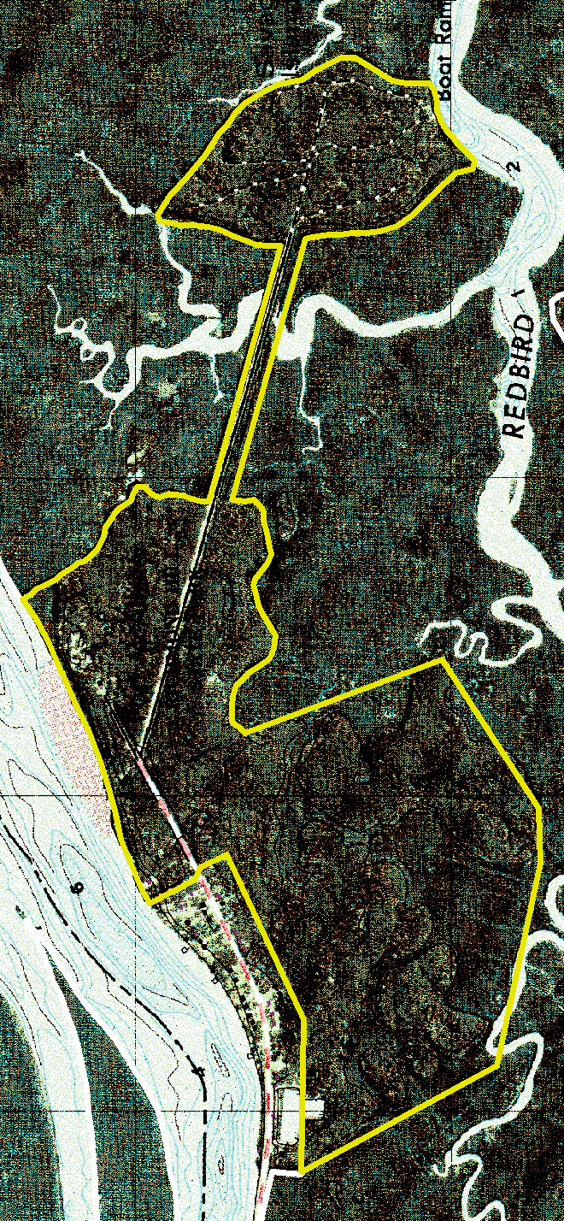
Topographic Map

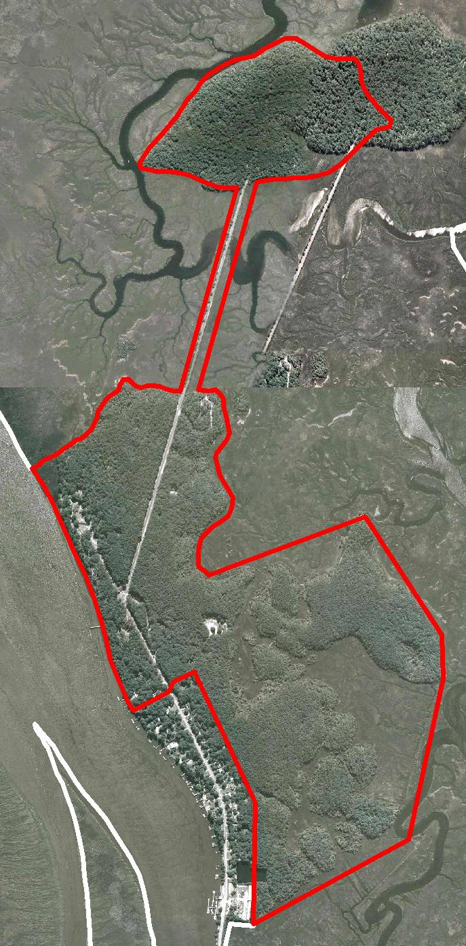
2007 True-Color Leaf-on

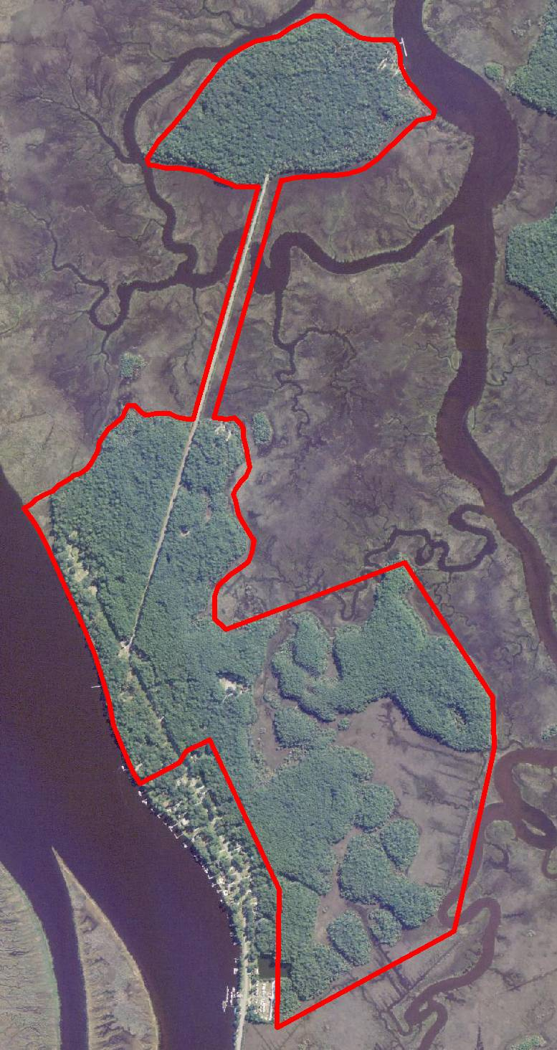
2005 True-Color Leaf-On

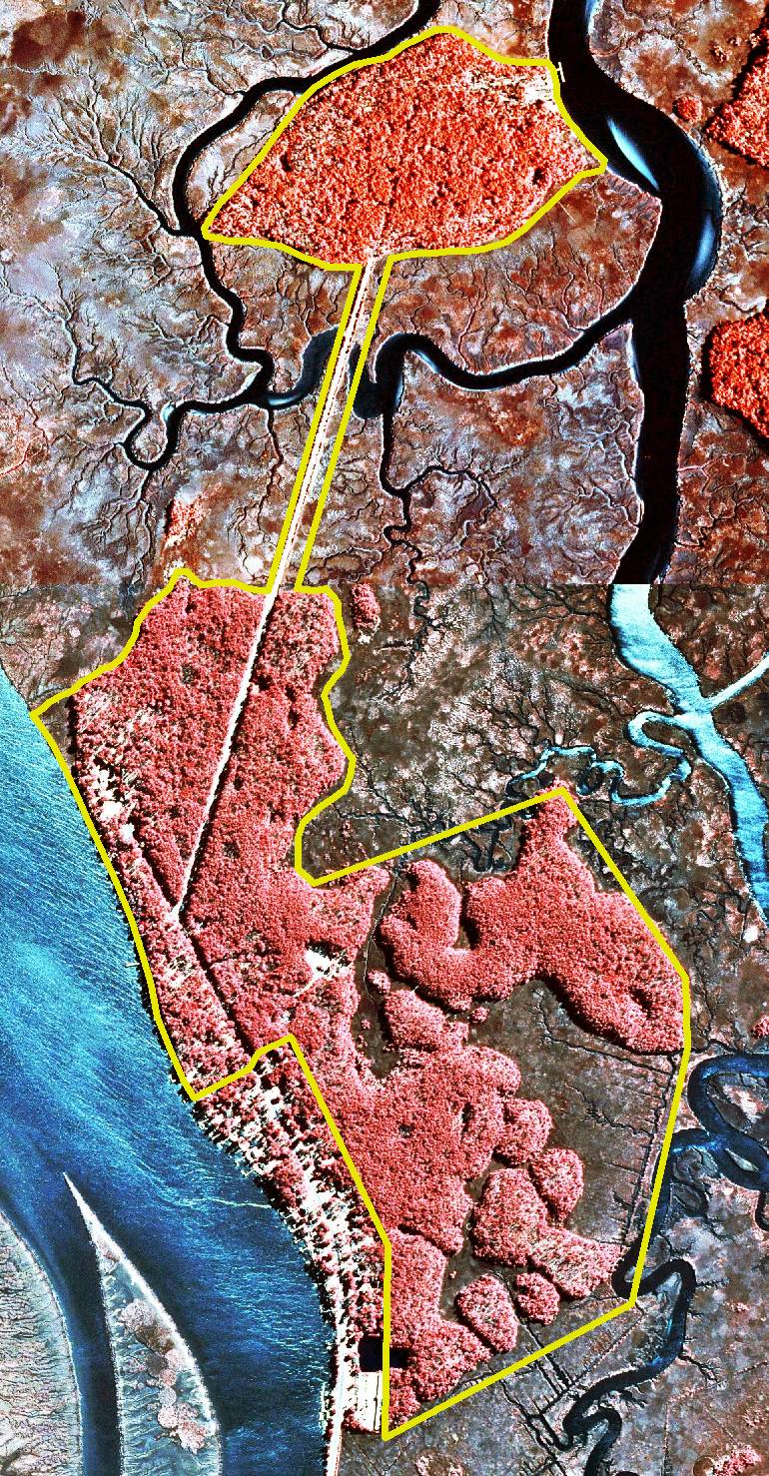
1999 Infra-red Leaf-Off

