Preliminary Maps for Georgia Veterans State Park

Topographic Map

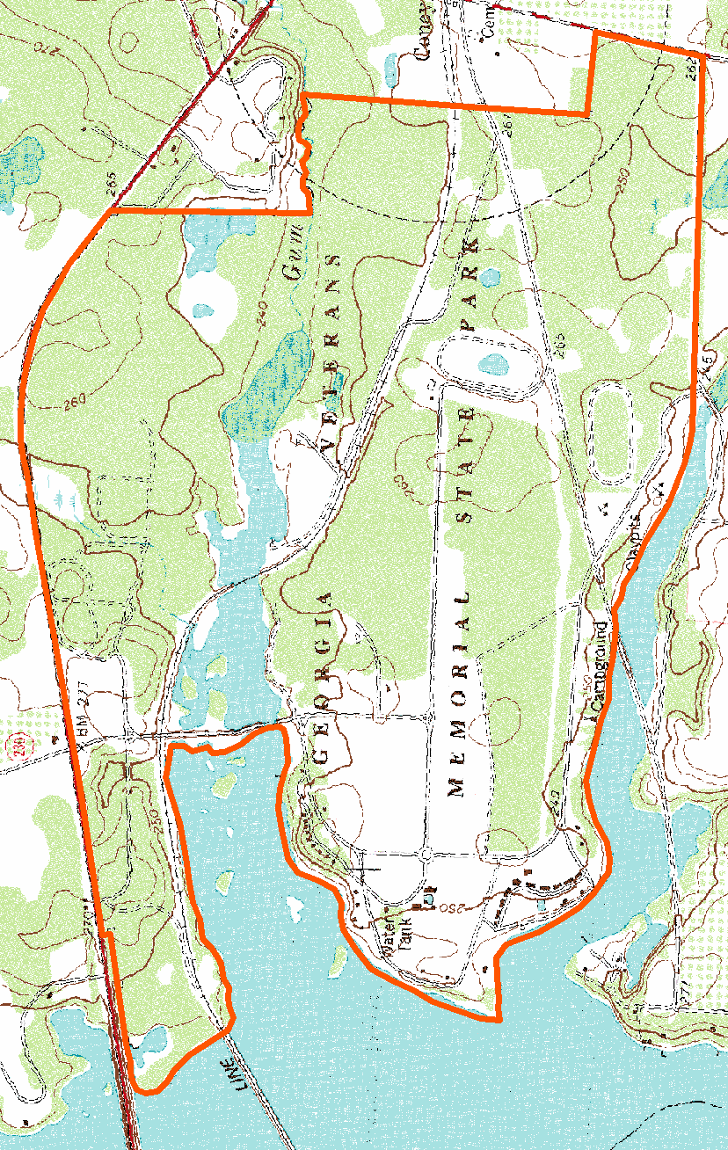

2007 True-Color Leaf-on

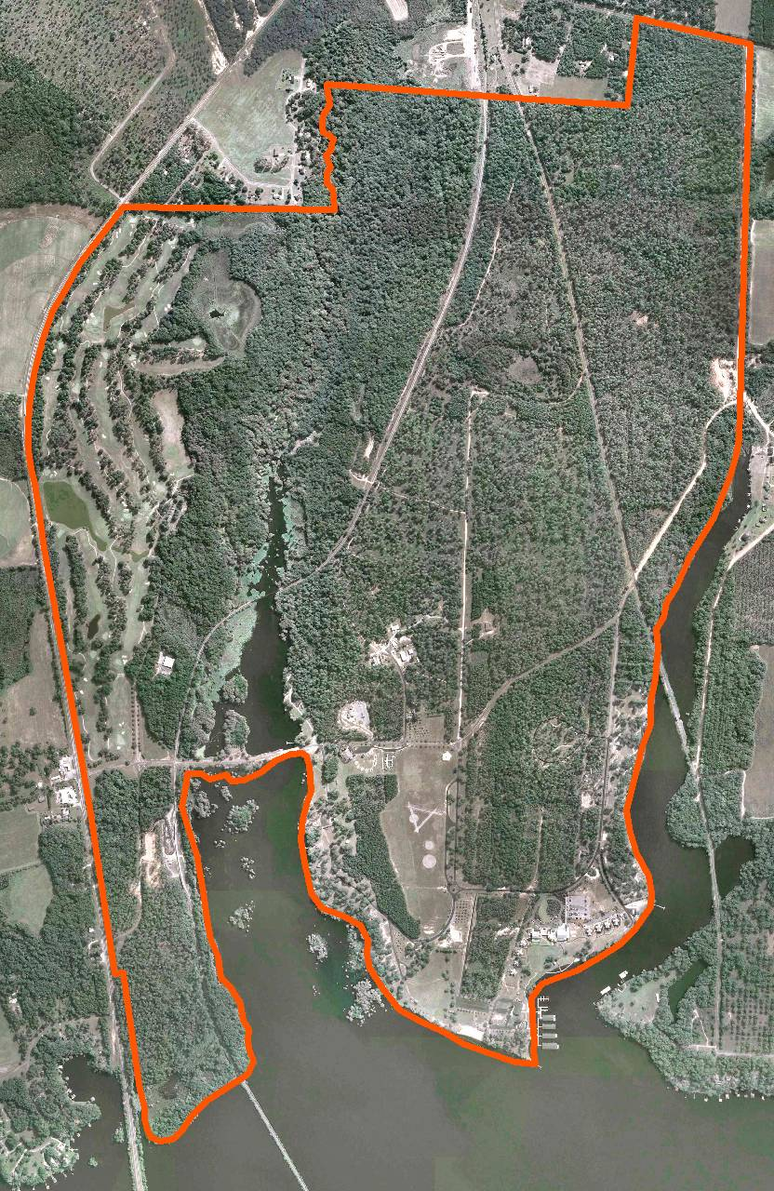

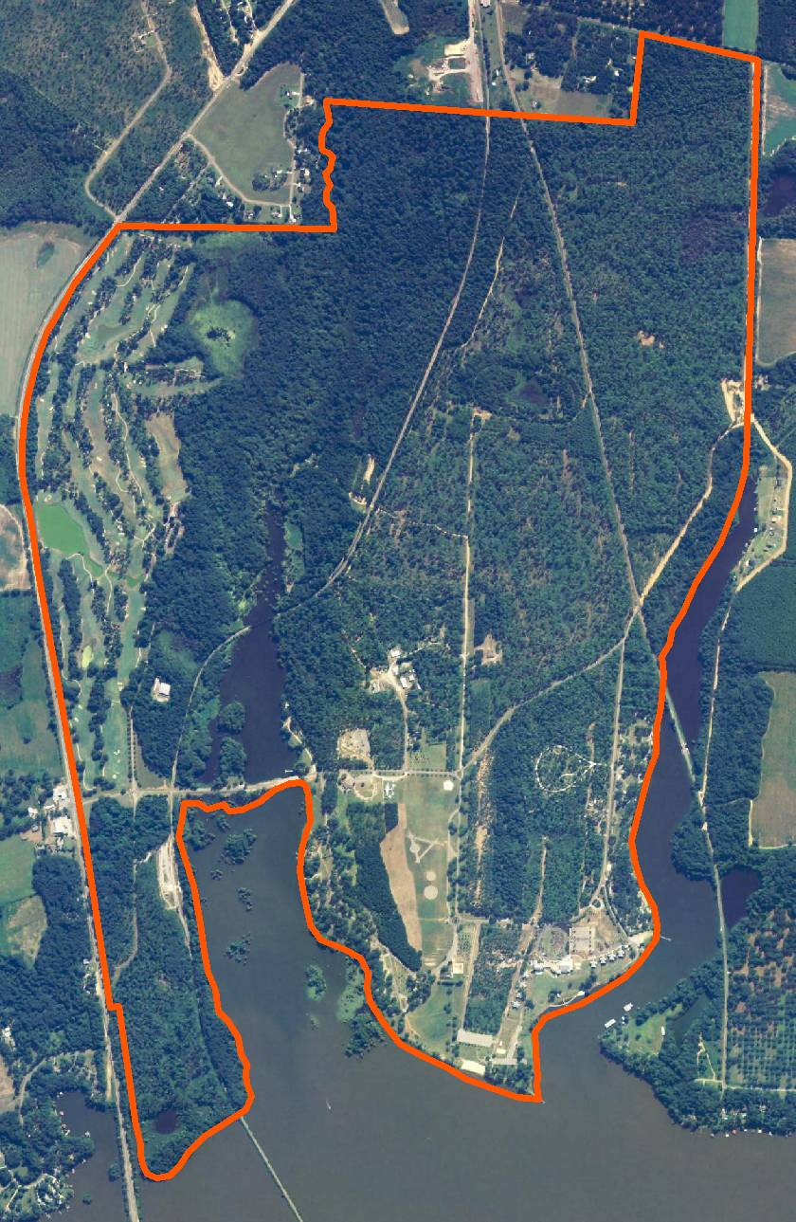
2005 True-Color Leaf-On

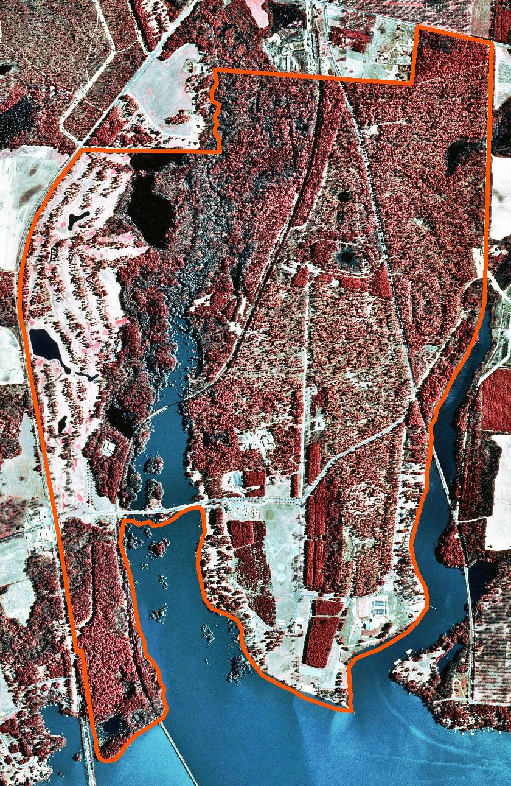
1999 Infra-red Leaf-Off

