Preliminary Maps for – Hard Labor Creek State Park

Topographic Map

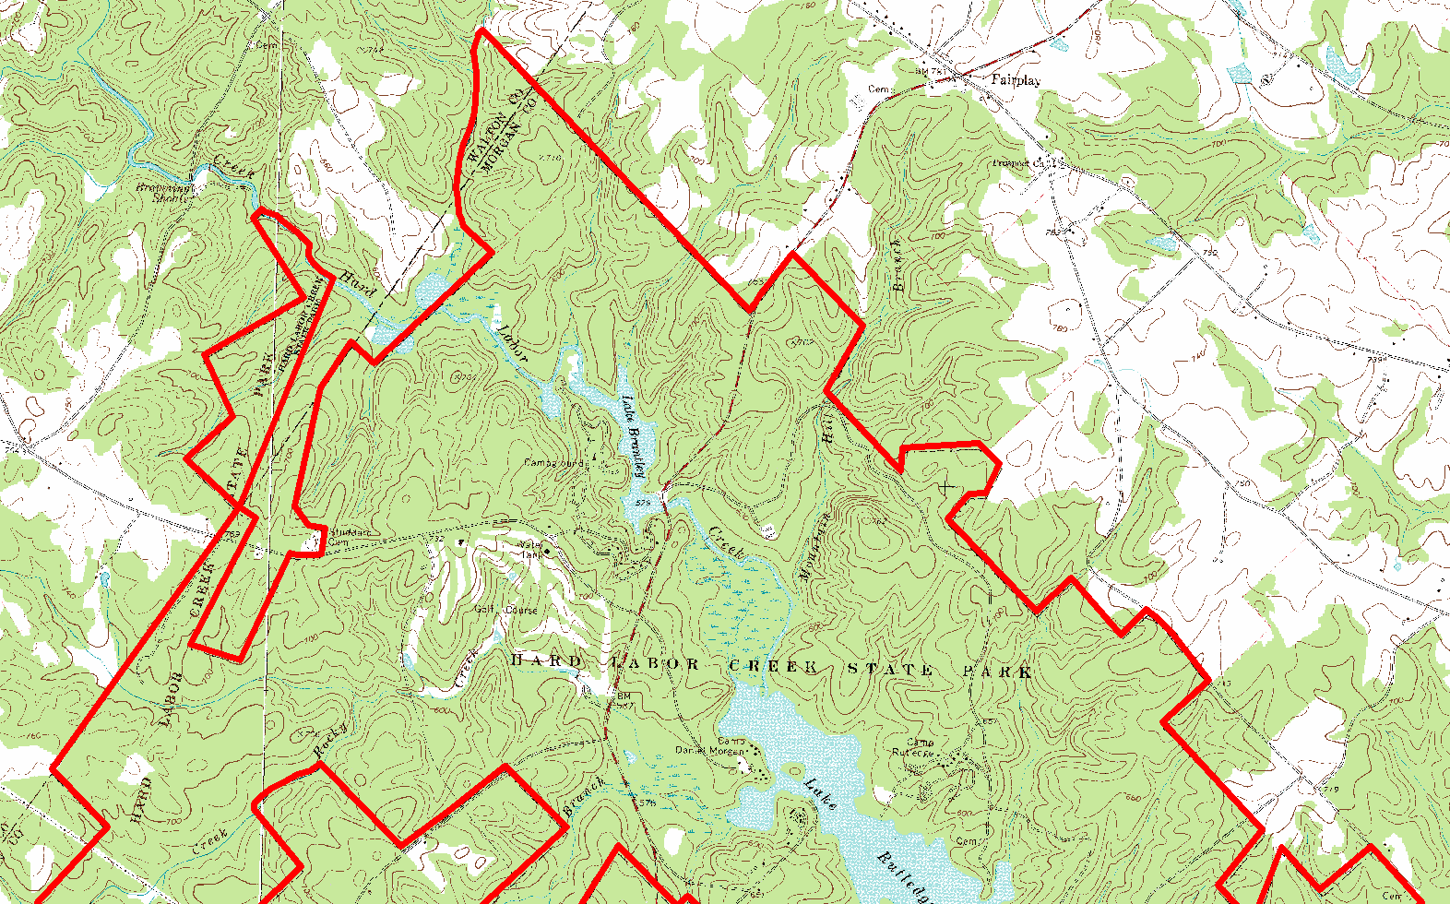

Topographic Map

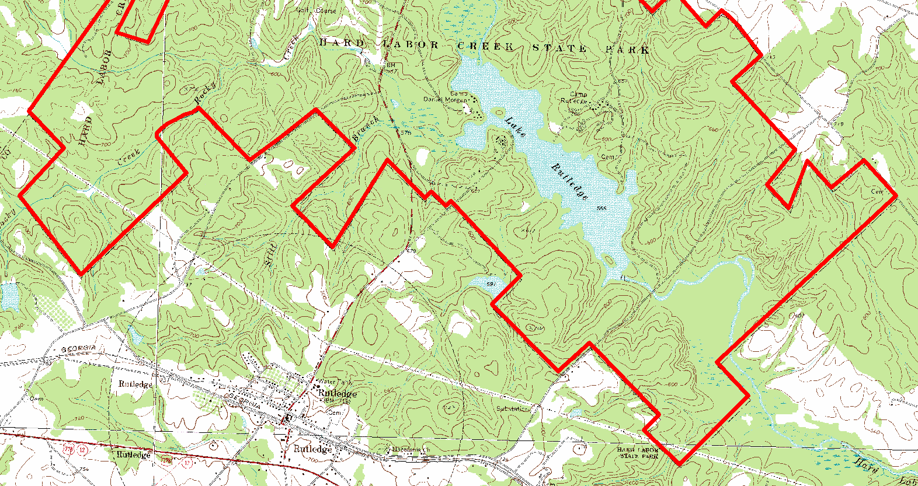

2007 True-Color Leaf-on

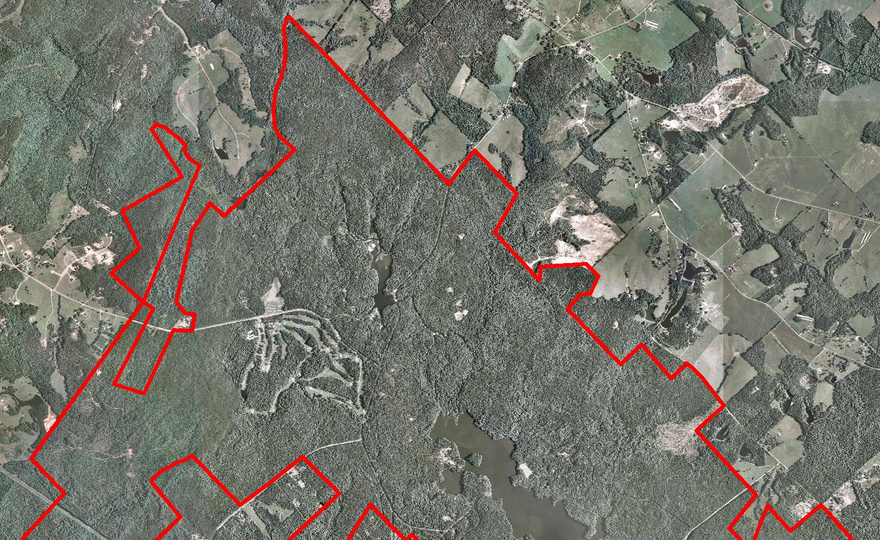

2007 True-Color Leaf-on

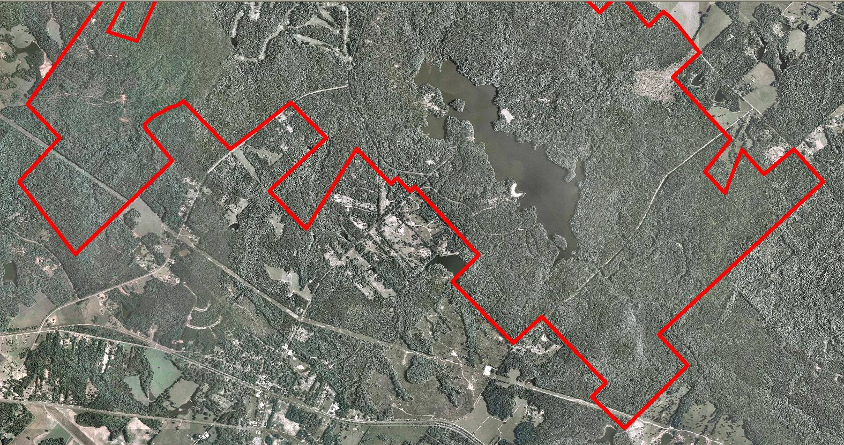

2005 True-Color Leaf-On

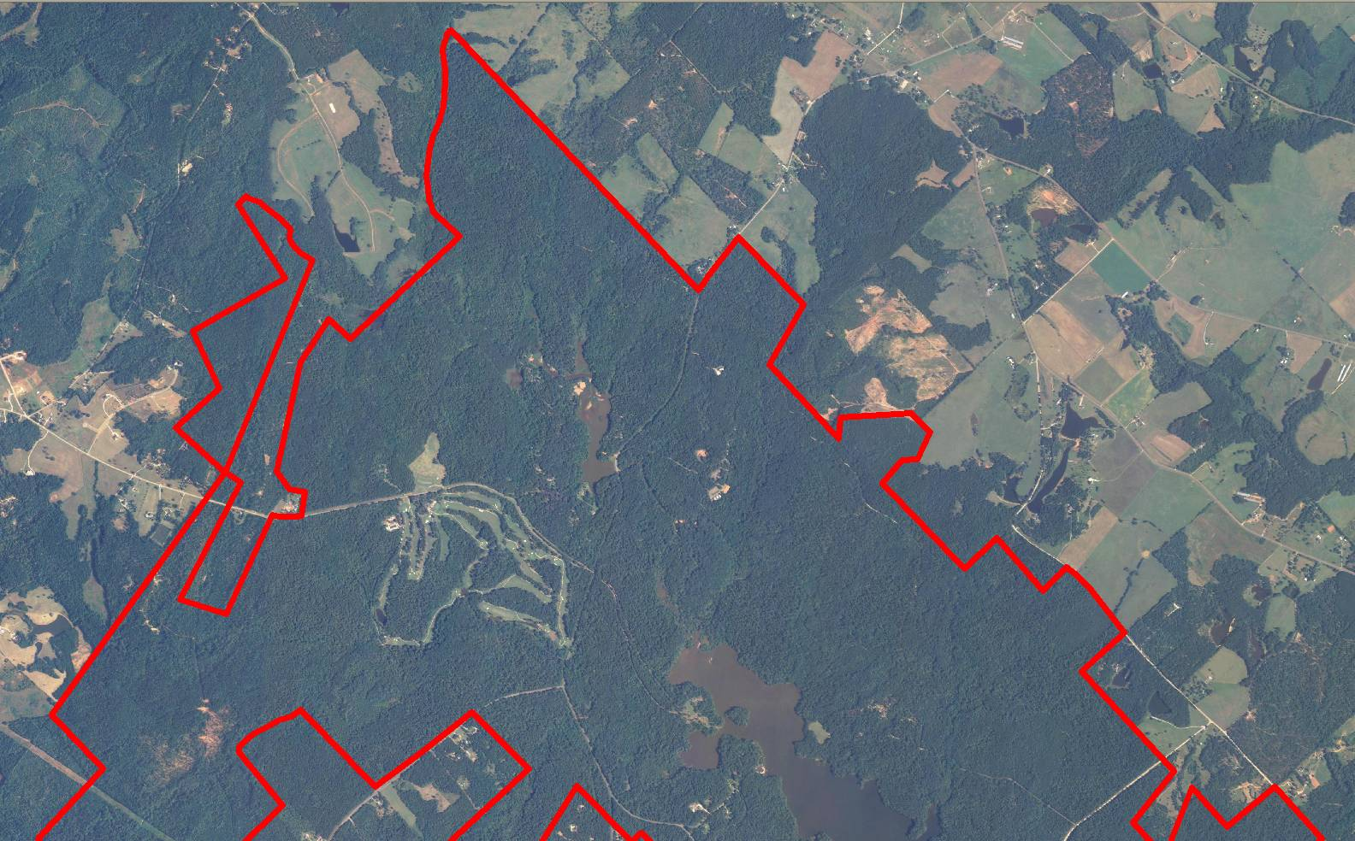

2005 True-Color Leaf-On

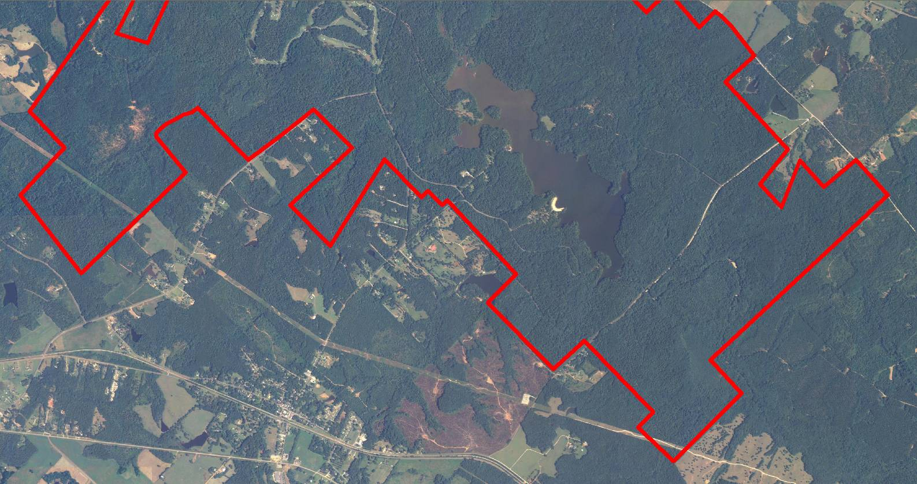

1999 Infra-red Leaf-Off

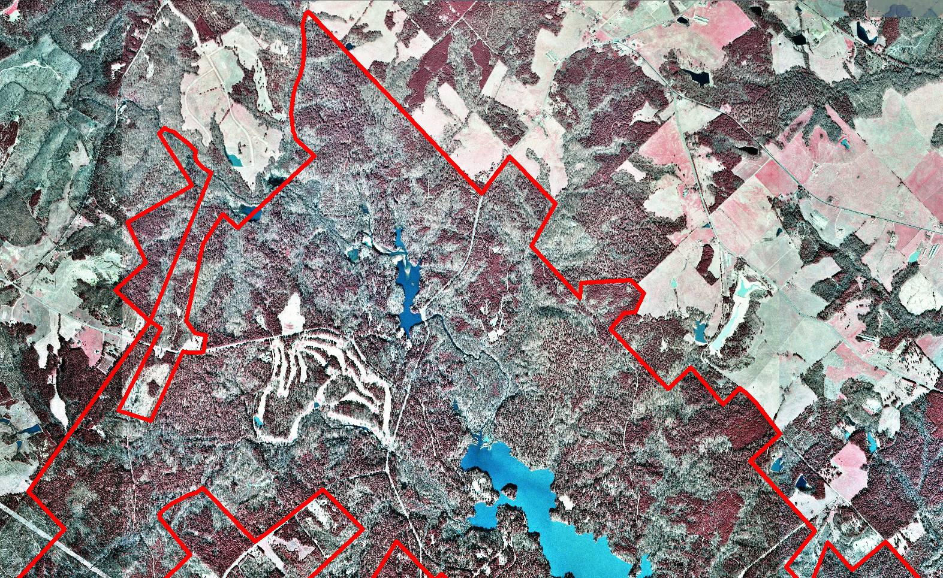

1999 Infra-red Leaf-Off

