Preliminary Maps for Little Ocmulgee State Park

Plat Map with Commentary

Topographic Map

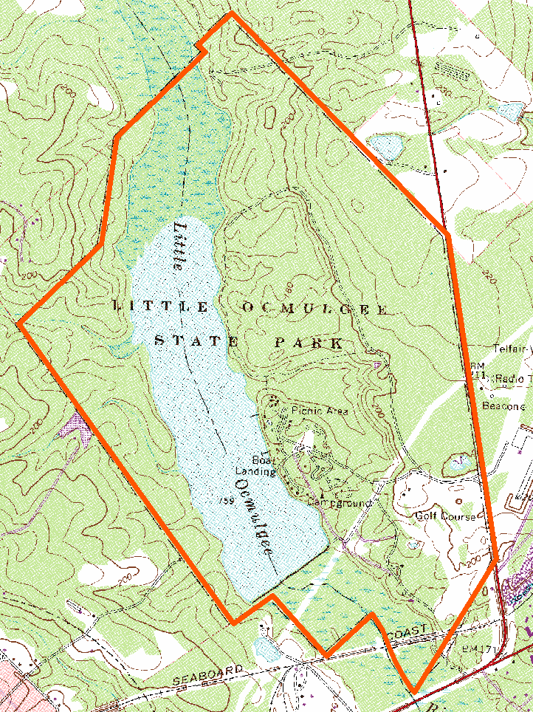

2007 True-Color Leaf-on

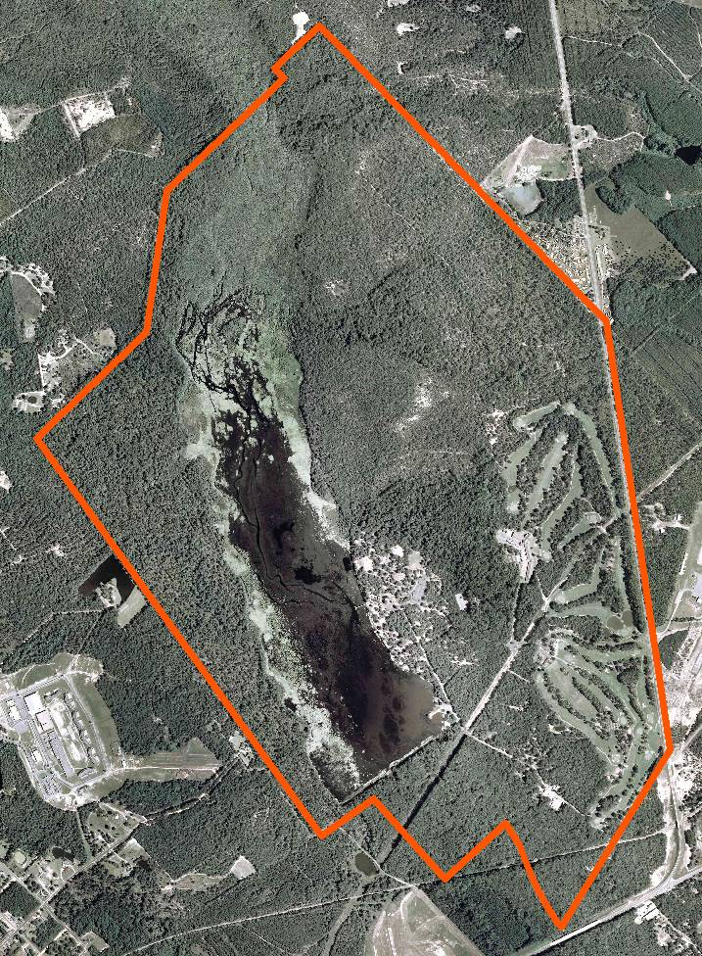

2005 True-Color Leaf-On

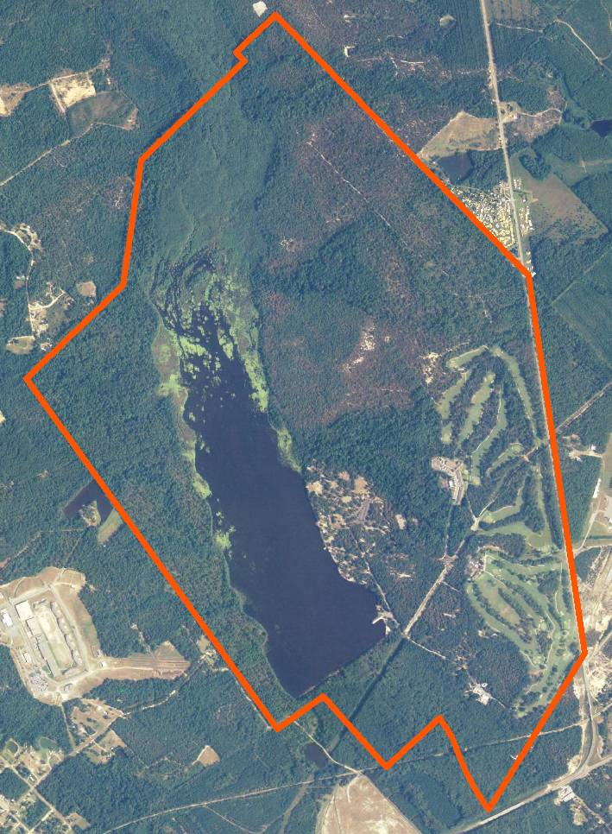

1999 Infra-red Leaf-Off

