Preliminary Maps for
Roosevelt’s Little White House State Historic Site

Topographic Map

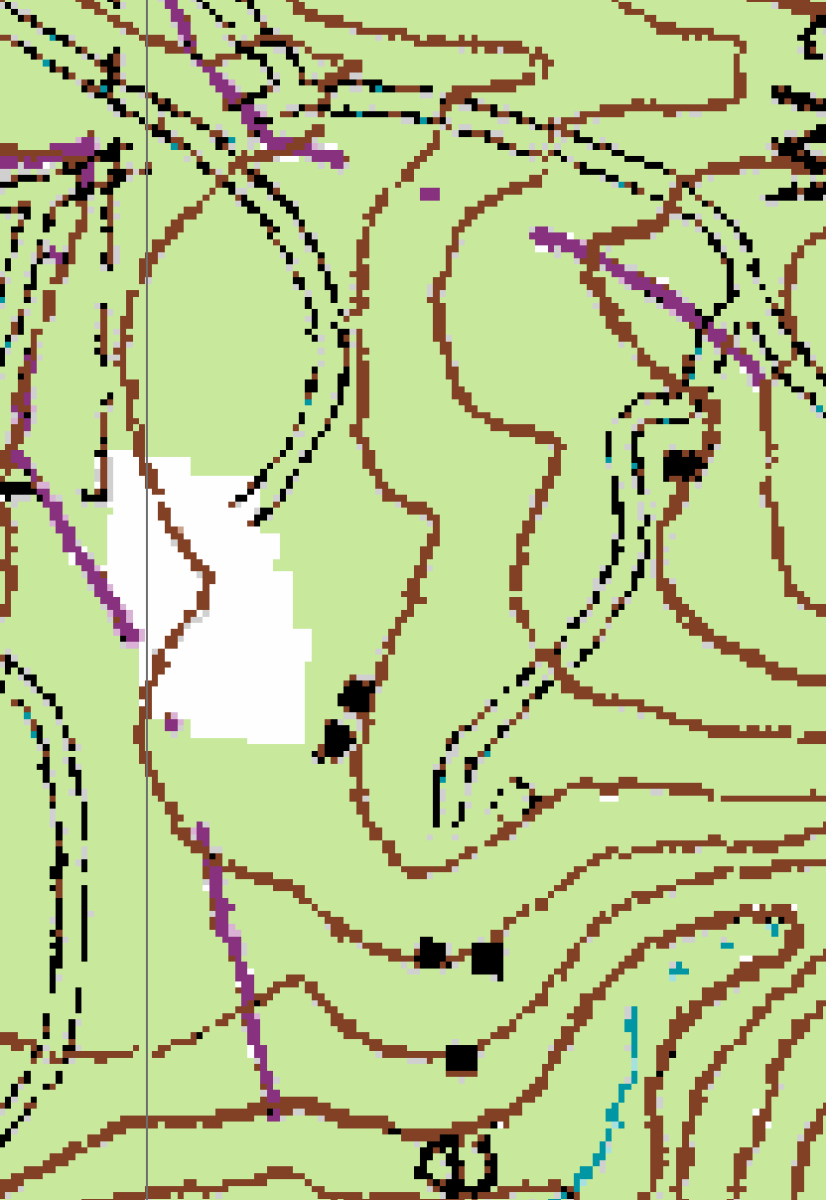

2007 True-Color Leaf-on

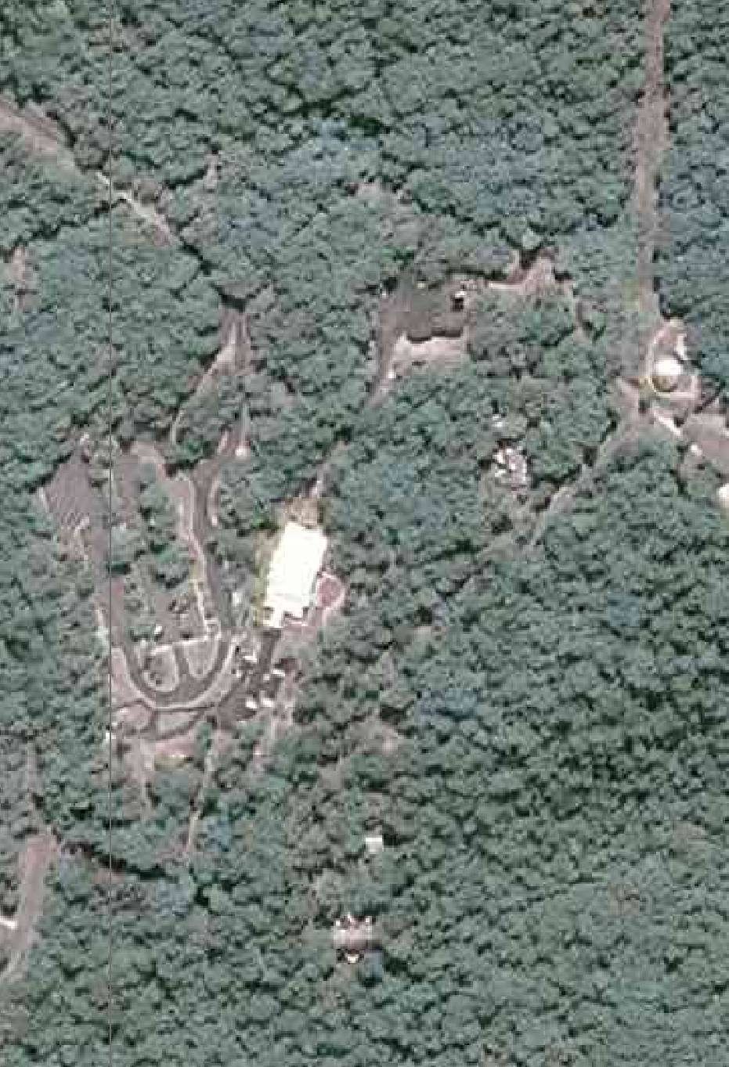

2005 True-Color Leaf-On
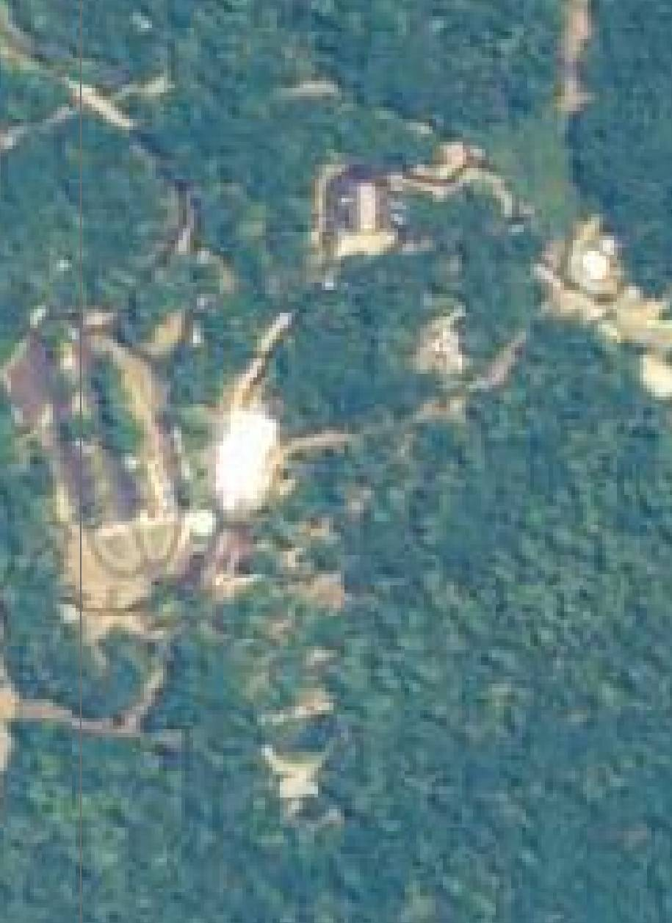

1999 Infra-red Leaf-Off

