PAYMENTS

As a State Agency our payment terms are Net 30 days from receipt of goods/services. Therefore, paying vendors in a timely manner is key, and even more so for Statewide or Agency Contract vendors and Service Agreement vendors, as continually late or non-payment of invoices damages our relationship with these vendors who service all of our parks/agencies.

Everyone can miss processing a payment. Multiple missed payments to a single vendor however are another matter, especially if it is for a service vendor paid monthly. Trash and electricity vendors do have limits and when you reach that threshold of unpaid balance, they will cut off your service and once turned off, will take time to re-establish {misnomer: being a state agency guarantees us services= not true}.

Keys to successful accounting:
- Maintain a good filing system and create a system that works for your team to keep track of incoming invoices {electronically or mail}, Open Purchase Orders, routine monthly vendors, etc.

- Do Not wait to create a required Purchase Order for goods/services until you receive the invoice:
  - This will only delay being able to process payment.
  - Agency Contracts with Order Forms- As soon as you submit the order form to the vendor, you should create the Purchase Order, if not before.
  - #1- Service Purchase Orders for things like repairs should be completed before the work is begun, especially when E-verify documents and SAM reports showing they are in good standing are required.
  - Worst case scenario is to have a “Past Due” invoice only to learn that a PO has not yet been even started. Vendors should not have to hear that their payment will be further delayed because our requirement is to have a PO as the method of processing their invoice.

- Do Not hold an invoice because a Purchase Order is partially shipped. Pay for whatever goods and/or services are received within 30 days. Vendors will send additional invoices as remaining goods are shipped, so do not hold the 1st one waiting on the rest as this invoice will quickly turn into a past due status.

- Review merchandise carefully against the packing slip/invoice.
  - IF you did not receive an item shown as shipped, contact the vendor immediately for resolution. Confirm with vendor if they are going to create a Credit Memo for the missing item and re-invoice you when they re-ship the goods, will they re-issue a revised invoice, etc. Their answer will let you know how to proceed with processing payment. #1 Rule is Do Not pay for goods you did not receive.
  - IF an item is shown as backorder, then you should not be charged on the invoice until you receive the goods. Some vendors such as ServiceWear Apparel will list all of the items ordered on the invoice, however, they only charge you for the goods they shipped. In this instance, as noted above, Do Not hold the invoice waiting for the backorder items. Pay the invoice if all goods listed have been received. Vendor will send additional invoice(s) as backorder items are shipped.

- Returns: If you receive goods in error or incorrectly, contact the vendor immediately and confirm how they will fix the issue, IE, will they issue a credit memo for returned goods. If so, you will need that document to submit along with the original invoice to reduce the amount to only those goods you are keeping. Many times because folks are ordering multiple items, such as uniform apparel, there may be several returns. You must keep up track of all invoices and credit memos to ensure you have in the end only paid the vendor for everything you did receive/keep.

Communicating Payment Status:
If any vendor or DNR staff member inquiry about a ‘Past Due Invoice’ you need to be able to communicate specific details regarding the payment status.
Simply saying “It has been submitted to accounting” is not good Customer Service and does not instill confidence in the vendor or others that the payment is being processed in a timely manner.
Responses to internal staff should include:
- Date submitted
- Form ID number
- Review Voucher System to see if Form has been processed, and if so, supply the voucher number assigned. If no voucher number listed, review the Returned Voucher Forms section for rejected payment packages.

Responses to vendors should include:
- Payment Date
- Payment type- Paper check or ACH electronic payment
- Check number, if applicable
- Confirm invoice(s) processed for this payment and the total amount paid
In many instances, depending on the size of the company, your payment especially if by ACH may get ‘lost’ in their system {not posted to your account but instead held in an unmatched payment file}. DNR does not notify vendors via email that a payment is being processed nor do they receive details about the payment. IF after you supply the vendor with ACH payment details such as the date and amount and they are unable to locate, request from Annie Knox Bank Transactions Detail Report for voucher number 00xxxxxx. She will query the bank and forward the document to you to pass along to the vendor.

The #1 thing is to assure vendors that you will research and follow up with them shortly. Be honest with them regarding their payment status and if it has not been processed, let them know you will submit and contact them back with the payment details listed above as soon as they are available.

Below are steps you can take to check both the voucher system and PSoft for the necessary information.
Step 1 is to check your hard copies. Does the paperwork show you a) received the invoice, b) processed the necessary paperwork of a voucher or PO receiver and c) was the payment package uploaded into the Voucher System and a Form ID created.

Step 2 is to review the Voucher System to check the status of the Form ID {or you can skip to step 3} . Go to Manage Existing Vouchers and enter the Form ID number. The summary screen will show if a voucher has been assigned by Accounting. IF there is no voucher number, then it may have been Returned for an issue. Until the issue is resolved and you Click on the Return to Sender button, the Form ID will sit in limbo.

Step 3 is to review PSoft Accounting Module for payment details. You have multiple fields in which to search including vendor #, invoice # etc. Step 2 helps narrow down your search as you enter the voucher number directly associate to your payment.
From the Home Page, click on Payables
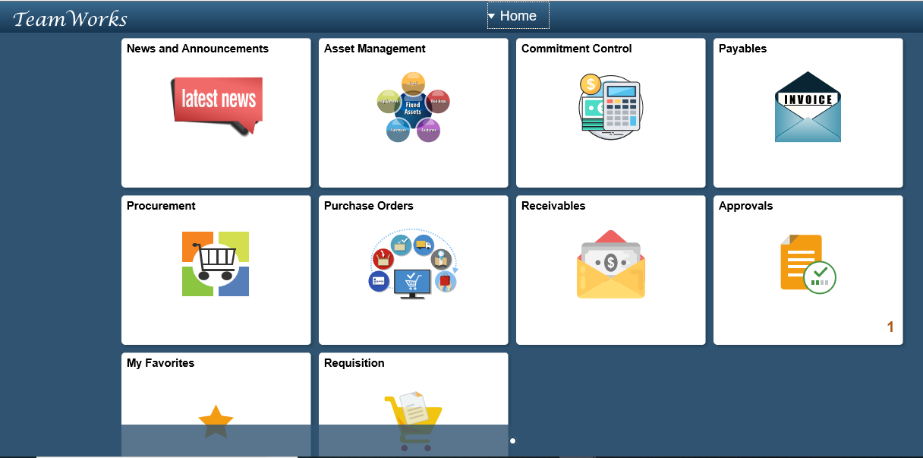

Click on Vouchers/Regular Entry
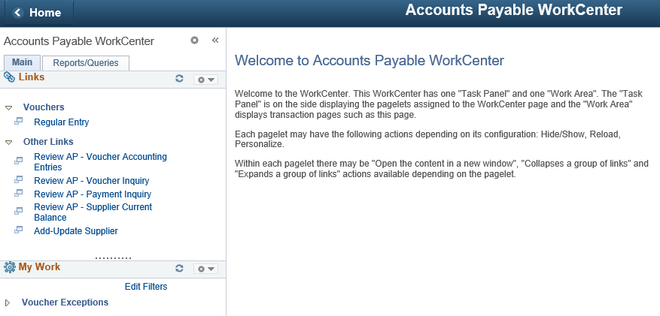

Enter Voucher Number or other search criteria
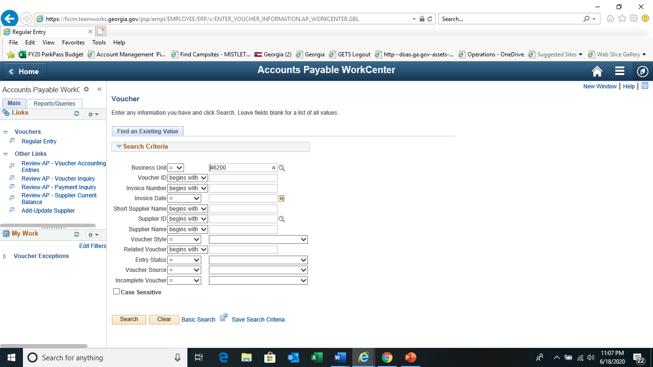
If you enter the voucher number or select a transaction from the search results, this is the Summary page for that voucher. Click on Payments tab.
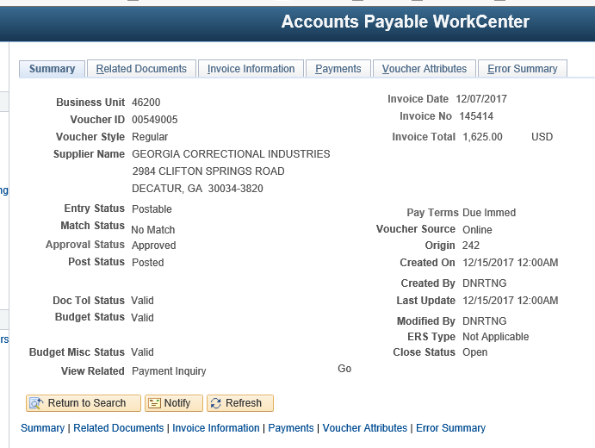
The Payments tab for a Check Payment will show the address a hard copy check was mailed to, check date, check number (reference number) and the amount.
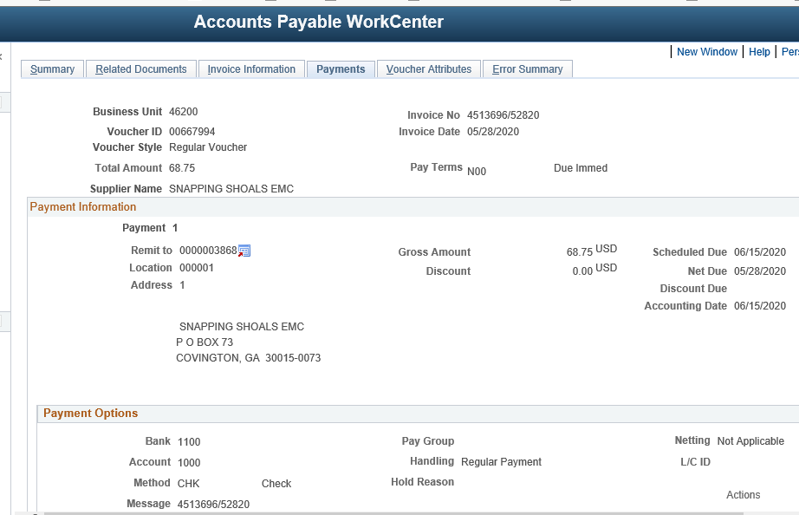
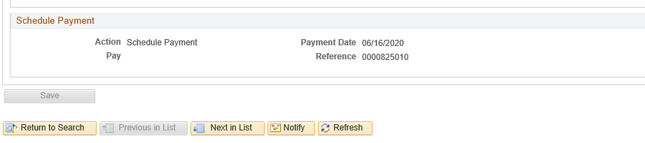

For ACH, you can confirm payment date and amount.
This payment was processed ACH on 12/18/2017 for invoice 145414. The reference number listed will not assist a vendor in locating payment as it is an internal number.
As noted previously, if the vendor needs further details to locate payment, contact Annie Knox with the voucher number and ask for Bank ACH Transaction Detail Report.
