# Microsoft Word Demo

1. Open Ex-Accessible-Documents.docx
   1. [Download the exercise sheet](https://digitalservices.georgia.gov/web-accessibility) at digitalservices.georgia.gov/web-accessibility
2. In the **Review** tab, click **Check Accessibility** towards the left  
   *[not available in some versions of Word]*  
    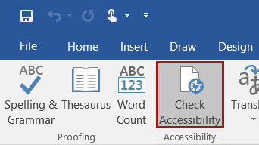

Figure Check Accessibility button in the Review tab of Word

* 1. You can see there are several errors. We’ll make some changes that will get rid of these as we go along. You can keep the checker open or close it throughout this exercise.

## Styles, Headings, & Colors

### Update Normal Text (font and size)

1. Highlight the **large paragraph** and change its font to **Calibri 12pt**
   1. Click in the paragraph to deselect (don’t click in the link to preserve link styling)
   2. Right-click **Normal** in the Styles panel and click **Update Normal to Match Selection**

### Update Heading 1 (custom color)

1. Highlight “**Year in Review**” and click **Heading 1** in the Styles panel to apply styling
2. Change the color of the heading:
   1. Click the Font Colors dropdown arrow, then click **More Colors…** and use the **Custom** tab to choose a color  
      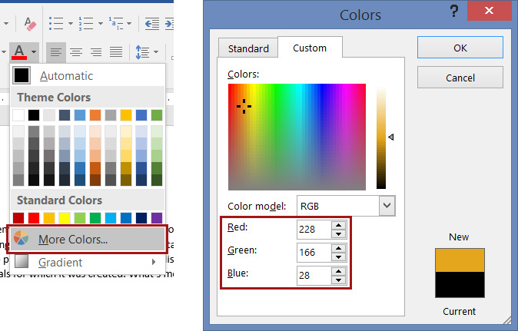

Figure More Colors button and window in Word

* 1. Go to [WebAIM’s Color Contrast Checker](https://webaim.org/resources/contrastchecker/) (webaim.org/resources/contrastchecker/)
  2. Click the **color preview** rectangle in the **Foreground Color** section.
  3. Enter **your color’s RGB** values in the color picker window.  
     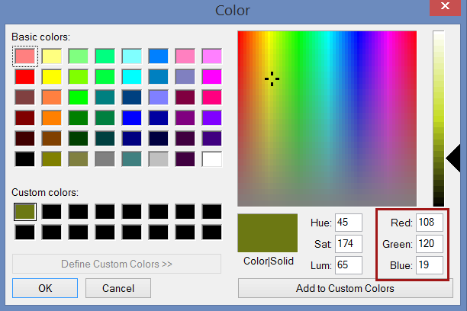

Figure RGB values in WebAIM's Color Contrast Checker

* 1. Click **OK**
  2. Make sure that the background color is hexadecimal: #FFFFFF (white)
  3. Check the “Normal Text” and “Large Text” sections listed under the color boxes.
     1. To be **acceptable**, the color combination must pass at least WCAG AA for Normal Text, and both AA and AAA for Large Text.  
        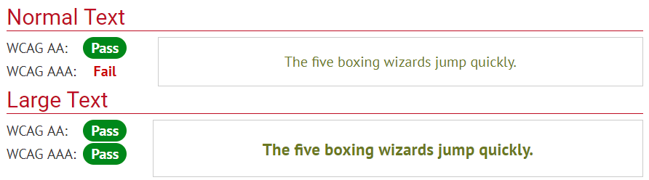

Figure WebAIM Color Contrast Checker results for an acceptable color combination

* + 1. If any of the three required levels is marked “**Fail**,” use the Lightness adjustment bar to darken your foreground color until you find an acceptable color combination. Copy the new RGB values into your Word document’s color.  
       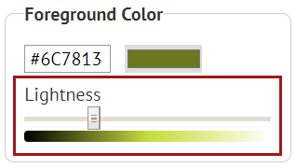

Figure WebAIM Color Contrast Checker’s Lightness adjustment bar for the foreground color

* 1. Right-click **Heading 1** in the Style panel and click **Update Normal to Match Selection**

### Update Heading 2 (line spacing)

1. Highlight “**Board of XYZ**” and turn it into a **Level 2 Heading**
2. Highlight “**Further Reading**” and turn it into a **Level 2 Heading**
   1. In the Paragraph panel, click the **Line and Paragraph Spacing** dropdown
   2. Click **Add Space After Paragraph**  
      *[In some versions of Word, click “Line Spacing Options…” and specify the spacing.]*  
       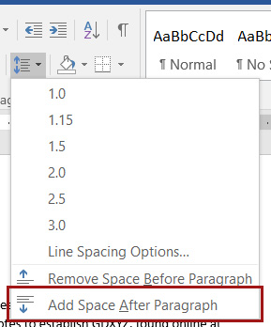

Figure Add Space After Paragraph button in Word's Line and Paragraph Spacing dropdown

* 1. Right-click **Heading 2** in the Style panel and click **Update Normal to Match Selection**

### View Your Headings

1. Go to the **View** tab and check the “**Navigation Pane**” box to view your headings  
   *[Mac 2011: View > Sidebar > Document Map Pane]*

## Table of Contents

1. Click at the beginning of the first paragraph, then hit **Ctrl+Enter** *[⌘+Return on Mac]* to add a page break
2. At the top of the document, add a new line after the Heading 1
   1. Go to **References** tab and click **Table of Contents**
   2. Choose one of the two Automatic Table of Contents styles  
      *[Mac 2011: Insert > Index and Tables… > Table of Contents > OK]*

## Tables

### Table 1 (make an accessible table)

1. Click in the first row of **Table 1**
   1. Go to the **Table Layout** tab now listed under “**Table Tools**” at the top of your window  
      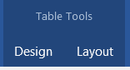

Figure Table Tools tabs in Word

* 1. Click **Repeat Header Rows** in the Data panel at the right
  2. Go to the **Table Design** tab
  3. In the Table Style Options panel, make sure that “**Header Row**” is checked, and *uncheck* “**First Column**”
  4. In the Table Styles panel, choose a style
  5. Go to the **References** tab
  6. In the Captions panel, click **Insert Caption**  
     *[Mac 2011: Insert > Caption]*
  7. Under Options, change the Label to “**Table**” and click **OK**  
     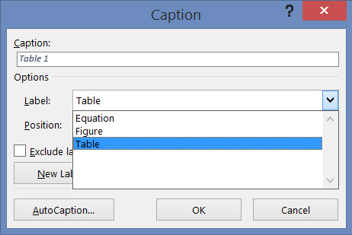

Figure Caption window

* 1. Delete the original “Table 1” label
  2. Right-click in the table and open **Table Properties**
  3. In the **Alt Text** tab, add a brief description of the table

### Table 2 (turn a table into columns)

1. Add a space before Table 2
   1. **Copy and paste** the names from the table in numerical order, each separated by a new line
   2. Highlight the list, go to the **Layout** tab, and click **Columns** in the Page Setup panel to put the list in 3 columns
   3. Highlight the entire 3-column table, right-click, and delete the table
   4. Delete “Table 2” and the extra line

### Table 3 (turn a table into columns)

1. Click in Table 3
   1. Go to the **Table Layout** tab and click **Convert to Text** in the Data panel
   2. Select “**Paragraph marks**” and click **OK**
      1. Note the order in which this method arranges the table text
   3. With the list highlighted, go to the **Layout** tab, and click **Columns** in the Page Setup panel to put the list in 3 columns
   4. Delete “Table 3”

## Bullets & Numbering

1. Separate the Board Chair’s responsibilities by line
   1. Turn the list into a **bulleted list** Bullets icon
   2. Use the bulleted list dropdown to change the list style
2. Separate the Board meeting agenda items by line
   1. Turn the list into a **numbered list** Numbers icon
   2. Separate the parenthetical notes paired with items 4 and 5 and turn them into sub-list items by:
      1. Hitting the **Tab** button on your keyboard,
      2. Clicking the **Increase Indent** iconIncrease Indent icon, or
      3. Changing **List Level** in the Numbering dropdown menu  
         *[not available in some versions of Word]*

## Images

1. Right-click on the Board image
   1. Click **Picture…** *[or “Format Picture…]*
   2. In the **Alt Text** tab, write an alt text description, 2 sentences at most. (This is “brief alt text”)
2. Right-click on the Annual Applications graph
   1. Click **Picture…** *[or “Format Picture…”]*
   2. In the **Alt Text** tab, write a longer alt text description to explain the graph

## Finish & Save

1. Go to the File tab
   1. Click on **Properties** at the right of the **Info** screen *[Mac 2011: File > Properties]*
   2. Click **Advanced Properties** from the drop-down menu
   3. In the Summary tab, add a title, author, and comment
   4. Click **OK**  
      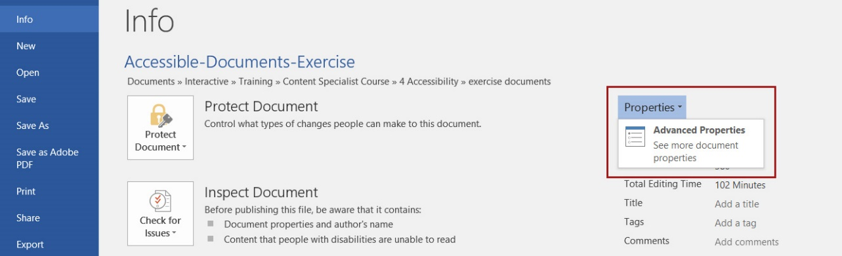

Figure Properties dropdown

1. In the **Review** tab, click **Check Accessibility** towards the left  
   *[not available in some versions of Word]*
   1. Fix any remaining errors

### Save as PDF

1. In the **File** tab, click **Save as Adobe PDF**
   1. Click **Options**
   2. Check the following *[not available in some versions]*:
      1. Convert document information
      2. Enable Accessibility and Reflow with tagged Adobe PDF
      3. Create Bookmarks
      4. Convert Word Headings to Bookmarks
   3. Click **OK** and save the PDF  
      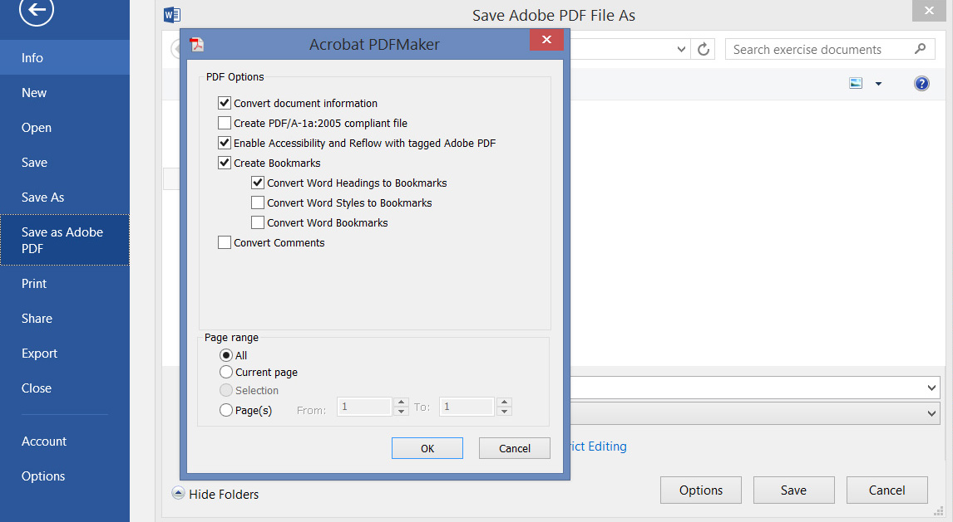

Figure Adobe PDF File Options window with appropriate boxes checked