Year in Review

In 1996, the Georgia General Assembly recognized the vast need in Georgia for greater oversight on matters such as thing one and thing two, so they cast their votes to establish GDXYZ, found online at <http://GDXYZ.georgia.gov/>. In the past two decades since being established, GDXYZ has taken great strides toward completing the goals for which it was created. What’s more, GDXYZ has made several specific advancements toward achieving its goals of improving lives and generating capital even more in 2016. Thanks to GDXYZ leadership, including that provided by Commissioner John Smith, Executive Assistant Susan Jones and Deputy Commissioners Jack Johnson and Jill Williams, there has been seen substantial progress over the past year for GDXYZ in terms of increasing the effectiveness and efficiency of its many processes. For the past several years, there has been an increased number of applicants for the GDXYZ programs, including the Money Management (MM) Program and the External Support Resources (ESR) Program. Provided below is a table giving an overview of how productivity for the GDXYZ has been increased over the past twenty years due to the implementation of better practices since it was first created.

Table 1

|  |  |
| --- | --- |
| Year | Applications Received |
| 1996 | 32 |
| 2001 | 56 |
| 2006 | 94 |
| 2011 | 92 |
| 2016 | 104 |

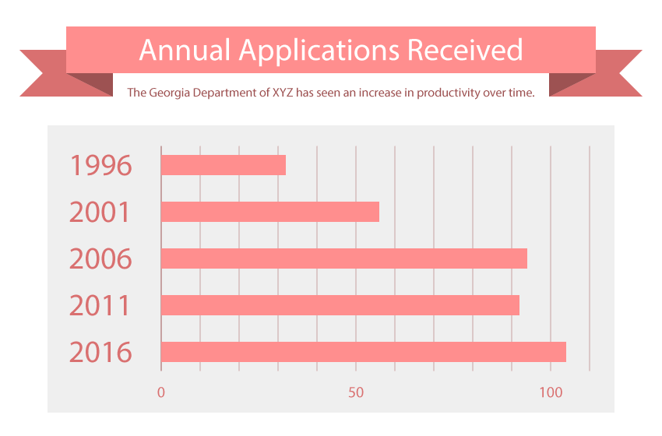

Full statistics aggregated here: http:// GDXYZ.georgia.gov/stats.

Board of XYZ

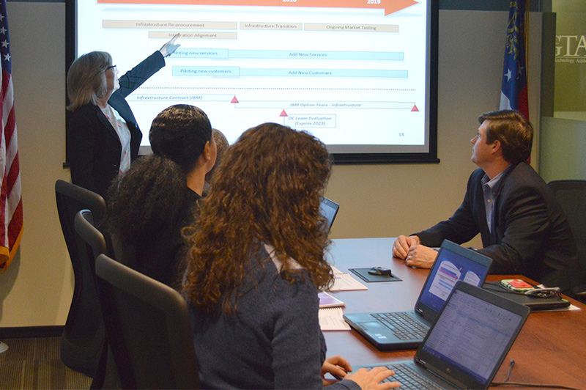

The Board of XYZ sets GDXYZ policy and approves the department’s goals and objectives. The following list includes names for all of the GDXYZ board members.

Table 2

|  |  |  |
| --- | --- | --- |
| 1 James Brown (Chair) | 3 Michael Davis (Vice Chair) | 5 Mary Miller (Secretary) |
| 2 Robert Wilson | 4 Linda Moore | 6 David Taylor |

Table 3

|  |  |  |
| --- | --- | --- |
| 1 James Brown (Chair) | 2 Michael Davis (Vice Chair) | 3 Mary Miller (Secretary) |
| 4 Robert Wilson | 5 Linda Moore | 6 David Taylor |

As the Board Chair, James Brown has the following responsibilities: setting Board meetings, running Board meetings, final say in Board decisions, and presenting Board findings to GDXYZ leadership

When the Board meets, the agenda is as follows: opening, approval of agenda, review of previous minutes, actions taken since previous meeting (progress of assignments), reports (C suite and standing committees), new business, and round table evaluations.

Further Reading

[Click here](http://GDXYZ.georgia.gov/) to learn more about GDXYZ.

*end copy here*

Note:

* GDXYZ = The Georgia Department of X, Y and Z