ΠΑΝΕΠΙΣΤΗΜΙΟ ΙΩΑΝΝΙΝΩΝ
ΤΜΗΜΑ ΜΗΧ. Η/Υ & ΠΛΗΡΟΦΟΡΙΚΗΣ

Προχωρημένα Θέματα Τεχνολογίας και Εφαρμογών Βάσεων Δεδομένων

ΠΡΟΓΡΑΜΜΑΤΙΣΤΙΚΗ ΕΡΓΑΣΙΑ για το ακαδημαϊκο έτος 2024-2025

ΓΕΩΡΓΙΑ ΚΑΤΣΑΡΟΥ, 2914 ΙΩΑΝΝΑ ΚΑΛΠΟΥΡΤΖΗ, 2448 ΘΑΝΑΣΗΣ ΚΟΥΚΟΥΛΙΑΤΑΣ,3256

ΤΕΛΙΚΗ ΑΝΑΦΟΡΑ

ΜΑΪΟΣ 2025

ΙΣΤΟΡΙΚΟ ΠΡΟΗΓΟΥΜΕΝΩΝ ΕΚΔΟΣΕΩΝ
Ημερομηνία | Έκδοση | Περιγραφή | Συγγραφέας
2025/02/26 | 1.1 | Μελέτη άσκησης,brainstorming
2025/02/27 | 1.2 | Δημιουργία scripts για καθαρισμό αρχείων
2025/03/4 | 1.3 | Τελειοποίηση των script και δημιουργία της βάσης, στο sql workbench
2025/03/5 | 1.4 | Load αρχείων, δημιουργία επιπλέον script(δημιουργία iso)
2025/03/11 | 1.5 | Αλλαγές στα script και mapping,έγιναν τα κλειδιά
2025/03/9 | 1.6 | Πρόσθεση script για να αλλάζει αυτόματα το encoding στα αρχεία και tab-seperated
2025/03/10 | 1.7 | Spring initializr
2025/04/10 | 2.0 | Τελειοποιήση και συζήτηση!
2025/04/27 | 2.1 | Upload schemas από workbench στο documentation

βαση δεδομενων

Σχεσιακό σχήμα 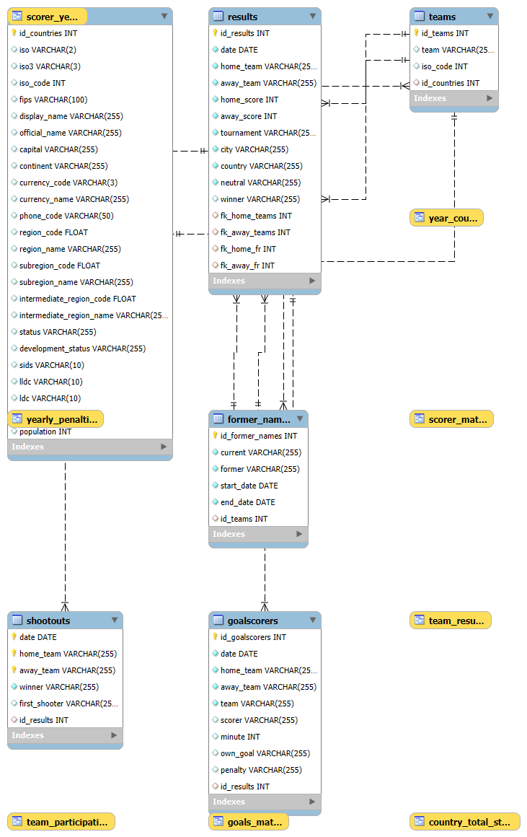σε λογικό επίπεδο

Σχήμα 1.1 Σχεσιακό σχήμα της βάσης δεδομένων του συστήματος

-- MySQL Script generated by MySQL Workbench
-- Sun Apr 27 22:57:16 2025
-- Model: New Model Version: 1.0
-- MySQL Workbench Forward Engineering

SET @OLD_UNIQUE_CHECKS=@@UNIQUE_CHECKS, UNIQUE_CHECKS=0;
SET @OLD_FOREIGN_KEY_CHECKS=@@FOREIGN_KEY_CHECKS, FOREIGN_KEY_CHECKS=0;
SET @OLD_SQL_MODE=@@SQL_MODE, SQL_MODE='ONLY_FULL_GROUP_BY,STRICT_TRANS_TABLES,NO_ZERO_IN_DATE,NO_ZERO_DATE,ERROR_FOR_DIVISION_BY_ZERO,NO_ENGINE_SUBSTITUTION';

-- -----------------------------------------------------
-- Schema mydb
-- -----------------------------------------------------
-- -----------------------------------------------------
-- Schema football_db
-- -----------------------------------------------------

-- -----------------------------------------------------
-- Schema football_db
-- -----------------------------------------------------
CREATE SCHEMA IF NOT EXISTS `football_db` DEFAULT CHARACTER SET utf8mb4 COLLATE utf8mb4_0900_ai_ci ;
USE `football_db` ;

-- -----------------------------------------------------
-- Table `football_db`.`countries`
-- -----------------------------------------------------
CREATE TABLE IF NOT EXISTS `football_db`.`countries` (
`id_countries` INT NOT NULL AUTO_INCREMENT,
`iso` VARCHAR(2) NULL DEFAULT NULL,
`iso3` VARCHAR(3) NULL DEFAULT NULL,
`iso_code` INT NULL DEFAULT NULL,
`fips` VARCHAR(100) NULL DEFAULT NULL,
`display_name` VARCHAR(255) NULL DEFAULT NULL,
`official_name` VARCHAR(255) NULL DEFAULT NULL,
`capital` VARCHAR(255) NULL DEFAULT NULL,
`continent` VARCHAR(255) NULL DEFAULT NULL,
`currency_code` VARCHAR(3) NULL DEFAULT NULL,
`currency_name` VARCHAR(255) NULL DEFAULT NULL,
`phone_code` VARCHAR(50) NULL DEFAULT NULL,
`region_code` FLOAT NULL DEFAULT NULL,
`region_name` VARCHAR(255) NULL DEFAULT NULL,
`subregion_code` FLOAT NULL DEFAULT NULL,
`subregion_name` VARCHAR(255) NULL DEFAULT NULL,
`intermediate_region_code` FLOAT NULL DEFAULT NULL,
`intermediate_region_name` VARCHAR(255) NULL DEFAULT NULL,
`status` VARCHAR(255) NULL DEFAULT NULL,
`development_status` VARCHAR(255) NULL DEFAULT NULL,
`sids` VARCHAR(10) NULL DEFAULT NULL,
`lldc` VARCHAR(10) NULL DEFAULT NULL,
`ldc` VARCHAR(10) NULL DEFAULT NULL,
`area_sqkm` FLOAT NULL DEFAULT NULL,
`population` INT NULL DEFAULT NULL,
PRIMARY KEY (`id_countries`),
UNIQUE INDEX `iso_code` (`iso_code` ASC) VISIBLE,
UNIQUE INDEX `display_name` (`display_name` ASC) VISIBLE,
UNIQUE INDEX `official_name` (`official_name` ASC) VISIBLE,
INDEX `idx_country` (`display_name` ASC) VISIBLE,
INDEX `idx_id_countries` (`id_countries` ASC) VISIBLE)
ENGINE = InnoDB
AUTO_INCREMENT = 273
DEFAULT CHARACTER SET = utf8mb4
COLLATE = utf8mb4_0900_ai_ci;

-- -----------------------------------------------------
-- Table `football_db`.`teams`
-- -----------------------------------------------------
CREATE TABLE IF NOT EXISTS `football_db`.`teams` (
`id_teams` INT NOT NULL AUTO_INCREMENT,
`team` VARCHAR(255) NULL DEFAULT NULL,
`iso_code` INT NULL DEFAULT NULL,
`id_countries` INT NULL DEFAULT NULL,
PRIMARY KEY (`id_teams`),
INDEX `idx_country_id` (`id_countries` ASC) VISIBLE,
INDEX `idx_team` (`team` ASC) VISIBLE,
CONSTRAINT `teams_ibfk_1`
FOREIGN KEY (`id_countries`)
REFERENCES `football_db`.`countries` (`id_countries`)
ON DELETE SET NULL
ON UPDATE CASCADE)
ENGINE = InnoDB
AUTO_INCREMENT = 335
DEFAULT CHARACTER SET = utf8mb4
COLLATE = utf8mb4_0900_ai_ci;

-- -----------------------------------------------------
-- Table `football_db`.`former_names`
-- -----------------------------------------------------
CREATE TABLE IF NOT EXISTS `football_db`.`former_names` (
`id_former_names` INT NOT NULL AUTO_INCREMENT,
`current` VARCHAR(255) NOT NULL,
`former` VARCHAR(255) NOT NULL,
`start_date` DATE NOT NULL,
`end_date` DATE NOT NULL,
`id_teams` INT NULL DEFAULT NULL,
PRIMARY KEY (`id_former_names`),
UNIQUE INDEX `current` (`current` ASC, `former` ASC, `start_date` ASC, `end_date` ASC) VISIBLE,
INDEX `id_teams` (`id_teams` ASC) VISIBLE,
CONSTRAINT `former_names_ibfk_1`
FOREIGN KEY (`id_teams`)
REFERENCES `football_db`.`teams` (`id_teams`)
ON DELETE SET NULL
ON UPDATE CASCADE)
ENGINE = InnoDB
AUTO_INCREMENT = 31
DEFAULT CHARACTER SET = utf8mb4
COLLATE = utf8mb4_0900_ai_ci;

-- -----------------------------------------------------
-- Table `football_db`.`results`
-- -----------------------------------------------------
CREATE TABLE IF NOT EXISTS `football_db`.`results` (
`id_results` INT NOT NULL AUTO_INCREMENT,
`date` DATE NOT NULL,
`home_team` VARCHAR(255) NOT NULL,
`away_team` VARCHAR(255) NOT NULL,
`home_score` INT NOT NULL,
`away_score` INT NOT NULL,
`tournament` VARCHAR(255) NOT NULL,
`city` VARCHAR(255) NOT NULL,
`country` VARCHAR(255) NOT NULL,
`neutral` VARCHAR(255) NOT NULL,
`winner` VARCHAR(255) NULL DEFAULT NULL,
`fk_home_teams` INT NULL DEFAULT NULL,
`fk_away_teams` INT NULL DEFAULT NULL,
`fk_home_fr` INT NULL DEFAULT NULL,
`fk_away_fr` INT NULL DEFAULT NULL,
PRIMARY KEY (`id_results`),
INDEX `fk_home_teams` (`fk_home_teams` ASC) VISIBLE,
INDEX `fk_away_teams` (`fk_away_teams` ASC) VISIBLE,
INDEX `fk_home_fr` (`fk_home_fr` ASC) VISIBLE,
INDEX `fk_away_fr` (`fk_away_fr` ASC) VISIBLE,
INDEX `idx_date_home_away` (`date` ASC, `home_team` ASC, `away_team` ASC) VISIBLE,
INDEX `idx_home_team` (`home_team` ASC) VISIBLE,
INDEX `idx_away_team` (`away_team` ASC) VISIBLE,
CONSTRAINT `results_ibfk_1`
FOREIGN KEY (`fk_home_teams`)
REFERENCES `football_db`.`teams` (`id_teams`)
ON DELETE SET NULL
ON UPDATE CASCADE,
CONSTRAINT `results_ibfk_2`
FOREIGN KEY (`fk_away_teams`)
REFERENCES `football_db`.`teams` (`id_teams`)
ON DELETE SET NULL
ON UPDATE CASCADE,
CONSTRAINT `results_ibfk_3`
FOREIGN KEY (`fk_home_fr`)
REFERENCES `football_db`.`former_names` (`id_former_names`)
ON DELETE SET NULL
ON UPDATE CASCADE,
CONSTRAINT `results_ibfk_4`
FOREIGN KEY (`fk_away_fr`)
REFERENCES `football_db`.`former_names` (`id_former_names`)
ON DELETE SET NULL
ON UPDATE CASCADE)
ENGINE = InnoDB
AUTO_INCREMENT = 47981
DEFAULT CHARACTER SET = utf8mb4
COLLATE = utf8mb4_0900_ai_ci;

-- -----------------------------------------------------
-- Table `football_db`.`goalscorers`
-- -----------------------------------------------------
CREATE TABLE IF NOT EXISTS `football_db`.`goalscorers` (
`id_goalscorers` INT NOT NULL AUTO_INCREMENT,
`date` DATE NOT NULL,
`home_team` VARCHAR(255) NOT NULL,
`away_team` VARCHAR(255) NOT NULL,
`team` VARCHAR(255) NOT NULL,
`scorer` VARCHAR(255) NULL DEFAULT NULL,
`minute` INT NULL DEFAULT NULL,
`own_goal` VARCHAR(255) NULL DEFAULT NULL,
`penalty` VARCHAR(255) NULL DEFAULT NULL,
`id_results` INT NULL DEFAULT NULL,
PRIMARY KEY (`id_goalscorers`),
INDEX `id_results` (`id_results` ASC) VISIBLE,
INDEX `idx_date_home_away` (`date` ASC, `home_team` ASC, `away_team` ASC) VISIBLE,
INDEX `idx_scorer` (`scorer` ASC) VISIBLE,
INDEX `idx_year` (`date` ASC) VISIBLE,
CONSTRAINT `goalscorers_ibfk_1`
FOREIGN KEY (`id_results`)
REFERENCES `football_db`.`results` (`id_results`)
ON DELETE SET NULL
ON UPDATE CASCADE)
ENGINE = InnoDB
AUTO_INCREMENT = 44363
DEFAULT CHARACTER SET = utf8mb4
COLLATE = utf8mb4_0900_ai_ci;

-- -----------------------------------------------------
-- Table `football_db`.`shootouts`
-- -----------------------------------------------------
CREATE TABLE IF NOT EXISTS `football_db`.`shootouts` (
`date` DATE NOT NULL,
`home_team` VARCHAR(255) NOT NULL,
`away_team` VARCHAR(255) NOT NULL,
`winner` VARCHAR(255) NOT NULL,
`first_shooter` VARCHAR(255) NULL DEFAULT NULL,
`id_results` INT NULL DEFAULT NULL,
PRIMARY KEY (`date`, `home_team`, `away_team`),
INDEX `id_results` (`id_results` ASC) VISIBLE,
CONSTRAINT `shootouts_ibfk_1`
FOREIGN KEY (`id_results`)
REFERENCES `football_db`.`results` (`id_results`)
ON DELETE SET NULL
ON UPDATE CASCADE)
ENGINE = InnoDB
DEFAULT CHARACTER SET = utf8mb4
COLLATE = utf8mb4_0900_ai_ci;

USE `football_db` ;

-- -----------------------------------------------------
-- Placeholder table for view `football_db`.`country_total_stats`
-- -----------------------------------------------------
CREATE TABLE IF NOT EXISTS `football_db`.`country_total_stats` (`id` INT);

-- -----------------------------------------------------
-- Placeholder table for view `football_db`.`goals_match`
-- -----------------------------------------------------
CREATE TABLE IF NOT EXISTS `football_db`.`goals_match` (`date` INT, `home_team` INT, `away_team` INT, `total_goals` INT);

-- -----------------------------------------------------
-- Placeholder table for view `football_db`.`scorer_match`
-- -----------------------------------------------------
CREATE TABLE IF NOT EXISTS `football_db`.`scorer_match` (`date` INT, `home_team` INT, `away_team` INT, `scorer` INT, `team` INT, `player_goals` INT);

-- -----------------------------------------------------
-- Placeholder table for view `football_db`.`scorer_years`
-- -----------------------------------------------------
CREATE TABLE IF NOT EXISTS `football_db`.`scorer_years` (`scorer` INT, `first_year` INT, `last_year` INT);

-- -----------------------------------------------------
-- Placeholder table for view `football_db`.`team_participation`
-- -----------------------------------------------------
CREATE TABLE IF NOT EXISTS `football_db`.`team_participation` (`id_countries` INT, `country_name` INT, `team` INT, `first_year` INT, `last_year` INT, `years_participated` INT);

-- -----------------------------------------------------
-- Placeholder table for view `football_db`.`team_results`
-- -----------------------------------------------------
CREATE TABLE IF NOT EXISTS `football_db`.`team_results` (`team` INT, `id_countries` INT, `id_results` INT, `team_role` INT, `result` INT, `match_year` INT);

-- -----------------------------------------------------
-- Placeholder table for view `football_db`.`year_count`
-- -----------------------------------------------------
CREATE TABLE IF NOT EXISTS `football_db`.`year_count` (`id` INT);

-- -----------------------------------------------------
-- Placeholder table for view `football_db`.`yearly_penalties`
-- -----------------------------------------------------
CREATE TABLE IF NOT EXISTS `football_db`.`yearly_penalties` (`id` INT);

-- -----------------------------------------------------
-- View `football_db`.`country_total_stats`
-- -----------------------------------------------------
DROP TABLE IF EXISTS `football_db`.`country_total_stats`;
USE `football_db`;
CREATE OR REPLACE ALGORITHM=UNDEFINED DEFINER=`root`@`localhost` SQL SECURITY DEFINER VIEW `football_db`.`country_total_stats` AS with `country_aggregates` as (select `football_db`.`year_count`.`id_countries` AS `id_countries`,`football_db`.`year_count`.`country_name` AS `country_name`,count(distinct `football_db`.`year_count`.`year`) AS `year_count`,sum(`football_db`.`year_count`.`win_count`) AS `total_wins`,((sum(`football_db`.`year_count`.`win_count`) * 3) + sum(`football_db`.`year_count`.`draw_count`)) AS `total_points` from `football_db`.`year_count` group by `football_db`.`year_count`.`id_countries`,`football_db`.`year_count`.`country_name`), `top_wins` as (select `country_aggregates`.`country_name` AS `country_name`,cast(sum(`country_aggregates`.`total_wins`) as signed) AS `total_wins`,NULL AS `total_points`,NULL AS `year_count` from `country_aggregates` group by `country_aggregates`.`country_name` order by `total_wins` desc), `top_points` as (select `country_aggregates`.`country_name` AS `country_name`,NULL AS `total_wins`,cast(sum(`country_aggregates`.`total_points`) as signed) AS `total_points`,NULL AS `year_count` from `country_aggregates` group by `country_aggregates`.`country_name` order by `total_points` desc), `year_counts` as (select `country_aggregates`.`country_name` AS `country_name`,NULL AS `total_wins`,NULL AS `total_points`,max(`country_aggregates`.`year_count`) AS `year_count` from `country_aggregates` group by `country_aggregates`.`country_name`) select `combined`.`country_name` AS `country_name`,cast(max(`combined`.`total_wins`) as signed) AS `total_wins`,cast(max(`combined`.`total_points`) as signed) AS `total_points`,max(`combined`.`year_count`) AS `year_count` from (select `top_wins`.`country_name` AS `country_name`,`top_wins`.`total_wins` AS `total_wins`,`top_wins`.`total_points` AS `total_points`,`top_wins`.`year_count` AS `year_count` from `top_wins` union select `top_points`.`country_name` AS `country_name`,`top_points`.`total_wins` AS `total_wins`,`top_points`.`total_points` AS `total_points`,`top_points`.`year_count` AS `year_count` from `top_points` union select `year_counts`.`country_name` AS `country_name`,`year_counts`.`total_wins` AS `total_wins`,`year_counts`.`total_points` AS `total_points`,`year_counts`.`year_count` AS `year_count` from `year_counts`) `combined` group by `combined`.`country_name`;

-- -----------------------------------------------------
-- View `football_db`.`goals_match`
-- -----------------------------------------------------
DROP TABLE IF EXISTS `football_db`.`goals_match`;
USE `football_db`;
CREATE OR REPLACE ALGORITHM=UNDEFINED DEFINER=`root`@`localhost` SQL SECURITY DEFINER VIEW `football_db`.`goals_match` AS select `football_db`.`goalscorers`.`date` AS `date`,`football_db`.`goalscorers`.`home_team` AS `home_team`,`football_db`.`goalscorers`.`away_team` AS `away_team`,count(0) AS `total_goals` from `football_db`.`goalscorers` group by `football_db`.`goalscorers`.`date`,`football_db`.`goalscorers`.`home_team`,`football_db`.`goalscorers`.`away_team`;

-- -----------------------------------------------------
-- View `football_db`.`scorer_match`
-- -----------------------------------------------------
DROP TABLE IF EXISTS `football_db`.`scorer_match`;
USE `football_db`;
CREATE OR REPLACE ALGORITHM=UNDEFINED DEFINER=`root`@`localhost` SQL SECURITY DEFINER VIEW `football_db`.`scorer_match` AS select `football_db`.`goalscorers`.`date` AS `date`,`football_db`.`goalscorers`.`home_team` AS `home_team`,`football_db`.`goalscorers`.`away_team` AS `away_team`,`football_db`.`goalscorers`.`scorer` AS `scorer`,`football_db`.`goalscorers`.`team` AS `team`,count(0) AS `player_goals` from `football_db`.`goalscorers` where (`football_db`.`goalscorers`.`scorer` is not null) group by `football_db`.`goalscorers`.`date`,`football_db`.`goalscorers`.`home_team`,`football_db`.`goalscorers`.`away_team`,`football_db`.`goalscorers`.`scorer`,`football_db`.`goalscorers`.`team`;

-- -----------------------------------------------------
-- View `football_db`.`scorer_years`
-- -----------------------------------------------------
DROP TABLE IF EXISTS `football_db`.`scorer_years`;
USE `football_db`;
CREATE OR REPLACE ALGORITHM=UNDEFINED DEFINER=`root`@`localhost` SQL SECURITY DEFINER VIEW `football_db`.`scorer_years` AS select `g`.`scorer` AS `scorer`,min(year(`g`.`date`)) AS `first_year`,max(year(`g`.`date`)) AS `last_year` from `football_db`.`goalscorers` `g` where (`g`.`scorer` is not null) group by `g`.`scorer`;

-- -----------------------------------------------------
-- View `football_db`.`team_participation`
-- -----------------------------------------------------
DROP TABLE IF EXISTS `football_db`.`team_participation`;
USE `football_db`;
CREATE OR REPLACE ALGORITHM=UNDEFINED DEFINER=`root`@`localhost` SQL SECURITY DEFINER VIEW `football_db`.`team_participation` AS select `c`.`id_countries` AS `id_countries`,`c`.`display_name` AS `country_name`,`t`.`team` AS `team`,min(year(`r`.`date`)) AS `first_year`,max(year(`r`.`date`)) AS `last_year`,count(distinct year(`r`.`date`)) AS `years_participated` from ((`football_db`.`countries` `c` join `football_db`.`teams` `t` on((`c`.`id_countries` = `t`.`id_countries`))) join `football_db`.`results` `r` on(((`t`.`team` = `r`.`home_team`) or (`t`.`team` = `r`.`away_team`)))) group by `c`.`id_countries`,`c`.`display_name`,`t`.`team`;

-- -----------------------------------------------------
-- View `football_db`.`team_results`
-- -----------------------------------------------------
DROP TABLE IF EXISTS `football_db`.`team_results`;
USE `football_db`;
CREATE OR REPLACE ALGORITHM=UNDEFINED DEFINER=`root`@`localhost` SQL SECURITY DEFINER VIEW `football_db`.`team_results` AS select `football_db`.`tp`.`team` AS `team`,`football_db`.`tp`.`id_countries` AS `id_countries`,`r`.`id_results` AS `id_results`,(case when (`football_db`.`tp`.`team` = `r`.`home_team`) then 'Home' when (`football_db`.`tp`.`team` = `r`.`away_team`) then 'Away' end) AS `team_role`,(case when (`r`.`winner` = `football_db`.`tp`.`team`) then 'Winner' when ((`r`.`winner` is null) and (`r`.`home_score` = `r`.`away_score`)) then 'Draw' else 'Loser' end) AS `result`,year(`r`.`date`) AS `match_year` from (`football_db`.`team_participation` `tp` join `football_db`.`results` `r` on(((`football_db`.`tp`.`team` = `r`.`home_team`) or (`football_db`.`tp`.`team` = `r`.`away_team`))));

-- -----------------------------------------------------
-- View `football_db`.`year_count`
-- -----------------------------------------------------
DROP TABLE IF EXISTS `football_db`.`year_count`;
USE `football_db`;
CREATE OR REPLACE ALGORITHM=UNDEFINED DEFINER=`root`@`localhost` SQL SECURITY DEFINER VIEW `football_db`.`year_count` AS with `year_count_help` as (select year(`r`.`date`) AS `year`,`football_db`.`tp`.`country_name` AS `country_name`,`football_db`.`tp`.`id_countries` AS `id_countries`,count(0) AS `match_count`,sum((case when (`r`.`winner` = `football_db`.`tp`.`team`) then 1 else 0 end)) AS `win_count`,sum((case when ((`r`.`winner` is not null) and (`r`.`winner` <> `football_db`.`tp`.`team`)) then 1 else 0 end)) AS `loss_count`,sum((case when ((`r`.`winner` is null) and (`r`.`home_score` = `r`.`away_score`)) then 1 else 0 end)) AS `draw_count` from (`football_db`.`team_participation` `tp` join `football_db`.`results` `r` on(((`football_db`.`tp`.`team` = `r`.`home_team`) or (`football_db`.`tp`.`team` = `r`.`away_team`)))) group by year(`r`.`date`),`football_db`.`tp`.`team`,`football_db`.`tp`.`id_countries`) select `year_count_help`.`year` AS `year`,`year_count_help`.`country_name` AS `country_name`,`year_count_help`.`id_countries` AS `id_countries`,sum(`year_count_help`.`match_count`) AS `match_count`,sum(`year_count_help`.`win_count`) AS `win_count`,sum(`year_count_help`.`loss_count`) AS `loss_count`,sum(`year_count_help`.`draw_count`) AS `draw_count`,((sum(`year_count_help`.`win_count`) * 3) + sum(`year_count_help`.`draw_count`)) AS `total_points` from `year_count_help` group by `year_count_help`.`year`,`year_count_help`.`id_countries`,`year_count_help`.`country_name` order by `total_points` desc,`win_count` desc;

-- -----------------------------------------------------
-- View `football_db`.`yearly_penalties`
-- -----------------------------------------------------
DROP TABLE IF EXISTS `football_db`.`yearly_penalties`;
USE `football_db`;
CREATE OR REPLACE ALGORITHM=UNDEFINED DEFINER=`root`@`localhost` SQL SECURITY DEFINER VIEW `football_db`.`yearly_penalties` AS with `yearly_penalties_help` as (select year(`g`.`date`) AS `year`,`football_db`.`tp`.`country_name` AS `country_name`,`football_db`.`tp`.`id_countries` AS `id_countries`,count(0) AS `penalty_count` from (`football_db`.`team_participation` `tp` join `football_db`.`goalscorers` `g` on((`g`.`team` = `football_db`.`tp`.`team`))) where (`g`.`penalty` = 'TRUE') group by year(`g`.`date`),`football_db`.`tp`.`country_name`,`football_db`.`tp`.`id_countries`) select `yearly_penalties_help`.`year` AS `year`,`yearly_penalties_help`.`country_name` AS `country_name`,`yearly_penalties_help`.`id_countries` AS `id_countries`,sum(`yearly_penalties_help`.`penalty_count`) AS `penalty_count` from `yearly_penalties_help` group by `yearly_penalties_help`.`year`,`yearly_penalties_help`.`country_name`,`yearly_penalties_help`.`id_countries` order by `yearly_penalties_help`.`year`,`yearly_penalties_help`.`id_countries`;

SET SQL_MODE=@OLD_SQL_MODE;
SET FOREIGN_KEY_CHECKS=@OLD_FOREIGN_KEY_CHECKS;
SET UNIQUE_CHECKS=@OLD_UNIQUE_CHECKS;

Σχεσιακό σχήμα σε φυσικο επίπεδο
Η βάση δεδομένων football_db αναπτύχθηκε σε MySQL Server 8.0 και περιλαμβάνει τις εξής τεχνικές ρυθμίσεις και χαρακτηριστικά:
- ➤ Ρυθμίσεις Βάσης
- Όνομα Βάσης: football_db
- Character Set: utf8mb4
- Collation: utf8mb4_0900_ai_ci
- Default Storage Engine: InnoDB
- ➤ Ρυθμίσεις Πινάκων
- Κάθε πίνακας διαθέτει πρωτεύον κλειδί (PRIMARY KEY) στο πεδίο id (π.χ. id_countries, id_results, id_goalscorers).
- Έχουν δημιουργηθεί μοναδικά ευρετήρια (UNIQUE INDEXES) σε σημαντικά πεδία όπως:
  - iso_code στους countries
  - display_name στους countries
  - official_name στους countries
- Έχουν οριστεί ξένα κλειδιά (FOREIGN KEYS) για διασύνδεση:
  - Πίνακας teams → countries
  - Πίνακας results → teams και former_names
  - Πίνακας goalscorers → results
  - Πίνακας shootouts → results
- ➤ Ρυθμίσεις Πεδίων
- Κείμενο αποθηκεύεται με τύπο VARCHAR(255).
- Ημερομηνίες αποθηκεύονται ως DATE.
- Αριθμητικά δεδομένα αποθηκεύονται ως INT ή FLOAT (όπου χρειάζεται, π.χ. population, area_sqkm).
- Πεδία όπως own_goal και penalty αποθηκεύονται ως VARCHAR(255) για μεγαλύτερη ευελιξία.
- ➤ Δομές Στατιστικών (Views)
- Δημιουργήθηκαν 8 Views για πιο αποδοτικά στατιστικά queries:
  - country_total_stats, goals_match, scorer_match, scorer_years, team_participation, team_results, year_count, yearly_penalties.
- Τα Views βασίζονται σε συγκεντρωτικά queries (με CTEs και aggregate functions) για ανάλυση απόδοσης χωρών, ομάδων και παικτών.

Ρύθμιση των παραμέτρων του dbms
➤ Storage Engine
- Προεπιλεγμένη Storage Engine: InnoDB
- Λόγος Επιλογής: Το InnoDB υποστηρίζει συναλλαγές (ACID properties), ξένα κλειδιά (FOREIGN KEYS) και indexes με βελτιωμένη απόδοση.
➤ Memory Allocation
- Buffer Pool Size: Ο MySQL Server χρησιμοποιεί το InnoDB Buffer Pool για caching δεδομένων και indexes στη μνήμη RAM.
- Προεπιλεγμένο μέγεθος: περίπου 128MB (εξαρτάται από τη διανομή και την έκδοση της MySQL).
- Η τιμή αυτή μπορεί να τροποποιηθεί μέσω της παραμέτρου innodb_buffer_pool_size στο αρχείο ρυθμίσεων my.cnf ή my.ini.
➤ Άλλες Ρυθμίσεις
- Character Set της Βάσης: utf8mb4
- Collation: utf8mb4_0900_ai_ci
- SQL Mode: ONLY_FULL_GROUP_BY, STRICT_TRANS_TABLES, NO_ZERO_IN_DATE, NO_ZERO_DATE, ERROR_FOR_DIVISION_BY_ZERO, NO_ENGINE_SUBSTITUTION
- Ασφάλεια: Οι τιμές FOREIGN_KEY_CHECKS και UNIQUE_CHECKS απενεργοποιούνται προσωρινά κατά την αρχικοποίηση της βάσης για τη μαζική εισαγωγή δεδομένων και επανενεργοποιούνται αμέσως μετά.

Ρύθμιση του φυσικού σχήματος της βάσης δεδομένων
➤ Δημιουργία Ευρετηρίων (Indexes)
Για την επιτάχυνση αναζητήσεων και join πράξεων, δημιουργήθηκαν τα εξής ευρετήρια:
- Στον πίνακα countries:
  - UNIQUE INDEX στο πεδίο iso_code
  - UNIQUE INDEX στο display_name
  - UNIQUE INDEX στο official_name
  - INDEX στο display_name (idx_country)
- Στον πίνακα teams:
  - INDEX στο id_countries για γρήγορη πρόσβαση μέσω των ξένων κλειδιών
  - INDEX στο team
- Στον πίνακα results:
  - INDEX σε date, home_team, away_team
  - INDEX σε home_team
  - INDEX σε away_team
  - INDEX σε fk_home_teams, fk_away_teams, fk_home_fr, fk_away_fr
- Στον πίνακα goalscorers:
  - INDEX σε id_results
  - INDEX σε date, home_team, away_team
  - INDEX σε scorer
  - INDEX σε date (για γρήγορη αναζήτηση ανά χρονιά)
- Στον πίνακα shootouts:
  - INDEX στο id_results

➤ Υλοποιημένες Όψεις (Views)
Για τη διευκόλυνση σύνθετων ερωτημάτων και τη βελτίωση της αναγνωσιμότητας του κώδικα, υλοποιήθηκαν τα εξής Views:
- country_total_stats: Συγκεντρωτικά στατιστικά ανά χώρα (πόντοι, νίκες, συμμετοχές).
- goals_match: Σύνολο γκολ ανά αγώνα.
- scorer_match: Γκολ ανά σκόρερ και αγώνα.
- scorer_years: Πρώτη και τελευταία χρονιά συμμετοχής σκόρερ.
- team_participation: Έτη συμμετοχής ομάδων σε διεθνείς αγώνες.
- team_results: Ρόλος και αποτέλεσμα ομάδων σε κάθε ματς.
- year_count: Αριθμός αγώνων, νικών και ισοπαλιών ανά έτος.
- yearly_penalties: Πέναλτι ανά χώρα και έτος.
➤ Αλλαγές και Βελτιώσεις στο Σχήμα
- Κατά τη διάρκεια της ανάπτυξης:
- Προστέθηκαν ξένα κλειδιά και indexes στα πεδία fk_home_teams, fk_away_teams, fk_home_fr, fk_away_fr για ταχύτερα joins στους πίνακες results και former_names.
- Σε δύσκολα queries, όπως εκείνα που αφορούν στατιστικές ανά παίκτη ή χώρα, η χρήση των Views απλοποίησε τη σύνταξη και βελτίωσε το χρόνο εκτέλεσης.
- Οι όψεις (views) βοήθησαν στην ελαχιστοποίηση της ανάγκης για nested subqueries στα ερωτήματα της εφαρμογής.

Ρύθμιση ασφάλειας
Για την προστασία της βάσης δεδομένων football_db εφαρμόστηκαν τα παρακάτω μέτρα ασφαλείας:
➤ Διαχείριση Χρηστών και Ρόλων
- Δημιουργήθηκαν ξεχωριστοί χρήστες με διαφορετικά επίπεδα πρόσβασης:
  - Admin χρήστης: Πλήρη δικαιώματα (ALL PRIVILEGES) για δημιουργία και διαχείριση πινάκων, δεδομένων και όψεων.
  - Read-Only χρήστης: Δικαιώματα μόνο για ανάκτηση δεδομένων (SELECT).
  - Data Entry χρήστης: Δικαιώματα για εισαγωγή (INSERT) και ενημέρωση (UPDATE) εγγραφών, αλλά όχι για διαγραφή (DELETE).
➤ Δικαιώματα (Privileges)
- Ο Admin χρήστης διαθέτει:
  - SELECT, INSERT, UPDATE, DELETE, CREATE, DROP, ALTER, INDEX, CREATE VIEW
- Ο Read-Only χρήστης διαθέτει:
  - SELECT
- Ο Data Entry χρήστης διαθέτει:
  - SELECT, INSERT, UPDATE
Τα δικαιώματα απονεμήθηκαν σε επίπεδο βάσης δεδομένων (Database-level privileges) με τη χρήση των εντολών GRANT στο MySQL Server.
➤ Επιπλέον Μέτρα Ασφαλείας
- Η πρόσβαση στη βάση περιορίστηκε τοπικά (localhost) για τους χρήστες που διαχειρίζονται την εφαρμογή.
- Οι ευαίσθητες εντολές όπως DROP TABLE και ALTER TABLE επιτρέπονται μόνο στον Admin.
- Για λόγους ασφαλείας, η σύνδεση στη βάση υποστηρίζει authentication με κρυπτογραφημένους κωδικούς χρηστών.

αρχιτεκτονικη Λογισμικού

αρχιτεκτονικη και δομη ETL
Η διαδικασία ETL (Extract – Transform – Load) του συστήματος υλοποιήθηκε μέσω Python scripts και SQL εντολών, με σκοπό την ορθή εισαγωγή των αρχικών δεδομένων σε κατάλληλη μορφή στη βάση δεδομένων football_db. Η αρχιτεκτονική περιγράφεται παρακάτω:

🔷 Extract
Τα αρχικά αρχεία δεδομένων διατίθενται σε μορφή .csv με πιθανές αποκλίσεις ως προς το encoding και τον διαχωριστή. Για τον λόγο αυτό, χρησιμοποιήθηκε το script convert_csv_to_tsv.py, το οποίο:
- Εντοπίζει το κατάλληλο encoding για κάθε αρχείο.
- Μετατρέπει τα .csv σε tab-separated για ασφαλέστερη ανάγνωση.

🔷 Transform
Η επεξεργασία των δεδομένων έγινε μέσω του script clean_data.py, το οποίο εφαρμόζει:
- Μετατροπή των τιμών NA σε NULL.
- Έλεγχο και καθαρισμό συμβολοσειρών (trim κενών, unidecode).
- Έλεγχο και μετατροπή μορφών ημερομηνίας.
- Αφαίρεση διπλότυπων και πλήρως κενών γραμμών.
Επιπλέον, χρησιμοποιήθηκαν βοηθητικά scripts όπως update_countries.py και results_countries_non_match.py για mapping ονομάτων και εντοπισμό ασυμφωνιών μεταξύ αρχείων(iso code χωρών).

🔷 Load
Η εισαγωγή των δεδομένων έγινε με χρήση των SQL αρχείων create_tables.sql και load_data.sql στο περιβάλλον του MySQL Workbench.
Συγκεκριμένα:
- Το create_tables.sql δημιουργεί το πλήρες σχεσιακό σχήμα της βάσης (πίνακες, πρωτεύοντα και ξένα κλειδιά, indexes).
- Το load_data.sql εκτελεί LOAD DATA INFILE για την εισαγωγή των καθαρισμένων αρχείων .tsv στους αντίστοιχους πίνακες.
- Περιλαμβάνει επίσης:
  - Μαζική εισαγωγή των ομάδων (INSERT INTO teams)
  - Σειρά από UPDATE εντολές που συνδέουν τους πίνακες μεταξύ τους με JOIN:
    - Συσχετισμός ομάδων με χώρες
    - Συσχετισμός πρώην ονομάτων (former_names)
    - Υπολογισμός winner σε κάθε αγώνα με βάση τα σκορ και τα penalty
    - Σύνδεση goalscorers και shootouts με τα results μέσω σύνθετων συνθηκών
Η δημιουργία των πινάκων της βάσης έχει προηγηθεί με SQL script, μέσω του MySQL Workbench.

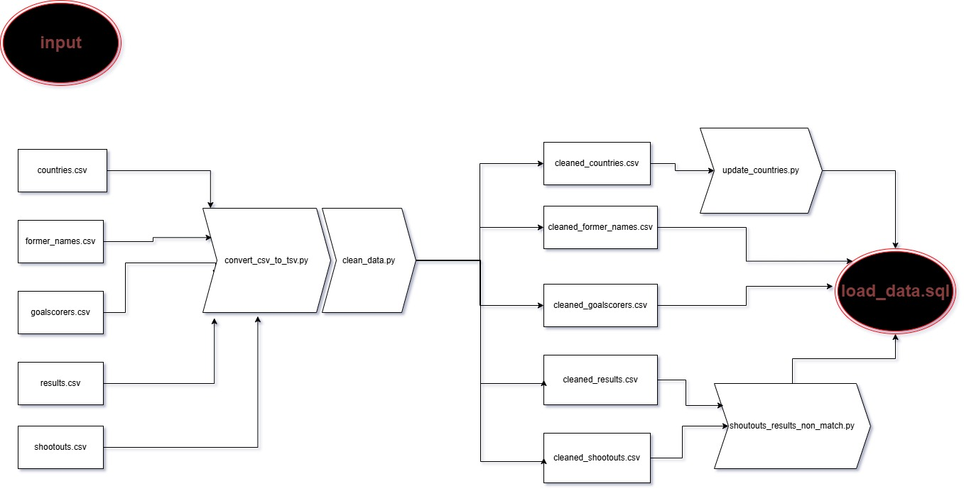Tο load_data.sql περιλαμβάνει όλα τα LOAD DATA INFILE για τα καθαρα αρχεία, τα INSERT για teams και τα UPDATE για foreign keys και τον υπολογισμό του winner

Διαγράμμα(τα) Κλάσεων κεντρικησ εφαρμογησ
Η εφαρμογή αναπτύχθηκε με χρήση Spring Boot (v3.4.4), ακολουθώντας τυπική MVC αρχιτεκτονική. Περιλαμβάνει:
- Controllers για την παρουσίαση και διαχείριση στατιστικών (ανά χώρα, χρονιά, παίκτη)
- Υποσύστημα δεδομένων με JPA, σύνδεση σε βάση MySQL (football_db)
- Χρήση Thymeleaf για την παρουσίαση των αποτελεσμάτων σε HTML views
- Τα δεδομένα φορτώνονται μέσω ETL διαδικασίας με Python/SQL και αποθηκεύονται σε πίνακες της βάσης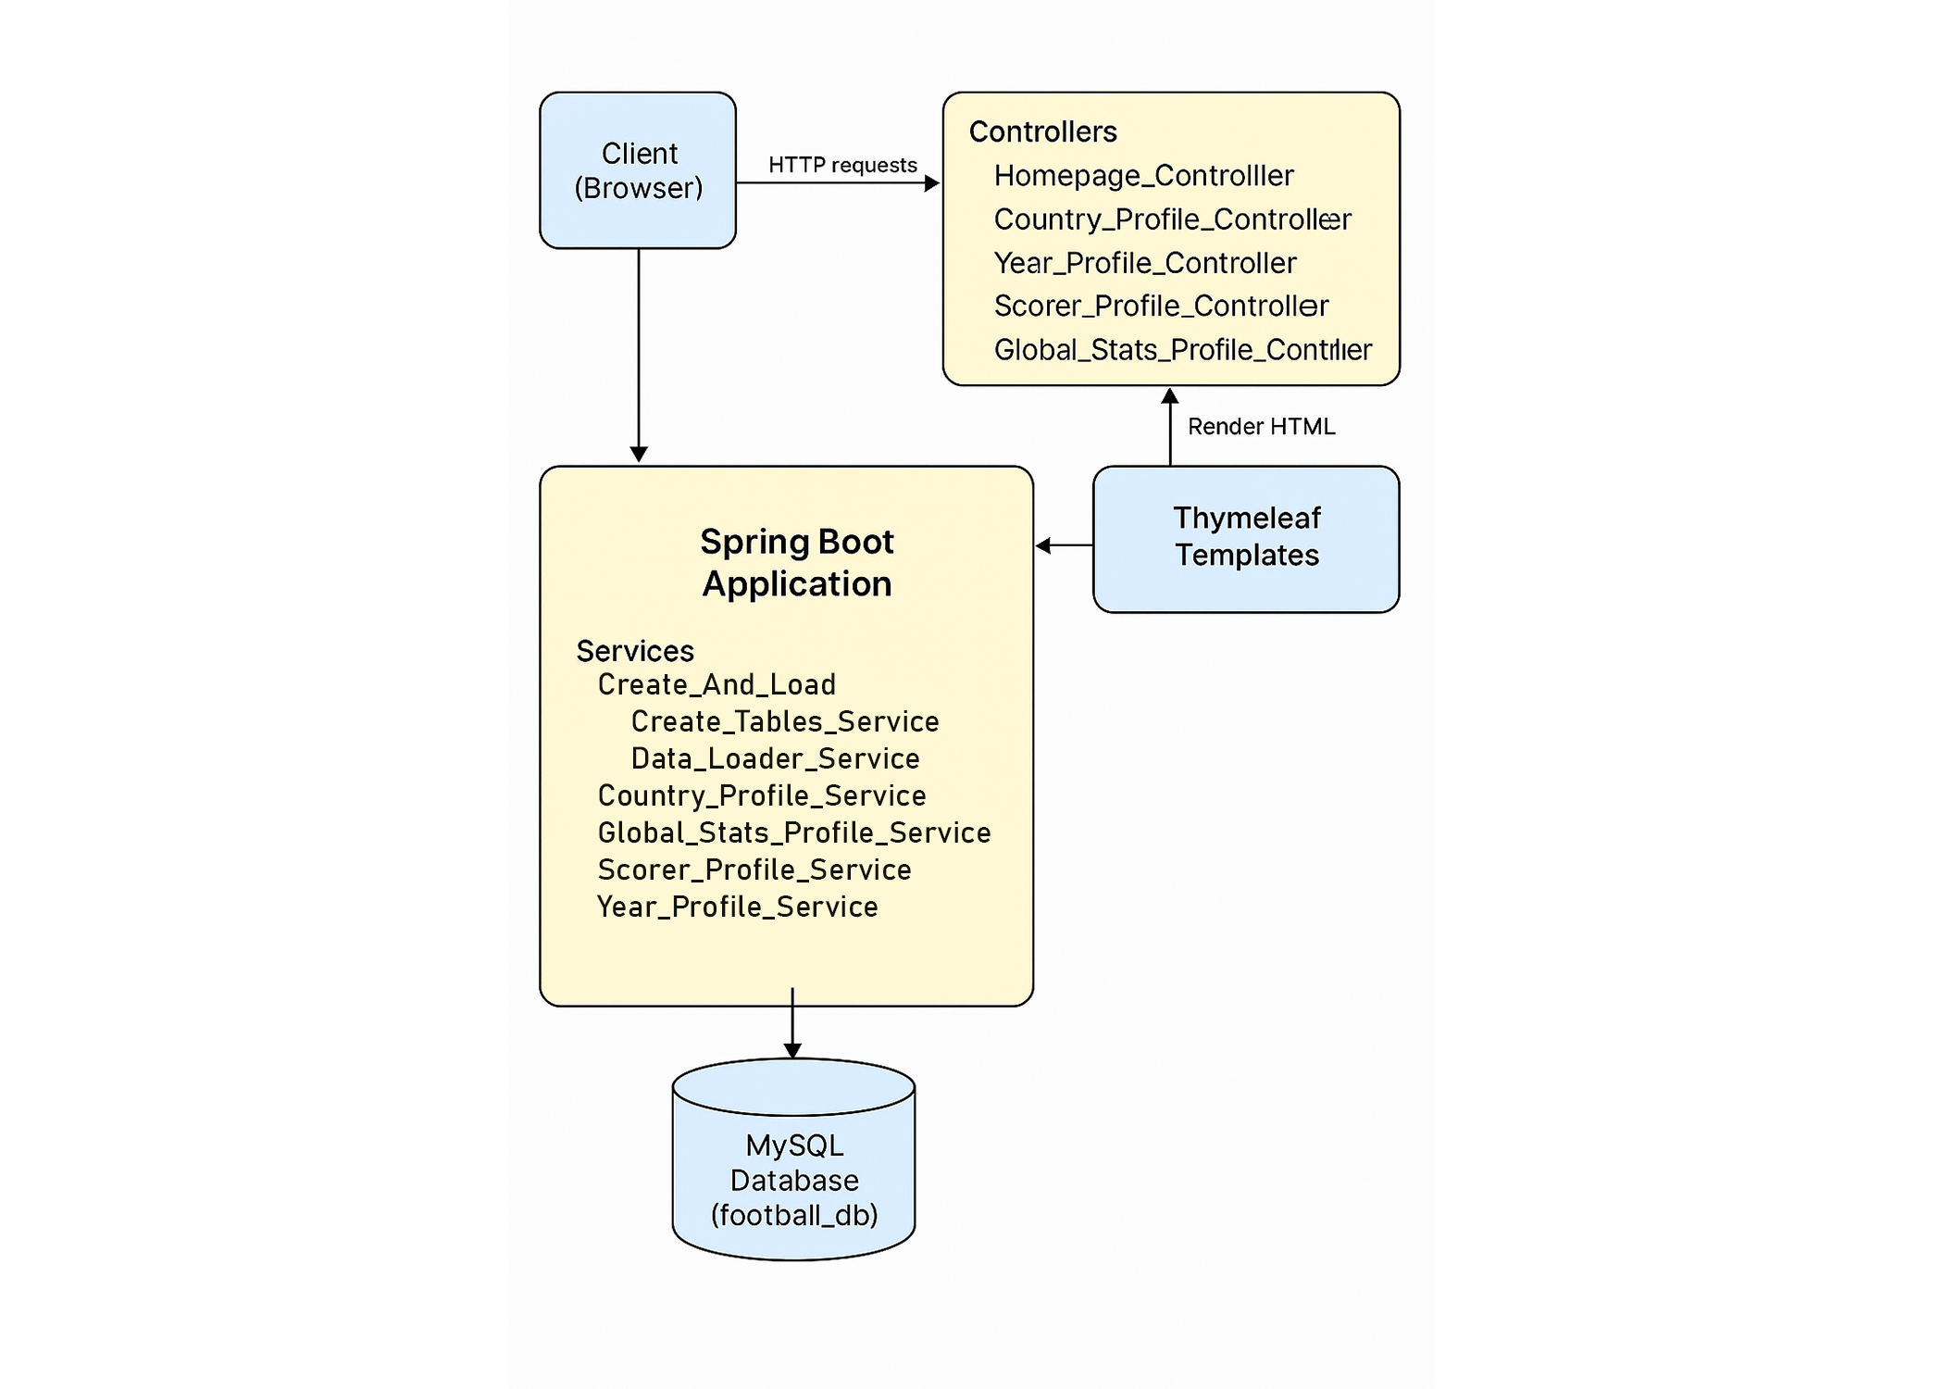

Υποδείγματα ερωτήσεων και απαντήσεων
Screen dumps από τα σημαντικά τμήματα του λογισμικού.
Σαν ένα σύντομο manual…

λοιπά σχόλια

