**First screen**



Image: Galaxy picture in the background

Text: name of the application

**Information Screen (Input)**

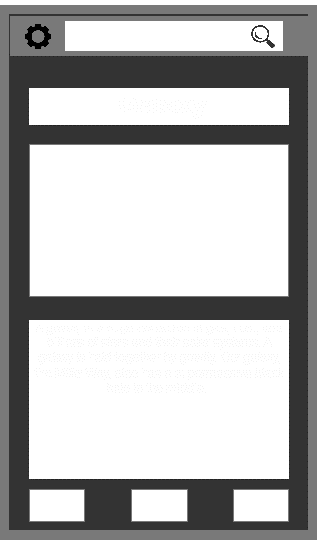

Button: which takes the user to the First screen

Button: which takes the user to the AR screen

Button: button which takes the user to item page relating to the object searched

Text: information of the object searched

Image: image of the searched object

Text: Tittle of searched object

Settings button

Search button

**Information Screen (output)**

Search button

Settings button

Button: button which takes the user to item page relating to the object searched

Button: which takes the user to the First screen

Button: which takes the user to the AR screen

Text: information of the object searched

Text: Tittle of searched object

Image: image of the searched object

