Wait your turn!

# Framing

## What?

It is a software product which enables any group of persons to assign a task or a role in a defined manner to every group member periodically.

This software is called Wait Your Turn! (wyt!).

The strategies to find the next task or role owner has to be interchangeable. Possible strategies are:

* Based on a time period
* Based on the frequency of the role ownership
* Based on a manual order.

Group members may be added dynamically by the owner of the group.

A team member is allowed to deny the appointment of the ownership.

It is also possible to gamify this software:

* A role owner is awarded by points in some manner
* He can compare the number of ownerships with his colleagues
* Scoring lists are available for every group member

## Who?

* For project teams if there is a project role which is periodically assigned to team member.
* For a clique of friends who wants to determine who has to pay the next cup of coffee.

## Why?

So we assume there is a need for some kind of software which manages the periodic change of the roles, tasks or things. Because to assign a rotating issue on their own has some drawbacks.

Manually assigning a role can be frustrating when answering the question who is next. Let’s consider a project team currently working on a software product which was already going productive. Typically these teams has a role for the third level support to work on production errors. Say we call this role the Responsible Support Engineer (RSE) which may be a really unloved task. And although a person would be in a defined order the next one, there might be some good reasons why he can’t take it. E.g. he is on holidays or he already owned the role a lot more than other ones on the project group.

So when assigning rotating issues there is a need for other strategies than just the sequential.

# Map the Big Picture

Defining the whole story:

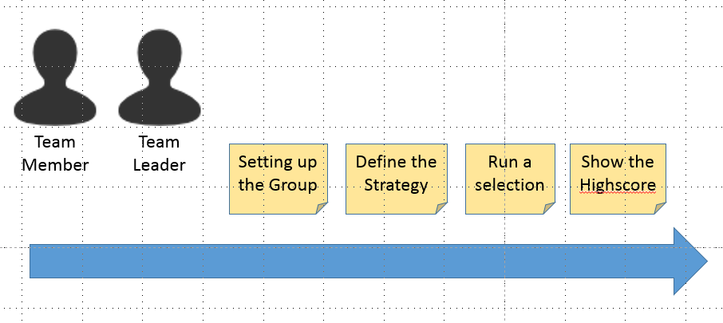

Personas:

|  |  |
| --- | --- |
| Team Leader: | The person who is responsible for the role assignment process. He wants to ensure a smooth operation of the role assignment process. |
| Team Member: | A member of the team to whom the role can be assigned.  He is interested in a fair assignment process. |

### Setting up the Group

The first step for the team is to set up a group in the application. The team leader has to create a group and add then every team member to the group.

### Defining the Strategy

A newly created group must be assigned a strategy. The team has to discuss this and then set the strategy for the group. In this step the team also makes a definition for the time period for which the role is assigned.

### Running a Selection

After the group setup has been completed. The selection process can start with a new round. Based on the defined selection strategy the system selects a team member for the defined time period.

### Showing the High Score

The high score shows a ranking of the team members. This ranking is based on the total numbers of role executions. Rewards can be offered based on the rankings.

## Stories for “Setting up the Group”

### Epic description:

The first step for the team is to set up a group in the application. The team leader has to create a group and add then every team member to the group.

### Stories:

* Register as user
* Create a new group
* Add users to the group

### Story “Register as user”

**As a** new customer

**I want to** register myself in wyt!

**So that** I can be part of a group

Acceptance Criteria:

* Given that I have not an account

### Story “Create a new group”

**As a** registered user

**I want to** create a new group

**So that** I can circulate the project support role

### Story “Add users to the group”

**As the** owner of a group

**I want** to add users to the group

**So that** the circulating role can be assigned to a group member

Ideas from come-together 26.9

Confirmation strategy:

By candidate

By others

By many?

Four-eyes commitment

Differentiate between

Positive / appreciated

Negative / reluctant

Scenarios:

TSV

Cappucino (price)

Car-Sharing (km?, time?)

Conflict strategies