Insights summary
- Identify product sales drivers, based on product category
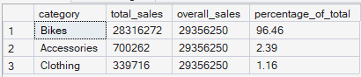
  - The business is overwhelmingly driven by Bikes, which generate 28,316,272 in sales, representing 96.46% of total revenue.
  - This suggests the company has a very strong flagship category, but it is also highly concentrated. If demand for bikes weakens, overall revenue would likely be affected significantly because the other categories are too small to offset the decline.
  - It also suggests there may be an opportunity to grow Accessories and Clothing as supporting revenue streams. These categories often work well as add on purchases, so the company could explore:
    - bundling accessories with bike purchases
    - recommending clothing or gear at checkout
    - running cross sell campaigns targeted at bike buyers
  - From a strategic perspective, Bikes should remain the priority in inventory planning, pricing, and marketing, but the business may also want to reduce concentration risk by expanding higher margin complementary categories.

- Identify the total sales and percentage contribution of each country to the overall sales
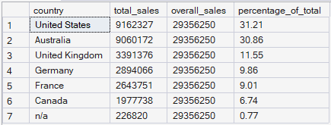
  - The top two markets are:
    - United States: 9,162,327 or 31.21%
    - Australia: 9,060,172 or 30.86%
These two countries alone contribute about 62% of total sales, which means the business is heavily reliant on them.
  - The company appears to have two dominant geographic markets, the United States and Australia, which are the main engines of international revenue. This is positive because it shows strong traction in those markets, but it also creates geographic concentration risk. Any slowdown, operational issue, or competitive pressure in either of these countries could materially affect total sales.
  - The mid tier markets, especially the United Kingdom, Germany, and France, look important because together they form a meaningful secondary revenue base. These markets may offer the best expansion opportunity because they are already established but not yet as large as the top two.
- Group customers into three segments based on their spending behavior:
  - VIP: Customers with at least 12 months of history and spending more than $5,000.
  - Regular: Customers with at least 12 months of history but spending $5,000 or less.
  - New: Customers with a lifespan less than 12 months.
And find the total number of customers by each group.
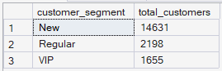
  - The largest segment is New customers with 14,631 customers, followed by Regular customers with 2,198, and VIP customers with 1,655.
    - This shows that most customers have been with the business for less than 12 months, while a much smaller number have developed into longer-tenure customers. Among customers who have stayed at least 12 months, more fall into the Regular segment than the VIP segment, meaning a larger share of mature customers are spending $5,000 or less rather than exceeding the high-value threshold.
  - Business implication
    - 1. The customer base is still relatively young
      - Because the New segment is by far the largest, the customer base appears heavily weighted toward recently acquired customers. This could indicate strong recent customer acquisition, business growth, or market expansion.
      - Implication:
This is positive from a growth perspective, but it also means the business has not yet converted many customers into long-term established relationships. The key challenge is whether these new customers can be retained long enough to move into the Regular or VIP segments.
    - 2. Retention matters just as much as acquisition
      - Since only a smaller portion of customers have at least 12 months of history, long-term growth will depend on how many New customers remain active over time.
      - Implication:
The business should not focus only on acquiring customers. It should also invest in:
        - onboarding experience
        - repeat purchase incentives
        - loyalty campaigns
        - personalised follow-up marketing
The goal is to increase the proportion of customers who survive beyond the 12 month mark.
    - 3. There is room to grow customer value
      - Among mature customers, Regular customers outnumber VIP customers. That means many long-standing customers are still spending $5,000 or less.
      - Implication:
This suggests an opportunity to increase customer lifetime value by moving more Regular customers into the VIP segment. The business could do this through:
        - upselling premium products
        - cross selling complementary items
        - tailored offers for repeat buyers
        - loyalty programmes for high-potential customers
In other words, the business may already be retaining some customers successfully, but not fully maximising their spending potential.
    - 4. VIP customers are a valuable but limited group
      - There are 1,655 VIP customers, which is the smallest segment, but likely the highest-value one because these customers combine longer history with high spend.
      - Implication:
Even though they are fewer in number, VIP customers are likely disproportionately important for revenue and profitability. They should be prioritised for retention through:
        - exclusive offers
        - early access to products
        - premium service
        - personalised engagement
Losing VIP customers could have a greater financial impact than losing customers from other segments.

