Hunting Rifles Online Retail Store “Big Caliber”

Winter 2019

Georgiy Voropayev

T00570108

1. Description

My idea is to write a website that would allow people who enjoy hunting to look for rifles, which are suitable for killing deer. This website consists of five layout pages (main page, shop page, forum page, and “sell a rifle” page).

Main page displays some basic descriptive information about deer, hunting them, and what rifles are great for doing so. In the upper right-hand corner, there is going to be a user management icon where the user can either sign in, sign out, log in, unsubscribe, or reset password. On the top bar there are three buttons such as “shop”, “forum”, and “sell rifle”, which are linked to corresponding page layouts.

On the shop page, at the top there are three buttons “main page”, “sell a rifle”, and “forum” to corresponding web pages. Below it there is a search field to look for a specific rifle. A list of rifles is displayed on the shop page with the name, a picture of the rifle, few sentences of description in length with a “read more” description button, which expands the description box, and a “buy” button.

When “buy” button is clicked, a layout with the name of the gun, a picture of it with the description to the right is displayed as well as the filling form with the buyer first and last name, driver’s license number, address, city, and credit card information. When the “submit” button is clicked, the buyer data is sent to the “buyers” database with the rifle he has purchased.

On the “sell rifle” page, a form is displayed where the seller must provide personal information such as first and last name, driver’s license number, address, and city; moreover, information about the rife such as make, type model, serial number (SIN), caliber, and some additional comments are provided to fill. When the “submit” button is clicked, the seller information is sent to the “sellers” database.

On the forum page, users can post reviews about rifles or post a question, which can then be answered. Information such as username and date are displayed next to the posts.

1. List of detail user level features

|  |  |
| --- | --- |
| **Features** | **Descriptions** |
| Sign in | The user signs in with an existing account, providing his username and password |
| Sign out | The user signs out the website |
| Unsubscribe | Delete the username from the database |
| Join | The user types in firs name, last name, address, city, username, password, email, driver’s license, age |
| Forgot password | The user reset the password by typing in a new password and validating it |
| Open Shop | A button that gets the user onto the shop page |
| Open Forum | A button that gets the user onto the forum page |
| Search rifle | The user types in the rifle name in the search line to look for a specific gun |
| Purchase rifle | The user provides information (first and last name, driver’s license number, address, city, and credit card information) to purchase the gun and presses “buy” button |
| Sell rifle | The user provides information (first and last name, driver’s license number, address, city, and credit card information) to sell the gun and presses “sell” button |
| “Read more” button | This expands description of a rifle |
| Post question | The user can post a question on the forum, which will be displayed |
| Post review | The user writes a review about a rifle, his thoughts and experience |
| Answer question | The user answers questions in the box below every question |

1. **Page layouts**, and user interface

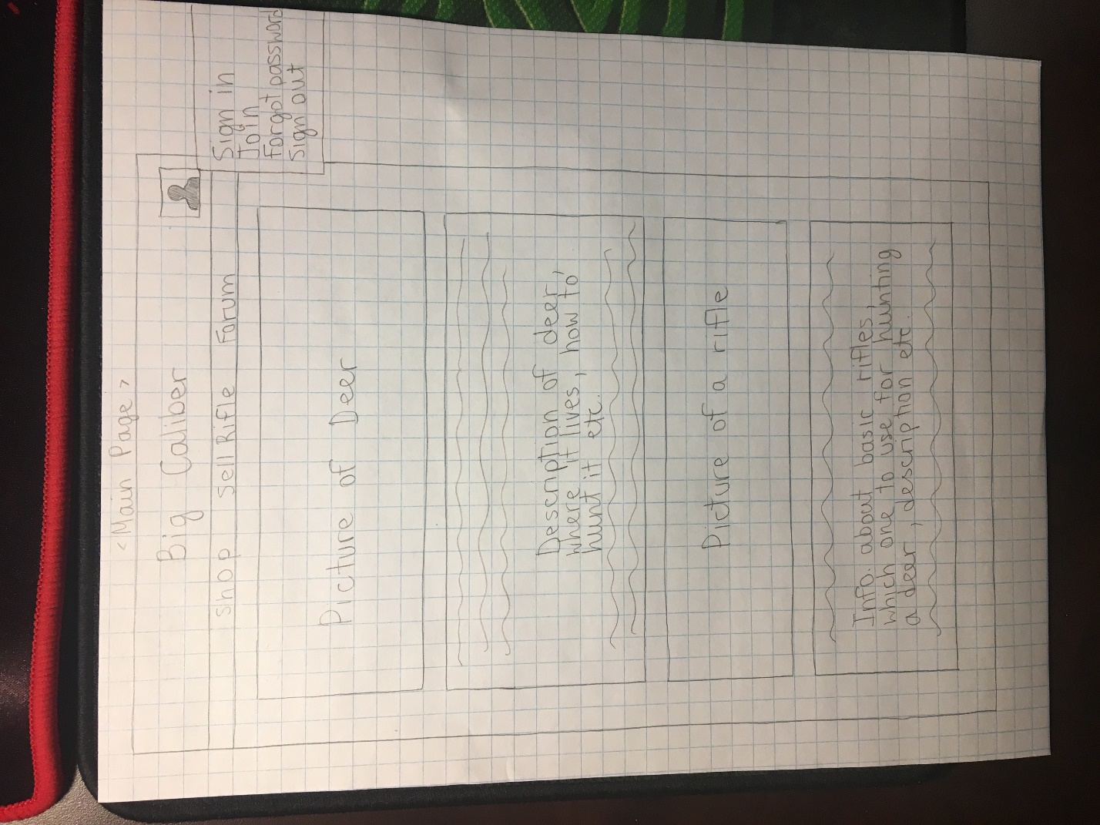

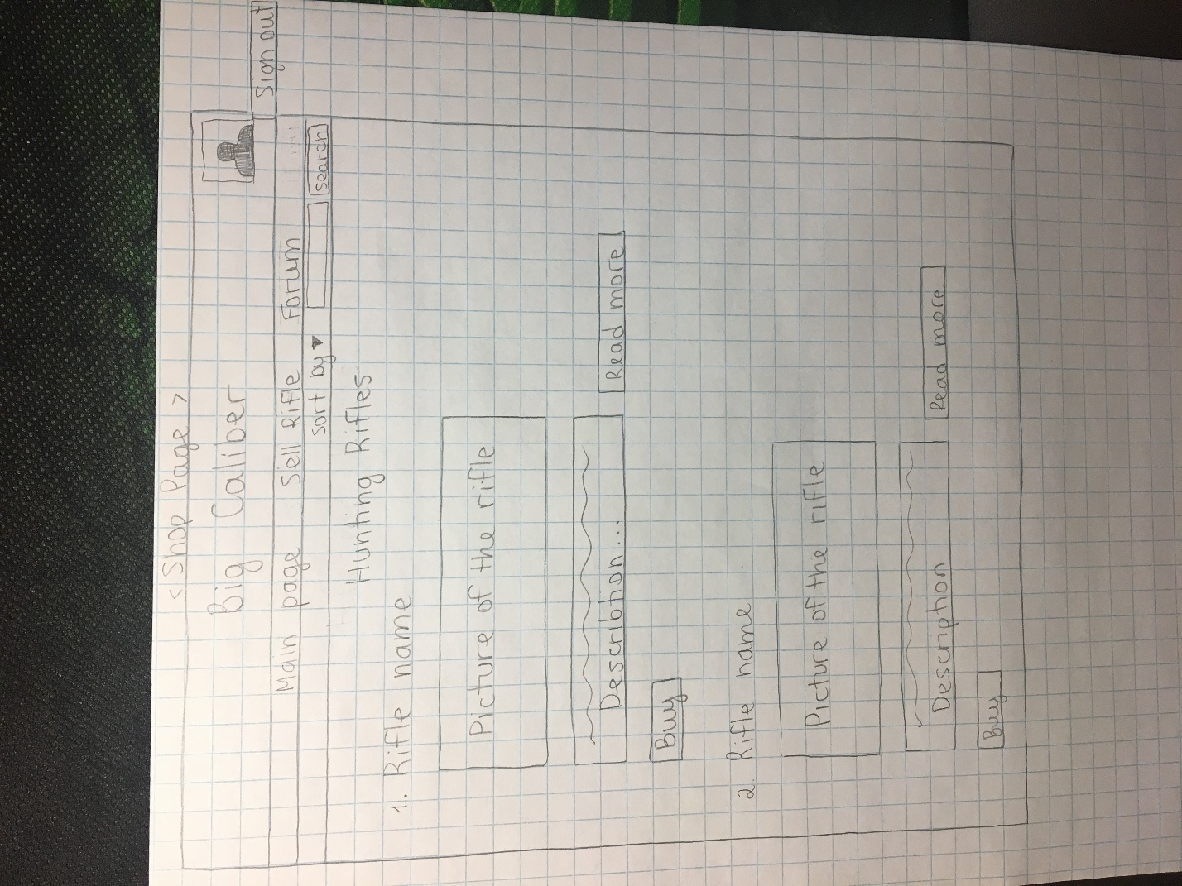

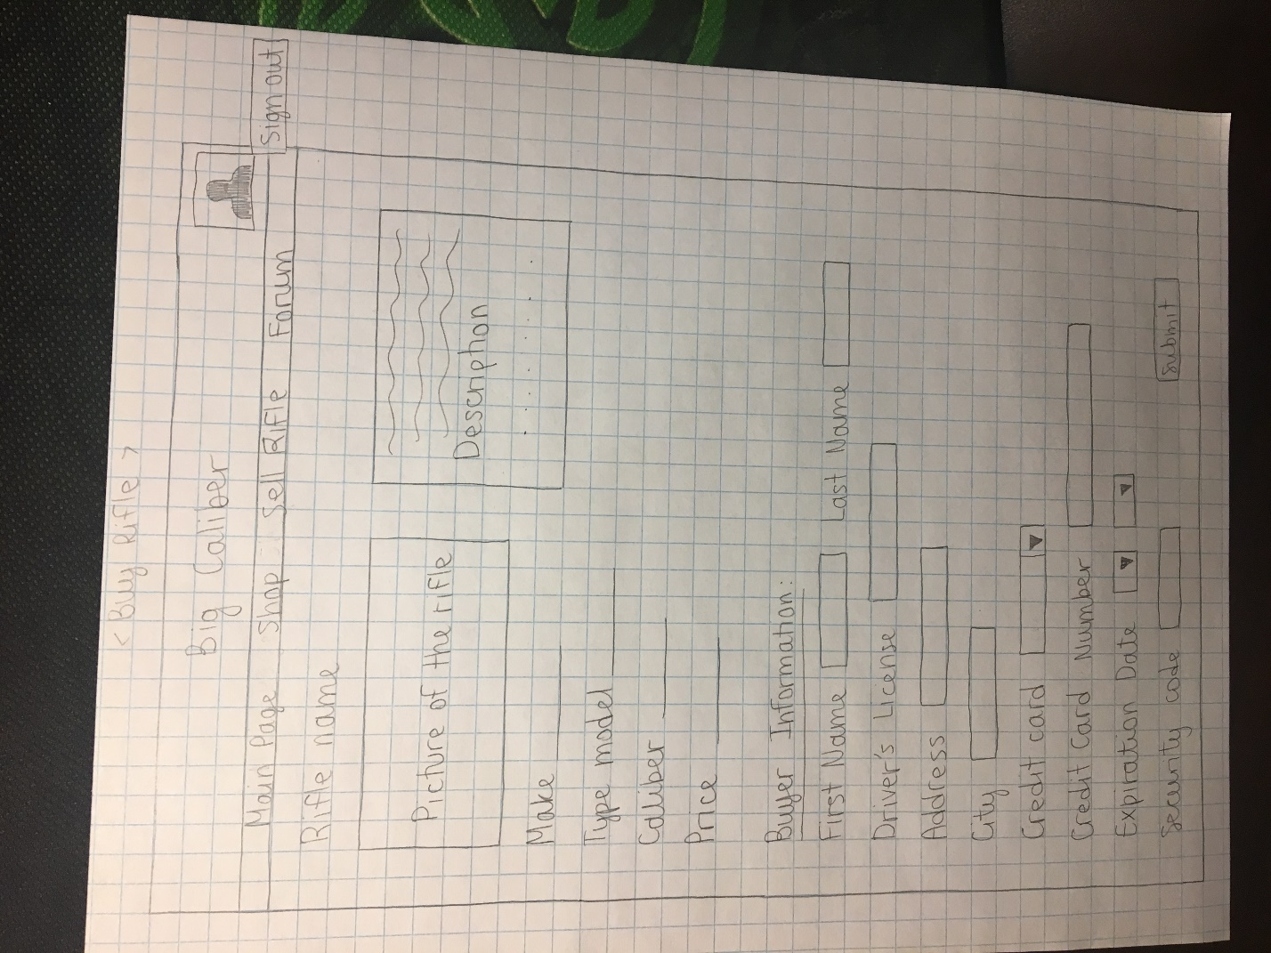

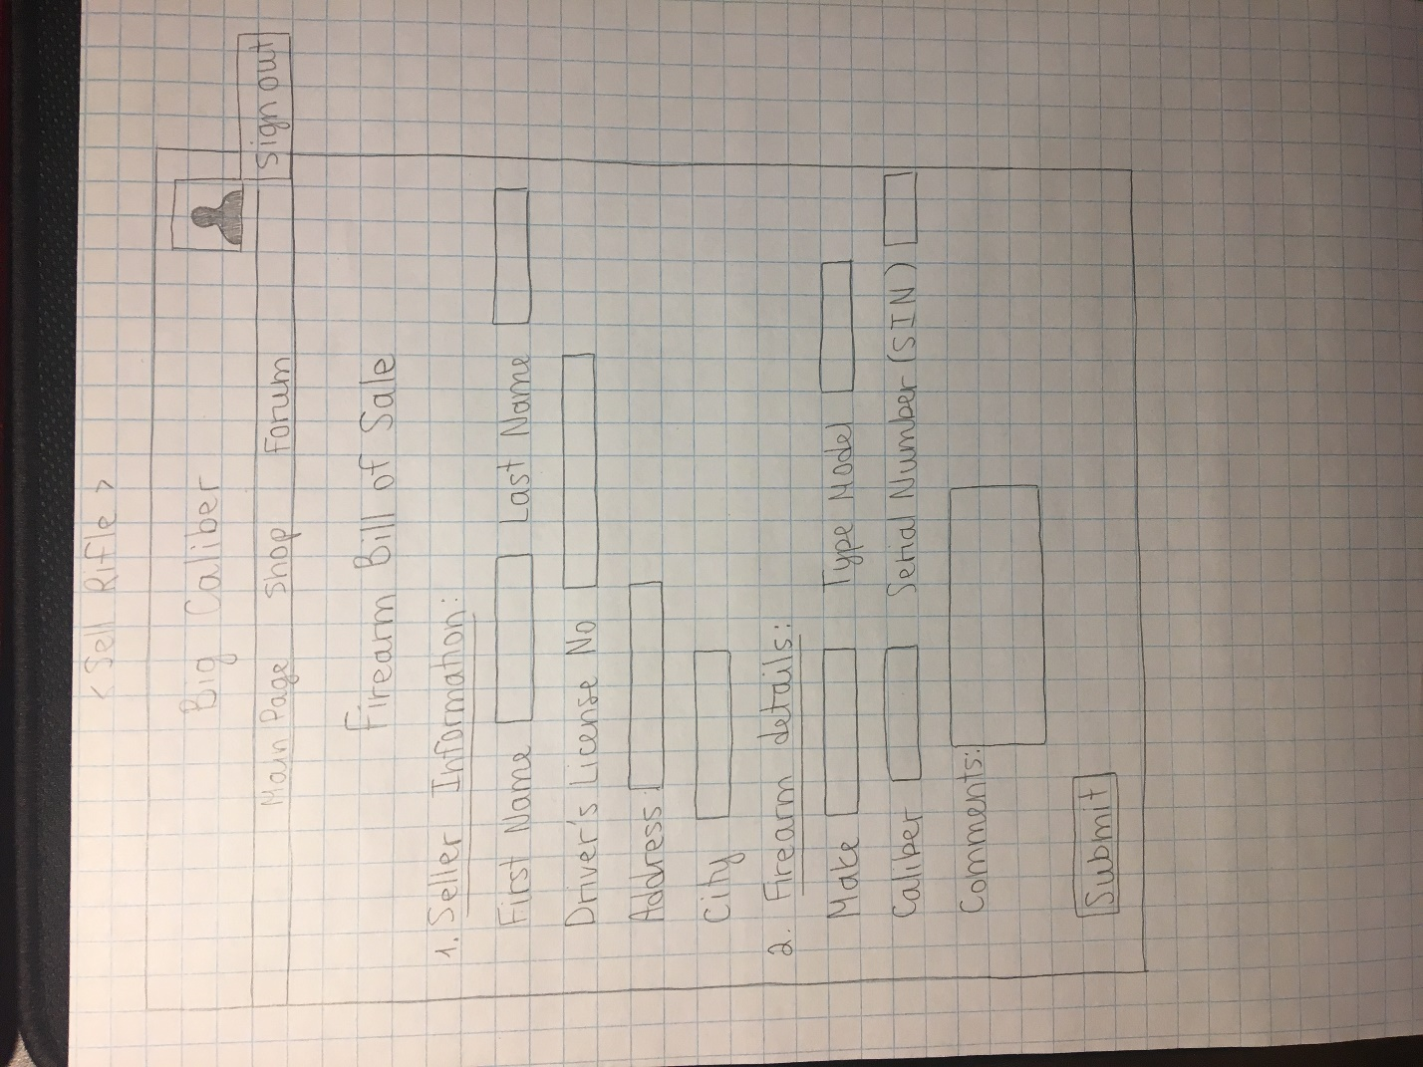

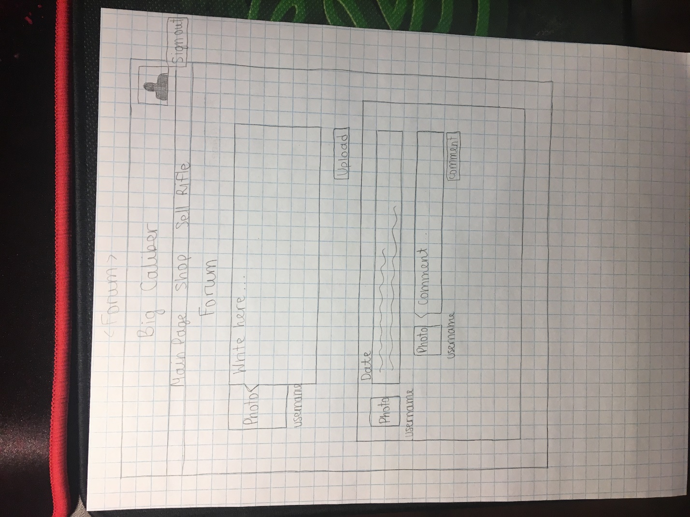

1. DB tables

* Customers

|  |  |  |
| --- | --- | --- |
| **Columns** | **Data types** | **Descriptions** |
| customerId | int(10) | Autoincremented. User’s custom number |
| fname | varchar(30) | First name of the user |
| lname | varchar(30) | Last name of the user |
| username | varchar(30) | Username of the user |
| password | varchar(30) | Password of the user |
| email | varchar(30) | Email of the user |
| dr_license | varchar(30) | Driver’s license |

* Rifles

|  |  |  |
| --- | --- | --- |
| **Columns** | **Data types** | **Descriptions** |
| sin | varchar(30) | Serial Number of the rifle |
| make | varchar(30) | Make of the rifle |
| model | varchar(30) | Model of the rifle |
| caliber | varchar(30) | Caliber of the rifle |
| price | int(5) | Price for the rifle |
| quantity | Int(2) | How many guns of this type are available at the store |

* Sellers

|  |  |  |
| --- | --- | --- |
| **Columns** | **Data types** | **Descriptions** |
| fname | varchar(100) | First name of the seller |
| lname | varchar(100) | Last name of the seller |
| dr_license | varchar(100) | His Driver’s License |
| address | varchar(100) | His Address (Street name and house number) |
| city | varchar(100) |  |
| make | varchar(100) | Make of the selling firearm |
| model | varchar(100) | Model of the selling firearm |
| caliber | varchar(100) | Caliber of the selling firearm |
| sin | varchar(100) | Serial Number of the selling firearm |
| comment | varchar(100) | Any comments about the selling firearm |

* Buyers

|  |  |  |
| --- | --- | --- |
| **Columns** | **Data types** | **Descriptions** |
| fname | varchar(100) | First name of the buyer |
| lname | varchar(100) | Last name of the buyer |
| dr_license | varchar(100) | His Driver’s License |
| address | varchar(100) | His Address (Street name and house number) |
| city | varchar(100) |  |
| rifle | varchar(100) | The rifle that the buyer is purchasing |

* Posts

|  |  |  |
| --- | --- | --- |
| **Columns** | **Data types** | **Descriptions** |
| username | varchar(100) | The username |
| posts | varchar(100) | What the user posts (data from the textfield) |

1. Design

* Mapping between user level features and files

|  |  |  |  |  |
| --- | --- | --- | --- | --- |
| **User level features** | **MainPage** | **ShopPage** | **SellPage** | **Forum** |
| Sign in | Yes | No | No | No |
| Sign out | Yes | Yes | Yes | Yes |
| Unsubscribe | yes | no | no | no |
| Join | Yes | No | No | No |
| Forgot password | Yes | No | No | No |
| Open Shop | Yes | No | No | No |
| Open Forum | Yes | Yes | Yes | No |
| Search rifle | No | Yes | No | No |
| Purchase rifle | No | Yes | No | No |
| Sell rifle | Yes | No | Yes | No |
| “Read more” button | No | Yes | No | No |
| Post question | No | No | No | Yes |
| Post review | No | No | No | Yes |
| Answer question | No | No | No | Yes |