High level architectural approach

The core item of proposed telemedicine platform is video conferencing service based on WebRTC technologies. WebRTC is free and open source project that provides web browser and mobile application with real-time communication (RTC) via simple application programming interfaces. It allows peer-to-peer online multimedia streaming using typical browser like Chrome and Firefox without any software installation or vendor-lock. As one of the GLOCO-RU telemedicine platform requirements is ability video-conferencing then a WebRTC server should be implemented to aggregate media streams and decrease data transfers and requirements for network bandwidth.

System diagram:

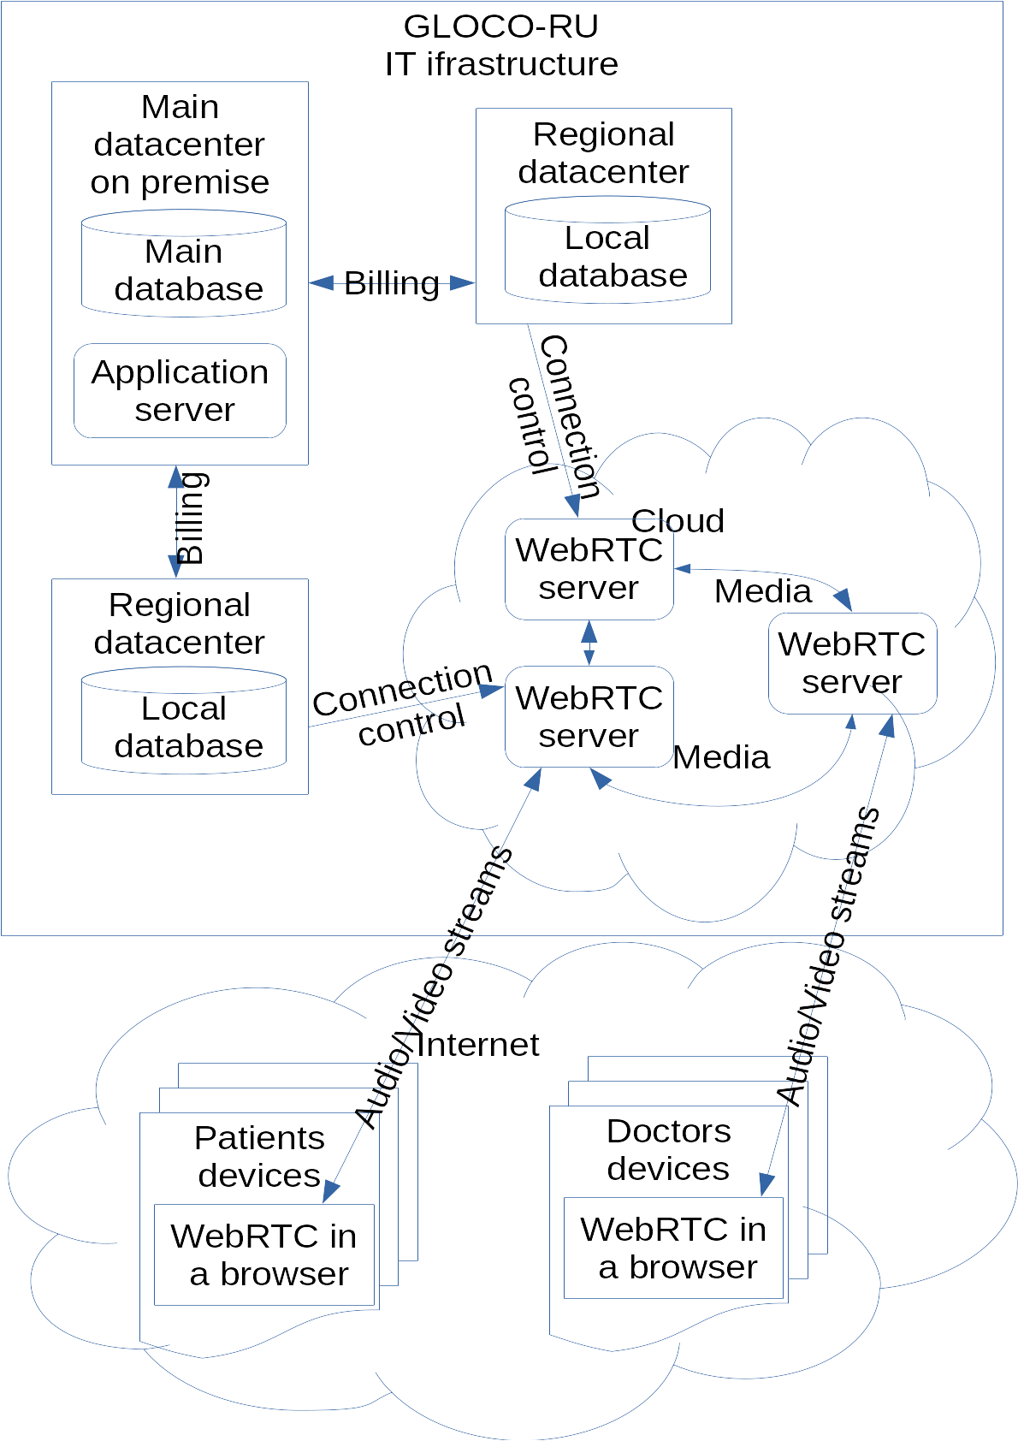

The first part of the telemedicine platform is a web cloud-based application what allows patients to use our platform without any specific software or hardware preparations except the very basic ones. This web application contains patients and doctors entry pages as well as private cabinets, and integrated video/voice/text messaging communication application based on webrtc technologies.

This part is stateless, hosted into clouds, and could be scaled on demand.

The second part is aggregating service, distributed by geographical locations and service load. This item hosts an SQL database to provide information to the web application, handle user requests, collect and store logs and usage statistic. Instances of this service bounded into replication groups that share the same data and allows redundancy and fail-safe behavior. Also Geo-distributed design decreases latencies and increases overall system performance.

The core part of the telemedicine platform interacts with intermediate servers, distributes data changes across whole platform and collects and aggregates input data. This item is used for internal GLOCO-RU CRM and ERP systems, usage reporting, statistics, and producing data for government structures.

Integration with other application and data sources

The telemedicine system should have an ability to identify real personalities of patients according to state’s legislative acts and regulatory and it is supposed to exchange data with various external systems as government reporting or insurance databases. Also the system should be integrated with GLOCO-RU’s own internal CRM system to allow billing.

As the base source of clients authorities was suggested to use a state service portal . This portal is intended to provide state services to any Russian citizen conforming to government acts No. 1231-p and No. 1555-p. The state service portal performs real personal identification and authorization and allows that services to be used by external systems using OAUTH2 or OpenID protocols. Base registration procedure is described on <https://partners.gosuslugi.ru/catalog/esia> and requires some steps like registration, security certificate creation and finishes with government acceptance.

As GLOCO-RU telemedicine system involves personal patients data like real names and documents then the system should conform federal laws No. 152 and No. 323 about storing and handling personal and medical information. One of the way to mitigate the requirements is to store and handle only impersonal information with abstract user identities bounded with government services accounts. Such integration is planned to be done by external team of NVISION Group – one of the leaders of Russian telecommunication markets and developer of the state services portal.

Conforming to federal law No. 210 state medical clinics are engaged into state portal services, so

innovative teams believes that future cooperation with NVISION Group also allows easy involving such clinics into GLOCO-RU telemedecine platform providing a video and voice communications between doctors and patients. (В соответствии с федеральным законом 210 государственные клиники должны быть включены в портал госудаственных услуг, поэтому комманда считает, что успешная коопераця с Энвижн позволит легко вовлечь такие клиники в ГЛОКОРУ телемедицинскую платформу предоставляя им видео и голосовую связь). So telemedicine platform could have two source of patients requests – one of them is the platform’s own private cabinet and the second – imported from state service portal.

The other side of integration is exporting billing data into internal information systems. GLOCO-RU already has ERP and CRM systems that are used to process payment bills and support customer interaction. So the telemedicine platform is able to provide usage statistic based on month-based terms in order to load data into GLOCO-RU ERP and CRM. For that purposes a reporting module was developed which allows to form usage reports by customers, date ranges and service types.