White dwarf cooling sequences for progenitors stars with Z=0.01 and Z=0.001 appropriate for precise white dwarf cosmochronology, and described in Renedo, Althaus, Miller Bertolami et al. 2010, ApJ, 717, 183, are provided. Calculations have been done with the stellar evolutionary code LPCODE developed at University of La Plata, Argentina. Details about LPCODE can be found at: Althaus, Serenelli, Panei et al. 2005, A&A, 435, 631; Althaus, Corsico, Bischoff-Kim et al. 2010, ApJ, 717, 897, and references therein. Evolutionary sequences are computed selfconsistently from progenitor stars evolved from the ZAMS through the core hydrogen- and helium-burning evolutionary phases to the thermally pulsing AGB and, ultimately, to the white dwarf stage. During the white dwarf stage, element diffusion, residual nuclear burning as well as latent heat and carbon-oxygen phase separation upon crystallization are considered. In addition, detailed non-gray model atmospheres are used to derive the outer boundary conditions of the evolving models (click here to download colors and magnitudes of our sequences). Calculations are extended down to an effective temperature of 2500 K. The full treatment of the entire evolutionary history of white dwarfs provides consistent white dwarf initial configurations. In particular, the mass of the hydrogen-rich envelope and of the helium buffer are obtained from evolutionary calculations, instead of using typical values and artificial initial white dwarf models. In addition, our calculations also yield self-consistent interior chemical profiles (click here to download the chemical profiles of our models)
Two sets of cooling sequences for Z=0.01 and Z=0.001 are provided. Each cooling sequence file lists from left to right:
Log L: The logarithm of the surface luminosity in solar unit;
Log Teff: The logarithm of the effective temperature (K);
Log Tc: The logarithm of the central temperature (K);
Log rho_c: The logarithm of the central density (gr/cm³);
Age/Myr: Cooling age in 10⁶ years counted from the stage of maximum effective temperature;
Mass: Stellar mass in solar unit;
Log Lpp: The logarithm of luminosity (in solar unit) due to proton-proton burning;
Log Lcno: The logarithm of luminosity (in solar unit) due to CNO burning;
Log LHe: The logarithm of luminosity (in solar unit) due to helium burning;
Log Lnu: The logarithm of luminosity (in solar unit) due to neutrino losses;
Log MHtot: The logarithm of hydrogen content in solar mass;
Log(grav): The logarithm of surface gravity (cm/s²);
R/R_sun: Stellar radius en solar unit.
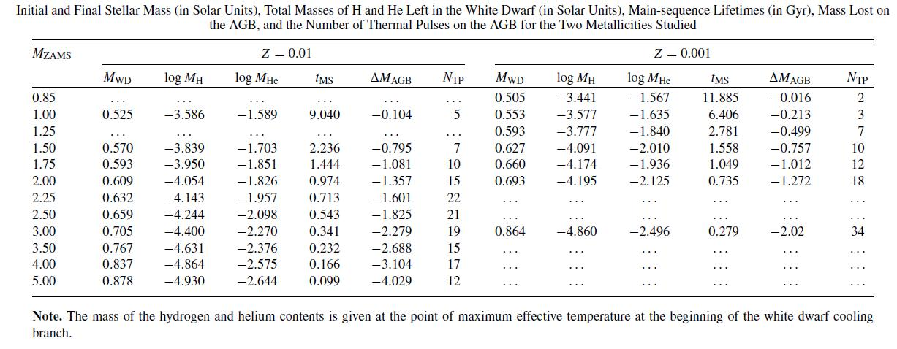

For the Z=0.01 set, the white dwarf stellar mass range goes from 0.525 to 0.934 M_{sun}, and for the Z=0.001 set, the mass range goes from 0. 505 to 0.864 M_{sun}.
The table below lists, among other things, the initial stellar mass of the progenitor stars and the resulting white dwarf mass for both metallicities. Additional sequences are provided upon request to Leandro Althaus at althaus@fcaglp.unlp.edu.ar
In addition to the stellar mass values listed in the table, a white dwarf sequence of 0.934 M_{sun} is provided. This sequence is the result of the full evolution of a progenitor star of initially 1.0 M_{sun.}

