Week 7 Homework Q26

Telmen Enkhbold

San Fransico Bay University

CE480 - Java and Internet Application

Dr. Chang, Henry

10/12/2023

# Author Note

# The Question

1. Inheritance + Aggregation

------------------------

| A |

| String name |

| --------- --------- |

| | B | | F | |

| | int b | | int f | |

| --------- --------- |

------------------------

|

|

|

-----------------------

| E |

| int e |

| ----------------- |

| | D | |

| | int d | |

| ----------------- |

-----------------------

Note:

* + Each class must implement 4 types of member functions
    - Helping function
    - private void trace(String s) {
    - System.out.println(s);
    - }

* + - Access functions
      * get
      * set
      * predicate
        + class A, B, D, E, F
        + isLargeValue()

==> Check whether the values of all its attributes are greater than 100. For example, class E's isLargeValue() returns true if all the values of b, f, d, e are greater than 100.

* + - * + class A
        + isBruceLee()
        + ==> Check whether the value of the attribute "name" is "Bruce Lee".

* + - Implementor function
      * class A, B, D, E, F
      * changetoZero()

==> The values of all its numerical attributes are set to 0. For example, class E's changeroZero() has this result:

----------------------------

| A |

| String name |

| ----------- ----------- |

| | B | | F | |

| | int b=0 | | int f=0 | |

| ----------- ----------- |

----------------------------

|

|

|

----------------------------

| E |

| int e=0 |

| ----------------- |

| | D | |

| | int d=0 | |

| ----------------- |

----------------------------

class A

changeName(String new_name)

==> The value of the attribute "name" is changed to a new name.

class A, B, D, E, F

* + - * + toString()
        + clone()
        + equals()

main function

Create this object eObj

----------------------------

| A |

| String name="jack" |

| ----------- ----------- |

| | B | | F | |

| | int b=1 | | int f=2 | |

| ----------- ----------- |

----------------------------

|

|

|

----------------------------

| E |

| int e=3 |

| ----------------- |

| | D | |

| | int d=4 | |

| ----------------- |

----------------------------

Display the values of all the attributes of eObj

Change the values of eObj to

----------------------------

| A |

| String name="jack" |

| ----------- ----------- |

| | B | | F | |

| | int b=4 | | int f=5 | |

| ----------- ----------- |

----------------------------

|

|

|

----------------------------

| E |

| int e=6 |

| ----------------- |

| | D | |

| | int d=7 | |

| ----------------- |

----------------------------

Display the values of all the attributes of eObj

Clone the eObj to create eObj1

Display the values of all the attributes of eObj1

Check whether eObj is equal to eObj1

* + References
    - [Class containg two layers of simple object attribute](https://hc.labnet.sfbu.edu/~henry/sfbu/course/introjava/java_class/slide/classStruct.htm#olomsoatce)
    - [One layer of simple object attribute + toString() + clone() + equals()](https://hc.labnet.sfbu.edu/~henry/sfbu/course/introjava/java_class/slide/classStruct.htm#cols)
    - [get/set](https://hc.labnet.sfbu.edu/~henry/sfbu/course/introjava/java_class/slide/get_set.html)
    - [4 Types of Member Functions](https://hc.labnet.sfbu.edu/~henry/sfbu/course/introjava/java_class/slide/javaMemFunc.html)
    - [Summary of toString(), clone(), equals()](https://hc.labnet.sfbu.edu/~henry/sfbu/course/introjava/java_class/slide/summary_table.html)
    - [Inheritance Class Structure](https://hc.labnet.sfbu.edu/~henry/sfbu/course/introjava/inheritance/slide/inhStruct.html)

============================Screenshot===============================

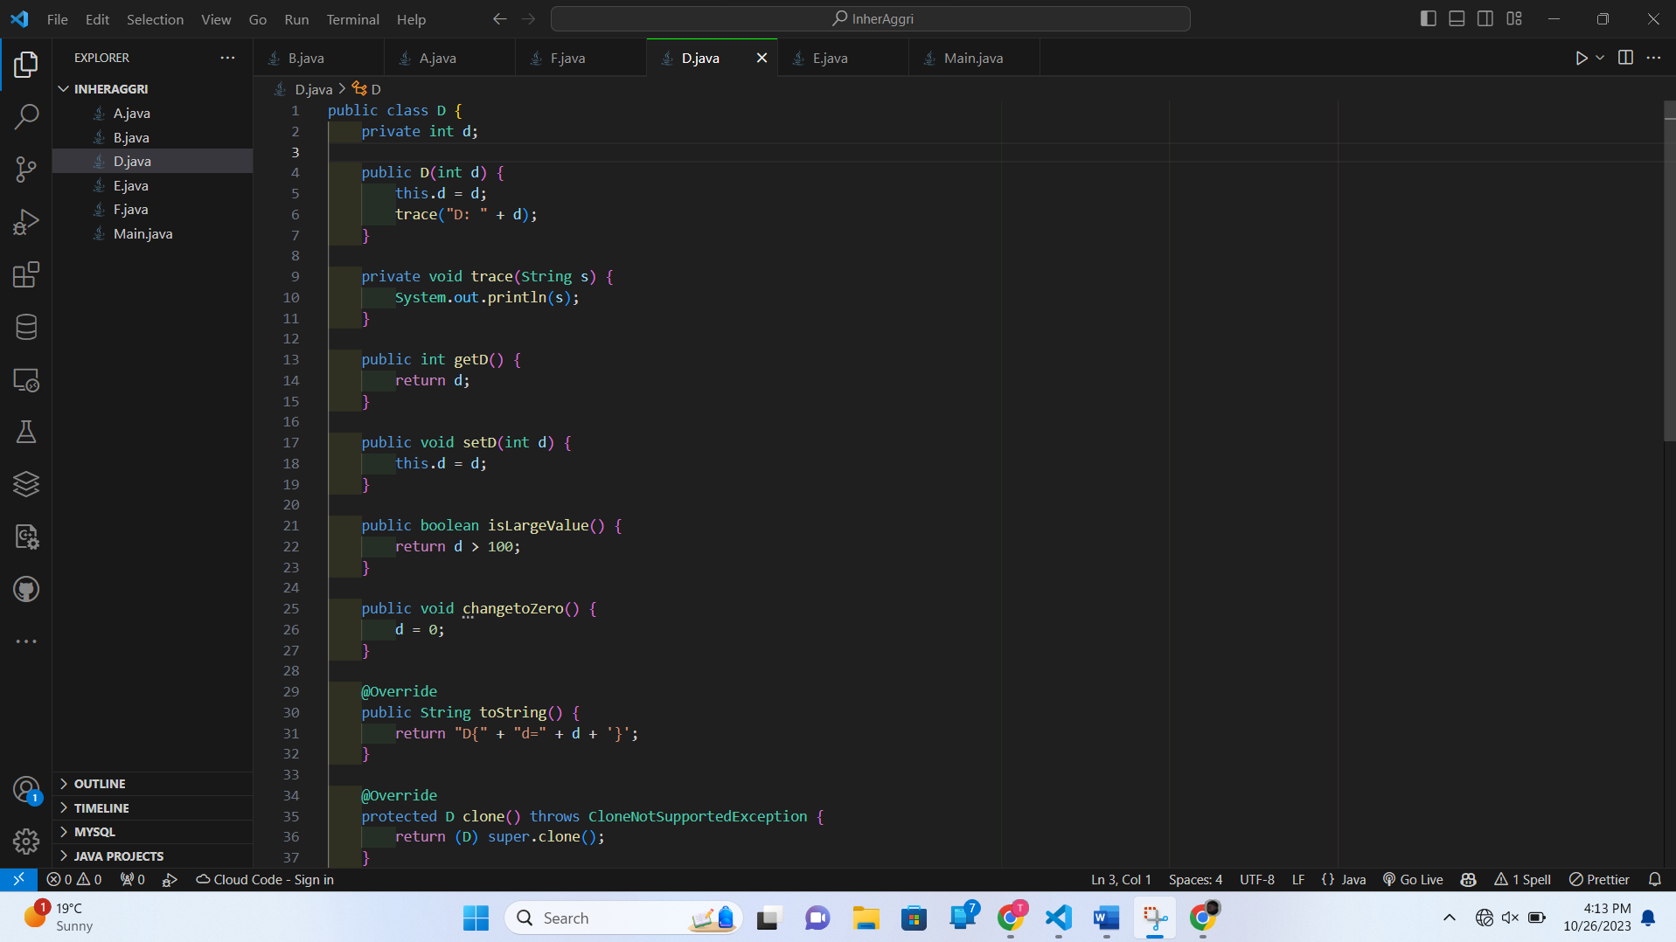

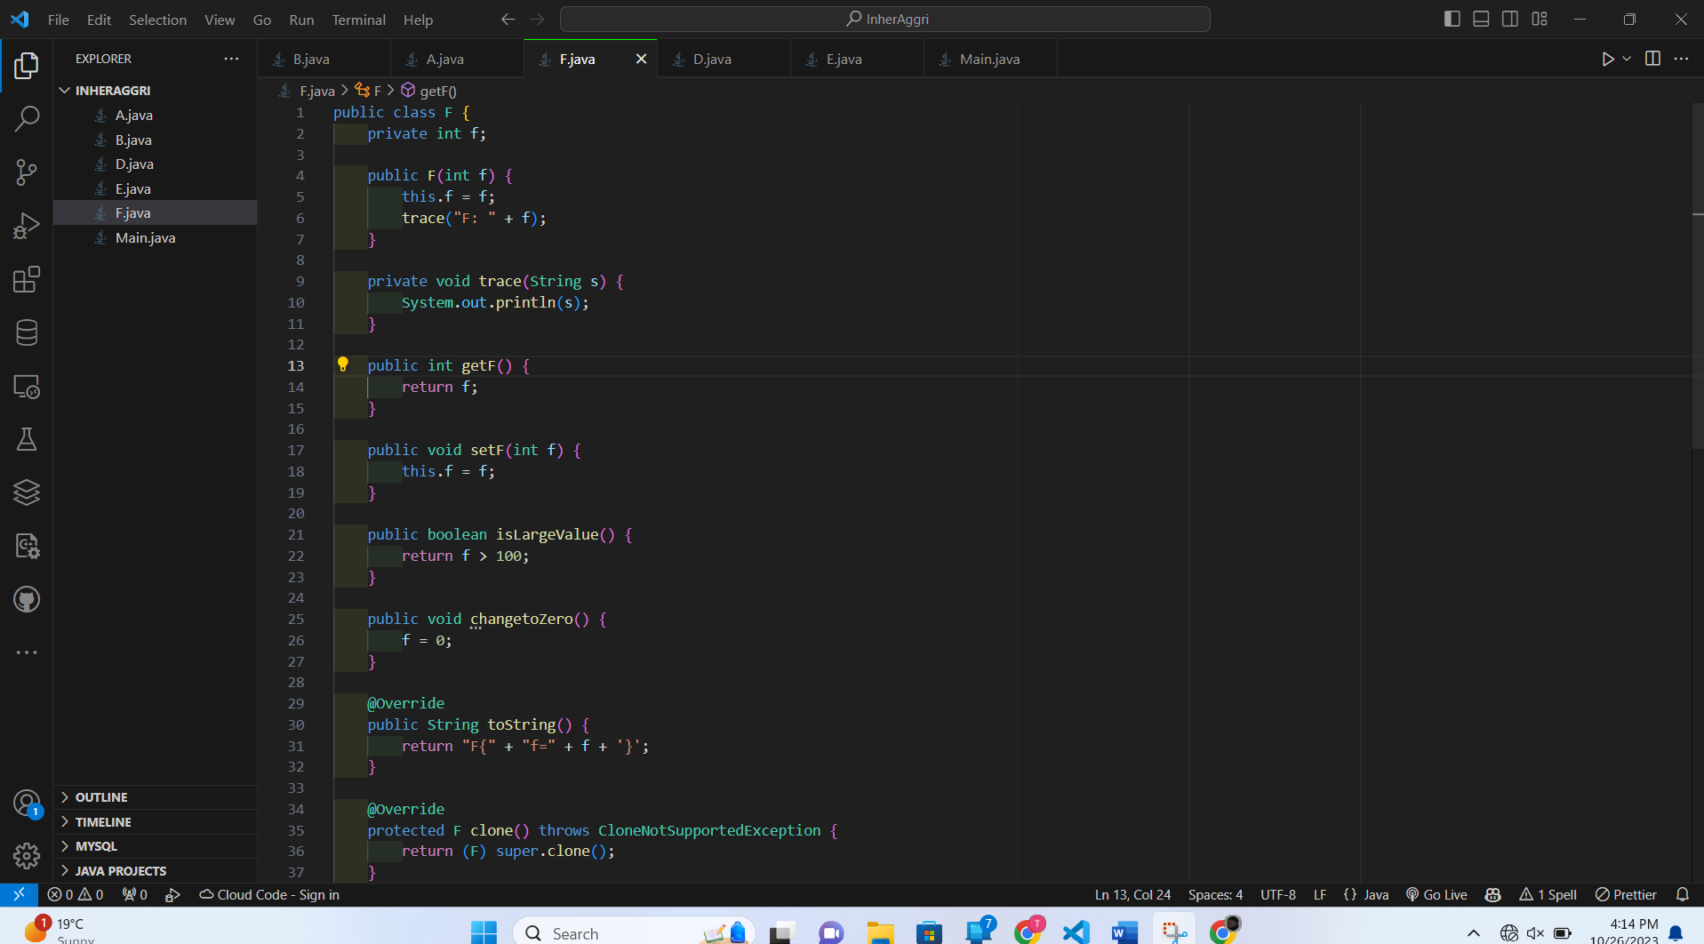

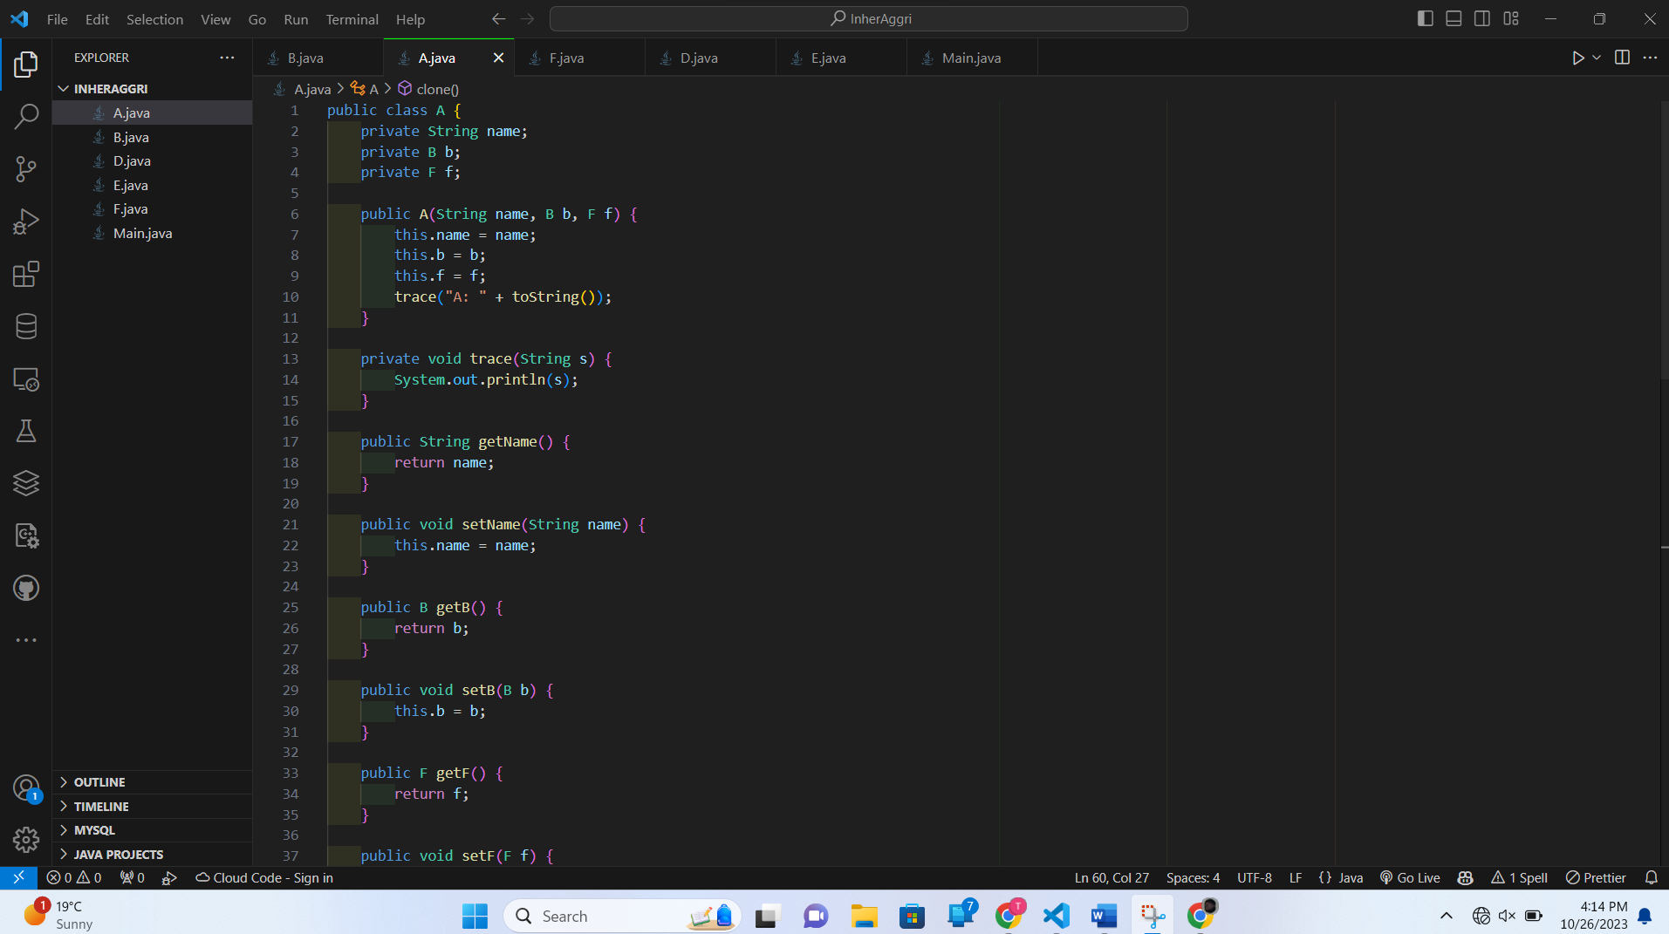

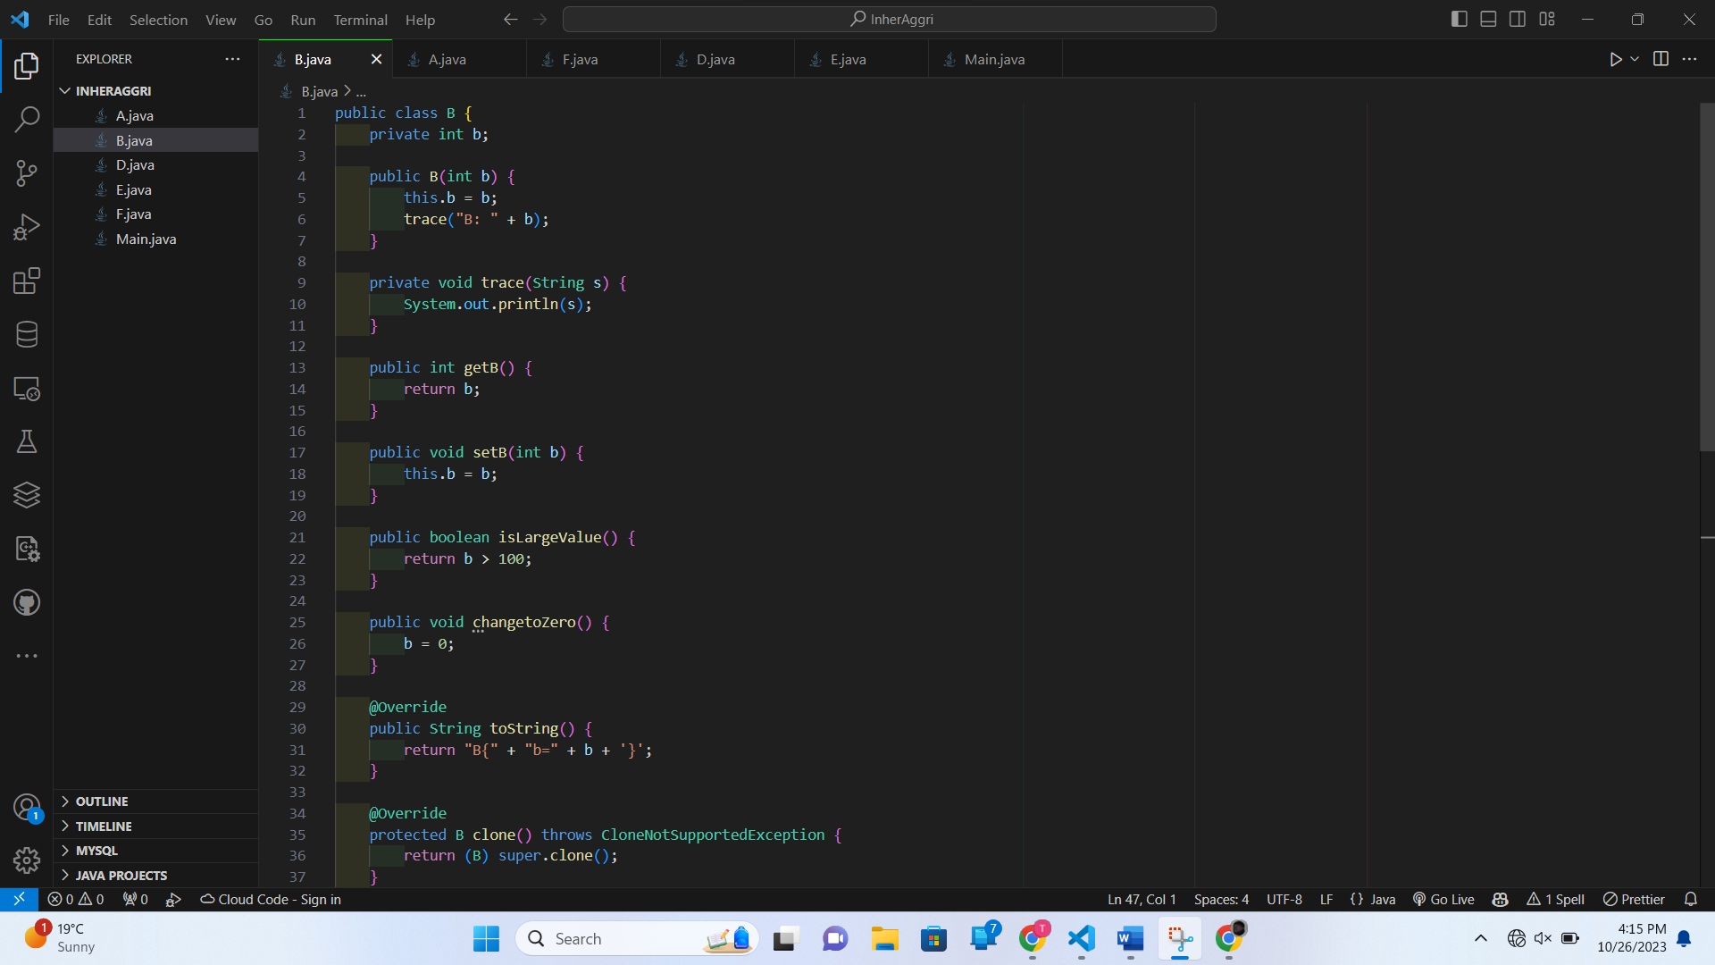

===============================The Code=============================

**A.java**

public class A {

    private String name;

    private B b;

    private F f;

    public A(String name, B b, F f) {

        this.name = name;

        this.b = b;

        this.f = f;

        trace("A: " + toString());

    }

    private void trace(String s) {

        System.out.println(s);

    }

    public String getName() {

        return name;

    }

    public void setName(String name) {

        this.name = name;

    }

    public B getB() {

        return b;

    }

    public void setB(B b) {

        this.b = b;

    }

    public F getF() {

        return f;

    }

    public void setF(F f) {

        this.f = f;

    }

    public boolean isBruceLee() {

        return "Bruce Lee".equals(name);

    }

    public void changeName(String newName) {

        this.name = newName;

    }

    public void changetoZero() {

        b.changetoZero();

        f.changetoZero();

    }

    @Override

    public String toString() {

        return "A{" + "name='" + name + '\'' + ", b=" + b + ", f=" + f + '}';

    }

    @Override

    protected A clone() throws CloneNotSupportedException {

        A cloned = (A) super.clone();

        cloned.b = this.b.clone();

        return cloned;

    }

}

B.java

public class B {

    private int b;

    public B(int b) {

        this.b = b;

        trace("B: " + b);

    }

    private void trace(String s) {

        System.out.println(s);

    }

    public int getB() {

        return b;

    }

    public void setB(int b) {

        this.b = b;

    }

    public boolean isLargeValue() {

        return b > 100;

    }

    public void changetoZero() {

        b = 0;

    }

    @Override

    public String toString() {

        return "B{" + "b=" + b + '}';

    }

    @Override

    protected B clone() throws CloneNotSupportedException {

        return (B) super.clone();

    }

    @Override

    public boolean equals(Object obj) {

        if (this == obj) return true;

        if (obj == null || getClass() != obj.getClass()) return false;

        B b1 = (B) obj;

        return b == b1.b;

    }

}

D.java

public class D {

    private int d;

    public D(int d) {

        this.d = d;

        trace("D: " + d);

    }

    private void trace(String s) {

        System.out.println(s);

    }

    public int getD() {

        return d;

    }

    public void setD(int d) {

        this.d = d;

    }

    public boolean isLargeValue() {

        return d > 100;

    }

    public void changetoZero() {

        d = 0;

    }

    @Override

    public String toString() {

        return "D{" + "d=" + d + '}';

    }

    @Override

    protected D clone() throws CloneNotSupportedException {

        return (D) super.clone();

    }

    @Override

    public boolean equals(Object obj) {

        if (this == obj) return true;

        if (obj == null || getClass() != obj.getClass()) return false;

        D d1 = (D) obj;

        return d == d1.d;

    }

}

E.java

import java.util.Objects;

public class E {

    private int e;

    private D d;

    private A a;

    public E(int e, D d, A a) {

        this.e = e;

        this.d = d;

        this.a = a;

        trace("E: " + toString());

    }

    private void trace(String s) {

        System.out.println(s);

    }

    public int getE() {

        return e;

    }

    public void setE(int e) {

        this.e = e;

    }

    public D getD() {

        return d;

    }

    public void setD(D d) {

        this.d = d;

    }

    public A getA() {

        return a;

    }

    public void setA(A a) {

        this.a = a;

    }

    public boolean isLargeValue() {

        return e > 100 && d.isLargeValue() && a.getB().isLargeValue() && a.getF().isLargeValue();

    }

    public void changetoZero() {

        e = 0;

        d.changetoZero();

        a.changetoZero();

    }

    @Override

    public String toString() {

        return "E{" + "e=" + e + ", d=" + d + ", a=" + a + '}';

    }

    @Override

    protected E clone() throws CloneNotSupportedException {

        E cloned = (E) super.clone();

        cloned.d = this.d.clone();

        cloned.a = this.a.clone();

        return cloned;

    }

    @Override

    public boolean equals(Object obj) {

        if (this == obj) return true;

        if (obj == null || getClass() != obj.getClass()) return false;

        E e1 = (E) obj;

        return e == e1.e && Objects.equals(d, e1.d) && Objects.equals(a, e1.a);

    }

}

Main.java

public class Main {

    public static void main(String[] args) {

        try {

            // Creating B, F, D, A, and E objects

            B b = new B(1);

            F f = new F(2);

            D d = new D(4);

            A a = new A("jack", b, f);

            E eObj = new E(3, d, a);

            // Displaying the values of all the attributes of eObj

            System.out.println("Original eObj: " + eObj);

            // Changing the values of eObj

            eObj.getA().getB().setB(4);

            eObj.getA().getF().setF(5);

            eObj.setE(6);

            eObj.getD().setD(7);

            // Displaying the values of all the attributes of eObj after changes

            System.out.println("Updated eObj: " + eObj);

            // Cloning eObj to create eObj1

            E eObj1 = eObj.clone();

            // Displaying the values of all the attributes of eObj1

            System.out.println("Cloned eObj1: " + eObj1);

            // Checking whether eObj is equal to eObj1

            System.out.println("Is eObj equal to eObj1? " + eObj.equals(eObj1));

        } catch (CloneNotSupportedException e) {

            System.err.println("Clone not supported: " + e.getMessage());

        } catch (Exception e) {

            System.err.println("An unexpected error occurred: " + e.getMessage());

        }

    }

}

Refrence

[https://hc.labnet.sfbu.edu/~henry/sfbu/course/introjava/inheritance/slide/exercises4.htmlLinks to an external site.](https://hc.labnet.sfbu.edu/~henry/sfbu/course/introjava/inheritance/slide/exercises4.html)

Q26 ==> Aggregation and inheritance

Github-https://github.com/Georgycas/CE350-Java-and-Internet-Applications/tree/main/Homework/Lec/Week8/InherAggri