**Graticular Block Cutting Tool Plugin for QGIS 3.4.x**

Qing Zhong

Geoscience Australia

[qing.zhong@ga.gov.au](mailto:qing.zhong@ga.gov.au)

8 March 2019

**Install**

* In order to process File Geodatabase, follow the instruction to install ESRI File Geodatabase support in QGIS:

<https://gis.stackexchange.com/questions/26285/installing-file-geodatabase-gdb-support-in-qgis>

* Copy the entire directory **GraticularBlockCuttingTool_QGIS_3_4_3**, which contains the plugin to the QGIS plugin directory:

C:\Users\USER\AppData\Roaming\QGIS\QGIS3\profiles\default

(see note 1)

* Start QGIS Desktop

Select Menu: Plugins->Manage and Install Plugins and then select **GraticularBlockCuttingTool_QGIS_3_4_3** to install it

**Use**

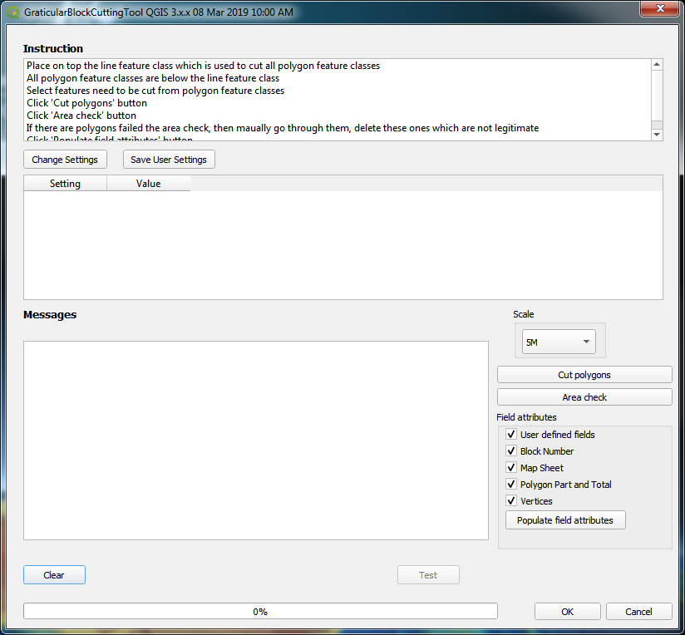

Specify setting by click ‘Change Settings’ button

**Sample of settings**

|  |  |
| --- | --- |
| **Setting** | **Value** |
| Instruction_File | C:\Users\uXXXX\AppData\Roaming\QGIS\QGIS3\profiles\default\python\plugins\**Graticular_Block_Cutting_Tool_Instruction_QGIS.docx** |
| Country | Australia |
| IP_Owner | Commonwealth of Australia (Geoscience Australia) |
| Licence | Creative Commons Attribution 3.0 Australia http://creativecommons.org/licenses/by/3.0/au/deed.en |
| Datum | GDA94 |
| Disclaimer | http://www.ga.gov.au/disclaimer/amsis |
| Epoch | AMB2001 |
| Comment |  |
| Cut: |  |
| Registry_No | C2014C00030 |
| Offshore_Area |  |
| LEGSOU: | Offshore Petroleum and Greenhouse Gas Storage Act 2006 |
| Map_Name | NEWCASTLE WATERS |
| Minimum_Polygon_Area_Hectares_App | 0.1 |
|  |  |

Setting ‘***Minimum_Poygon_Area_Hectares_App***’ defines the area of smallest legitimate polygons

* Place on top the line feature class which is used to cut all polygon feature classes
* All polygon feature classes are below the line feature class
* Select features need to be cut from polygon feature classes
  + Select the ‘cutter’ line features which are used to cut the polygons
  + Use the ‘cutter’ line features to select the polygon features to be cut
    - Goto Menu Vector -> Research Tools -> Select by Location

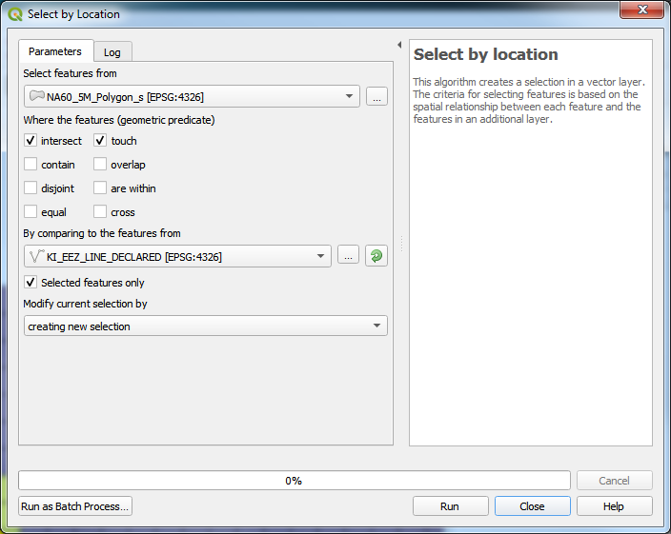

Use the following settings:

Select features from

Polygon feature class

Where the features (geometric predicate)

Intersect and touch

By comparing to the features from

Cutter line feature class

Selected features only

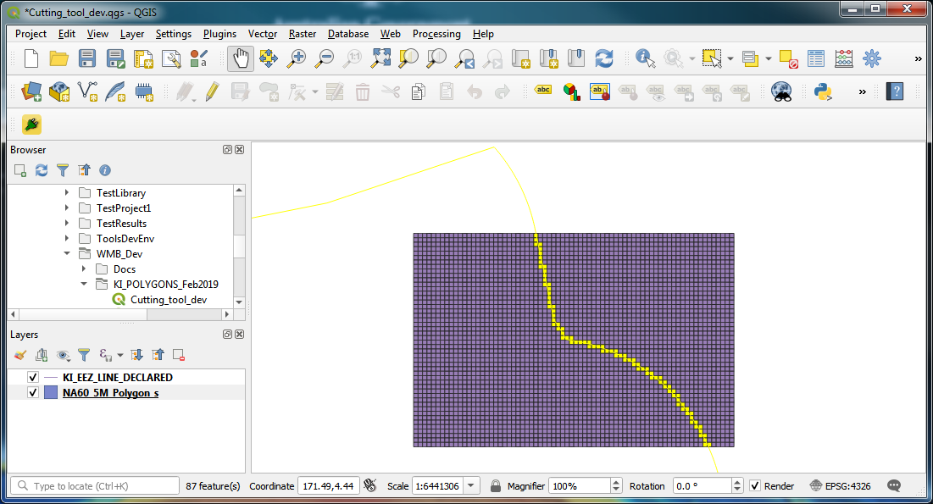

* Specify data scale (6M, 5M, 1M, 10S, 6S)
* Click 'Cut polygons' button
* Click 'Area check' button
* If there are polygons failed the area check, then manually go through them, delete these ones which are not legitimate
* Specify which ***field attributes*** to be populated
* Click 'Populate field attributes' button

**Note 1: How to find QGIS 3 Plugin folder location**

Go to menu Settings -> User profiles -> Open Active Profile Folder

From there, you can go to python -> plugins. That's the plugin folder for QGIS v3.

On a Windows machine:

C:\Users\USER\AppData\Roaming\QGIS\QGIS3\profiles\default\python\plugins

In those paths, USER will change by yours and default might change as well if you're using another profile.