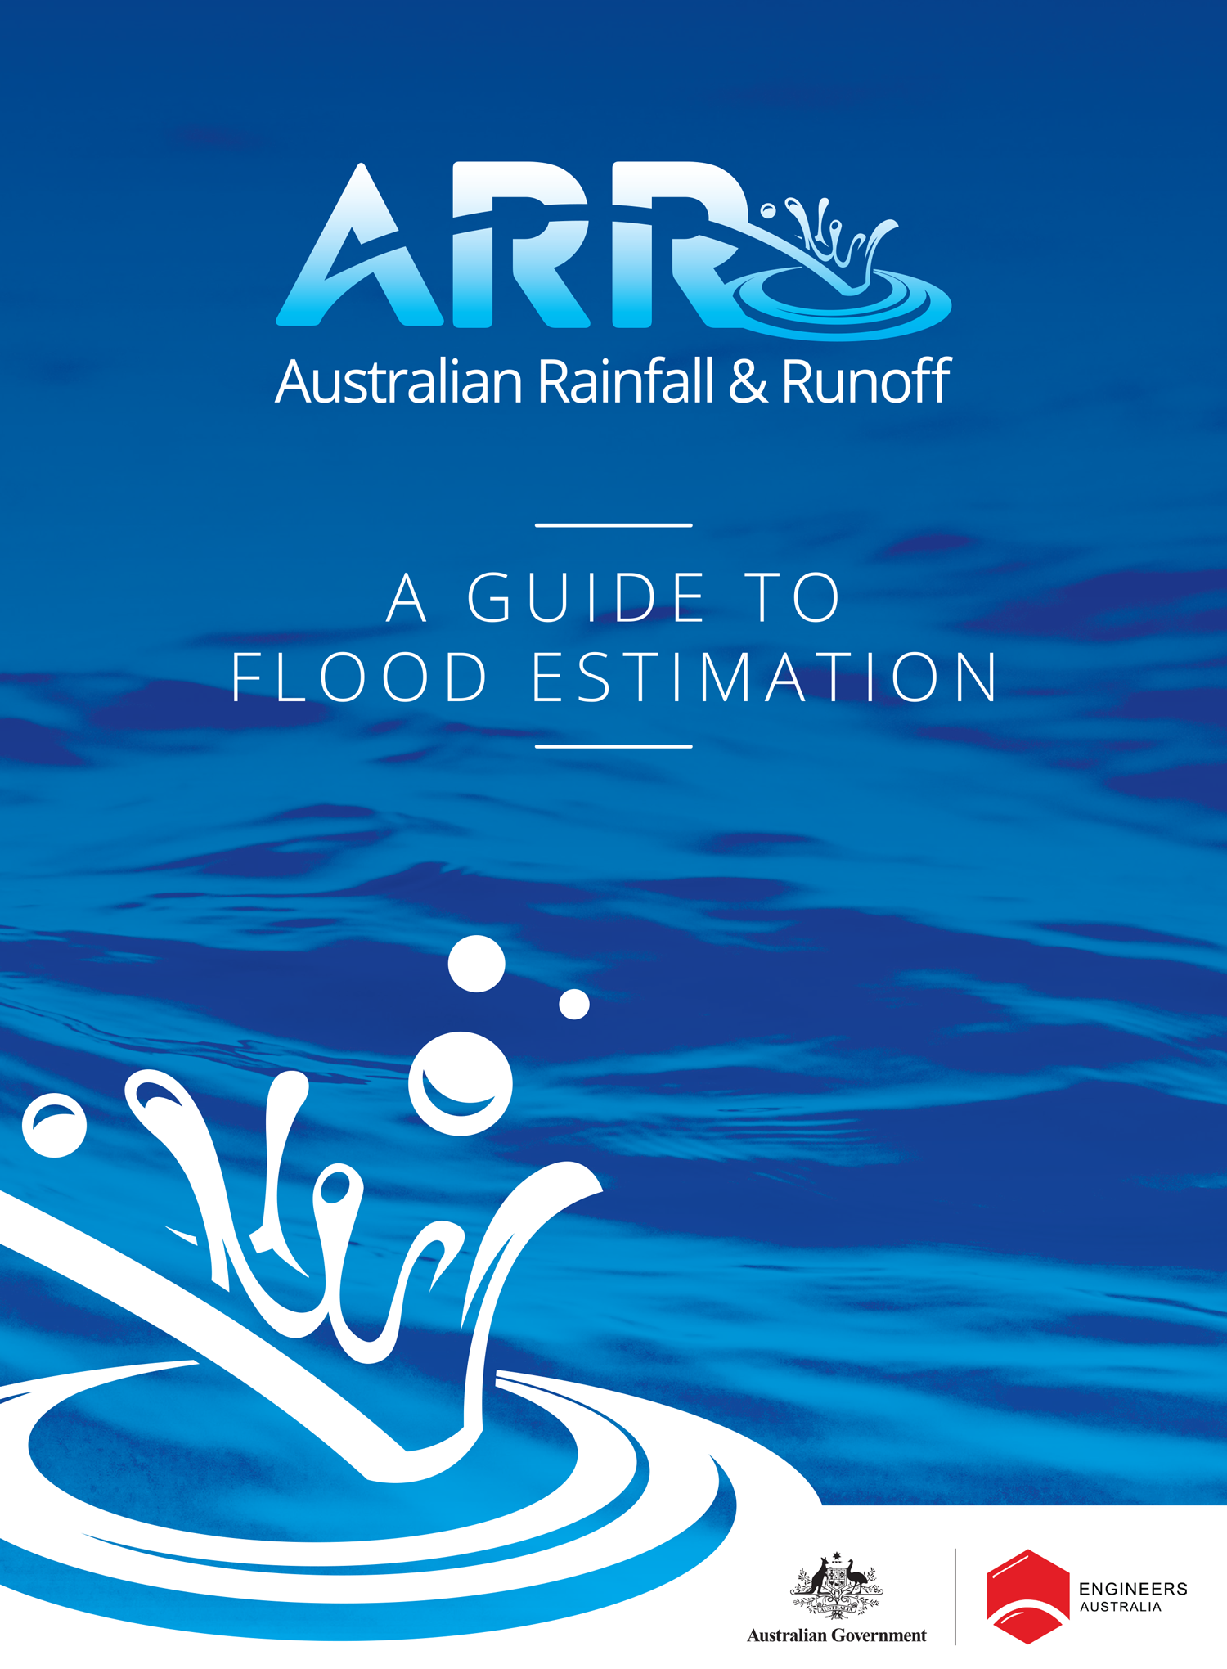

[https://lh6.googleusercontent.com/4ue9SnXsaNilcReE2vRxdSVyA0Peo5oJM5xYiQ7EgpeYNcrE4oeankS-rZANGP_N4KzAzk8v_nVIaBQJrsDJvCNXX9AGvBkzvrlsTOfis8IwcklpiW8m1Vw-nVBgTqcerPQ0Kg0](http://creativecommons.org/licenses/by/4.0/)

The Australian Rainfall and Runoff: A guide to flood estimation (ARR) is licensed under the [Creative Commons Attribution 4.0 Licence](http://creativecommons.org/licenses/by/4.0/legalcode), unless otherwise indicated or marked.

**Please give attribution to:** © Commonwealth of Australia (Geoscience Australia) 2019.

**Third-Party Material**

The Commonwealth of Australia and the ARR’s contributing authors (through Engineers Australia) have taken steps to both identify third-party material and secure permission for its reproduction and reuse. However, please note that where these materials are not licensed under a Creative Commons licence or similar terms of use, you should obtain permission from the relevant third-party to reuse their material beyond the ways you are legally permitted to use them under the fair dealing provisions of the Copyright Act 1968.

If you have any questions about the copyright of the ARR, please contact:

[arr_admin@arr.org.au](mailto:Arr_admin@arr.org.au)

c/o 11 National Circuit,

Barton, ACT

ISBN 978-1-925297-07-2

How to reference this book:

Ball J, Babister M, Nathan R, Weeks W, Weinmann E, Retallick M, Testoni I, (Editors) Australian Rainfall and Runoff: A Guide to Flood Estimation, © Commonwealth of Australia (Geoscience Australia), 2019.

**ARR 2019 Ministerial Foreword**

In late 2010 and early 2011 Queensland and Victoria were devastated by a series of storms, floods and cyclones that resulted in loss of life, significant property damage and financial loss for many communities. Events such as these highlight the challenges in predicting these extreme events as well as managing their impacts.

The Australian Government recognised this challenge and committed to the comprehensive revision of the Australia Rainfall and Runoff (ARR) guidelines.

ARR 2019 will have national application and will be essential for policy and planning decisions related to flood risk in areas as diverse as:

* infrastructure such as roads, rail airports, bridges, dams, stormwater and sewer systems
* town planning
* mining
* developing flood management plan for urban and rural communities
* flood warnings and flood emergency management
* operation of regulated river systems, and
* estimation of extreme flood levels.

The ARR was last updated completely in 1987. Since then, our understanding of the complexity of the Australian landscape has grown. This understanding has been gained through the collection and analysis of new data, reflective of Australia’s variable landscape. In previous versions of the ARR, only limited Australian data was available so overseas models were applied in many cases. The 2016 revision is based wholly on Australian data, including a national database of extreme flood hazards and 30 years of over 8000 rainfall gauges. Not only does the ARR 2016 make use of rich historical data but its digital format will allow new data and information to be incorporated as it becomes available.

The revision of the ARR would not have been possible without the support and funding from the Australian Government as well as the significant contributions from Engineers Australia members, flood practitioners and academia. This collaborative effort is a testament to the willingness of those in industry, academia and government to improve our understanding the nature of flooding. It is hoped that these guidelines will help to reduce the social and economic impacts of floods and will help strengthen the resilience of our communities.



The Hon Karen Andrews MP

Assistant Minister for Science

**PREFACE**

Since its first publication in 1958, Australian Rainfall and Runoff (ARR) has remained one of the most influential and widely used guidelines published by Engineers Australia (EA). The 3rd edition, published in 1987, retained the same level of national and international acclaim as its predecessors.

With nationwide applicability, balancing the varied climates of Australia, the information and the approaches presented in Australian Rainfall and Runoff are essential for policy decisions and projects involving:

* infrastructure such as roads, rail, airports, bridges, dams, stormwater and sewer systems;
* town planning;
* mining;
* developing flood management plans for urban and rural communities;
* flood warnings and flood emergency management;
* operation of regulated river systems; and
* prediction of extreme flood levels.

However, many of the practices recommended in the 1987 edition of ARR have become outdated, and no longer represent industry best practice. This fact, coupled with the greater understanding of climate and flood hydrology derived from the larger data sets now available to us, has provided the primary impetus for revising these guidelines. It is hoped that this revision will lead to improved design practice, which will allow better management, policy and planning decisions to be made.

One of the major responsibilities of the National Committee on Water Engineering of Engineers Australia is the periodic revision of ARR. While the NCWE had long identified the need to update ARR it had become apparent by 2002 that even with a piecemeal approach the task could not be carried out without significant financial support. In 2008 the revision of ARR was identified as a priority in the National Adaptation Framework for Climate Change which was endorsed by the Council of Australian Governments.

In addition to the update, 21 projects were identified with the aim of filling knowledge gaps.

Funding for Stages 1 and 2 of the ARR revision projects were provided by the now Department of the Environment. Stage 3 was funded by Geoscience Australia. Funding for Stages 2 and 3 of Project 1 (Development of Intensity-Frequency-Duration information across Australia) has been provided by the Bureau of Meteorology. The outcomes of the projects assisted the ARR Editorial Team with the compiling and writing of chapters in the revised ARR. Steering and Technical Committees were established to assist the ARR Editorial Team in guiding the projects to achieve desired outcomes.

**Assoc Prof James Ball Mark Babister**

ARR Editor Chair Technical Committee for

ARR Revision Projects

**ARR Technical Committee:**

*Chair*: Mark Babister

*Members:*

Associate Professor James Ball

Professor George Kuczera

Professor Martin Lambert

Associate Professor Rory Nathan

Dr Bill Weeks

Associate Professor Ashish Sharma

Dr Bryson Bates

Steve Finlay

Related Appointments:

ARR Project Engineer: Monique Retallick

ARR Admin Support: Isabelle Testoni

Assisting TC on Technical Matters: Erwin Weinmann, Dr Michael Leonard

**ARR Editorial Team:**

*Editors*:James Ball

Mark Babister

Rory Nathan

Bill Weeks

Erwin Weinmann

Monique Retallick

Isabelle Testoni

Associate Editors for Book 9 - Runoff in Urban Areas

Peter Coombes

Steve Roso

**Status of this document**

As of May 2019, this version is considered to be final. This document is a living document and will be regularly updated in the future.

In development of this guidance, also discussed in Book 1 of ARR 1987, it was recognised

that knowledge and information availability is not fixed and that future research and

applications will develop new techniques and information. This is particularly relevant in

applications where techniques have been extrapolated from the region of their development

to other regions and where efforts should be made to reduce large uncertainties in current

estimates of design flood characteristics.

Therefore, where circumstances warrant, designers have a duty to use other procedures and

design information more appropriate for their design flood problem. The Editorial team of

this edition of Australian Rainfall and Runoff believe that the use of new or improved

procedures should be encouraged, especially where these are more appropriate than the

methods described in this publication.

Care should be taken when combining inputs derived using ARR 1987 and methods

described in this document.