**Compare products from Data Cube using the inter-comparison tool**

1. Copy the link (below) into your web browser. It will ask your github password if not login yet.

<https://jupyter.mgmt.devkube.dea.ga.gov.au>

After login, users should see this start-up page:

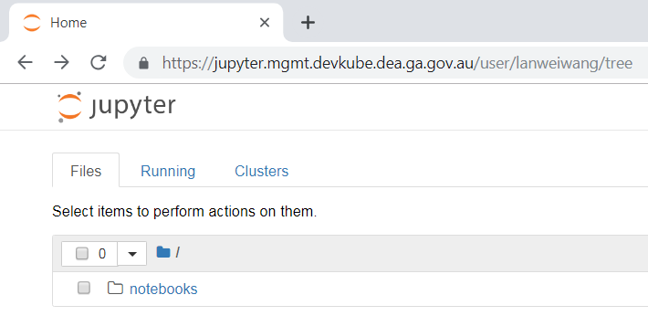

1. Click on ‘notebooks’ to expand the tree; navigate to the “inter_comparison” sub-directory and click “compare_products_opensource.ipynb”

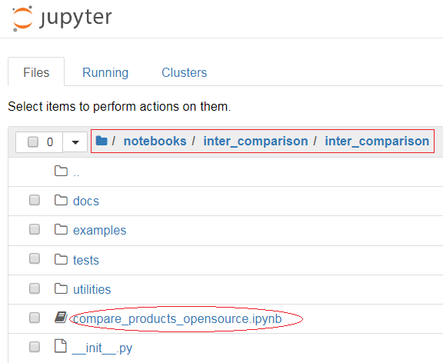

1. A new window will show up for the inter-comparison tool, but not run yet.

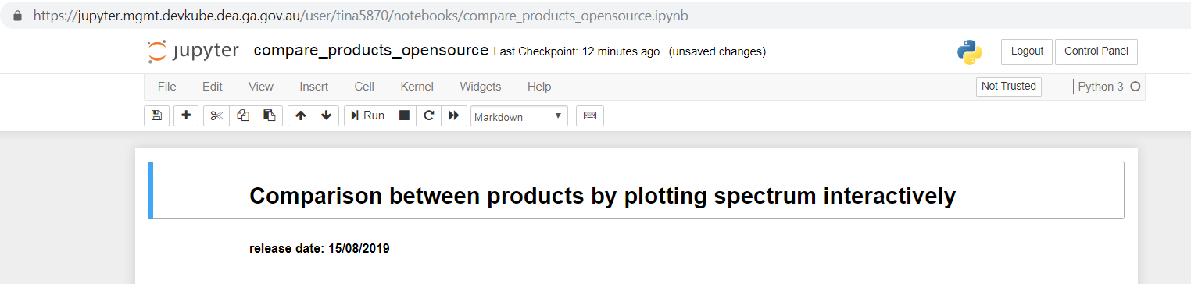

To run the tool, users can run block-by-block (for debugging purpose), or use the “Restart & Run all” command to load the GUI. For the first time, please select “Restart & Run all” under “Kernel”.

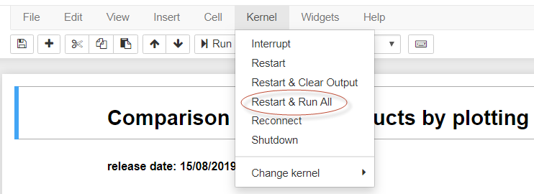

A GUI will show up inside the Jupyter Notebook. Scroll down to find the GUI located just above the “Define the plotting options and plot via a GUI” section near the bottom of the Jupyter notebook.

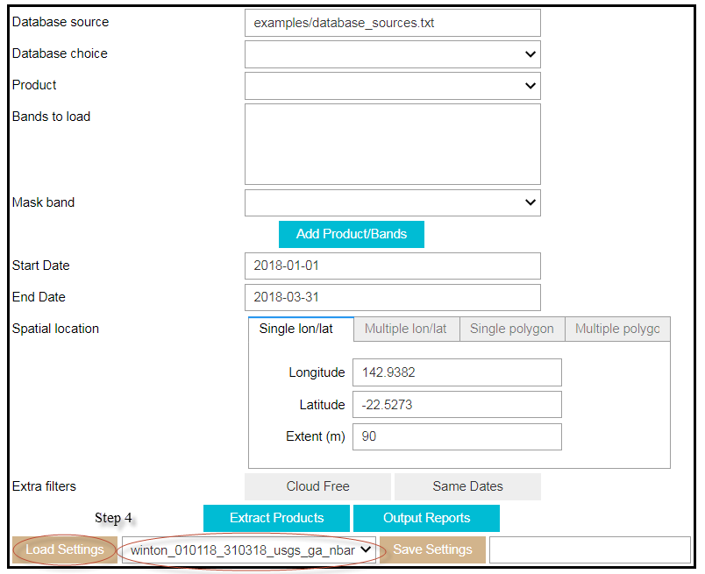

1. There are pre-saved configuration settings that include database source, database to choose, products, bands, time range and spatial locations. They can be used repeatedly for consistence and time saving purpose. For example choose ‘winton_010118_310318_usgs_ga_nbar’ from drop down menu in the bottom row and click Loading Settings. Then all fields in the GUI are populated. In this setting, all GA Surface Reflectance (SR) NBAR bands and USGS SR bands are selected for a site called Winton during the period from 01/01/2018 to 31/03/2019. The acquisitions are also filtered to only include cloud free data, and those having the same dates between GA SR and USGS SR.

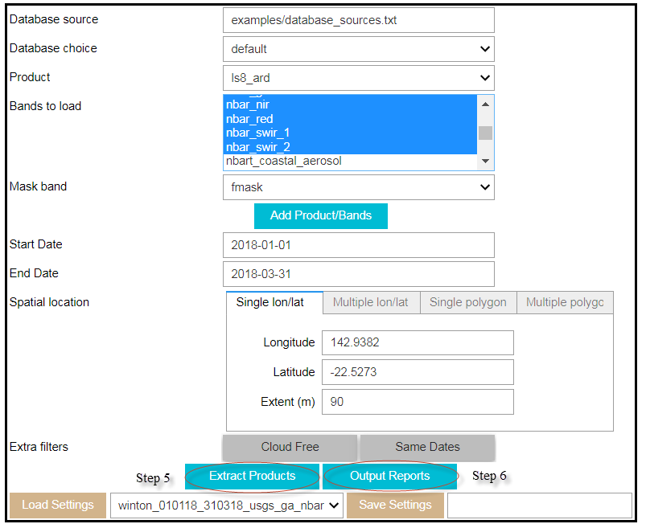

1. Click the button Extract Products to extract all products matching the criteria, which include the selected bands that will be used for visualization later. Once extracting is finished, the following information is outputted below the GUI.

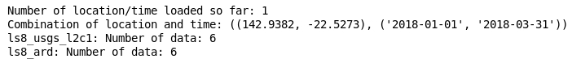

1. To export the Surface Reflectance attributes into csv files**,** click Output Reports button to generate the surface reflectance csv files. The report contains pre identified attributes for all relevant bands for the selected products. The output is displayed as follows. If some output csv files already exist, they will not be overwritten.

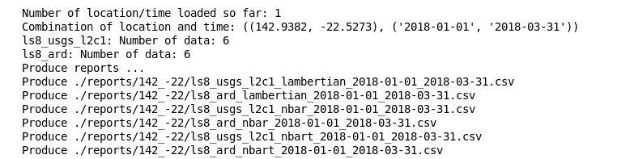

Users can see relevant csv files under the “reports” – sub directory. Three USGS SR csv files are produced to correspond to GA LAM/NBAR/NBART products respectively. As GA NBART products may have additional null data due to terrain shadows, these USGS files may have the same content, but the NBART file (~usgs_l2c1_nbart~.csv) may have less available acquisitions than the NBAR file (~usgs_l2c1_nbar~.csv).

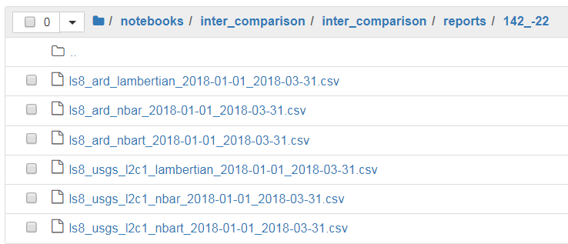

In addition to loading a pre saved configuration file, users can create their own settings by going through each step as follows. If they want to use the same settings repeatedly, they can save the current settings into a new configuration file for future use.

1. Select the cell of “examples/database_sources.txt” and press “Enter”, database choice will show up.

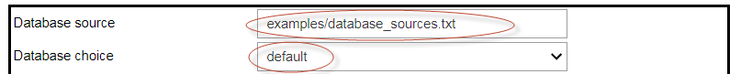

Select “default” (current operational GA Data Cube) in the “Database choice” drop list, it may take a few minutes to finish loading all available products, and users can see the working progress symbol (see below) – we are aware of the performance issue and migrating into a new AWS infrastructure in the nearest future.



1. Once product loading is finished, select “ls8_usgs_l2c1” from “Product” drop list; select “coastal_aerosol” from “Bands to load” (only this band will be used for plotting, but csv output will contain all bands), select “quality” for Mask band (use USGS Level 2 quality bands for masking), then click Add Product/Bands button.

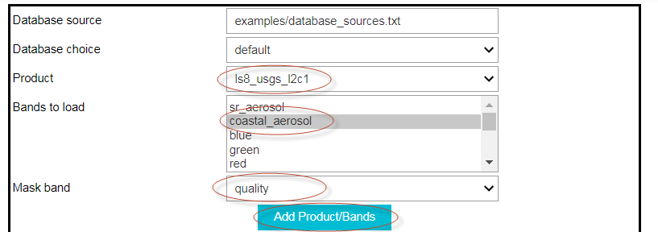

Repeat the same process for the corresponding GA SR product ls8_ard.

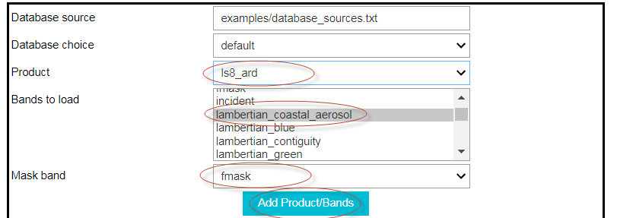

1. Choose the preferred time and location. Alternatively for first time testing purpose, keep the default start/end date and location/extents, select the two extra filters to exclude any cloud/cloud shadow affected ROIs and only extract data that have common dates between the selected products, After providing all above parameters, user can save the current setting for future use by typing a name in the Save Settings box at the bottom of the GUI. Then it will be available within the Load Settings box after the cell containing GUI is refreshed.
2. Step 5 and 6 can be repeated to extract the products and export the attribute reports.

The following part describes how to plot the selected bands for the selected products.

Under “Define the plotting options and plot via a GUI”, there are 3 blocks of code. As we already run “Restart and Run all” at step 3, all we need to do now is to run the last block of code to bring up the GUI display. Click at any place in the last block of the code, then click “Run” on the menu bar at the top, a GUI will show up.

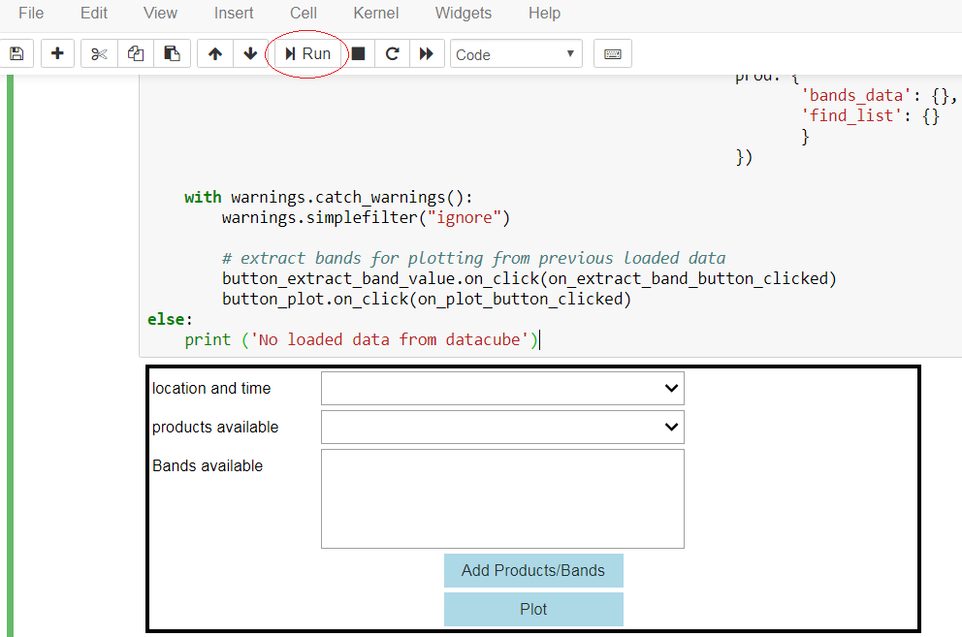

Select the “location and time” drop list, only one set of location and time we input in the above step is available for choose. Choose that location and time range, then the two selected products become available in the products available box.

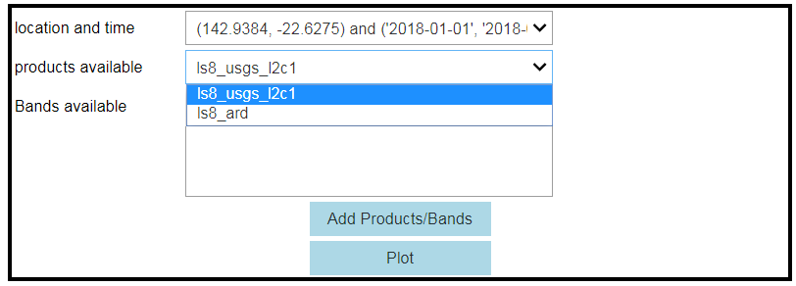

Select products/bands and click Add Products/Bands button.

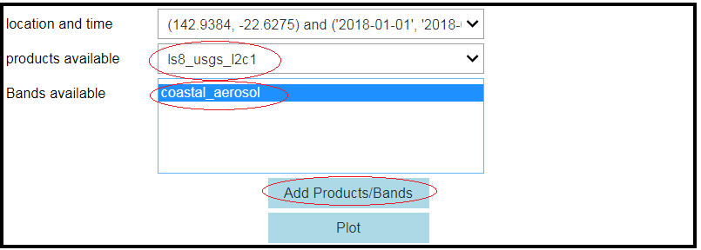

Then repeat the actions for GA products.

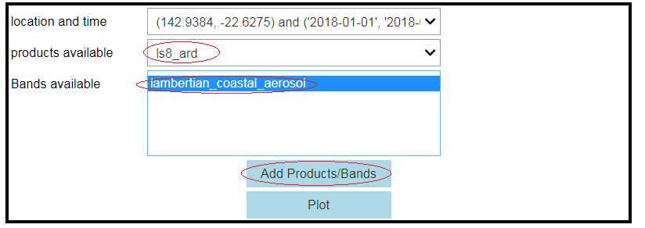

Click “Plot”, a plot GUI will show up:

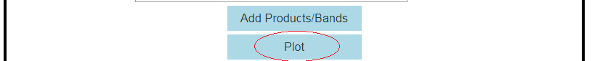

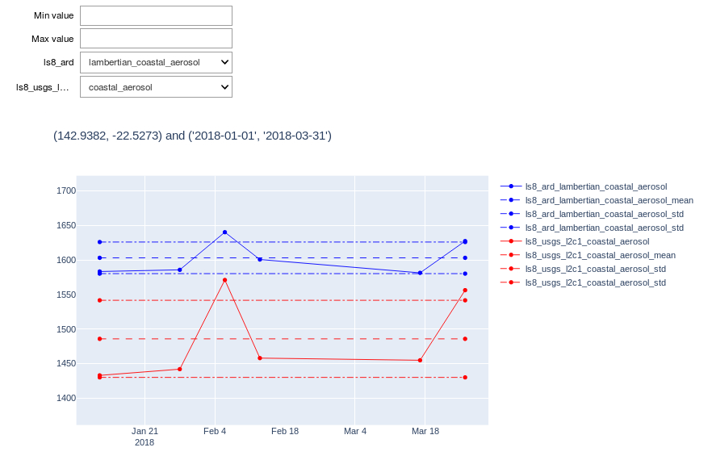

By default, the chosen bands from the selected products are displayed within its minimum and maximum value. Users can adjust min/max for display purpose (DN = 10000 means 100% reflectance) by typing the minimum value in the Min value box and the maximum value in the Max value box. For example, type 1000 and 2000 respectively for Min value and Max value box.

