Distance to vertical projection of rupture plane
Method 1 (Andres Mendez)

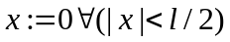 Truncate x to zero if it is within the x-range of the rupture
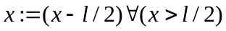 Otherwise reduce the absolute value of x by length/2
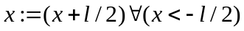

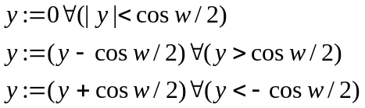Do the same for y (added complexity: cos(dip))
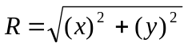

Modified Method 1 (Peter Row)

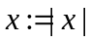 : Set x to its absolute value – we don’t need to know its signed value.
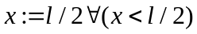 : Set x to the edge if it is inside the box
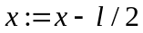 : Reduce x by length / 2

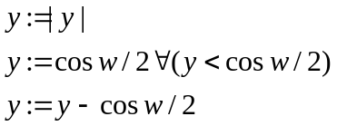 Then do the same for y

I think it is quicker.

Distance to rupture plane: Method 1 (Peter Row)
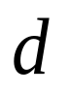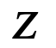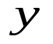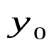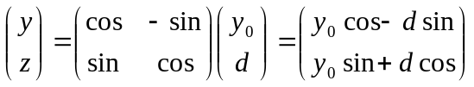: Rotate to a better frame of reference.
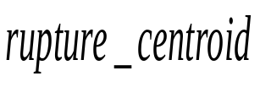
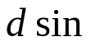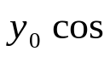
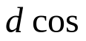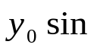
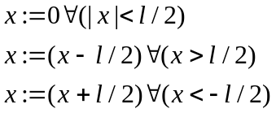
Set x to zero if it is on the rupture plane, otherwise reduce its absolute value by 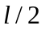.

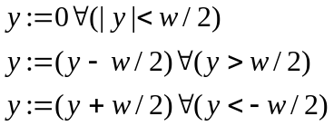
Similar for y. Note that the change of coordinate system eliminates the need to mess with transforming width, or to truncate z.

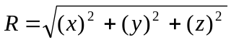

Modified Method 1 (Peter Row)

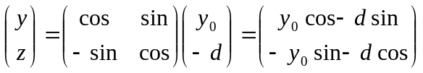: Rotate to a better frame of reference

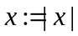

Same as method 1, but use absolute value to reduce number of operations.

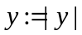: take the absolute distance to the projection of the rupture centre.
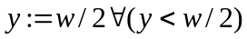: set y to w/2 if it is less than w/2
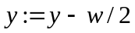 : reduce the absolute value by w/2

Method 2 (Andres Mendez)
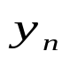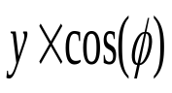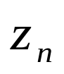
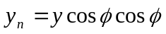,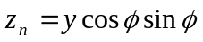: Locate the nearest point on the rupture plane
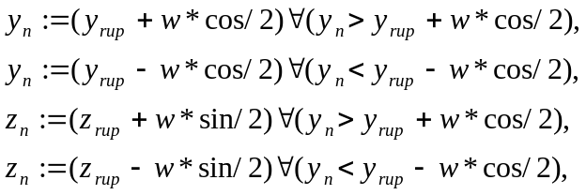: Truncate by bounded rupture plane
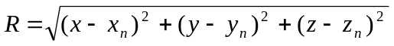
NOTE: n stands for “nearest”, rup stands from “rupture” (centroid)

