Some comments on my program NGA_GM_TMR.

13 January 2010

David M. Boore

NGA_GM_TMR evaluates four of the five PEER NGA ground-motion prediction equations (GMPEs) (not evaluated is Idriss’s GMPE, because it does not include site response). The core of the computations uses Fortran code written by Ken Campbell; I have changed the input/output. The program uses a control file to specify the values of the input variables, including the magnitude, distance, and period. This is a more general way of generating output for plotting than special purpose programs that evaluate the GMPEs vs. distance or vs. magnitude. I find that a spreadsheet (nga_gm_tmr_prepare_ctl.xls is provided) is useful in building the control file, as is a text editor that allows block operations (I use TextPad, available from http://www.textpad.com/). Here is a portion of a sample control file (from nga_gm_tmr_zips.zip, which also contains the output file for this control file):

! Control file for program nga_gm_tmr.for
! Revision of program involving a change in the control file on this date:
11/05/09
!Header to add to output file (no "!" at beginning!)
[blank]
!name of output file:
! hanging_wall_example_m7_vs30_760_fw_21.2.out
nga(new_nga_gm_tmr)_gm_vs_interpolated_periods_m_7_r_20_vs_760.out
! available periods for BA08: -1.0 0.0 0.01 0.02 0.03 0.05 0.075 0.1 0.15 0.2 0.25 0.3 0.4 0.5 0.75 1 1.5 2 3 4 5 7.5 10
! force the program to derive Ztor from RHyp and Wells and Coppersmith W by setting Ztor<0.0
! If dip < 0, the program uses generic values of 90 for SS, 55 for N, 40 for r (after CY08)
! if do not know enough to specify Rx, I think entering Rx<0 is good, as it avoids hanging wall terms
! in AS, CY (but CB will still include an effect, as it depends on Rjb and Rrup
! Note: Fhw=1 for hw; Rjb, Rrup, Rx, Zhyp, Ztor in km; Vs30 in m/s; Zsed1.0, Zsed2.5 in m (CB use km for Zsed2.5, but the NGA flatfile uses m).
! T M Rjb Rrup Rx Zhyp rake Dip W Ztor Vs30 Zsed1.0 Zsed2.5 as(1=as)
!T M Rjb Rrup Rhoriz Zhyp rake Dip W Ztor V30 Zsed1p0as08 Zsed2p5 as
0.010 7 20 20 -20 5.00 90 -1 -1 -1 760 -1.0 -1.0 0
0.020 7 20 20 -20 5.00 90 -1 -1 -1 760 -1.0 -1.0 0
0.022 7 20 20 -20 5.00 90 -1 -1 -1 760 -1.0 -1.0 0
0.025 7 20 20 -20 5.00 90 -1 -1 -1 760 -1.0 -1.0 0

Unfortunately, the input lines are wrapped in the above segment---see the actual control file for the unwrapped version (and ignore everything below the “Stop” line in the control file).

Assigning unspecified variables

Note that values of -1 have been specified for some of the input variables. In many applications some or all of these variables will not be known or easy to estimate. For the convenience of the user, I assign values to these missing variables, as follows (see the program source code for details):

Rrup: I use Scherbaum et al.’s (2004) median relation between 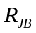 and 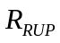.

Dip: I assign generic values, based on the rake of the slip.

W: This is assigned using the Wells and Coppersmith (1994) relation.

Ztor: This is assigned using the dip, fault width, and a specified hypocentral depth (based on Mai et al., 2005, the hypocenter is assumed to be located 0.6 down the fault width).

Zsed1.0. The Abrahamson and Silva or the Chiou and Youngs empirical relations between Zsed1.0 and Vs30 are used, as appropriate.

Zsed2.5. This is given by the Campbell and Bozorgnia empirical relation between Zsed2.5 and Zsed1.0 (from Abrahamson and Silva, if Zsed1.0 is not specified).

Interpolation of spectral values for periods not corresponding to the tabulated coefficients

The program uses straight-line interpolation of vs. 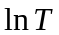. Here are two graphs showing a comparison of the PSA and sigma values from an older version of NGA_GM_TMR (for which the periods were required to be the tabulated periods) and given in the new version of the program. Note that the values shown here correspond to the sample control and output files given in nga_gm_tmr_zips.zip. These graphs confirm that the interpolation is being done correctly.

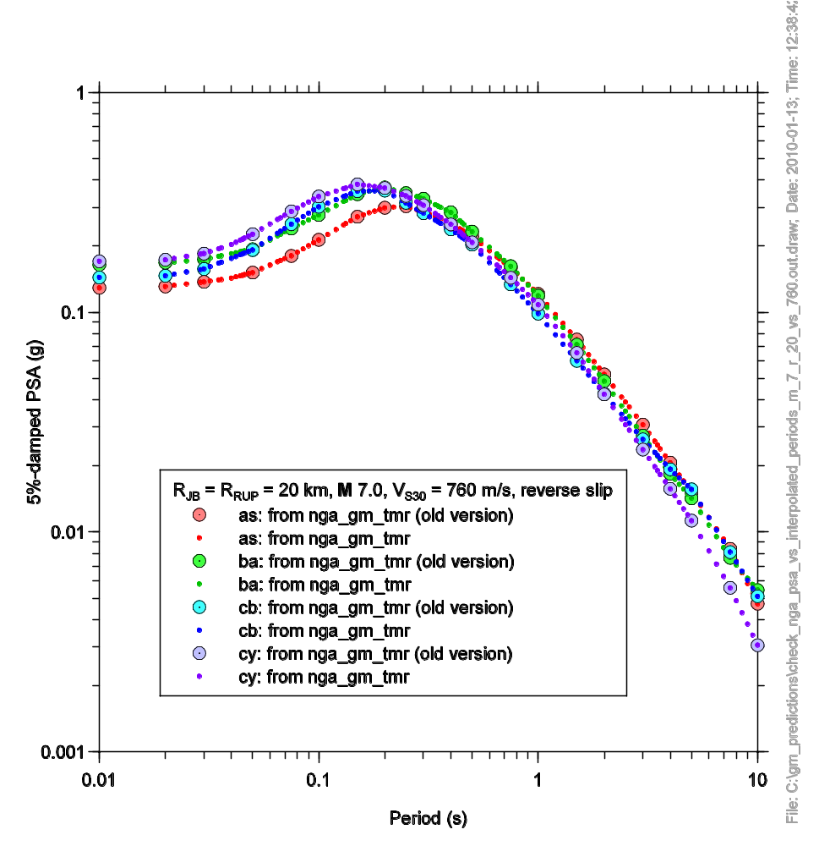
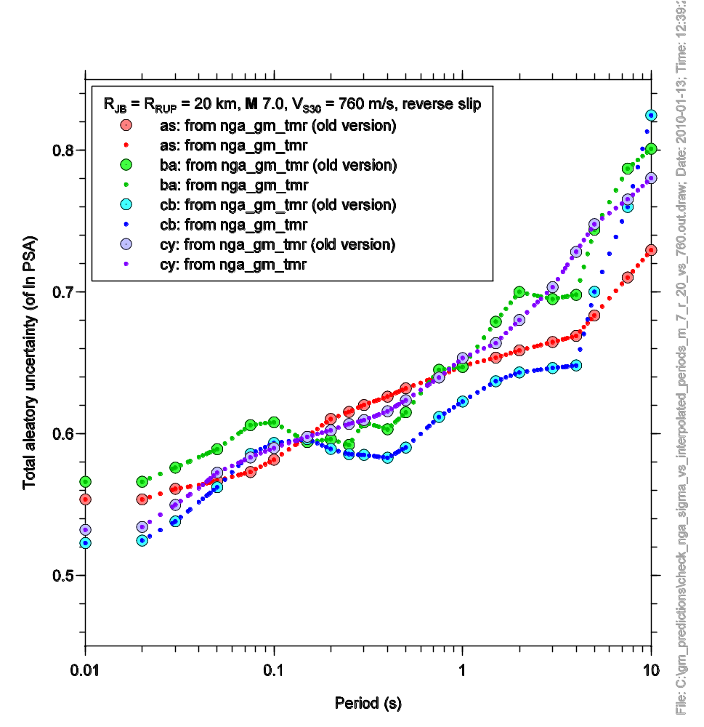

References

Mai, P. M., P. Spudich, and J. Boatwright (2005). Hypocenter locations in finite-source rupture models, Bull. Seismol. Soc. Am. 95, 965—980. doi: 10.1785/0120040111.

Scherbaum, F., J. Schmedes, and F. Cotton (2004). On the conversion of source-to-site distance measures for extended earthquake source models, Bull. Seismol. Soc. Am. 94, 1053—1069.

Wells, D. L. and K. J. Coppersmith (1994). New empirical relationships among magnitude, rupture length, rupture width, rupture area, and surface displacement, Bull. Seism. Soc. Am. 84, 974--1002.

