

GeoSciML version 3.1

Summary of changes from GeoSciML version 3.0 to version 3.1

GeoSciML version 3.0 documentation is available at
http://www.geosciml.org/geosciml/3.0/documentation/html/index.html

Ollie Raymond
IUGS-CGI Interoperability Working Group
3 December 2012

email: Oliver.Raymond@ga.gov.au

Application Schema: GeoSciML-Core

Changed cardinality of the “classifier” association between GeologicFeature and ControlledConcept to 1..* (voidable)

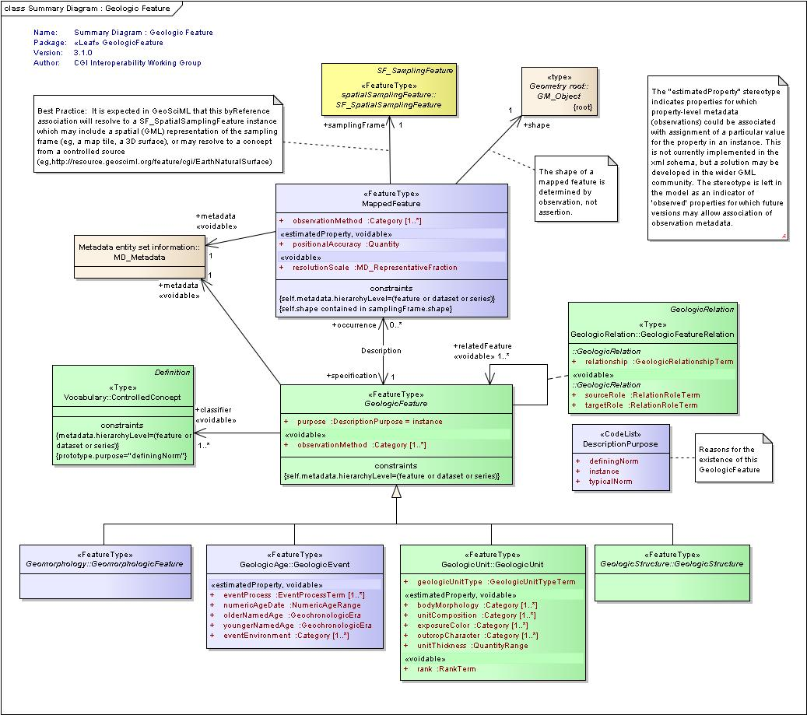
Application Schema: Geomorphology

Added new attribute to NaturalGeomorphologicFeature: “activity” (0..1). An accompanying placeholder for an ActivityStatus codelist was also added.

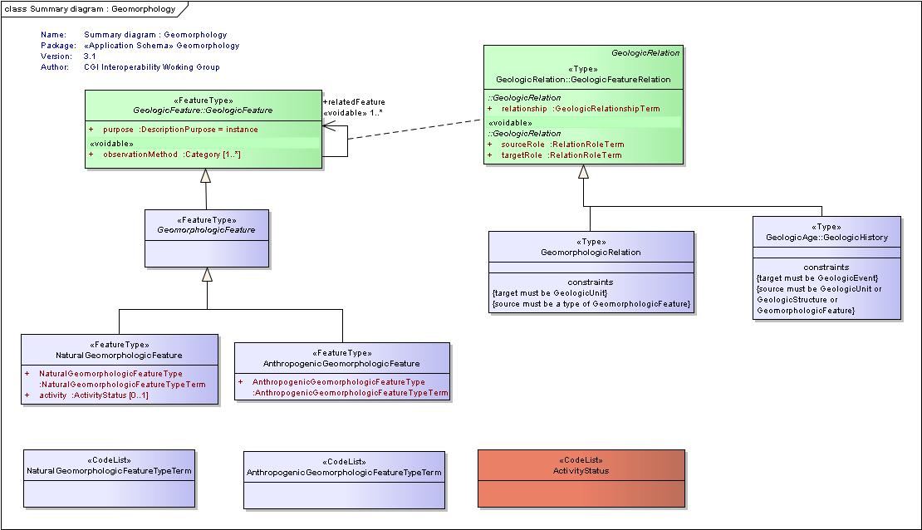

Application Schema: Borehole

New version 3.1 schema changed to import the updated GeoSciML-Core v3.1 schema.

Application Schema: Collection

New version 3.1 schema changed to import the updated GeoSciML-Core v3.1 schema.

Application Schema: EarthMaterial

New version 3.1 schema changed to import the updated GeoSciML-Core v3.1 schema.

Application Schema: GeologicAge

New version 3.1 schema changed to import the updated GeoSciML-Core v3.1 schema.

Application Schema: GeologicStructure

New version 3.1 schema changed to import the updated GeoSciML-Core v3.1 schema.

Application Schema: GeologicUnit

New version 3.1 schema changed to import the updated GeoSciML-Core v3.1 schema.

Application Schema: LaboratoryAnalysis-Specimen

New version 3.1 schema changed to import the updated GeologicAge v3.1 schema.

Application Schema: GeoSciML

New schema added which imports all of the 13 related GeoSciML application schema packages for version 3.1.

