Engineering, Economics and Exposure Project

Vulnerability and Adaptation to Wind Simulation

‘VAWS’

Version 1.1.5

Technical User Manual


Contents
1 Introduction 4
1.1 Overview 4
1.2 Project Background 5
1.3 Program Components 6
1.4 Program Logic 7
1.5 Program Data Model 8
1.6 Software Functionality 10
1.7 Software Installation 10
2 Source Code Distribution 11
2.1 Batch Interface 11
2.2 Building a EXE distribution 12
2.3 Build Environment Scripts 13
2.4 Source Code Overview 14
2.4.1 src/core 14
2.4.2 src/gui 14
3 User Interface Guide 15
3.1 Installation 15
3.2 Main Window 16
3.3 The Connection Type Editor 18
3.4 The House Information Viewer 19
3.5 Connection Viewer 21
3.6 Zone Editor 24
4 Feature Workflow 26
4.1 Configure and Run Simulator 26
4.2 Graphically Browse Simulation Results 29
4.3 House Results Tab 34
4.4 Browse and Understand Data Model 35
4.4.1 Core Component Damage Model 35
4.4.2 Debris Model 36
4.4.3 Water Ingress Model 37
4.5 Generate Vulnerability and Fragility Curves 38
5 Reporting 40
5.1 house_damage.csv 40
5.2 house_cpi.csv 40
5.3 wind_debris.csv 40
5.4 house_damaged_at_v.csv 40
5.5 wateringress.csv 40
5.6 fragilities.csv 40
6 Future Directions 41
7 Appendix A – Database Import Files 42
7.1 debris_regions.csv 42
7.2 debris_types.csv 42
7.3 mzcat_terrain_x.csv 42
7.4 house_data.csv 42
7.5 walls.csv 42
7.6 coverages.csv 42
7.7 cov_types.csv 43
7.8 zones.csv 43
7.9 damage_costing_data.csv 43
7.10 conn_group.csv 43
7.11 conn_types.csv 43
7.12 connections.csv 44
7.13 damage_factorings.csv 44
7.14 water_ingress_costing_data.csv 44
7.15 connectionzoneinfluences.csv 44
7.16 influencefactorpatches.csv 44
8 References 45

Introduction

Overview
This manual is for users of the VAWS software developed by Geoscience Australia in collaboration with JCU Townsville and JDH Consulting. The development of key input components of the software was funded by the Department of Climate Change and Energy Efficiency. The current version delivers data for a single house, the ‘Group 4’ house that models a high-set timber framed house typical of 1960’s north Queensland residential construction.

Users of this software will be able to conduct interactive assessment of the reductions of severe wind related building damage as a result of a range of adaptation strategies. Further chapters have been added to this document addressing other user roles, such as programmers and modellers.

There are four broad types of VAWS users:

- Engineers looking to research adaption strategies to a modelled house.
- Engineers looking to model a new house.
- Batch processes that need to consume fragility output on demand.
- Programmers looking to maintain and extend the python codebase.

The modelling approach taken permits the strength of components to be changed, the influence of overall vulnerability evaluated, and the benefits of structural improvements quantified.

A possible utility of this capability to the insurance industry is with assessing current risk and with assessing premium reduction incentives for property owners who reduce the vulnerability of their buildings and, thereby, the insurance portfolio risk.

Project Background
This project takes a component-based approach to modelling building vulnerability. It is based on the premise that overall building damage is strongly related to the failure of key connections and members. If these failures can be ascertained, and associated damage from debris and water penetration reliably estimated, scenarios of complete building damage can be assessed. This approach has been developed with varying degrees of rigour by researchers around the world and is best practice for the insurance industry. This Australian project involves the integration of existing Australian work and the development of additional key components required to complete the process.

More recently the scope for applying this approach has widened. The effects of climate change on severe wind likelihood are now the subject of serious consideration. Present forecasts suggest that the wind hazard in some Australian regions will be gradually exacerbated and strategies for the progressive adaptation of infrastructure need to be developed. In particular, increased investment in infrastructure needs to be balanced with quantified benefits to communities. In the first instance this is with the reduction in direct damage, but ultimately the assessment process needs to include reductions in human casualties and business disruption.

The project work program for 2009/2010 was scoped at an expert workshop convened at James Cook University in Townsville. The development of this software prototype is seen as a first step in advancing this adaptation research that will inform policy decisions into the future

The range of building types in any urban environment is wide. Buildings differ as to geometry, structural system, architectural finishes, and design standard, quality of construction, age, and extent of retrofit/refurbishment and maintenance level. All of these variables translate into differences in wind vulnerability that are generally wind direction specific. It is not possible to develop a comprehensive suite of vulnerability relationships to capture precisely this variability in exposure. The pragmatic approach adopted by this software is to assign buildings to one of a limited number of categories, or types, with the residual vulnerability differences within one of these “pigeon holes” captured as an uncertainty in the vulnerability relationship attributed to the type.

Further sources of uncertainty are associated with the wind event itself and the effects of upwind structures in influencing the damage outcomes. Wind is a turbulent and stochastic phenomenon that exerts time dependent dynamic forces on structural elements. The generalisation of these effects to static and correlated building component loads also introduces further uncertainties. Further sources of uncertainty are associated with the attribution of repair cost to damage scenarios which will be influenced by insurance loss assessment process and the quotes by builders that will follow.

Program Components
From a systems perspective: the tool loads a house structure from the database, runs a Monte Carlo simulation of wind damage to randomised houses and outputs the resulting damage as fragility curve coefficients. The simulation and house structure may be customized via the GUI and Scenario file.

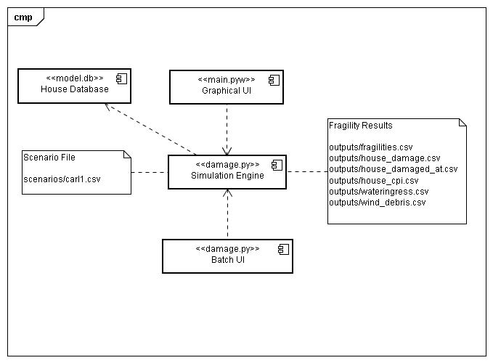

The scenario file is human readable and may be directly edited, although the GUI provides a nicer way to do this. The housing database is created offline and provided as a read only reference data source.

The various output files have evolved over time to include much disaggregated simulation information. The primary output from a systems perspective is the ‘fragilities.csv’ file, which would feed other components simulated fragility curves for a given house scenario.

The GUI provides a richer set of views on the simulation inputs and results. It provides the following high level operations: editing scenarios, viewing house structures stored in the database, running simulations and viewing results.

Program Logic
The program is built around the following high level sequence:

- Initialize the debris module with specified settings.

- Run for ‘n’ iterations:

  - Generate a house by sampling various factors.
    - Wind direction.
    - Wind profile and resulting boundary envelope.
    - Zone pressure coefficients.
    - Construction quality level.
    - Connection strengths and dead loads.

  - For each wind speed from lowest to highest, split into ‘s’ steps:
    - Generate debris for the current wind speed and check for a pressurization event.
    - Calculate the free stream wind pressure (qz), optionally applying a regional shielding factor.
    - Calculate zone pressures from qz.
    - Translate zone pressures into connection loads.
    - Determine which connections have failed and redistribute loads as appropriate.
    - Check for total house collapse event and force if triggered.
    - Cost the External Envelope damage:
      - Calculate percentage breakage per connection group.
      - Translate percentage into repair cost via damage scenarios.
    - Cost the Internal Lining damage from Water Ingress.
    - Calculate damage index.

- Produce outputs: fit four fragility level curves.
  - Many other results collected and displayed.

Program Data Model
The need to store multiple complex house structures and dynamically switch between them led to the use of a database model. A primary driver of the design was the anticipated requirement to model different structural types and to minimise the special code paths required to support each model: In other words drive the system with data rather than code.

The read only database is created offline at Geoscience Australia by our team and requires access to the source code distribution and is shipped as ‘model.db’. There is currently no editing supported as the database represents a large amount of investment.

It is important to understand the concepts and relationships represented in the following diagram:

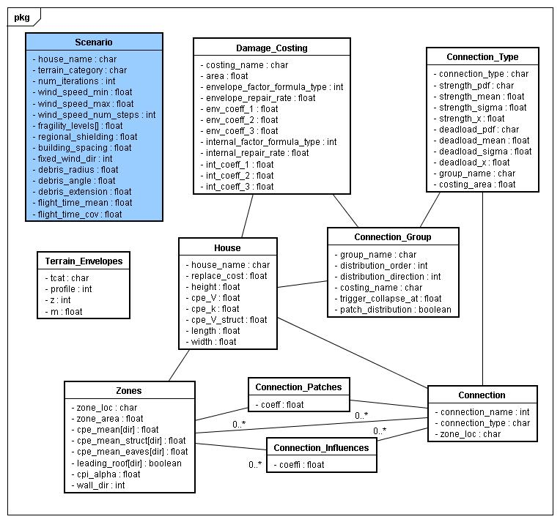

- Scenario: not part of the database itself, but on this diagram given its key importance to the system. Represents the user settings needed to recreate a simulation at a later date.

- House: the structure to be simulated, it has a list of spatial zones, connections, damage costing scenarios and connection groupings. It also has basic spatial, statistical and costing attributes defining the house.

- Zone: models a rectangular 2d area located at a zone grid coordinate, e.g “A1”. A zone has an effective area and a pressure applied to it at runtime that influences load onto connections via the Connection_Influences relation table.

- Connection: models a physical structural connection that will bear a simulated load and when broken cause load to be distributed and generate damage outcomes. Strength and dead loads of each connection will be simulated at runtime. A connection ‘lives within’ a zone location.

- Connection_Type: models a type of connection sharing the same strength and dead load statistical characteristics and costing area. Every connection has exactly one type.

- Connection Group: models a collection of Connection_Types for the purposes of abstracting out common distribution and costing behaviours. These may be enabled and disabled from the model by the user as a group.

- Connection_Influences: models the influence that each zone has on each connection, used to calculate a summed load on each connection at runtime. These values represent the structure of the house, or where individual connections take load from on a structure.

- Connection_Patches: when connections of a certain group break under load, the structure of the house changes. These relations define how the existing set of influences is patched at runtime to reflect this. A connection may patch many arbitrary influence coefficients.

- Damage_Costing: defines how connection damage will be translated into a quantity surveyor based damage cost.

- Terrain_Envelopes: defines various boundary layer profiles that will be randomly sampled at runtime.

Software Functionality
This release of the focuses on these key functional areas:

- Run the simulator and configure its parameters.
- Graphically browse and understand simulator results.
- Browse the data model being used.
- Modify probability distributions relating to connection strengths and zone pressures.
- Generate fragility and vulnerability curves.
- Produce detailed damage reports to ‘outputs’ folder.

Software Installation

For normal users of the tool that just need to run the application, an easy to use windows installer is provided as an installable executable. Double click on this file and the follow the prompts to install the product. Shortcuts will be created in the start menu:
- Run the simulator (“Start->Programs->VAWS->Run VAWS”).
- View this PDF manual.
- View the release notes.
- Uninstall the client.

A desktop shortcut for “Run VAWS” will also be added to the current user.

See later chapters for a user guide discussion of the core application.

Source Code Distribution
If maintaining the tool or as an advanced modeller, you may wish to view the full source code distribution. You will need the following python environment available on your machine (the latest version of these files at time of writing may be found in C:\temp\projects\windtunnel\thirdparty).

- Standard Python 2.6.x release: recommend download of pythonxy package from the internet. This advanced distribution includes the following sub components:
  - Qt4.x and PyQt bindings.
  - scipy and numpy.
  - matplotlib.
  - mingw.
  - Eclipse editor with PyDev installed.
- SqlAlchemy 0.6.x
- NSIS installation tool (also helps to install eclipse plugins).
- Cygwin with subversion installed.
  - Repository currently at file:///cygdrive/h/svnrepos/windtunnel/trunk
  - The bash shell is required to run build scripts.

Batch Interface
If you have access to the source code distribution of VAWS (for example you are a programmer or data modeller) you may run the tool from the command line, provided you have the correct python environment installed. The interface supports:

- Command line testing and plotting.
  - python damage.py –-verbose –s ../scenarios/test1.csv

- Automated tool usage by other systems (consumers of outputs).
  - python damage.py –s ../scenarios/test1.csv

When running this way your current directory should be ‘src/core’. The main script is called ‘damage.py’ and has the following usage:

$ python damage.py –help

--version show program's version number and exit
-h, --help show this help message and exit
-s FILE, --scenario=FILE
read scenario description from FILE
-m FILE, --model=FILE
Use Model Database from FILE
-o FOLDER, --output=FOLDER
folder name to store simulation results
-v, --verbose show verbose simulator output
-i FOLDER, --import=FOLDER
data folder to import into model.db
--plot_vuln show vulnerability plot
--plot_frag show fragility plot

Several other python modules have important, unit-test driven entry points that you may wish to research if coding. You may directly edit the scenario CSV files if you understand the format.

An example new programmer scenario might look like:

- Install requirements and be able to create and run pydev projects, be able to run the QtDesigner (ie designer.exe).

- Launch a cygwin shell and type:
  - mkdir projects
  - cd projects
  - svn checkout file:///cygdrive/h/svnrepos/windtunnel/trunk <project_root>
    - <project_root> is the folder name you choose for this projects working area, for example ‘VAWS’.
  - cd <project_root>/src/core
  - python damage.py –version

- Once that works, try and run the GUI:
  - cd <project_root>/src
  - python main.pyw
  - clicking the RUN button should work.

Building a EXE distribution
The project should run as a standalone windows program without external dependencies (on python, matplotlib, scipy, etc) on a clean windows PC. There are several tools available that assist with this process. The problem consists of discovering all python and python module dependencies, gathering them up in a single folder and creating a windows executable called main.exe that reflects the logic found in main.pyw

Installation of the simulator will therefore not interact with (or require) existing python installations on the client desktop. Various alternatives were considered, including PyInstaller, cx_Freeze and bbfreeze. Some of those tried to bundle all the python binaries into an internal “resource” so to ship as a single (large) main.exe. This would be the preferred outcome; however none of these tools could handle our project dependencies. Of these PyInstaller seemed the most promising, but the EXE would crash on exit.

The module py2exe was chosen to create a binary distribution folder. You may find the details in src/setup.py. A simple set of (bash) build scripts are provided to create the final ‘dist’ folder.

NSIS was chosen to package up this binary distribution for public distribution, you can review the script at: <project_root>/setup.nsi.

Build Environment Scripts

The decision was made to build components using a set of simple BASH scripts. This was considered to be a simpler, yet adequate technique as opposed to ant scripts or make files. The NSIS program was chosen to build the windows installers. There are several components that need to be built; you need to run the script from the parent folder:

- The pyqt gui bindings to the Qt screens (src/gui/ui) used by the application:
  - projects/windtunnel/src/gui/build.sh
    - Bundles qt resources:
      - WindSim_rc.py (from WindSim.qrc)
    - Creates bindings:
      - <screen>_ui.py (eg main_ui.py from ui/main.ui)

- The database file shipped with the product as model.db (a sqlite3 database):
  - projects/windtunnel/src/core/build_db.sh
    - Runs “python damage.py –i <datafolder>”.

- The custom C extension called ‘engine.pyd’:
  - projects/windtunnel/src/core/build_ext.sh
    - Uses mingw to compile engine.c.
    - Depends on gsl-1.11 to provide some stats helpers.
    - Implements key component of debris module.

- To clean the source code of all built components:
  - projects/windtunnel/clean.sh
    - triggers a recursive clean.sh call.

- To build the binary windows installer:
  - projects/windtunnel/build.sh
    - Builds all components mentioned above.
    - Creates a source distribution staging area.
    - Runs the distutils script to generate py2exe ‘sdist/dist’ folder.
    - Runs NSIS script to produce the installable exe file.

Source Code Overview

The python code in ‘src’ is split into two main packages: ‘core’ and ‘gui’.

src/core

The core module represents the engine of the simulation and is driven by the damage controller script. Each data entity from the model is represented by a separate python file. Other modules assist for specific tasks, such as curve, debris and database.

The SQLAlchemy ORM framework is used to manage persistence of the house data model. You will need to read the introductory material on that package. Usage of the package is kept simple and is contained mainly within the database and house modules.

A custom profiling aspect is implemented via the carlprofile module; you may annotate any method with ‘@profile’ to receive detailed timings.

The debris module uses a statistical engine implemented in C, you can use the build_ext.sh script to build this. Parts of the debris module are also in this C module for performance.

src/gui

The program uses the Qt frameworks provided by pythonxy to deliver an advanced GUI to the user that wraps the core simulation engine. It is recommended that your read the first few chapters of “Rapid GUI Programming with Python and Qt” by Summerfield,

The GUI screens are defined by the QtDesigner application and files within the ‘src/gui/ui’ folder. Python bindings to these screens are created by running the ‘build.sh’ script. This script also creates python bindings to the image resources used by the toolbar.

You will need to run the ‘install_surface.sh’ script once in order to integrate the custom matplotlib widgets into the Designer.

User Interface Guide

The normal user of this tool will be assumed to be familiar with windows applications and their operation. No assumption is to be made about their use of python or other internal dependencies. They install the program like any other windows program and launch it via the start menu shortcuts installed.

Installation
The user will double click the provided installer.exe and click through a simple wizard to install the software. By default the software will be installed into C:\Program Files\VAWS. It may be uninstalled via the Control Panel:

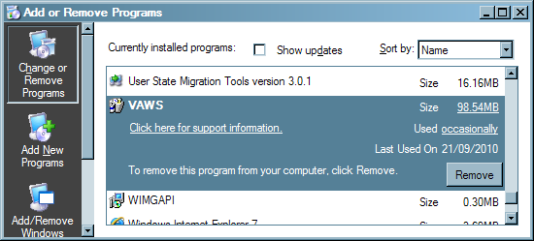

A desktop shortcut to launch the program with a house icon will also be created. When the user launches the program for the first time they will be asked to select a scenario file, select one of the ones provided to start from.

Main Window

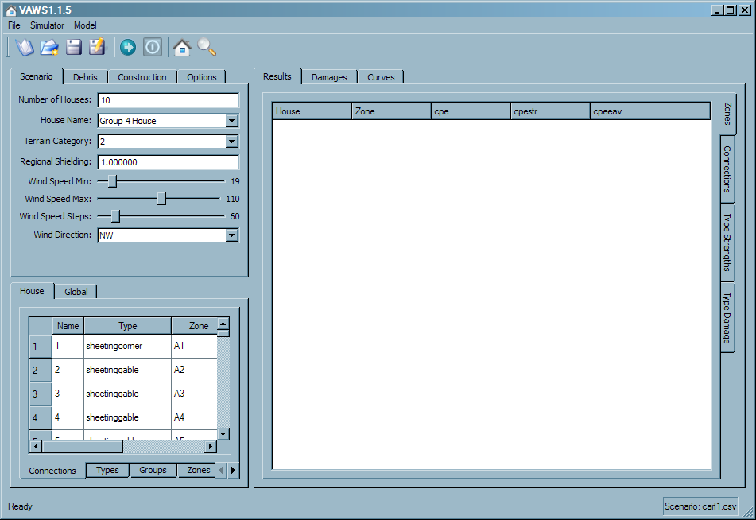

The main window is logically separated into distinct areas of functionality:

- Top: Toolbar with action buttons:
  - Open a scenario
  - Create a new scenario with default settings.
  - Save current scenario.
  - Save current scenario to a new file.
  - Run the scenario
  - Stop the simulator when in progress.
  - View the current house information (including wall coverages)
  - Show detailed information for selected connection/zone.
- Bottom: Status bar, showing flyover zone information and current scenario.
- Top Left: Simulation Settings: Tabs breakout functional groups.
- Bottom Left: Data Browser: Tabbed with new Global data visible.
- Right: Tabbed results viewer:
  - Results:
    - Zones: list of sampled zones.
    - Connections: list of sampled connections.
      - Expand damaged connections for detailed breakout of influences.
    - Type Strengths: scatter plot of sampled strengths broken out against connection types.
    - Type Damage: scatter plot of observed damage wind speeds broken against connection types.
  - Damages: one damage heatmap for each connection type group. These heatmaps show average breakage speeds observed per connection type and zone location.
  - Curves: This area plots results and outputs from sub models.
    - Vulnerability Curve: shows a scatter plot of observed damage indexes at each increasing wind speed bucket. It also shows a curve fitted through the means.
    - Fragility Curve: plots the fitted fragility level curves, which reflect observation counts falling within certain damage ranges. The coefficient of the lognormal cdf curves fit here are the primary system output.
    - Water Ingress: shows a scatter plot of the costing associated with water ingress by wind speed.
    - Debris: shows mean debris supplies against wind speed.

The “left” and “right” sides are separated by a splitter bar that may be dragged to either side for focusing on either results or data.

The Connection Type Editor

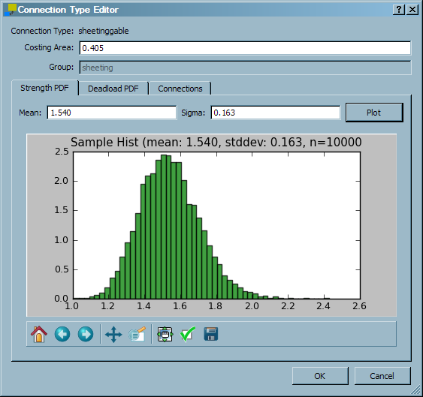

Double clicking on a “connection type” will allow the user to make runtime changes to a connection types’ strength and deadload probability distributions. These changes are not saved. The user may interactively sample from specified distribution.

The House Information Viewer

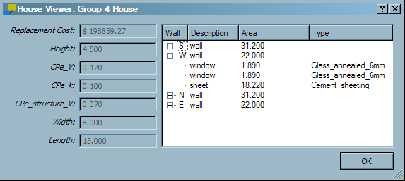

This dialog is accessed by clicking the far right ‘house’ toolbar button and from the “Model->House Info…” menu item. It shows the house replacement cost, height and structural factors used as parameters when sampling zone pressures from GEV Type III distributions.

Cpe_V and Cpe_structure_V are coefficients of variation for a GEV Type III distribution, used to sample zone pressures. Cpe_k is a shaped factor for same. Attached on the next page is the relevant material (courtesy of JDH Consulting)

Walls and their attached coverages are shown as children: This data is used by the debris module when simulating debris impact on the house footprint, generated from the house width, height and current wind direction.

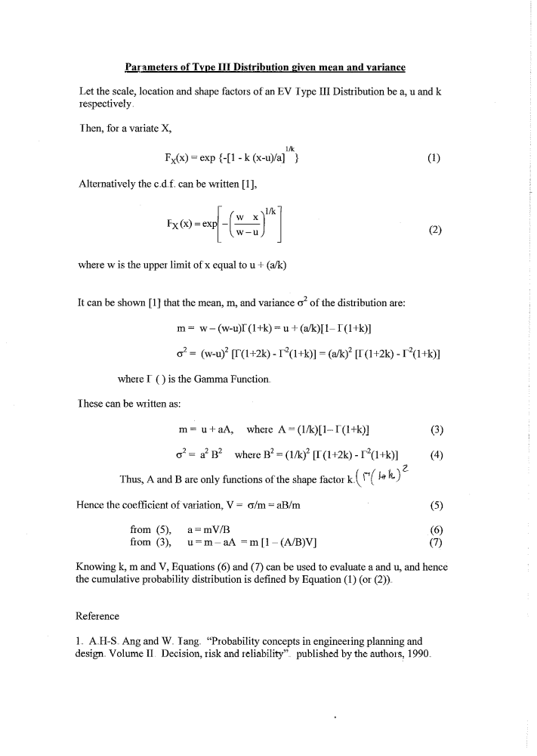

Connection Viewer
This dialog can be accessed by double clicking on a connection in the connection table or by selecting a connection and pressing the ‘info’ toolbar:

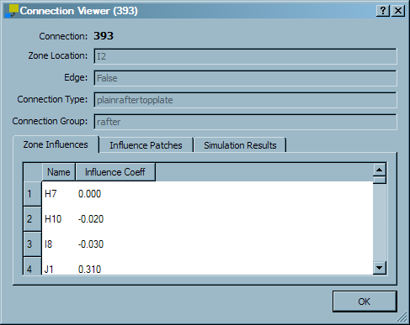

The header shows the location connection name, location zone, edge status, connection type and connection type group as read-only fields (all connection information is read-only).

The ‘Zone Influences’ tab shows the zones that this connection has load attributed from and their loading factors. A more complex connection like this rafter will have many such influences.

The ‘Influence Patches’ tab shows the changes made to zone influences (globally) when this connection is damaged. For example:

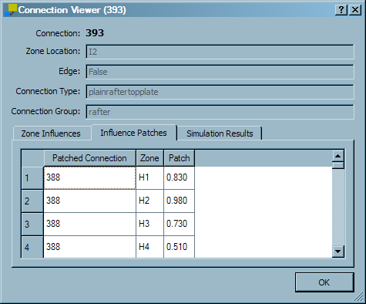

This can be read as “when connection 393 breaks, patch the influence from zone H1 to 388 to be 0.83” and so on.

The ‘Simulation Results’ tab will be populated after a simulation has been run:

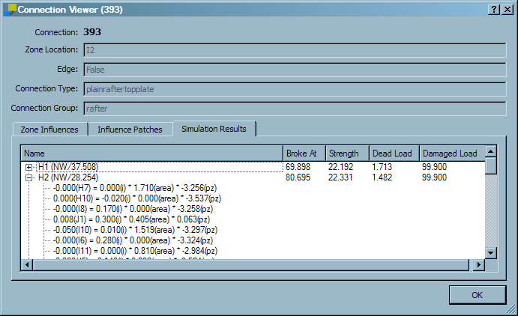

The first column shows the House number (Wind direction/internal pressure speed) and the other columns show connection information for that simulation. If you expand the house node you are given a detailed breakout of influence loads that lead to the breakage:

Note that this connection is the most complex rafter type. For each influence we show the load calculation used at the time of damage, eg:

-0.001 (A1) = -0.050(i) * 0.203(area) * 0.139(pz)

If you sum these load contributions and add the dead load you should equal the ‘Damaged Load’ column for that connection for that house.

Zone Editor
This dialog can be accessed by double clicking on a zone in the zones table or by selecting the ‘info’ toolbar button with a zone selected:

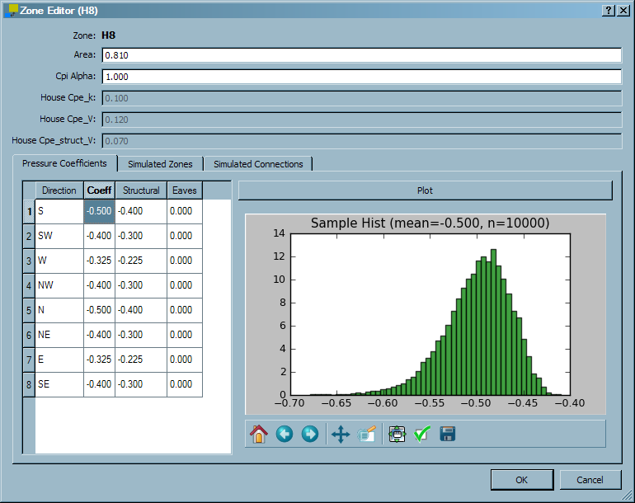

The zone header contains editable fields for zone area and cpi_alpha, as well as read-only values from the house that effect the Type III GEV probability distribution. The first tab shows the directional pressure coefficients for the zone. These may be edited directly in the table and plotted. Be aware that the plot may take some time as the GEV distribution is computationally expensive.

The ‘Simulated Zones’ tab shows the actual sampled coefficients from the last simulation run.

The ‘Simulated Connections’ tab shows detailed connection results for the connections located within the zone. A filter is provided to limit connections to those matching a particular connection type group.

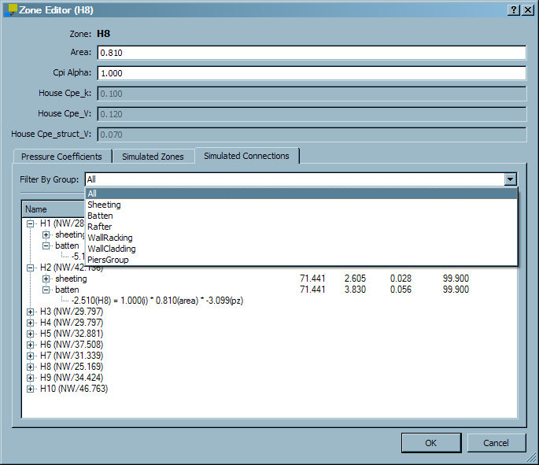

Feature Workflow

Configure and Run Simulator

The following simulator settings may be changed (spread amongst different tabs):

- Scenario/House Name: At the moment only the “group 4 house” is available. In the future it is hoped that others will be added. The houses are shipped with the product as a “model.db” sqlite3 database file.

- Scenario/Number of Houses: how many houses should be “sampled” and simulated.

- Scenario/Terrain Category: defines the set of 10 boundary profiles to sample from based on a report by JDH Consulting titled “Randomized wind gust profiles for vulnerability modelling” Terrain category 5 denotes a ‘downburst’ wind event.

- Scenario/Regional Shielding Factor: variable shielding parameter; wind speed modifier, if this is > 0.85 it has no effect on the simulation. When less than 0.85, Ms is sampled from a PDF (1.0, 0.95 or 0..85) provided by JDH Consulting titled “Variability of shielding effects for vulnerability modelling”. The modification looks like:
  - Vmod = (V * Ms) / regional_shielding_factor

- Scenario /Wind Speed Min: each house will be subjected to a range of wind speeds starting from this value.

- Scenario /Wind Speed Max: maximum wind speed to stop simulation at for each house.

- Scenario /Wind Speed Steps: number of wind speed steps to get from min to max.

- Scenario /Wind Direction: if “Random” then each house will have a random wind direction chosen, else each house will be subjected to the selected direction.

- Debris/Debris Region: Defines the characteristics of debris items generated, including proportions of debris types and number of debris items per V.

- Debris/Building Spacing: differential shielding parameter; if this is set to zero then differential shielding is disabled. If 20 or 40 then a modification is made to the calculate of pz:
  - zone_pz = qz * (zone_cpe – cpi) * differential_shielding

- Debris/Radius: Defines the maximum horizontal distance in meters used to generate upwind debris sources.

- Debris/Angle: Defines the angle of the cone used to generate upwind debris sources.

- Debris/Source Items: Defines the maximum supply of debris items generated per source for each wind delta.

- Debris/Flighttime Mean & Cov: Used by the debris module to sample flight times for debris items from a lognormal distribution. Note that in this case these values are direct values (unlike connection strengths… we will fix this so that all user input for lognormal samples are direct values).

- Debris/Extension (m): This allows you to extend the downwind footprint of the house by the specified number of meters.

- Debris/Options/Staggered Sources: If checked the debris module will stagger upwind debris sources, rather than use a strict grid.

- Debris/Options/Enabled: If checked the debris module will be enabled.

- Debris/Test: click to test run the debris module with the current settings and show a plot of the resulting debris field.

- Construction/Enabled: If checked the building quality factoring will be enabled.

- Construction/Test: Will ask the user to specify a connection type to test with and then plot an example sampling of the current construction settings. Note that the user must ensure the probability numbers add up to 1.0.

- Options/Red_V & Blue_V: These values define custom overrides for the hot and cold colours used by the damage heatmaps. It can be useful tweaking these to get better colour information. The default values of ‘40/80’ have been found to give generally good results. You may apply these values by pressing the “Update Display” button.

- Options/Distribute Damage: enable damage distribution.

- Options/Seed Random Numbers: If checked random numbers will be the same each time.

- Options/Differential Shielding: If checked differential shielding will be enabled.

- Options/Water Ingress: If checked then the water ingress module will be enabled.

To run the simulation as configured, hit the “Run” button on the toolbar. A progress bar should now appear on the bottom status bar and proceed to update as the simulation runs. This can take a while to complete. On completion the progress bar will hide and the result areas will be populated.

You may save the current scenario to a file by hitting the “Save” toolbar button.

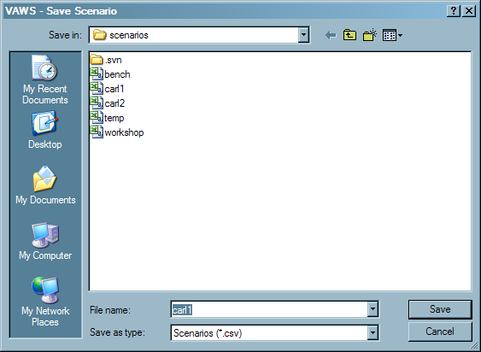

Graphically Browse Simulation Results
There are several ways to navigate the simulation results:

- Look at the “Connections” table:
  - Connections that have been damaged are shown highlighted in yellow.
  - Result columns show how many houses had this connection break and what the average breakage speed over all houses was.

- Look at the “Heatmap” plots:
  - One plot per “connection type group” of interest: i.e. sheeting, batten
  - Grid of zone locations showing a “hotter colour” for lower average breakage speeds of collocated connections.
  - If you click on a zone, selections in the “zones” and “connections” tables will be updated to reflect selection.
  - As you fly over the zones you will see information in the status bar being updated.

- Browse the Results tab: global lists or via connection or zone dialogs.

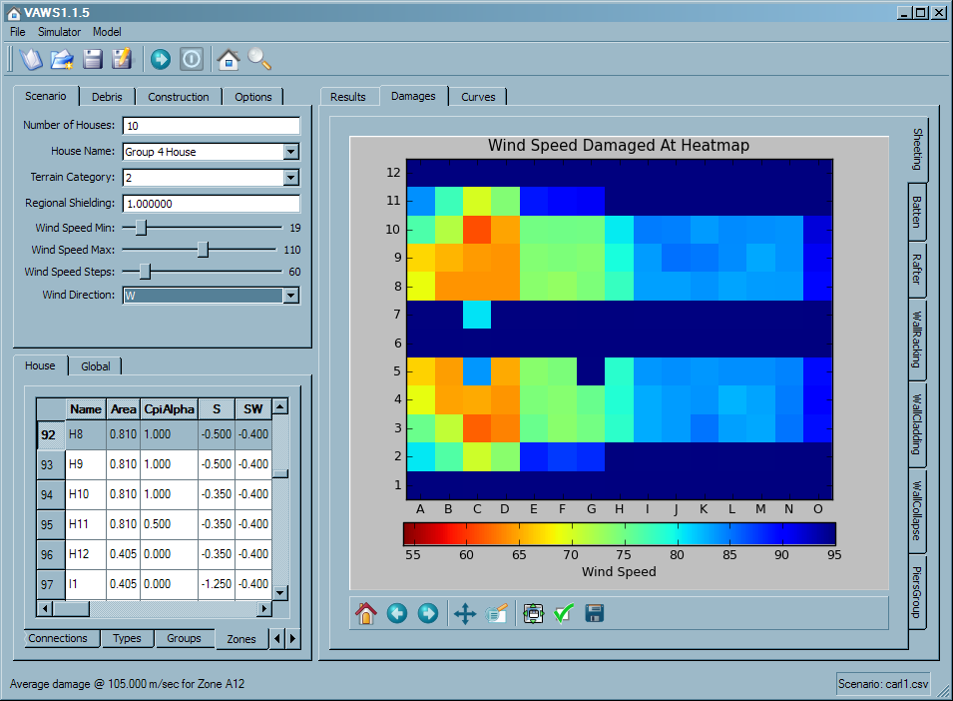

This example shows a wind from the west blowing from 19 to 110 m/s onto 10 houses, without distribution and its effect on roof sheeting. If we enable distribution we see the results reflect the “up and down” movement of damage:

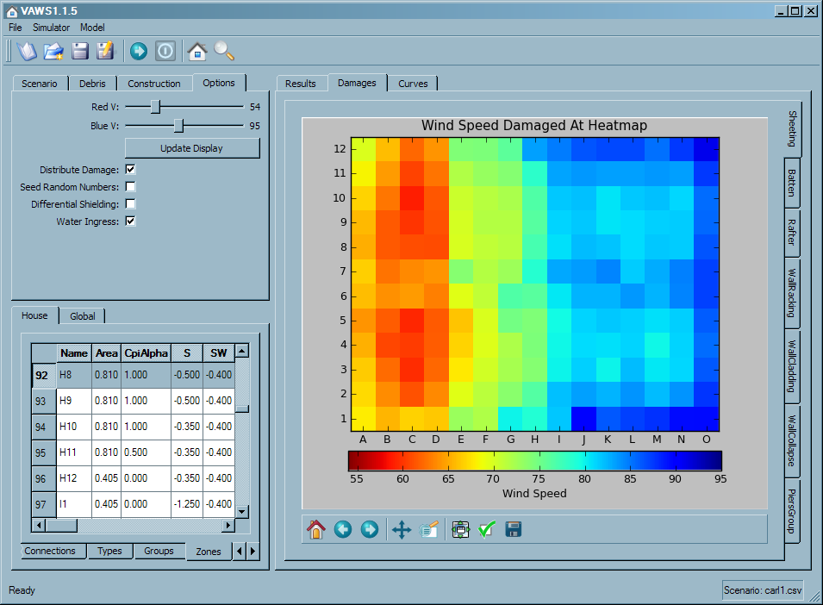

You can clearly see the vertical effect of sheeting distribution, along with the edge in the middle that stops the distribution in between rows 6 and 7 for sheeting; simulating the physical break in the roof sheeting at the ridge-line.

The mapping of wind speed to colours has been changed to be dynamically set from the scenario maximum and minimum wind speeds. Note that connection one has now been damaged and highlighted in the connections table.

To better see individual distribution effects, it can be useful to disable connection groups by clicking on the checkboxes that appear on the Groups table. These settings are now saved as part of the scenario file.

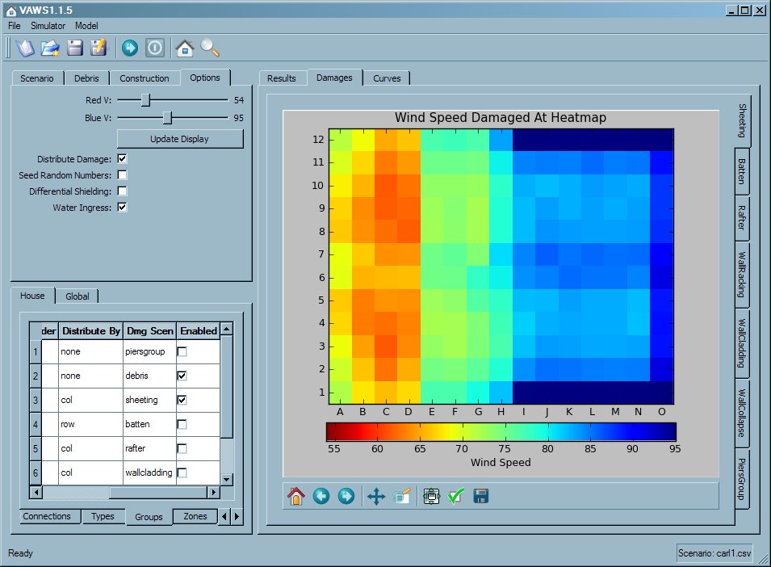

In this example I’ve disabled other groups so the vertical distribution, stopping at the edge is clearly visible. The example below shows the horizontal distribution that happens when battens are isolated:

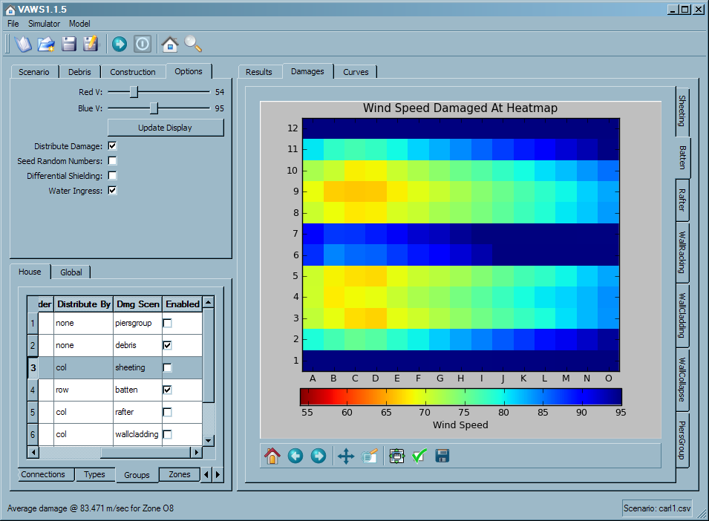

In the next example we see the rafters being isolated and distributed. Roof structure distribution is handled very differently from battens and sheeting, being based around influence coefficient patching, but the general effect is visible. First we show without distribution:

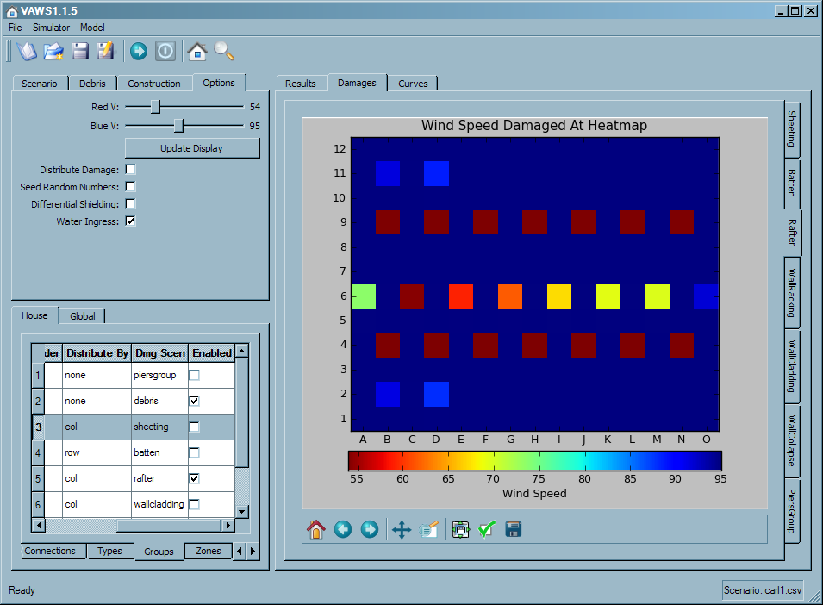

This gives a good feel for where the rafter connections have been modelled.

Next we see with distribution enabled:

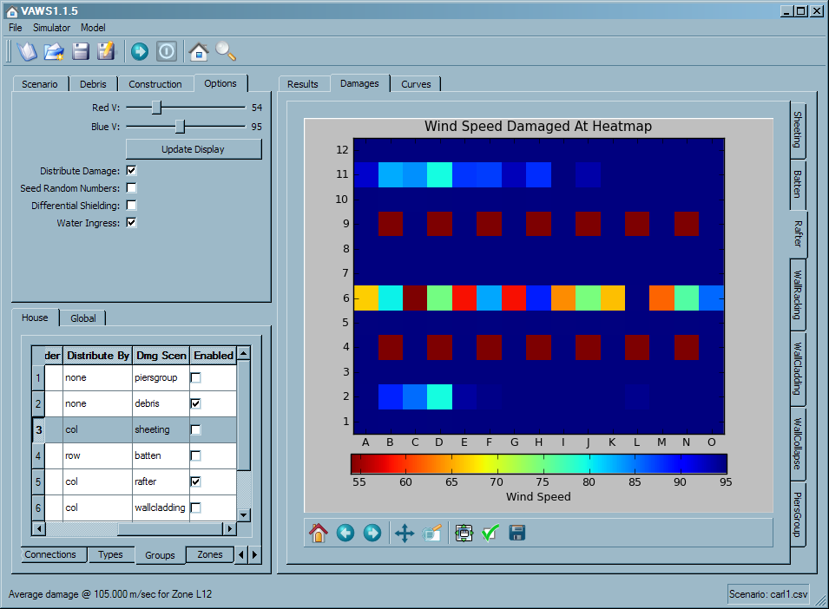

You can see that connections have been broken earlier as a result of the rafter ‘influence patches’ being applied to the zone/connection influence matrix.

House Results Tab
The results tab shows summary results for each house simulated (more detailed damage breakdowns can now be found in outputs/house_damage.csv):

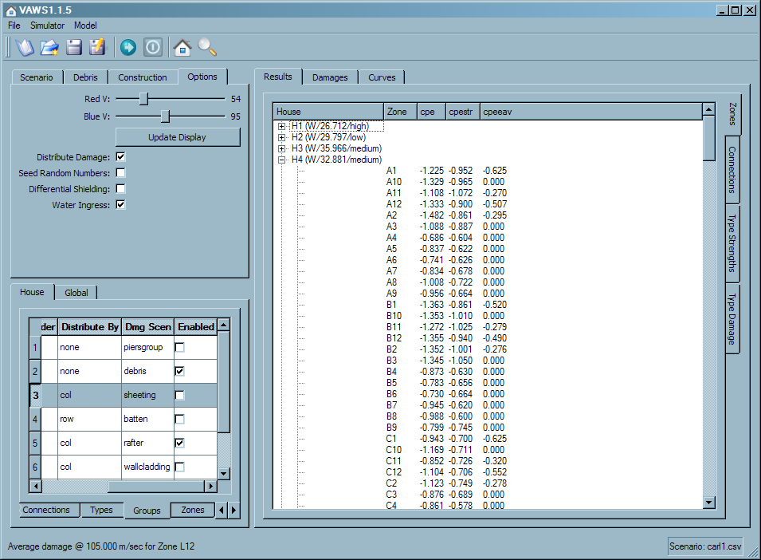

It should be noted that ‘H3 (W/45.128)’ means the simulation results for the 3rd sampled house, with wind from the west and cpi change at 45.128. This tab now contains the following result areas:

- Zones tab: on house expansion shows the actual sampled coefficients and final pressures (i.e.: at maximum wind speed) for each zone.

- Connections tab: on house expansion shows detailed breakout of connection samples and load calculations:

- Type Strengths: Scatter plot of sampled strengths against connection type.

- Type Damage: Scatter plot of breakage wind speeds observed again connection type.

Browse and Understand Data Model

Effort has been made to develop a reusable, flexible database model of the data that runs the wind simulator. This database is created from source spreadsheets at Geoscience Australia and shipped as a read-only SQL database called “model.db”. A database may have many house types, at the moment we have just one: “Group 4 House”.

Core Component Damage Model

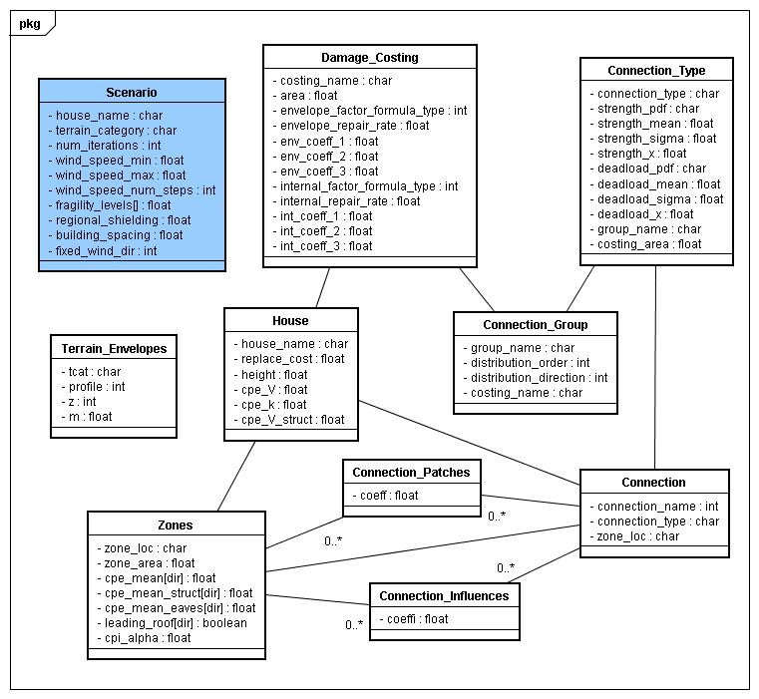

You may browse through most of this information by navigating around the tabbed tables on the bottom left side of the main window. Almost everything ‘belongs to’ the current house being modelled. A Scenario represents the user input for the current simulation. Each house has many connections of type which are grouped together by distribution algorithm and costing method. A connection’s load may be influenced by many zones. The “Damage Costing” table encapsulates information supplied by QS report [1].

Debris Model

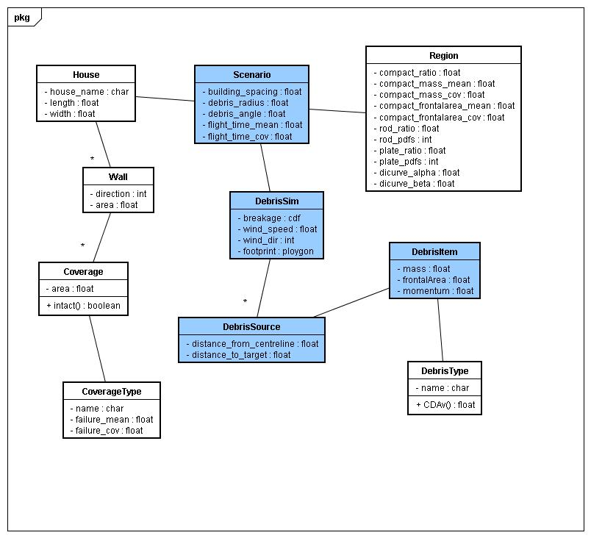

Blue boxes represent runtime only information. A house has many walls facing a given wind direction. Each wall has multiple coverages with an area and type (eg a window). Each type has different impact breakage properties. The Region represents a type of suburb/location and determines the type ratio and amount of debris items.

Water Ingress Model

The water ingress model is used by the simulator to determine an appropriate vulnerability ‘lognormal cdf’ to water ingress versus wind speed for a given envelope damage index. This is then sampled to arrive at a percentage of water ingress damage, which is then costed according to other damage occurrences.

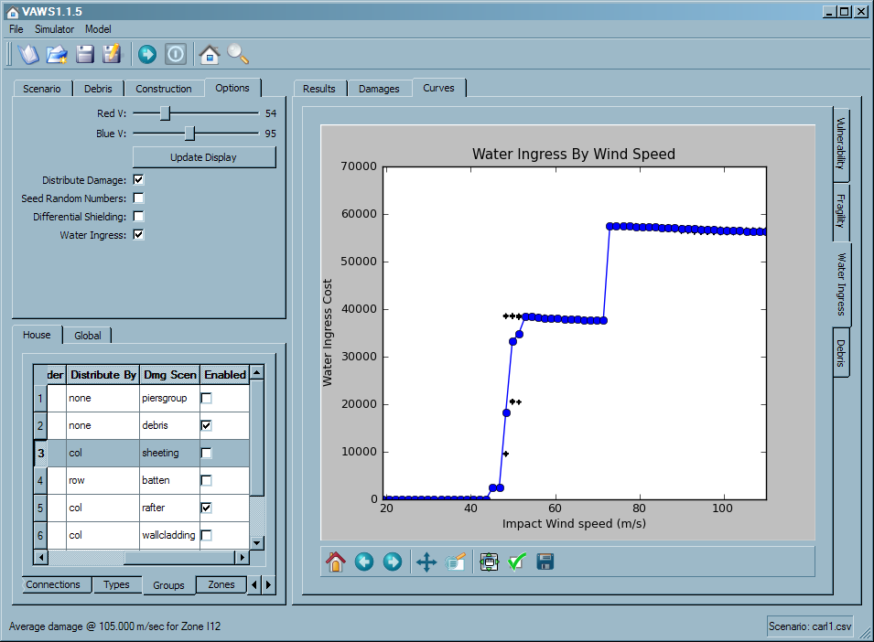

Note that the water ingress cost depends on the degree of envelope damage, the nature of envelope damage [ i.e. what part of the house envelope has dominant damage] and the degree of water ingress. The water ingress cost is the repair cost to that part of the house’s internal linings and fittings that are not directly damaged by envelope damage. Note that this can lead to apparently counter intuitive results (such as rapid jumps up and down of water ingress cost or decreasing water repair cost with increasing wind speed).

Generate Vulnerability and Fragility Curves
As part of the project deliverables, the simulator must produce vulnerability and fragility curves, for reporting purposes and downstream economic assessment of vulnerability and adaptation. The vulnerability curve plots the means of observed DI across all simulated houses at each wind speed step. It then uses non linear regression to fit these means to the curve model described by “Appendix A – Derivation of Curves” in the document “Report on Wind Vulnerability Research Workshop, 14th and 15th March 2006” and described by the equation below.
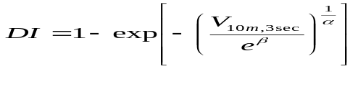
An example curve looks like (note the different scenario parameters):

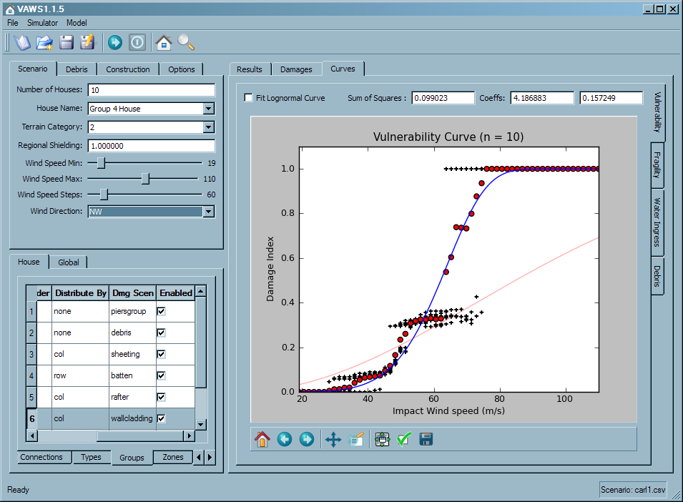

The program allows you to fit the observed damage index means to a lognormal cdf form by ticking the “Fit Lognormal Curve” checkbox. Any previous fit curve will be shown in a faint red colour to allow comparisons. The ‘sum of squares’ for the curve fit is shown as a rough guide of fit. Also shown are the two coefficients for the curve fit.

If the number of houses is less than 100 this plot also shows individual scatters of all simulation results at each wind speed.

Note that the total house collapse event caused by piers breaking around their mean strength is resulting in a large step after that point.

The fragility curve is formed by counting the number of simulation results at each wind speed above defined damage thresholds and plotting the probabilities for each threshold (slight, medium, severe, and complete):

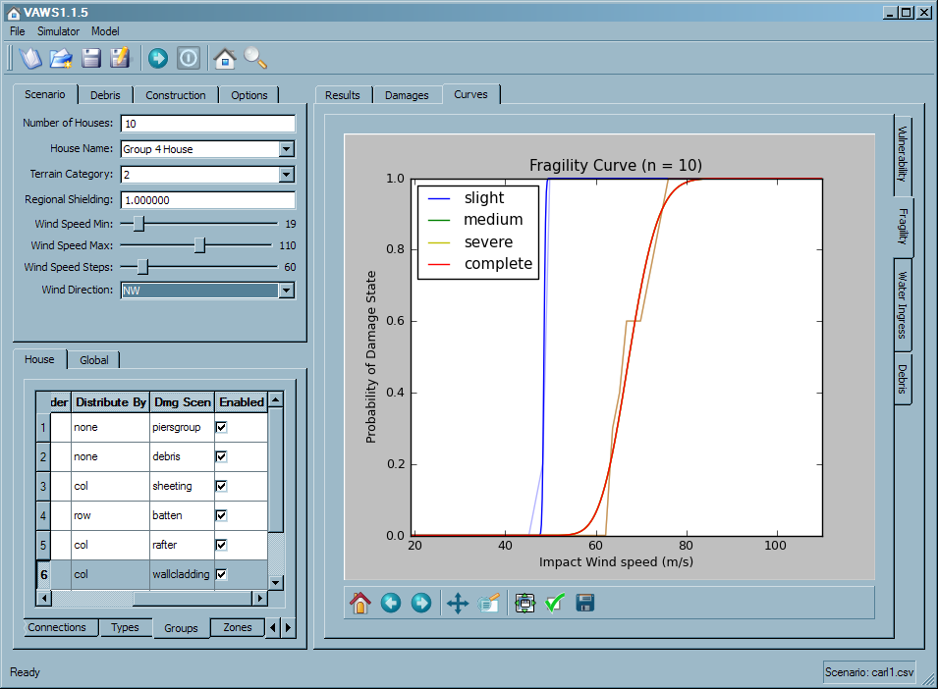

This curve will be more effective (have more detail) as the number of houses simulated increases and as the model is improved to produce more variation in outcomes along the entire spectrum of wind speeds.

Reporting
This release includes some new reporting files saved in the ‘outputs’ folder underneath where VAWS was installed on your PC (usually C:\Program Files\VAWS\outputs). All report files are saved as “Comma Separated Value” files suitable for direct import into Excel and other packages.

house_damage.csv
This report provides a detailed listing of simulated damage for each sampled house at each wind speed. Damage is broken out into connection types.

house_cpi.csv
This report provides the wind speed that caused pressurization to occur for each sampled house. This will only be available if you activate the debris module for the simulation.

wind_debris.csv
This report breaks out for each wind speed the percentage of houses pressurized and the mean percentage debris damage suffered.

house_damaged_at_v.csv
This report breaks out for each wind speed the number of houses damaged per connection type.

wateringress.csv
This report breaks out water ingress damage cost observed during each simulation.

fragilities.csv
This file reports the coefficients for fragility curves fit at each damage level: slight, medium, severe and complete. It is envisaged to be the main output of this system, to be fed to larger components as vulnerability information for modelled structures.

Future Directions
This prototype has been developed to allow the simulator to be distributed and used by non programming staff at both Geoscience and JCU as desired. It is in no way a completely formed final version. Please provide any feedback you may have to either myself (Carl.Sandland@ga.gov.au) or Martin (Martin.Wehner@ga.gov.au).

Future work on the software is likely to focus on adding more house types into the database. This will present challenges as the structure varies in composition and type. The goal is to allow further structures to be added internally in collaboration with JCU.

Appendix A – Database Import Files
This section outlines the input files used to create the read-only house structure database ‘model.db’ that is shipped with the product. The import itself is done by running the bash script ‘build_db.sh’ whilst in the ‘src/core’ folder.

The import script enumerates folders of CSV information located in ‘data’. This structure and the format of the files are very rigid. Extra care must be taken to ensure that these files are correctly representing the house being modelled. Funding was not directed at making this process friendly and bulletproof.

Within the ‘data’ folder are several ‘global’ files that should not need to be changed whilst entering new structures:

debris_regions.csv
This file defines several debris ‘regions’ that define the statistical properties of the debris field generated during simulation. These values are based on work from JDH Consulting [4].

debris_types.csv
This file defines the CDAv values for the three types of debris generated during the simulation.

mzcat_terrain_x.csv
This set of files (one fore each ‘x’) defines the boundary profile for winds in each terrain category.

The import program then enumerates all subfolders within ‘data/houses’: each subfolder contains a house structure. Within the house subfolder are the following files:

house_data.csv
This file has one row that represents the House data entity. It has data about the house in general, such as replacement cost, footprint, dimensions and structural coefficients.

walls.csv
A house may have one wall for each of the eight wind directions. Each wall has an area.

coverages.csv
Each wall can be covered by various features, such as windows, door or sheeting. Each row in this file lists a coverage description, a direction (i.e. wall), an area and a coverage type.

cov_types.csv
Each coverage defined has a type, this type is represented by rows in this file containing a name and statistical momentum failure characteristics to be sampled during simulation of debris.

zones.csv
Each row represents a Zone data entity: a zone has a name (grid location), area, wall direction and set of pressure coefficients for each of the 8 wind directions modelled.

damage_costing_data.csv
Each row represents a damage scenario to be costed, creating a DamageCosting data entity.A costing has a name, area and costing coefficients for define internal and external costing function variations. Internal knowledge of quantity surveying materials will be required to create this file.

conn_group.csv
Each row represents a grouping of connection types that share common costing and distribution behaviour. Each entry represents a ConnectionTypeGroup data entity. A group has several important fields:

distribution_order: This integer field defines the order that connection damage will be distributed. If zero then no distribution will occur.

distribution_direction: This string field can have values [none,row,col] and defines the direction of damage distribution for appropriate connections.

damage_scenario_name: This string field must refer to an existing DamageCosting.

trigger_collapse_at: A Boolean value of 1 or 0. If set to 1 then connections of this type can trigger a total house collapse when the percentage of them damaged exceeds this threshold. Currently used only by piers in the group4 model.

patch_distributon: A Boolean value of 1 or 0. If set to 1 then distribution of damage for child connections are driven by explicit influence patches. If 0 then distribution is automated by load transfers.

set_zone_to_zero: A Boolean value of 1 or 0. If set to 1 and distribution is auto, this will force the effective area of the zone to zero after distribution has occurred.

conn_types.csv
Each row represents a type of connection, or ConnectionType data entity. A type has a name, costing area, costing group and statistical properties of connection strengths and connection deadloads sampled during simulation.

connections.csv
Each row represents a Connection data entity: each one has a name, a connection type, a location zone and a Boolean specifying the edge type. The edge type may be [0,1,2] and effects the automatic distribution of damage.

damage_factorings.csv
Each row represents a DamageFactoring dataentity. This represents a hierarchy of costings, where each row has a parent and child connection type group. When costing the parent group, all child costings will be factored out of the parent. This mechanism reflects the QS methodology used by external documents.

water_ingress_costing_data.csv
This file contains damage costing information for various scenarios of structural damage. Each row contains coefficients that are used by a fixed set of costing functions, based on simulated envelope damages to various damage scenarios.

connectionzoneinfluences.csv
When calculating the load on each connection, the influence from many zone pressures can be added together, weighted by specified rows in this file. The final load is used to determine breakage. Each row in this file lists a connection name, a zone name and a weighting.

influencefactorpatches.csv
When a connection is broken, its damage can be distributed automatically, not at all, or via an explicit set of influence patches listed in this file. Each row in this file has the name of the connection damaged, the name of the target connection to modify and a series of (zone_name, influence) pairs.

References
      - Wind Damage Cost Module Development for North Queensland Building Types, Report prepared for Geoscience Australia by Turner and Townsend Rawlinsons, 15 September, 2006 (4 volumes).
      - Effective wind Pressure Coefficients for Two House Types, Report prepared for Geoscience Australia by JDH Consulting, June 2007.
      - Effective wind Pressure Coefficients for Industrial Buildings, Report prepared for Geoscience Australia by JDH Consulting, June 2009.
      - Contributions to Development of a Wind Vulnerability Model – Final Report 2009-10, Report prepared for Geoscience Australia by JDH Consulting, June 2010
      - Input to Vulnerability Tool JCU group 4 Houses, Hot Rolled Sheds & West Sydney Houses CTS Research Report: TS778 Revision 2, Report prepared for Geoscience Australia by James Cook University, July 2010.

