|  |  |  |  |  |  |  |
| --- | --- | --- | --- | --- | --- | --- |
| |  |  | | --- | --- | | **Building on Windows using Microsoft Visual C++** |  | |  |  |  | | |
|  | Xerces-C++ source distribution comes with Microsoft Visual C++ projects and solutions. The following describes the steps you need to build with this compiler.  To build Xerces-C++ from the source distribution you will need to open the solution containing the project. The solutions containing the Xerces-C++ project files are in the following sub-directories in the xerces-c-3.1.2 directory:   |  |  |  | | --- | --- | --- | |  |  |  | |  | (For VC7.1) projects\Win32\VC7.1\xerces-all\xerces-all.sln  (For VC8.0) projects\Win32\VC8\xerces-all\xerces-all.sln  (For VC9.0) projects\Win32\VC9\xerces-all\xerces-all.sln  (For VC10.0) projects\Win32\VC10\xerces-all\xerces-all.sln  (For VC11.0) projects\Win32\VC11\xerces-all\xerces-all.sln  (For VC12.0) projects\Win32\VC12\xerces-all\xerces-all.sln |  | |  |  |  |   Once you have the solution open, you need to build the project named XercesLib. You can select Debug/Release, Static/DLL, and, for VC8+, 32/64 bit builds using the Configuration Manager dialog. You can also select whether the Xerces-C++ library should use ICU for transcoding.  When building your own applications you need to make sure that you are linking your application with the xerces-c_3.lib (Release) and/or xerces-c_3D.lib (Debug) libraries (or the static versions of them) and also that the associated DLLs are somewhere in the executable/DLL search path (PATH).   |  |  | | --- | --- | |  | *If you are linking your application to the static Xerces-C++ library, then you will need to compile your application with the XERCES_STATIC_LIBRARY preprocessor macro defined in order to turn off the DLL import/export mechanism.* | |

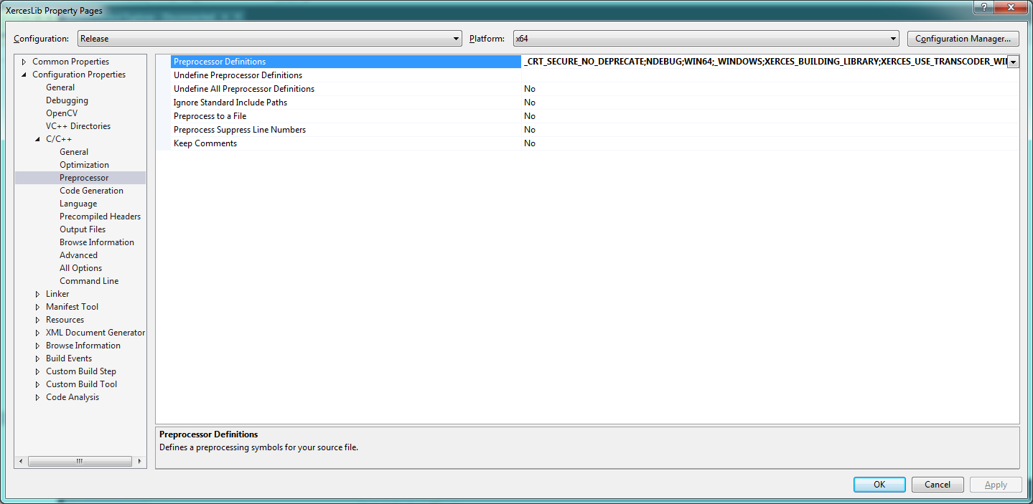

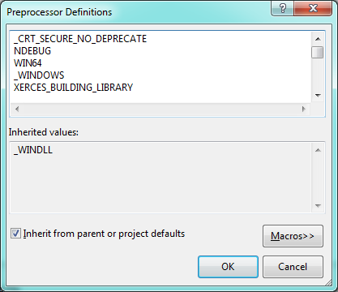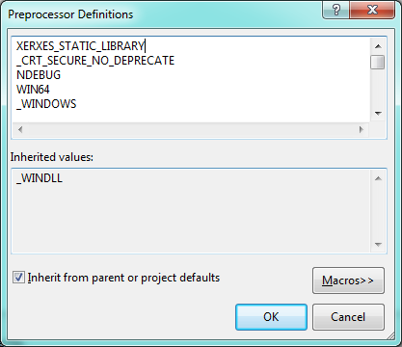

<https://xerces.apache.org/xerces-c/build-3.html#Windows>

# Concern:

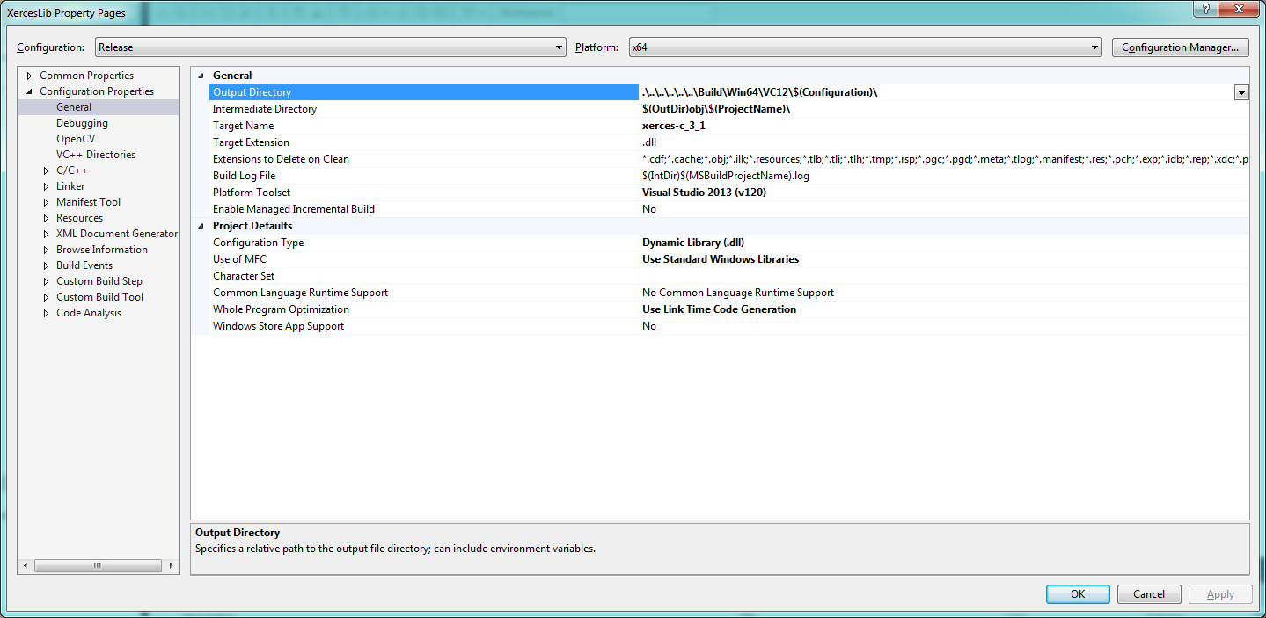

DLL set here as target instead of DLL.

Bad static build?