Title of the thesis:
and its sub-title
Full Name
Faculty of Life and Health Sciences of Ulster University
Thesis submitted for the degree of Doctor of Philosophy
Month Year
I confirm that the word count of this thesis is less than 100,000 words excluding the title page, contents, acknowledgements, summary or abstract, abbreviations, footnotes, diagrams, maps, illustrations, tables, appendices, and references or bibliography.

Abstract
Write the abstract here.
Contents
Right-click and choose Update Field.
List of figures
Right-click and choose Update Field.
List of tables
Right-click and choose Update Field.

Abbreviations
GIS | geographic information system
PRISMA | Preferred Reporting Items for Systematic Reviews and Meta-Analyses

Acknowledgements
Write the acknowledgements here.

Declaration on the use of generative artificial intelligence
This declaration follows the Ulster University Doctoral College guidance on the use of generative artificial intelligence (AI) tools. The use described here was agreed with the supervisory team on [date].
Tools. [Name and version of each tool, and the period of use.]
Purposes. [For example: code assistance; checking references; language editing; drafting of specified sections, which were checked and revised by the candidate.]
Not delegated. [For example: the research questions, design, analysis, interpretation and conclusions.]
Responsibility. The candidate takes full responsibility for the content of this thesis.

Chapter 1
Introduction

1.1 Background
Text with a citation in Harvard style (Page et al. 2021), or naming the authors, as Roberts et al. (2017) show. Cross-references are written with \cref: Chapter 3, Table 4.1, Figure 4.1 and Appendix A.

1.2 Aim, objectives and research questions
- First objective.
- Second objective.

1.3 Structure of the thesis
Chapter 2 reviews the literature, Chapter 3 describes the methods, Chapter 4 presents the results, Chapter 5 discusses them and Chapter 6 concludes.

Chapter 2
Literature review

2.1 Review method
For a systematic review, report the methods following PRISMA 2020 (Page et al. 2021).

Chapter 3
Methods

3.1 Data
Equations are numbered by chapter:
$$\overset{‾}{x}=\frac{1}{n}\sum_{i=1}^{n}{x_{i}}.$$

3.2 Validation
Describe how results are validated, for example with spatially separated test data (Roberts et al. 2017).

Chapter 4
Results

4.1 Main results
Tables have their title above (Ulster), figures their caption below.
Table 4.1: An example table (title above the table).
Group | Mean | SD
A | 1.20 | 0.30
B | 1.45 | 0.28
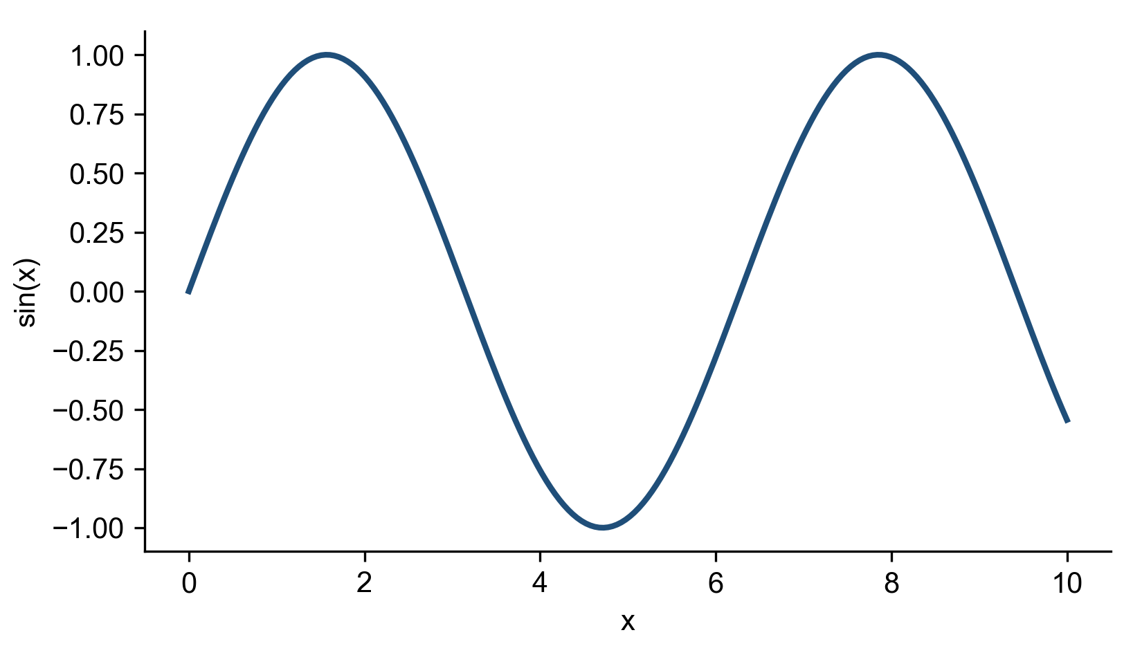
Figure 4.1: An example figure (caption below the figure).

Chapter 5
Discussion

5.1 Principal findings
Discuss the findings.

5.2 Limitations
State the limitations.

Chapter 6
Conclusions
Conclude, and give recommendations and future work.

Appendix A
Supplementary material
Supplementary tables, code descriptions or data registers.

References
Page, M.J., McKenzie, J.E., Bossuyt, P.M., Boutron, I., Hoffmann, T.C., Mulrow, C.D., Shamseer, L., Tetzlaff, J.M., Akl, E.A., Brennan, S.E., Chou, R., Glanville, J., Grimshaw, J.M., Hróbjartsson, A., Lalu, M.M., Li, T., Loder, E.W., Mayo-Wilson, E., McDonald, S., McGuinness, L.A., Stewart, L.A., Thomas, J., Tricco, A.C., Welch, V.A., Whiting, P. and Moher, D. (2021) The PRISMA 2020 statement: an updated guideline for reporting systematic reviews. BMJ n71. https://doi.org/10.1136/bmj.n71
Roberts, D.R., Bahn, V., Ciuti, S., Boyce, M.S., Elith, J., Guillera-Arroita, G., Hauenstein, S., Lahoz-Monfort, J.J., Schröder, B., Thuiller, W., Warton, D.I., Wintle, B.A., Hartig, F. and Dormann, C.F. (2017) Cross-validation strategies for data with temporal, spatial, hierarchical, or phylogenetic structure. Ecography 40, 913–929. https://doi.org/10.1111/ecog.02881

