2-Day Course – Spatial Modeling with Geostatistics

Prof. Michael J. Pyrcz, Ph.D., P.Eng.

Hildebrand Department of Petroleum & Geosystems Engineering

University of Texas at Austin

Paper-based Hand’s On Exercises

Simple paper-based hands-on exercises are useful to communicate geostatistical concepts. We will discuss and cover the solution set in class.

Unit 2 Probability Theory

**Calculate the following probabilities for event A and B:**

Note Event A: Sandstone and Event B: Shale

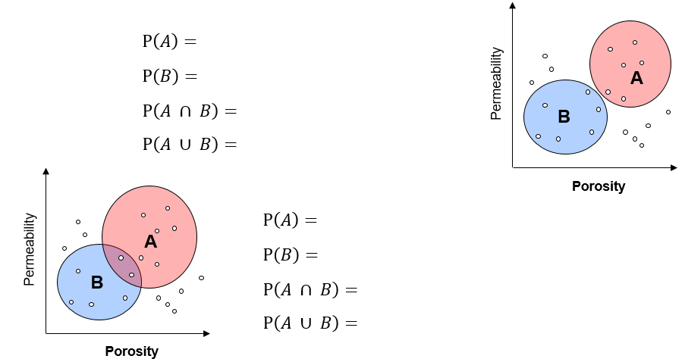

**Calculate the following conditional probabilities:**

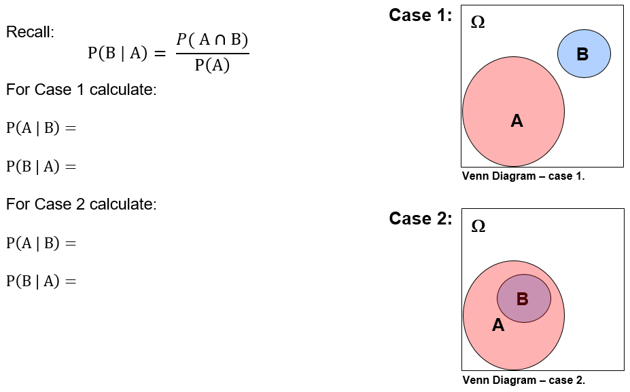

**Calculate the following probabilities for events A and B:**

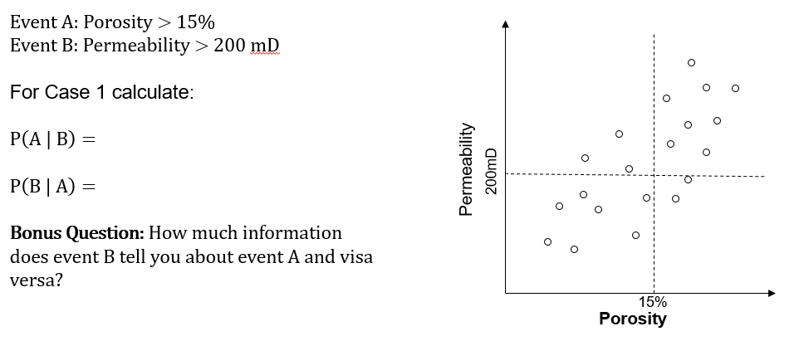

**Given these joint probabilities calculate the:**

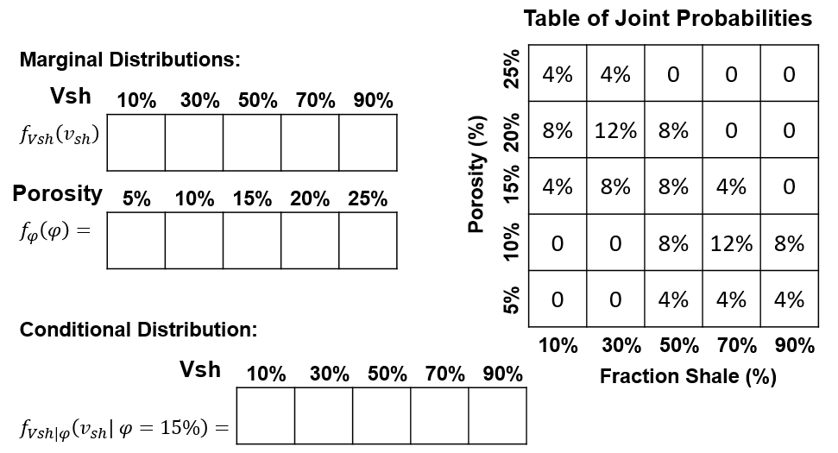

**Given there is independence between fluid type and porosity:**

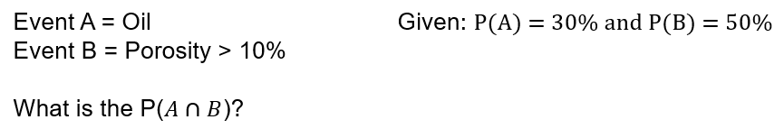

**Given there is independence between fluid type, porosity and saturation:**

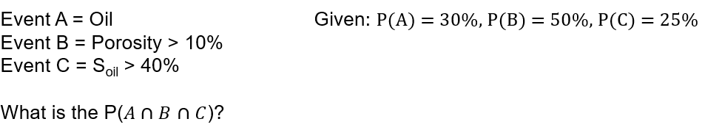

**Given facies F1, F2 and F3 in 10 wells:**

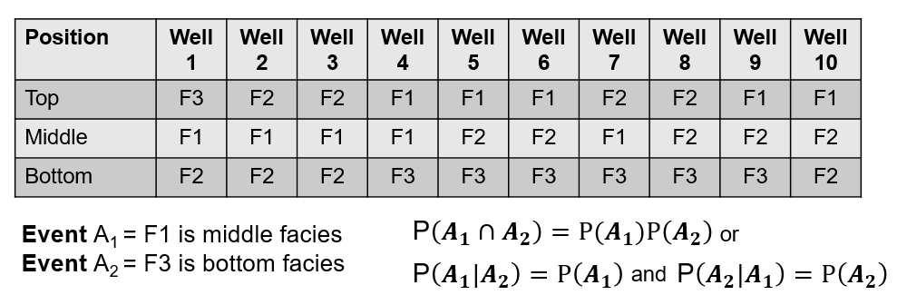

**Are events A1 and A2 independent?**

**Calculate the probability of a channel feature given it appears in seismic using Bayesian methods:**

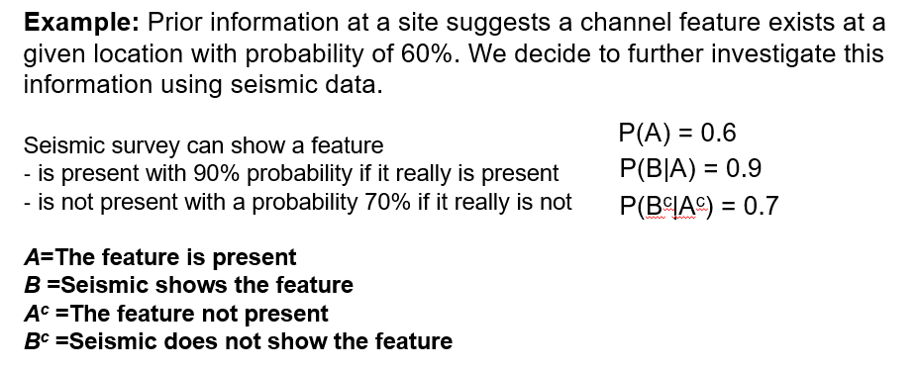

**Will seismic information be useful?**

**Calculate the expected grain size, given these results with associated probabilities.**

The following grain sizes (mm) outcomes with probability in brackets

10 (10%), 20 (50%), 30 (10%), 40 (20%), 50 (10%)

Unit 4 and 5 – Spatial Analysis I and II

**Estimate the experimental variogram calculation parameters:**

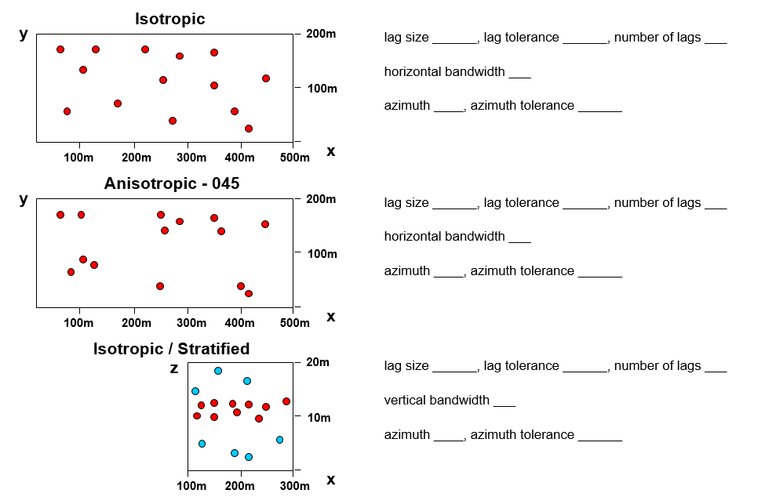

**Interpret these variograms. Identify trend, cyclicity, and zonal anisotropy.**

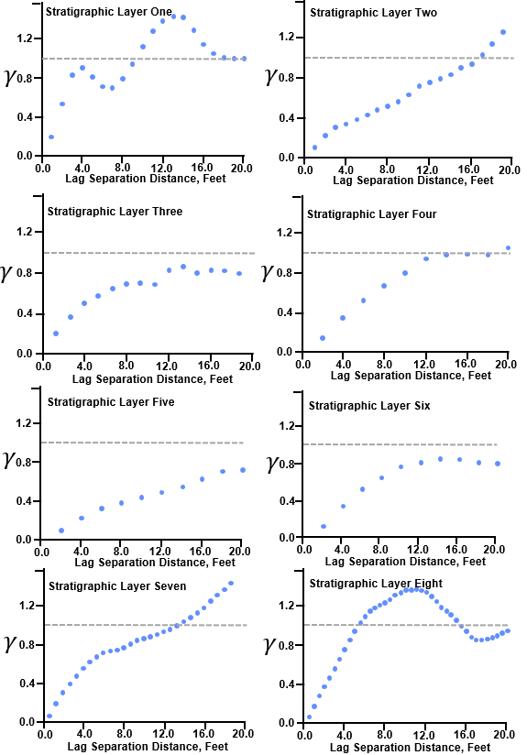

**Fit nested positive definite 2D variogram models to these directional experimental variograms.**

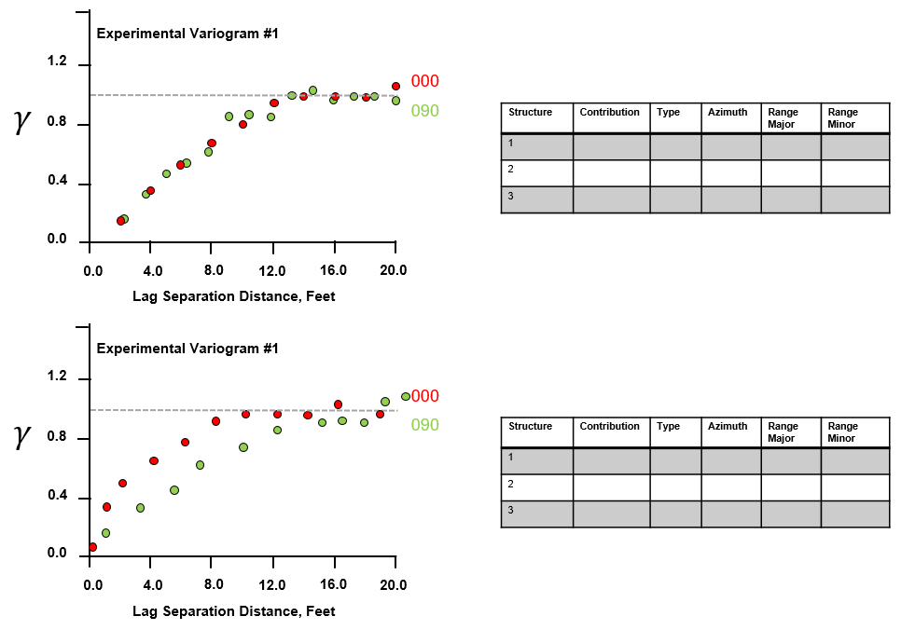

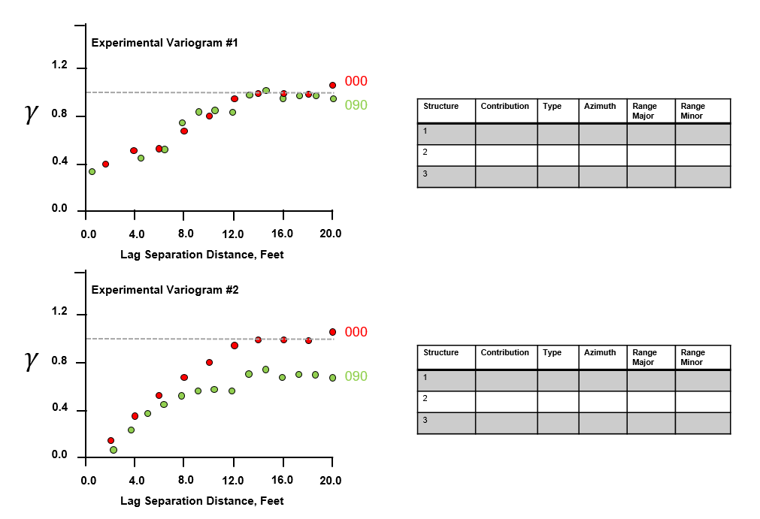

Unit 8 Uncertainty

**Where would you drill?**

* 1. **To maximize production?**
  2. **To minimize risk of a bad well?**
  3. **To gather information?**

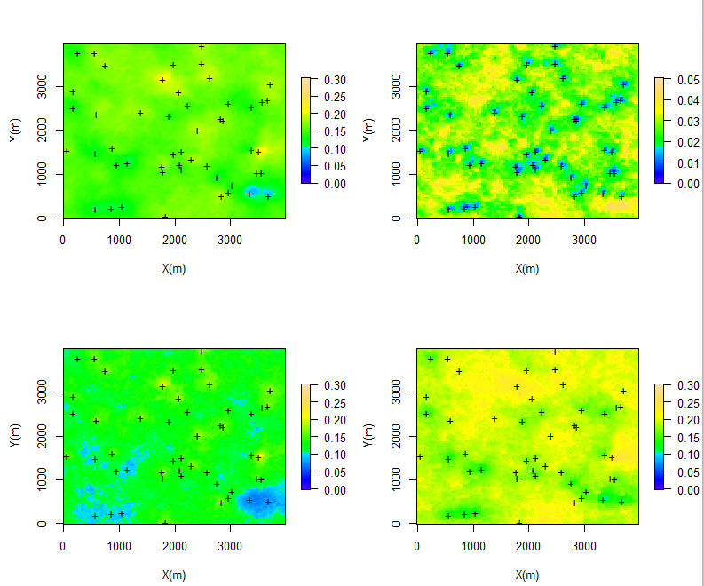

**e-type**

**local standard deviation**

**local P90**

**local P10**