1 Week Course – Data Analytics and Geostatistics Workflows

Prof. Michael J. Pyrcz, Ph.D., P.Eng.

Hildebrand Department of Petroleum & Geosystems Engineering

University of Texas at Austin

Paper-based Hand’s On Exercises

Simple paper-based hands-on exercises are useful to communicate geostatistical concepts. We will discuss and cover the solution set in class.

Unit 1 Probability Theory

**Calculate the following probabilities for event A and B:**

Note Event A: Sandstone and Event B: Shale

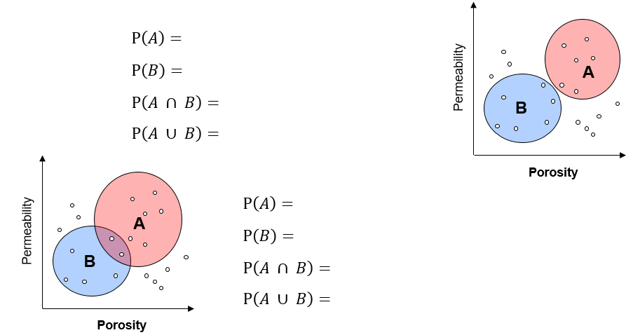

**Calculate the following conditional probabilities:**

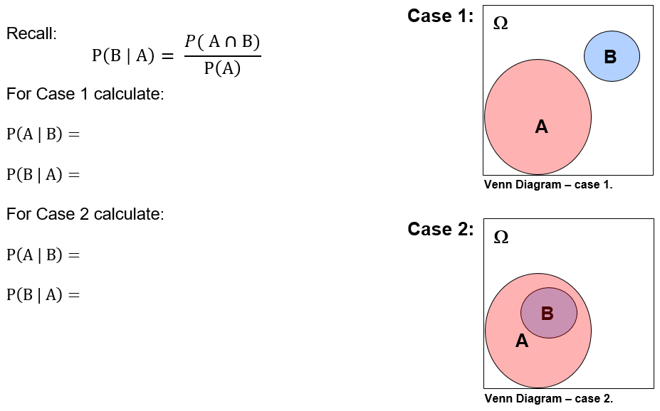

**Calculate the following probabilities for events A and B:**

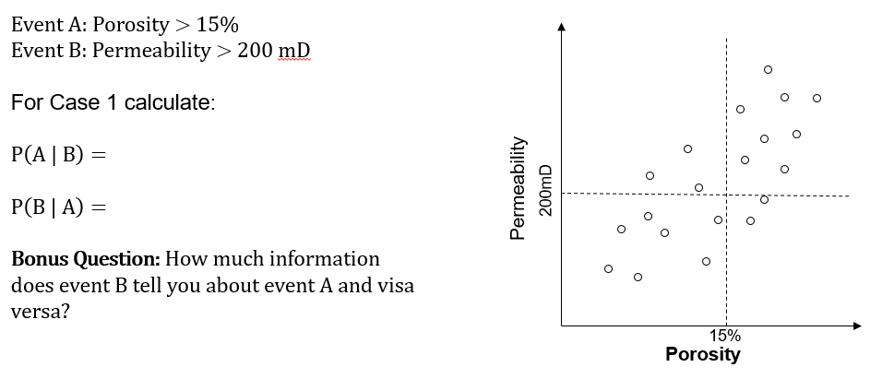

**Given these joint probabilities calculate the:**

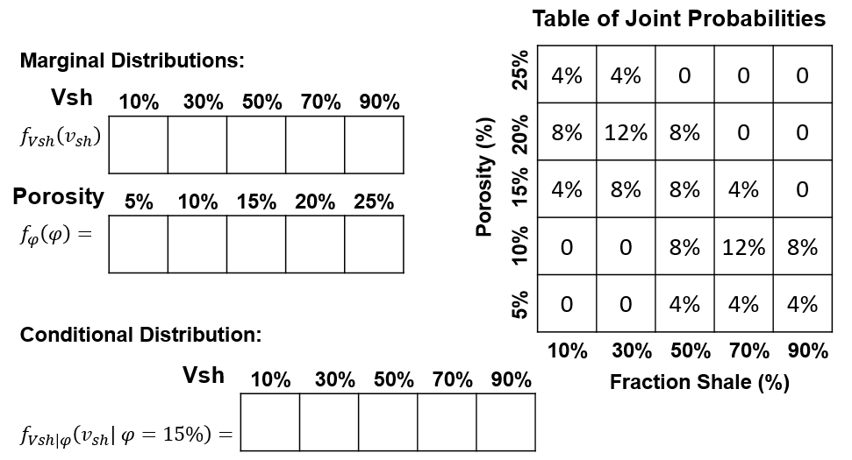

**Given there is independence between fluid type and porosity:**

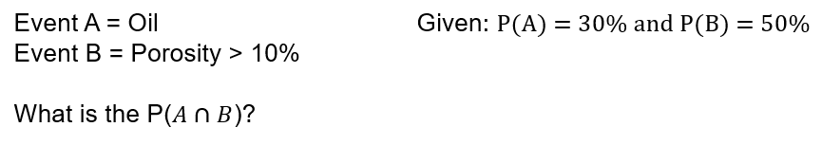

**Given there is independence between fluid type, porosity and saturation:**

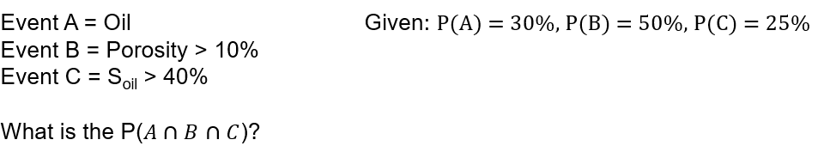

**Given facies F1, F2 and F3 in 10 wells:**

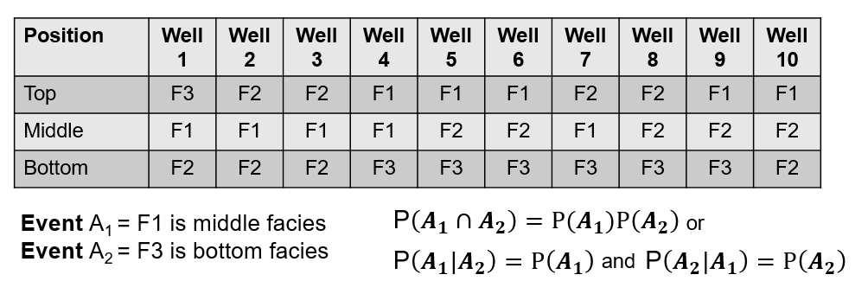

**Are events A1 and A2 independent?**

**Calculate the probability of a channel feature given it appears in seismic using Bayesian methods:**

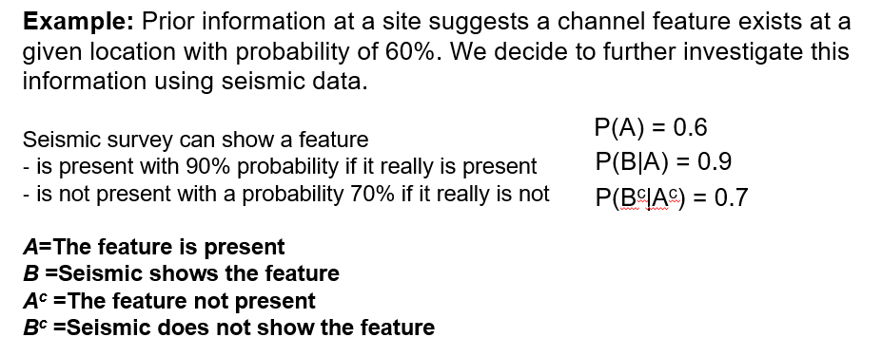

**Will seismic information be useful?**