Pizza Time

Christopher Hanratty

Applied Data Science Capstone

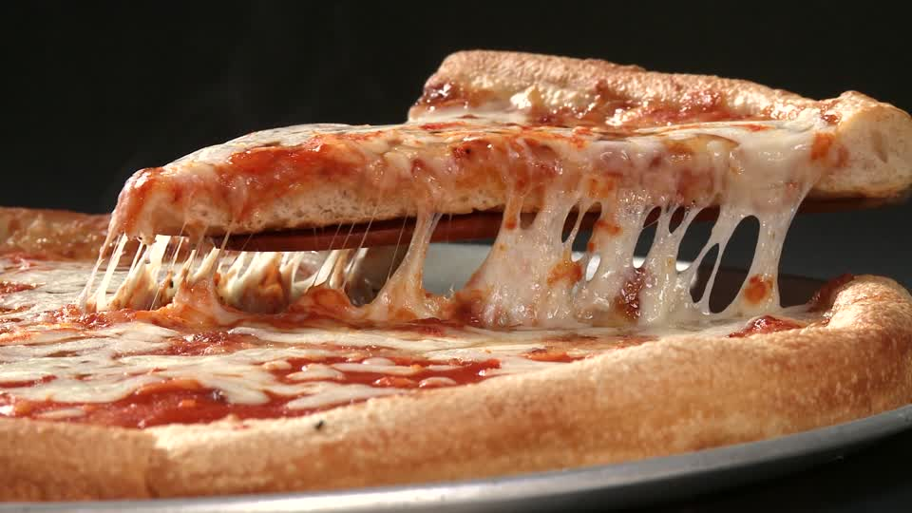

**1. Introduction**

**1.1 Background:**

In 2017, global revenue for the entire restaurant industry was estimated at [$799 billion](http://www.fesmag.com/research/industry-forecast/15056-fe-s-forecast-2018-steady-as-the-foodservice-industry-grows). At the end of 2018, United States pizza sales totaled 45.73 billion USD.

That said, Pizza is quite profitable! Pizza places come in all different shapes and sizes, from corporate chains to tiny family establishments. I want to open a pizza place in my home town so that I can contribute to spreading the pizza love and sharing in that profit total.

Milwaukie,OR is my neighborhood and I am a pizza lover!

**1.2 Problem**

From my own personal experience, I feel like there is a serious lack of good pizza in town (within 5 miles, that is…). This experiment aims to quantify that feeling by utilizing Foursquare’s location data and more!

The study will identify the best location to place my new pizza business based on information obtained by using the Fourquare API. The study will consider, distance from downtown Milwaukie, existing pizza places (i.e. competition), the rating of existing pizza places, and much more!

**1.3 Interest**

A similar study could be performed and expanded upon by any one else attempting to make data driven business decisions.

**2. Data:**

**2.1 Foursquare Location Data**

**Foursquare Location Data Used:**

Search: Categorical data used to isolate pizza establishments.

Explore: Venue data used to distance, ID, rating, etc.

**Additional Data Used:**

US Cities Latitude/Longitude data

Yelp rating data

Milwaukie.gov zoning data

**2.2 SMS**

A dataframe consisting of Foursquare location data and Yelp rating data was generated to visualize proximity to local competition and its social media score (SMS). The social media score was determined by summing a pizza place’s Foursquare rating and the Yelp rating.

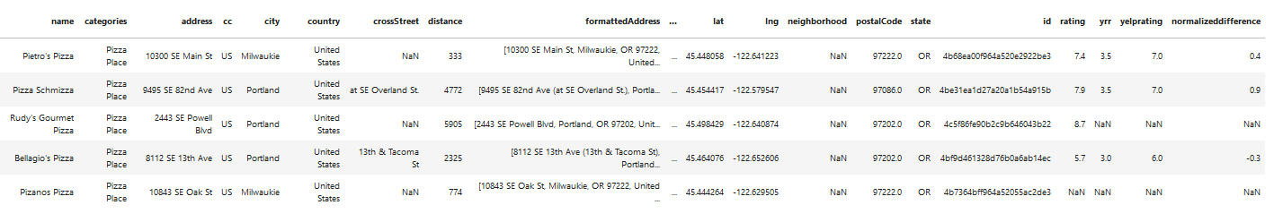

**3. Methods**

**3.1 Regression and SMS**

Linear regression techniques were applied to both the Foursquare and Yelp rating data. A SMS was derived by averaging the two platform scores. Additionally, linear regression plots of rating versus distance were created to explore any correlation between distance and rating.

**3.2 Data Visualization**

Data visualization includes making folium maps of satellite imagery, pizza place location and then clustering of the pizza places based on map zoom level.

4. Results:

**4.1 Regression and SMS**

Foursquare user data indicates that restaurants rated greater than 8.0 are located greater than 3 km from downtown Milwaukie,OR.

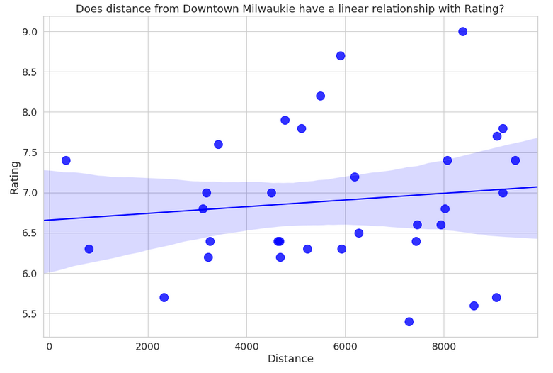

Yelp user data indicates that downtown Milwaukie is indeed a good location as other clusters farther away have higher rated pizza places.

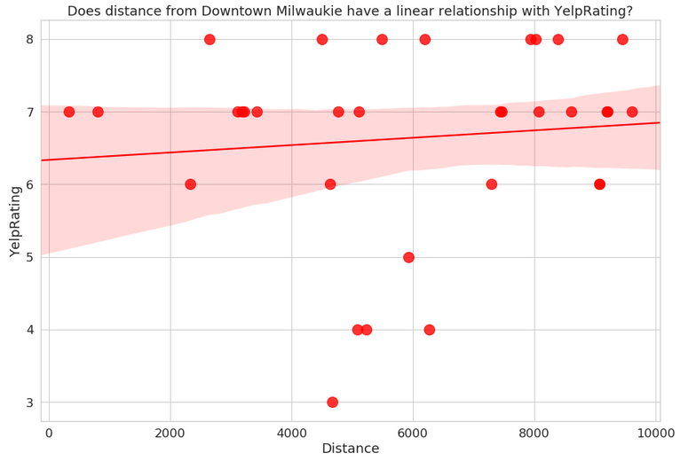

SMS scores indicate that the highest rated pizza places are local establishments as opposed to national pizza chains.

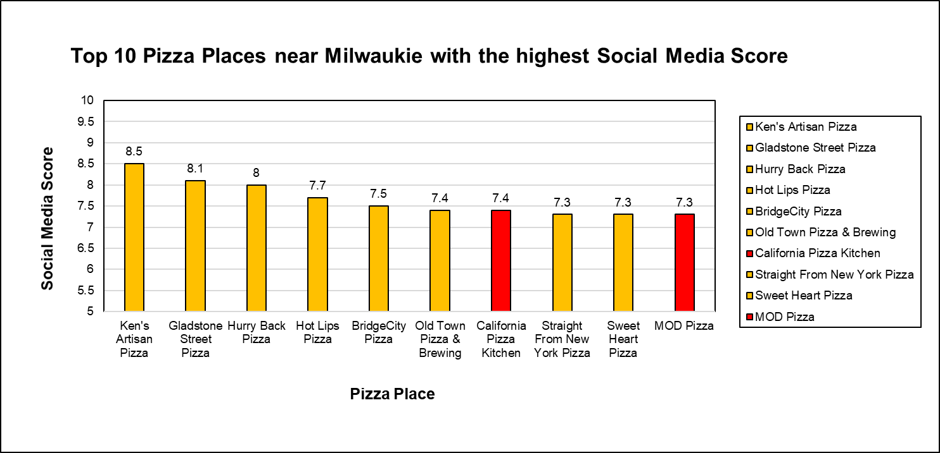

**5. Discussion/Conclusions:**

Foursquare location data is incredibly useful! With just a basic account one can learn a great deal about any location within the Foursquare location database. Overlaying the data on a map is a great way to really get an idea of where the best place to open a business might be.

One interesting takeaway point is that it appears that Foursquare Users rate pizza places higher than Yelp users do. On average, Yelp users were a bit more critical of pizza places and are in turn harder to impress. So if you want to have a successful business model, pay attention to Yelp users.

The highest rated pizza places are >5 km away from downtown. So location is important and downtown Milwaukie isn’t overcrowded with too many restaurants as is. Perhaps the most interesting point is the fact that the highest rated pizza places are non-national chains. Milwaukie,OR residents prefer non-corporate options, and that makes sense! Oregon is unique and one size certainly doesn’t fit everyone!

I’ll be opening a non-chain restaurant right in downtown Milwaukie!

**6. Sources:**

<https://www.rewardsnetwork.com/industry-trends/2018-restaurant-trends-industry/>

<http://www.pmq.com/December-2018/The-2019-Pizza-Power-Report-A-State-of-the-Industry-Analysis/>

<https://www.milwaukieoregon.gov/documents>