Data:Marketing:Brett Houston:Digital-Media-Library:External Branding:Logos:Geosyntec_Logo_Color_EPS.eps

|  |
| --- |
| TECHNICAL METHODS AND APPROACH DOCUMENT  City of Tacoma Watershed Planning Project  Prepared for  City of Tacoma  747 Market St  Tacoma, WA 98402  Prepared by  Geosyntec Consultants, Inc. 520 Pike Street, Suite 2600  Seattle, Washington, 98102  Project Number: PNW0448  June 2023 |

|  |
| --- |
|  |

TABLE OF CONTENTS

[Chapter 1. BMP Performance 1](#_Toc139037363)

[1.1 Introduction 1](#_Toc139037364)

[1.1.1 Components 1](#_Toc139037365)

[1.2 Hydrologic Simulation 3](#_Toc139037366)

[1.2.1 Data Sources 3](#_Toc139037367)

[1.3 Hydrologic Performance 5](#_Toc139037368)

[1.3.1 Long-Term Volume Capture Performance 5](#_Toc139037369)

[1.3.2 Simplified Treatment Volume Capture Performance 14](#_Toc139037370)

[1.4 Water Quality Performance 14](#_Toc139037371)

[1.4.1 Statistical Analysis Approach 14](#_Toc139037372)

[1.4.2 Influent - Effluent performance curves 15](#_Toc139037373)

[1.5 Performance of Source Control BMPs 18](#_Toc139037374)

[1.5.1 Street Sweeping 18](#_Toc139037375)

[1.5.2 Storm Line Cleaning 18](#_Toc139037376)

[Chapter 2. Cost MOdule 20](#_Toc139037377)

[2.1 Introduction 20](#_Toc139037378)

[2.2 Parameters 20](#_Toc139037379)

[2.2.1 Global Parameters 20](#_Toc139037380)

[2.2.2 Asset Specific Parameters 20](#_Toc139037381)

[2.2.3 Reference Costs 21](#_Toc139037382)

[2.2.4 Cost Calculations 22](#_Toc139037383)

[Chapter 3. Watershed Prioritization MOdule 24](#_Toc139037384)

[3.1 Introduction 24](#_Toc139037385)

[3.2 Methodology 24](#_Toc139037386)

[3.2.1 PROMETHEE II MCDA Overview 24](#_Toc139037387)

[3.2.2 Decision Matrix 25](#_Toc139037388)

[3.3 Example 27](#_Toc139037389)

[Chapter 4. System architecture 29](#_Toc139037390)

[Chapter 5. References 30](#_Toc139037391)

# Introduction

The Tacoma Watershed Insights web application (also referred to as Tacoma watershed tool, or tool) allows for City of Tacoma users to assess and plan stormwater best management practices (BMPs) across the city. It consists of components to explore existing BMPs, view water quality and flow-control performance of BMPs under different climate conditions, help prioritize locations for new facilities, and investigate scenarios for new BMP locations.

This report describes the technical basis and methods used to develop the tool. It is organized into the following chapters.

1. Introduction
2. Best Management Practice (BMP) Performance Module – Module for predicting the performance of BMP strategies. Includes documentation on pollutant loading, hydrology calculations, and influent-effluent relationships.
3. Cost Module - a lifecycle cost calculator that analyzes capital costs, operations and maintenance costs, with facility lifespan providing the net present costs of different facility types.
4. Watershed Prioritization Module – A graphic multi-criteria decision analysis (MCDA) interface that assists users in identifying and prioritizing areas of high priority for stormwater actions.
5. System Architecture

These components represent the core technical features of the tool. The chapters below document the assumptions and technical methods used to develop these features.

# BMP Performance

## Introduction

This section describes the technical basis and assumptions to be used for the Best Management Practice (BMP) Performance Module of the Tacoma Watershed Planning Project tool.

### Components

#### Chemicals of Concern

Eight chemicals of concern (COCs) have been selected for this study as summarized in Table 1‑1. Chemicals of Concern below.

Table 1‑1. Chemicals of Concern

|  |  |  |
| --- | --- | --- |
| **Parameter** | **Group** | **EIM Parameter CAS** |
| Bis(2-ethylhexyl)phthalate- Water - Total | Phthalate | 117-81-7 |
| Copper - Water - Total | Metal | 7440-50-8 |
| Phenanthrene - Water - Total | LPAH | 85-01-8 |
| Pyrene - Water - Total | HPAH | 129-00-0 |
| Total Nitrogen - Water - Total | Nutrient | NA |
| Total Phosphorus - Water - Total | Nutrient | 7723-14-0 |
| Total Suspended Solids - Water - Total | Conventional | NA |
| Zinc - Water - Total | Metal | 7440-66-6 |

#### BMPs

Best management practices (BMPs) to be evaluated include both structural and non-structural BMPs. These are described below.

Structural BMPs refer to BMPs that capture stormwater and improve water quality or hydrology. Facility type names shown in Table 2 conform with the names used in their asset management database.

Table 1‑2. Structural BMP Definitions

| **Facility Type** | **Description** |
| --- | --- |
| **Filterra/Vegetated box** | Manufactured devices with high rate filtration media that support plants. |
| **Media Filter** | Manufactured devices with high-rate filtration media consisting of a variety of inert and sorptive media types and configurations (e.g., cartridge filters, upflow filters, membrane filters, vertical bed filters). |
| **Oil-water Separator** | Manufactured devices including oil/water separators and baffle chambers designed for removing floatables and coarse solids. |
| **Pervious Pavement** | Full-depth pervious concrete, porous asphalt, paving stones or bricks, reinforced turf rings, and other permeable surface designed to replace traditional pavement. |
| **Pond/wet vault** | Surface wet pond with a permanent pool of water, may include underground wet vaults. |
| **Bioretention** | Shallow, vegetated basins with a variety of planting/filtration media and often including underdrains. |
| **Sand Filter** | Filter bed with granular media, typically sand. |
| **Swale** | Shallow, vegetated channel, also called bioswale or vegetated swale. |
| **Swirl Separator** | Manufactured devices providing gravitational settling using swirl concentrators, screens, and baffles. Also referred to as hydrodynamic separators (HDS). |
| **Dry Extended Detention Basin/Tank** | Dry extended detention including grass-lined and concrete lined basins that are designed to empty after a storm. |
| **Trench** | Filter bed with granular media, typically sand. Full infiltration |
| **Vault** | Concrete-lined basins that drain after a storm. |

In addition to the structural BMPs shown in Table 2, non-structural BMPs will be included as described in Section 6 of this document.

## Hydrologic Simulation

Continuous hydrologic simulation will be performed for historic and future climate scenarios. The results of these simulations will be used to calculate inflow to BMPs as well as annual runoff rates.

### Data Sources

#### Precipitation

The tool will use a region-wide, simulated precipitation dataset developed by the University of Washington Climate Impacts Group (Mauger et al., 2018). This dataset contains modeled hourly precipitation using the Geophysical Fluid Dynamics Laboratory (GFDL) Climate Model version 3 (CM3) and the Representative Concentration Pathways (RCP) 8.5 scenario. This is the regional climate model dataset that was used by King County for their most recent update of intensity-duration-frequency curves for design of stormwater facilities.

The GFDL model was chosen by CIG due to its ability to accurately model winter storm drivers, important for stormwater applications. Combined with the higher emissions scenario, this modeling scenario represents the upper end of expected future climate changes effects.

CIG downscaled climate model results using a statistical-dynamical approach to capture the expected changes in extreme events as well as the different drivers of rainfall that affect the Puget Sound Region. Regional simulations were performed using the Weather Research and Forecasting community mesoscale model. This resulted in hourly rainfall predictions at an approximately 12 km grid size across Puget Sound. Predictions were bias-corrected on a quantile-mapping basis (individual mean bias corrections for precipitation in each quantile range) using the historic (1970-2005) WRF data. Four runoff scenarios/epochs will be developed as shown in Table 3.

Table 1‑3. Historic and Future Climate Precipitation Scenarios

|  |  |  |
| --- | --- | --- |
| Scenario | Begin | End |
| Historic | January 1, 1970 | December 31, 1999 |
| 2030s | January 1, 2000 | December 31, 2039 |
| 2050s | January 1, 2040 | December 31, 2069 |
| 2080s | January 1, 2070 | December 31, 2099 |

#### Potential Evapotranspiration

Evapotranspiration includes evaporation directly from soil layers and vegetation as well as transpiration through plants. For runoff calculations, evapotranspiration is used to account for direct loss of water from stored water and loss of water from transpiration.

For this modeling effort, monthly values of potential evapotranspiration (PET) from the TerraClimate long-term monthly dataset. PET values were calculated for the study area for the period 1970-2000 as shown in Table 4.

Table 1‑4. Terra Climate Monthly Potential Evapotranspiration, Tacoma, Washington

|  |  |  |
| --- | --- | --- |
| Month | Monthly PET  *(mm)* | Monthly PET  *(in)* |
| Jan | 185 | 7.3 |
| Feb | 278 | 11.0 |
| Mar | 496 | 19.5 |
| Apr | 720 | 28.4 |
| May | 1000 | 39.4 |
| Jun | 1148 | 45.2 |
| Jul | 1334 | 52.5 |
| Aug | 1198 | 47.2 |
| Sep | 795 | 31.3 |
| Oct | 425 | 16.7 |
| Nov | 233 | 9.2 |
| Dec | 163 | 6.4 |

#### Hydrologic Response Units

Modeling will be performed on discretized landscape units based on common soils, land cover, and slope characteristics known as hydrologic response units (HRUs). The HRU approach provides a computationally efficient method of pre-computing hydrologic response for later use. Results for a particular watershed can be calculated by summing or averaging the results for individual HRUs.

Each combination of parameters was modeled in separate batched simulations. HRUs were designated by a three-digit number according to the following convention:

* First digit: Hydrologic Soil Group Number (0 = A/B, 1 = C, 2 = Saturated)
* Second digit: Land cover (0=Forest, 1=Pasture, 2=Lawn, 5=Impervious)
* Third Digit: Slope (0=Flat, 1=Mod, 2=Steep)

For example, a site with Type C soils, with forested land cover, on a moderate slope would be represented by 101. This schema allowed for HRUs to be stored as an eight-bit unsigned integer on a raster image, minimizing storage size.

#### HSPF Parameters

A set of regional HSPF regional calibration factors for the Puget Lowlands Ecoregion were developed the USGS in the 1990s (Dinicola, 1990) and updated by Clear Creek Solutions for use within WWHM (Department of Ecology, 2014). These parameters, referred to as the 'default parameters' by Ecology will be used in this study. Parameters are provided in Appendix A

## Hydrologic Performance

### Long-Term Volume Capture Performance

Hydrologic performance refers to: (1) the long-term volume captured and retained by a BMP (i.e., lost to infiltration, ET, harvesting, diversion, or another pathway), (2) long-term volume captured and treated by a BMP, and (3) long-term volume bypassed or overflowing (not captured). To complete the water balance, the sum of these three pathways equals the total inflow volume to the BMP.

The approach uses long-term capture nomographs to determine the estimated hydrologic performance. A nomograph is a chart that relates BMP design attributes like volume, drawdown time, and design flowrate, with pre-computed values for long-term hydrologic performance. Each point on these charts is the result of a continuous simulation model run for 20-30 years.

The Modeling Engine supports two primary BMP sizing and design paradigms:

* Volume-based nomographs. The capture efficiency is a function of the normalized BMP storage volume and the drawdown time for the stored water to be fully drained or otherwise treated.
* Flow-based nomographs. The capture efficiency is a function of the flow-through capacity for providing treatment and the time of concentration of the tributary area.

The modeling approach allows for separate sets of nomographs to be consulted for any given climate scenario depending on the sizing paradigm for a given facility type. These nomographs are created by running batches of long-term continuous simulations for BMPs with various storage volumes and drawdown times (for volume-based BMPs) or various flow rates and watershed time of concentration (Tc) values (for flow-based BMPs).

This methodology for determining long-term percent capture was previously used for the Puget Sound Partnership BMP Performance tool (Nilsen and Koryto, 2017). It was first developed and technically vetted for the National Cooperative Highway Research Program (Taylor et. al, 2016).

This approach is intended to facilitate the rapid estimation of long-term volume capture performance of structural stormwater BMP facilities, it is not intended to assess adequacy of design or to perform detailed BMP sizing.

#### Nomograph Preparation

##### Volume-Based Nomographs

Volume-based nomographs encode three pieces of information about the BMP facility:

1. Ratio of the volume capacity provided by the BMP design to the Design Capture Volume (DCV) for the tributary area. This value is a unitless ratio. The equation for the DCV of the tributary area is:

Where: *Vdc* = Design Capture Volume *(ft3)*

*An* = Watershed area comprised of a particular HRU *(ft2)*

*Q91,n* = 91st percentile, 24-hour runoff depth for a particular HRU *(ft)*

The ratio is the actual volume of the BMP divided by the DCV of the tributary area. So, if a BMP is designed exactly to the DCV then it would have a ratio of 1.0, and a BMP sized to smaller than the DCV would have a ratio of less than 1.

1. Drawdown time of the facility. This is computed differently for different types of BMPs. In general, this is computed as the volume divided by the relevant discharge rate. The units for this value are hours.
2. Long-term capture efficiency resulting from many years of continuous simulation for a given facility relative size and drawdown time.

The three dimensions of data can be represented in a nomograph plot as shown below in Error! Reference source not found..



Figure ‑. Example of a capture efficiency nomograph for a volume-based BMP with a constant drawdown time.

The process for nomograph development for each climate scenario includes:

1. Define a representative unit tributary area (typically one acre). Determine the DCV produced from this tributary area for each impervious HRU.
2. Produce a continuous timeseries of discharge from this area over a long-term period.
3. Perform batch simulations consisting of relevant combinations of BMP volume and drawdown time, representing the range of expected values (one simulation for each combination of HRU, drawdown time, and BMP volume). Produce a continuous timeseries of BMP storage and discharge using the same long-term period as in Step 2.
4. Extract the long-term capture efficiency from each run. Load these results into a standard data table to support lookups and interpolation.

**Flow-Based Nomographs** This nomograph type encodes two pieces of information about facilities designed with a flow-based sizing approach:

1. Effective design intensity of the facility. This value relates the treatment rate provided by the facility to the effective area of the tributary area it is meant to treat. The units for this value are inches per hour. The equation for the design intensity is:

Where: I*d* = Design intensity *(in/hr)*

*q91,n* = 91st percentile discharge for a particular HRU *(in/hr)*

*An* = Watershed area comprised of a particular HRU *(ft2)*

1. Long-term capture efficiency resulting from continuous simulation for a given facility design intensity and its adjacent land surface Tc.

The three dimensions of data can be represented in a nomograph plot as shown below in Figure 1‑2.

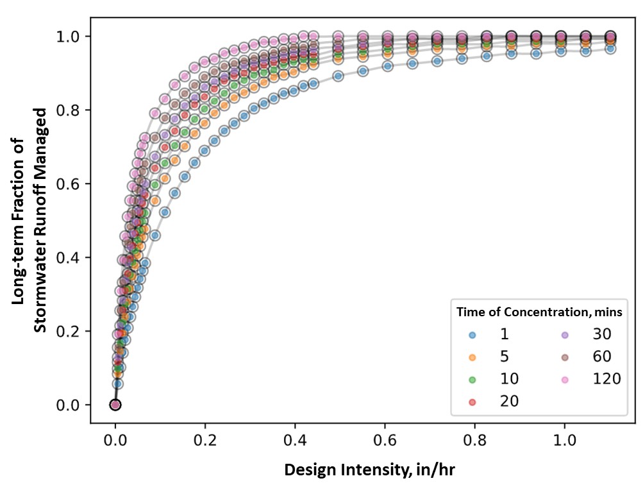

Figure ‑. Capture efficiency nomograph for a flow-based BMP.

#### Nomograph Solution Approaches

The nomograph solution approach relies on the definition of distinct ‘compartments’ within a BMP. Each facility may be composed of one or two compartments, and the volume managed by each compartment is either counted as ‘treated/detained’ and discharged downstream or it is counted as infiltrated and is eliminated from the water balance.

This compartment-based approach allows the Modeling Engine to calculate BMP capture for a wide variety of facility configurations. **Table 1‑5** shows the modeled BMP types mapped to their respective treatment solution approaches. The table indicates whether the facility has one or two-compartments and which nomograph type is being used to calculate wet-weather volume capture performance.

Table 1‑5. Structural facility types & solution approach table

|  |  |  |  |  |
| --- | --- | --- | --- | --- |
| Modeled BMP Name | Pseudocode Mapping to Tacoma Asset Management Type | No. of Compartments | Volume-based Compartments | Flow-based Compartments |
| Bioretention with raised underdrain | FACILITYTYPE == “Bioretention” AND  INFILTRATED ≠ “FULL” | 2 | Infiltration &  Treatment | -- |
| Dry Extended Detention Basin/Tank | FACILITYTYPE == “Tank” AND FLOWCONTROL ≠ true | 2 | Infiltration &  Treatment/Detention | -- |
| Flow Duration Control Tank | FACILITYTYPE == “Tank” AND  FLOWCONTROL == true | 2 | Infiltration &  Treatment/Detention | -- |
| Bioretention with no Underdrain | FACILITYTYPE == “Bioretention” AND  INFILTRATED == “FULL” | 1 | Infiltration | -- |
| Infiltration Basin/Trench | FACILITYTYPE == “Trench” | 1 | Infiltration | -- |
| Permeable Pavement | FACILITYTYPE == “Pervious Pavement” | 1 | Infiltration | -- |
| Sand Filter | FACILITYTYPE == “Sand Filter” | 1 | Treatment | -- |
| Filterra /Vegetated box | FACILITYTYPE == “Vegetated Box” | 1 | -- | Treatment |
| Media Filter | FACILITYTYPE == “Media Filter” | 1 | -- | Treatment |
| Oil-water Separator | FACILITYTYPE == “Oil Water Separator” | 1 | -- | Treatment |
| Hydrodynamic Separator | FACILITYTYPE == “Swirl Separator” | 1 | -- | Treatment |
| Vegetated Swale | FACILITYTYPE == “Swale” | 2 | Infiltration1 | Treatment |
| Wet Pond | FACILITYTYPE == “Pond” | 1 | Treatment | -- |

1 Vegetated Swales and Filter Strips perform ‘incidental infiltration’ due to their un-lined design. This is discussed further in the ‘hybrid flow and infiltration’ discussion below.

**Single-Compartment Volume-Based Nomograph Traversal.** This is the simplest case for volume-based facilities, such as an infiltration basin, lined bioretention, bioretention with no underdrain, permeable pavement, and several other types. For a single compartment BMP, the normalized BMP volume is determined as the ratio of the facility’s total volume to the DCV of the tributary area. BMP input parameters are structured so that the drawdown time can be inferred from available design information such as facility depth, total volume, and underlying infiltration rate so that the correct curve can be chosen from the nomograph.

Figure 1‑3 illustrates an example solution for an infiltration facility with a six-hour draw-down time whose total volume is equal to the DCV of the tributary area. In this case, the modeling module would estimate that the facility achieves approximately 85% of long-term runoff volume infiltration.

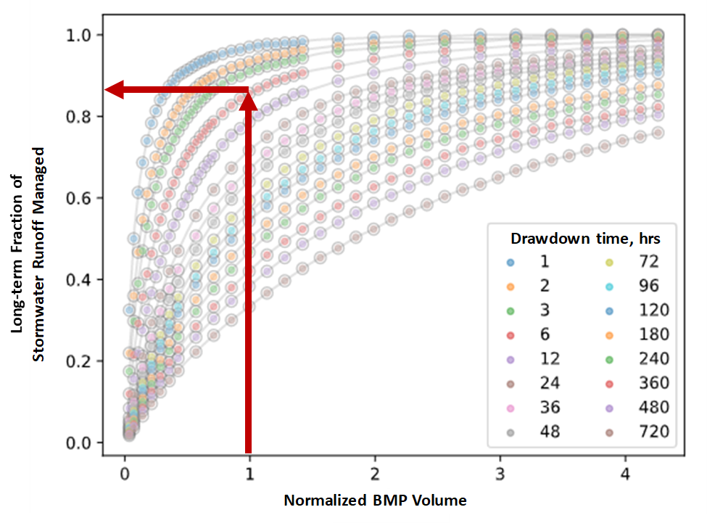

Figure ‑. Single compartment volume-based nomograph solution example

**Two-Compartment Volume-Based Nomograph Traversal.** This type of BMP solution is used for volume-based facilities that are capable of both infiltration and treatment of inflowing stormwater. Common examples of this type of BMP include bioretention facilities with a raised underdrain and extended dry detention facilities. These facility types may perform volume infiltration via infiltration into the native soil and may discharge treated flow via elevated underdrains or outlet structures.

The first nomograph traversal is for the infiltration compartment since these facilities fill from the bottom and infiltration typically begins to occur before treated discharge. The following figure illustrates the traversal process for a two-compartment facility in which each compartment is sized to be 50% of the design volume. In this case, the drawdown time is 24 hours for the infiltration compartment and 3 hours for the treatment compartment. The following steps demonstrate the traversal process which is illustrated below in **Figure 1‑4**.

Determine the infiltration capture performance by traversing 0.5 units along the x-axis and locate the correct trace for the 24-hour drawdown time of the infiltration compartment. The value is approximately 48% of long-term capture. This is shown in brown in the figure below.

Translate horizontally to the trace for the next compartment which draws down in 3 hours. The second compartment trace is shown in green in the figure below.

Follow the green 3-hour drawdown trace up the nomograph for 0.5 units of x-axis distance.

In this example, about 83% of long-term capture is achieved by both compartments working in concert. Infiltration accounts for 48% (from step 1), treatment accounts for 35% (83% - 48%), and 17% is bypassed (100% - 83%).

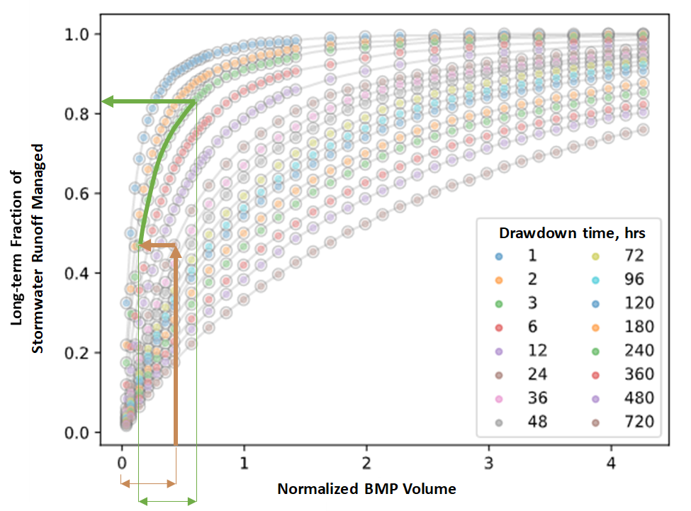

Figure ‑: Two-compartment nomograph traversal. In this case both compartments have the same volume capture capacity (0.5 Design Volumes) but they have different drawdown times.

For some BMP types, such as extended detention with permeable bottoms, there is not a defined infiltration compartment. Instead, infiltration occurs simultaneously with treatment. For these BMPs, the facility is divided into two parallel compartments with equal drawdown time. The volume in each compartment is prorated based on the ratio of the discharge rate from each compartment. For example, a hypothetical detention basin with a DCV ratio of 1.0 has a treated surface discharge rate of 0.35 cfs and an infiltration discharge rate of 0.15 cfs. The basin is divided into two parallel compartments, a treatment compartment with a DCV ratio of 0.7 and 0.35 cfs discharge rate and a infiltration compartment with a DCV ratio of 0.3 and 0.15 cfs discharge rate. Each compartment is analyzed individually (in parallel) and then the results are summed.

**Single-Compartment Flow-Based Nomograph Traversal.** This is the simplest case for flow-based BMPs. It is based on the flow rate of the facility. This nomograph is useful for modeling facilities such as an HDS unit or a proprietary flow-through biofilter since these facilities do not perform stormwater volume infiltration. In the example nomograph below (Figure 1‑5) a facility with a design treatment intensity of 0.2 inches per hour is expected to manage 83% of long-term runoff.

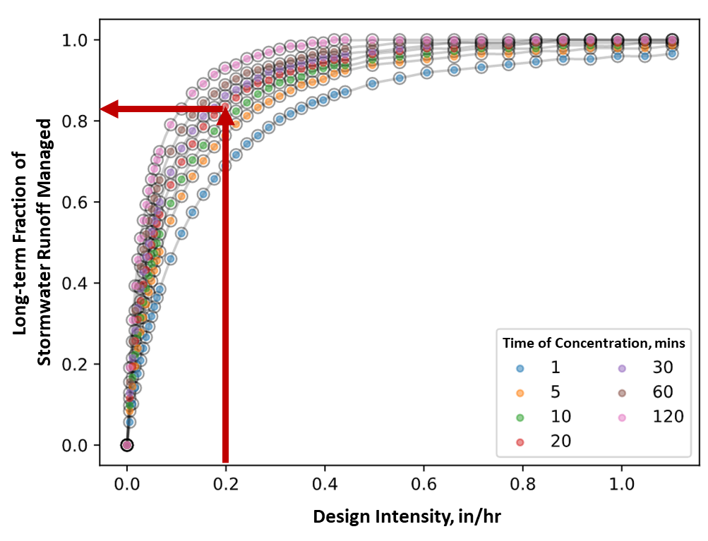

Figure ‑. Single compartment flow-based nomograph solution

**Hybrid Flow-Based Nomograph Traversal.** This volume capture solution applies only to facilities that are both unlined and flow-based facilities like a typical vegetated swale. These facilities are often sized and designed as flow-based facilities, but they may provide incidental volume reduction via infiltration depending on underlying soil conditions. For these facilities, the nomograph solution for capture is:

1. Consult the relevant flow-based nomograph to compute the total long-term capture volume.
2. Utilize the facility volume, depth, and underlying soil group to estimate the total storage volume and drawdown time for the facility.
3. Consult the relevant volume-based nomograph to calculate the long-term retained volume.
4. Calculate the treated and discharged volume as the difference between the total long-term capture volume and the retained volume.

This approach helps ensure that the overall long-term volume capture is consistent with the flow-based nomograph traversal result but allows for a portion of the capture volume to be counted as infiltration to better represent the incidental infiltration performance of these facilities.

**Nested BMPs.** The nomograph solution supports regional BMPs that receive discharge from BMPs in their upstream catchments. This means that upstream facilities that achieve long-term volume capture and attenuation will affect the potential volume capture performance of downstream facilities since that volume, or a portion of that volume, was removed from the system. It should be noted that in practice BMPs are typically only nested once, such as in a distributed BMP upstream of a centralized BMP, and more deeply nested facility configurations are uncommon.

This approach implements a corrective algorithm to track and correct the impacts of upstream infiltration and detention when applying nomograph traversal capture solutions in nested BMP configurations. This effectively treats upstream BMPs similarly to the first compartment in a two compartment BMP, described above. Therefore, the downstream BMP traverses the nomograph curve further to the right, where the slopes are lower (somewhat less capture per unit of volume provided). Comparisons between this algorithm and an explicit continuous simulation analysis in EPA SWMM 5.1 are within 5% of long-term capture efficiency, long-term volume infiltration performance, and long-term treatment performance for equivalent BMP configurations.

### Simplified Treatment Volume Capture Performance

The approach allows for a simplified method to model catchments with many treatment facilities for which individual facility delineations are not available, or to model facilities where specific design parameters are unknown. The user can enter the fractions of the site treated by given types of BMP and enter the long-term fraction of runoff volume retained and treated by the facility. This method requires the user to delineate the overall site treated area, but uses the user-entered values for percent of volume treated and retained rather than nomographs.

## Water Quality Performance

### Statistical Analysis Approach

Water quality performance estimates will be derived from the International Stormwater BMP Database (<http://bmpdatabase.org/>), version 2021 or later. Analysis will be based on the distribution of paired influent and effluent water quality concentrations for individual events by BMP category as reported in the database. This approach follows a similar study performed for the Puget Sound Partnership, evaluating the performance of water quality BMPs (Nilsen and Koryto 2017). Analysis steps are described below.

#### Data Sufficiency

In order to be used in this study, a minimum of 20 paired results must be reported with at least three distinct studies.

#### Paired difference test

For each BMP-pollutant combination, a parried difference test will be performed to test whether influent and effluent data represent statistically distinct populations. The Wilcoxon signed-ranked test, which is a non-parametric hypothesis test will be used. Only relationships that show a statistically distinct difference between influent and effluent will be used.

#### Monotonicity test

Next, data will be tested for monotonicity (e.g. a nondecreasing function) using the non-parametric Spearman’s Rho test. Only monotonic relationships will be used.

#### Regression

Finally, a regression relationship between influent and effluent concentrations will be developed using the non-parametric Kendall-Theil Robust Line regression. This approach was chosen to handle data outliers better than other regression methods, such as ordinary least-squares regression.

### Influent - Effluent performance curves

The pollutant load entering a BMP is estimated by calculating the product of the average annual influent volume and the mean COC concentration in the watershed. The BMP pollutant load reduction is calculated by the sum of:

1. **Infiltration** - The load reduced by infiltration is calculated as the watershed pollutant concentration multiplied by the volume lost to infiltration by the facility.
2. **Treatment** - The load reduced by treatment is calculated as the product of the volume treated and the reduction in concentration achieved by the facility between the influent and treated effluent.

To calculate the concentration reduction for treated water, this approach uses as input a set of influent-versus-effluent concentration curves. These define the best estimate of average effluent quality based on the average influent quality. These curves were developed based on monitoring studies in the International Stormwater BMP Database (<http://bmpdatabase.org/>), as prepared for the San Diego WQE (2018). An example plot representing the functional relationship between influent and effluent TSS concentration for several BMP types is shown below in Figure 1‑6.

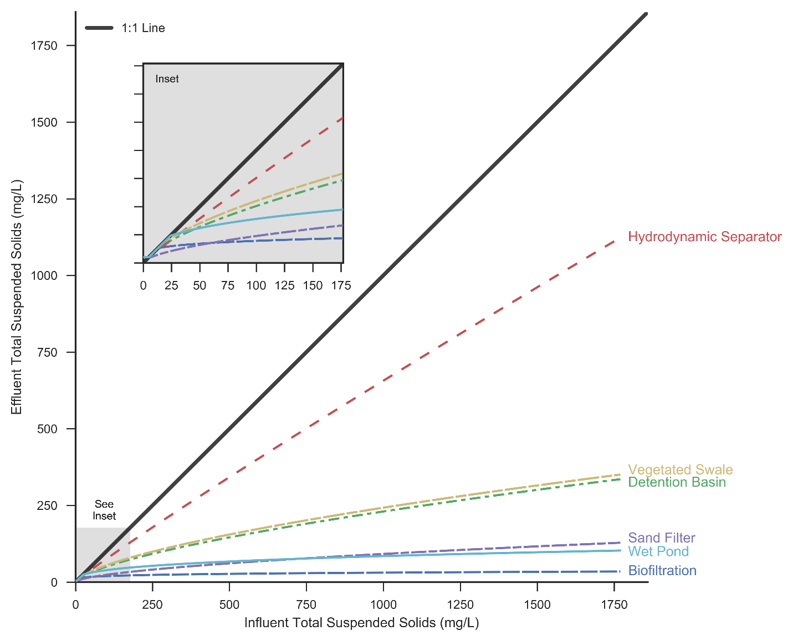

Figure ‑. Influent vs effluent curve for TSS removal by BMP type

The load reduction mechanism(s) for each of BMP types are listed below in Table 1‑6.

Table 1‑6. Load reduction calculation approach for BMP types

|  |  |  |
| --- | --- | --- |
| Water Quality BMP Types | Eliminates Load (Infiltrated / diverted) | Treatment & Discharge Influent-Effluent Curve |
| Garden with no Underdrain | Infiltration | No treatment assumed (infiltration only) |
| Infiltration Basin/Trench | Infiltration | No treatment assumed (infiltration only) |
| Drywell | Infiltration | No treatment assumed (infiltration only) |
| Permeable Pavement | Infiltration | No treatment assumed (infiltration only) |
| Underground Infiltration | Infiltration | No treatment assumed (infiltration only) |
| Cisterns for Harvest and Use | Infiltration | No treatment assumed (infiltration only) |
| Rain Garden (bioretention with raised underdrain) | Infiltration | Biofiltration/Bioretention |
| Dry Extended Detention Basin/Tank | Infiltration | Detention Basin |
| Flow Duration Control Basin/Tank | Infiltration | Detention Basin |
| Vegetated Swale | Infiltration | Vegetated Swale |
| Rain Garden with Underdrain and Liner | No infiltration assumed | Biofiltration/Bioretention |
| Filterra /Vegetated box | No infiltration assumed | High Rate Biofiltration |
| Media Filter | No infiltration assumed | High Rate Media Filter |
| Other Proprietary Biotreatment | No infiltration assumed | High Rate Biofiltration |
| Oil-water Separator | No infiltration assumed | Oil-water separator |
| Sand Filters | No infiltration assumed | Sand Filter |
| Hydrodynamic Separator | No infiltration assumed | Hydrodynamic Separator |
| Wet Pond | No infiltration assumed | Wet Pond/Wetland Basin |

The overall load reduction is calculated as the sum of the load removed via infiltration and the load removed via treatment. The load downstream of a BMP is calculated as the influent load minus these two components of load reduction. The effluent concentration is calculated as the load divided by the effluent volume. Bypass volume is assumed to be untreated and is assigned the contributing catchment concentration.

## Performance of Source Control BMPs

### Street Sweeping

#### Performance Data

Tacoma performs enhanced street sweeping across the city using regenerative air machines. Currently, all areas of the city are swept at least twice a year, with more frequent sweeping occurring for major arterials and business districts (City of Tacoma, 2017).

Tacoma has been monitoring sweeping performance in the Thea Foss watershed since 2012. A summary of monitoring results is shown in Table 7. For most COCs, the trend in removal efficiencies are relatively steady, although values fluctuate from year-to-year.

*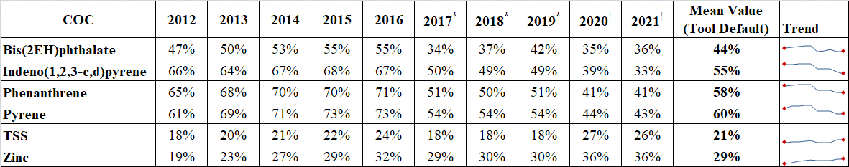Table* 1‑7. Summary of Reduction in COC Concentrations for Street Sweeping

in the Thea Foss Watershed, 2012-2021

\* includes enhanced sweeping for outfalls 243, and 245

† includes enhanced sweeping for outfalls 243, 245, and 254

#### Tool assumptions

To calculate pollutant removal attributable to street sweeping, the tool will employ the following assumptions.

* Default removal for each COC will be set at the mean value as shown in Table 7.
* Pollutant reduction will be calculated prior to influent concentrations draining to BMPs.
* Street sweeping will be assumed to apply evenly to an entire watershed.

### Storm Line Cleaning

Similar to Street Sweeping, Anchor QEA (2012) evaluated performance of basin-wide storm-line cleaning.

Table 1‑8. Summary of Storm Line Cleaning Monitoring in the Thea Foss Watershed, 2012-2021



#### Tool assumptions

To calculate pollutant removal attributable to line cleaning, the tool will employ the following assumptions.

* Default removal for each COC will be set at the mean value as shown in Table 8.
* Pollutant reduction will occur after to effluent concentrations discharging from BMPs.
* Storm line cleaning will be assumed to apply evenly to an entire watershed.

# Cost MOdule

## Introduction

This section describes the development of a lifecycle module for selected stormwater facilityy types. This module incorporates capital costs, operations and maintenance costs, and lifespan, to provide the present costs of various facility types.

## Parameters

The cost module contains parameters that can be adjusted by the user. Global parameters are set for the tool as a whole and apply to all cost calculations. Asset specific parameters are used to calculate costs for a specific asset and should be based on the specific attributes of an asset.

### Global Parameters

The following parameters apply to all cost calculations in the tool. These are adjusted at a global level so costs of specific assets can be compared to one another.

* **Cost Basis Year**: The reference year for inflation adjustment (i.e. what year should dollar values be reported in).
* **Discount Rate:** The interest rate used to determine the present value of future cash flows. The discount rate in the tool has been initialized with the 30-year rate published in the White House Office of Management and Budget (OMB) Circular A-94 (OMB, 2023) This rate corresponds to the long-term nominal interest rate on US Treasury notes and bonds.
* **Inflation Rate**: This is the annual inflation rate to be applied to purchases and services. The inflation rate has been initialized with the long-term inflation rate published by the Congressional Budget Office (2023)
* **Planning Horizon**: This is the total time-period in years over which future cash flows will be considered.

### Asset Specific Parameters

The following parameters apply to a specific asset. These are adjusted on a per asset basis, based on that asset’s characteristics.

* **Capital Costs**: These are the initial costs required for constructing and installing an asset. Capital costs may include property acquisition costs depending on the scenario.
* **Capital Cost Basis Year**: This refers to the reference year used to express the capital costs. For example, if capital costs were calculated in 2020 dollars, the user would input 2020 for the Capital Cost Basis Year.
* **Install Year**: The year when the asset was constructed.
* **Lifespan**: The expected duration of facility service before it requires replacement or significant overhaul.
* **O&M Cost Basis Year**: This is the base year from which the annual operation and maintenance costs are calculated.
* **O&M Costs per Year:** The reference year used to express operation and maintenance costs.
* **Replacement Cost**: The cost to replace or significantly overhaul an asset beyond routine maintenance (e.g., media replacement in a bioretention facility).

### Reference Costs

To assist with estimation of costs, unit costs for facilities were adapted from the King County Water Quality Benefit Evaluation (WQBE) program (Hadler and others, 2022). This study used data from a number of sources including King County Wastewater Treatment Division and the Washington State Department of Ecology to create cost curves, which are based on the predicted costs of different water quality actions. Unit cost curves were developed for both capital and operations and maintenance costs.

Cost curves were mapped to Tacoma’s facility type definitions as shown in Table 2‑1.

Table 2‑1. Facility types and corresponding unit cost curves

|  |  |
| --- | --- |
| **Facility Type** | **Corresponding King County Unit Cost Curves** |
| Bioretention | WQBE\_03A\_Bioretention Underdrain on Property |
| WQBE\_03Aa\_Bioretention Underdrain with Property Cost |
| WQBE\_03B\_Bioretention No Underdrain on Property |
| WQBE\_03Bb\_Bioretention No Underdrain with Property Cost |
| WQBE\_03C\_Bioretention Underdrain in ROW |
| WQBE\_03D\_Bioretention No Underdrain in ROW |
| Holding Basin | WQBE\_12A\_Detention Pond on Public Property |
| WQBE\_12B\_Detention Pond with Property Cost |
| Media Filter | WQBE\_05A\_Media Filter Drain Underdrain |
| WQBE\_05B\_Media Filter Drain No Underdrain |
| Pervious Pavement | WQBE\_08A\_Pervious Concrete Sidewalk (no sand layer) |
| WQBE\_08B\_Porous Asphalt Driveway (with sand layer) |
| WQBE\_08C\_Permeable Paver Driveway (with sand layer) |
| WQBE\_08D\_Permeable Paver Plaza (no sand layer) |
| Pond | WQBE\_13A\_Infiltration Pond Till Soil on Public Property |
| WQBE\_13B\_Infiltration Pond Outwash Soil on Public Property |
| WQBE\_13C\_Infiltration Pond Till Soil with Property Cost |
| WQBE\_13D\_Infiltration Pond Outwash Soil with Property Cost |
| WQBE\_13E\_Infiltration Pond Outwash Soil with High Rate Underground Filter System on Public Property |
| Swale | WQBE\_04A\_Bioswale in ROW |
| WQBE\_04B\_Bioswale on Public Property |
| WQBE\_04C\_Bioswale with Property Cost |
| Tank  Tank  Tank | WQBE\_11A\_Detention Vault on Public Property |
| WQBE\_11B\_Detention Vault in ROW |
| WQBE\_11C\_Detention Vault with Property Cost |
| WQBE\_16\_Cistern on Property |
| Vault | WQBE\_14A\_Infiltration Vault Till Soil on Public Property |
| WQBE\_14B\_Infiltration Vault Outwash Soil on Public Property |
| WQBE\_14C\_Infiltration Vault Till Soil in ROW |
| WQBE\_14D\_Infiltration Vault Outwash Soil in ROW |
| WQBE\_14E\_Infiltration Vault Till Soil with Property Cost |
| WQBE\_14F\_Infiltration Vault Outwash Soil with Property Cost |
| WQBE\_14G\_Infiltration Vault Outwash Soil with High Rate Underground Filter System in ROW |
| Vegetated Box | WQBE 02A\_Bioretention Planter on Property |
| WQBE\_02B\_Bioretention Planter in ROW |
| WQBE\_02C\_Bioretention Planter with Property Cost |

### Cost Calculations

#### Net present value

Costs are calculated as the net present value (NPV) of all capital and operations and maintenance costs. NPV is the value of a stream of benefits or costs when discounted back to a single time. The formula for calculating NPV of future outlays is:

where

NPV = net present value of costs

Rt  = Annual regular costs

i = discount rate

N = Number of years (planning horizon).

#### Inflation adjustments

Users can input capital costs and operations and maintenance costs derived in different basis years from each other. This functionality permits the user to incorporate cost estimates or actual expenditures from prior years and still be able make a comparative analysis using the tool. Costs are adjusted for inflation using the formula below:

where

V0 = Value from previous time period

Vn = Current value

r = inflation rate

n = Number of years between periods

Capital costs are costs are adjusted for inflation by this formula directly. Operation and maintenance costs are first translated to the whole life-cycle value corresponding to the previous period, and then adjusted using this formula.

# Watershed Prioritization MOdule

## Introduction

The watershed prioritization module allows users to identify and prioritize areas that are a high priority for actions to meet watershed planning goals related to water quality, habitat, and social equity. By developing a structured decision support process, decisions can be made that better allocate resources, plan for new facilities, and identify areas for preservation.

This chapter presents the methodology used to develop the watershed prioritization module. The module leverages GIS data, water quality modeling, BMP performance modeling, and multi-criteria decision analysis (MCDA). The approach presented below reconciles the complexities of watershed planning with the need for practical, science-driven decision making.

## Methodology

This section described the process used to incorporate the PROMETHEE II (Preference Ranking Organization Method for Enrichment Evaluation) MCDA methodology with available spatial data. It provides an overview of the MCDA framework, development of critieria, and methods for calculating watershed metrics.

### PROMETHEE II MCDA Overview

The PROMETHEE II is a widely used Multi-Criteria Decision Analysis (MCDA) methodology developed by Brans and Vincke (1985). This approach is primarily designed to aid decision-makers in handling complex decision problems involving multiple, often conflicting, criteria. It offers an organized framework to compare and rank various alternatives based on the decision-maker's preferences.

PROMETHEE II works by converting criteria into a comparable scale, which allows for the evaluation of alternatives based on different aspects. The methodology consists of several steps:

1. Formation of a decision matrix that contains all the alternatives and their performance on each criterion.
2. Assignment of weights to the criteria reflecting their relative importance.
3. Application of a preference function to each pair of alternatives to establish their pairwise comparison.
4. Calculation of outranking flows (positive "leaving flow" and negative "entering flow").
5. Generation of a complete or partial ranking of alternatives based on the net outranking flow (difference between positive and negative flows).

One of the primary benefits of PROMETHEE II over other MCDA methodologies is its transparency and ease of interpretation. The method uses straightforward mathematical calculations, and the decision-maker's preferences are clearly reflected in the process through weights and preference functions. This visibility of decision parameters contributes to the method's acceptability among decision-makers.

PROMETHEE II MCDA methodology has been successfully used in a wide array of fields, including environmental management, healthcare, finance, and logistics. In the context of watershed prioritization, it provides a systematic for evaluating and ranking watersheds based on multiple environmental and socio-economic criteria.

### Decision Matrix

#### Criteria

The MCDA methodology in the tool uses several criteria to meet the goals of improving water quality, increasing resilience to climate change impacts, preserving and restoring critical and sensitive habitats, and implementing equity and social justice.

Watershed Planning staff identified four prioritization goals that align with the goals of the City’s Watershed Plan. Goal 1 addresses water quality outcomes, focusing on pollutant concentrations and stormwater management infrastructure improvement. Goal 2 aims to increase resilience to climate change impacts by targeting areas most vulnerable to these impacts. Goal 3 centers around preserving and restoring critical and sensitive habitats. Goal 4 seeks to implement equity and social justice, with a focus on areas identified as having overlapping equity needs by other Tacoma programs. Table Table 3‑1summarizes the subgoals, critieria, and sources of data for each goal.

Table 3‑1 Watershed Planning Goals and associated Subgoals and Criteria

|  |  |  |
| --- | --- | --- |
| Goal 1: Improve Water Quality Outcomes (Clean Water Goal) | | |
| **Sub-goal** | **Criteria** | **Data Source** |
| 1.1 Prioritize areas based on pollutant concentrations | Total Nitrogen Concentration | TNC Stormwater Heatmap |
| TSS Concentration | TNC Stormwater Heatmap |
| Annual Runoff | TNC Stormwater Heatmap |
| Imperviousness | TNC Stormwater Heatmap |
| 1.2 Improve infrastructure in areas with inadequate stormwater management | Percent of Area Treated | Calculated in tool |
| Age of Development | TNC Stormwater Heatmap |

|  |  |  |
| --- | --- | --- |
| Goal 2: Increase Resilience to Climate Change Impacts (Resilient Community Goal) | | |
| **Sub-goal** | **Criteria** | **Source** |
| 2.1 Target areas most vulnerable to and at risk for climate change impacts | Urban Heat Island | City of Tacoma |
| Capacity Issues Layer | City of Tacoma |

|  |  |  |
| --- | --- | --- |
| Goal 3: Preserve and Restore Critical and Sensitive Habitat (Healthy Ecosystems) | | |
| **Sub-goal** | **Criteria** | **Source** |
| 3.1 Preserve and improve Natural Spaces | ES Open Space/Natural Resource Areas | City of Tacoma |
| Biodiversity Corridors | City of Tacoma |

|  |  |  |
| --- | --- | --- |
| Goal 4: Implement Equity and Social Justice (Healthy Neighborhoods; Equity) | | |
| **Sub-goal** | **Criteria** | **Source** |
| 4.1 Prioritize areas of overlapping equity needs as identified by other Tacoma programs | Equity Index Score | City of Tacoma |
| Livability Index | City of Tacoma |
| 4.2 Improve access to safe, high-quality roadway infrastructure (green infrastructure recommendation) | Pavement Condition Index | City of Tacoma |

#### Direction of Criteria

The direction of the criteria—whether they are minimized or maximized—depends on the nature of the criterion itself.

For Goal 1, pollutant concentrations such as Total Nitrogen Concentration and TSS Concentration are to be minimized to improve water quality. Conversely, the Annual Runoff and the Percent of Area Treated are criteria aimed to be maximized for better stormwater management.

Under Goal 2, the Urban Heat Island effect is a criterion to be minimized to enhance climate resilience, whereas the capacity to handle climate change impacts is to be maximized.

For Goal 3, the preservation and improvement of Natural Spaces, Salmon Streams, and Biodiversity Corridors are all maximized to ensure healthy ecosystems.

Finally, in Goal 4, the Equity Index Score and Livability Index are maximized to enhance social justice and improve the quality of life in neighborhoods. In contrast, pavement condition, indicative of needed infrastructure work, is minimized to reflect improved roadway conditions. Sidewalk density is maximized to reflect better access to safe, high-quality roadway infrastructure.

#### Preference Function

PROMETHEE II can use several preference functions (Brans and Vincke, 1985) representing different thresholds for criteria indifferences and preferences. The decision support module uses the “Usual” preference function representing the simplest case for user preferences, whereby any difference in criteria results in a strict preference. In other words if a criterion value for one watershed exceeds another, the preference value is 1 (indicating a clear preference). If not, the preference value is 0 (indicating no preference).

#### Calculation of Outranking flows

Watersheds are compared to each other on a pairwise basis. A given watershed is compared to every other watershed with respect to each criterion. For each comparison, a binary (i.e. 0 or 1) value is assigned and multiplied by the weight of the criterion. This represents the positive outranking flow. This process is then repeated by comparing every other watershed back to the initial watershed. For each of these comparisons, a binary value of 0 or -1 is assigned representing whether or not another watershed is preferred to the selected watershed. This is the negative outranking flow. Positive and negative outranking flows are illustrated in **Figure 3‑1**.

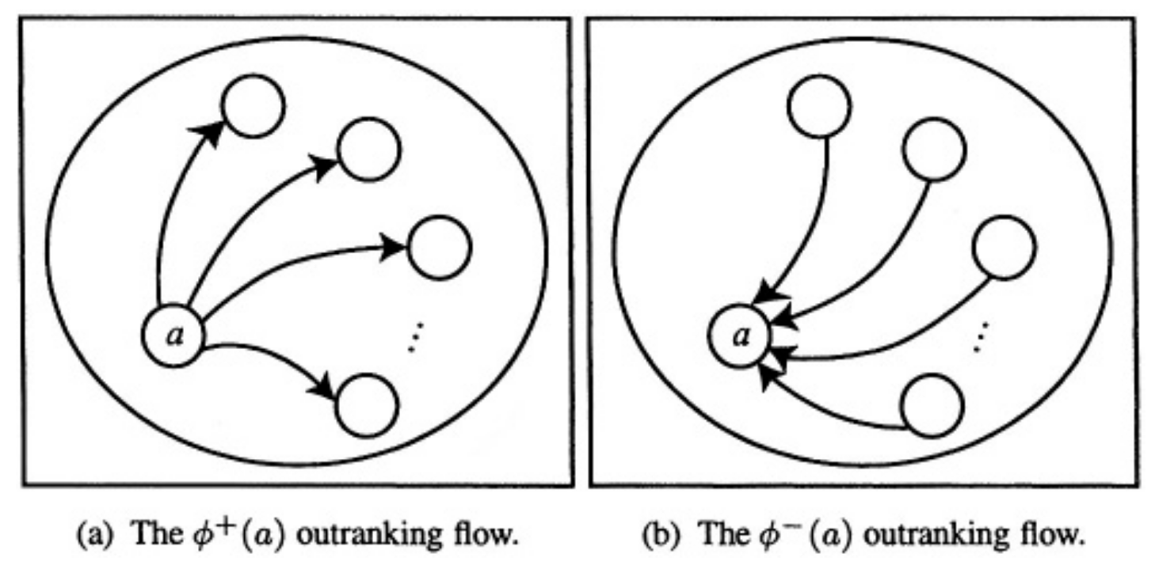

**Figure 3‑1 Illustration of positive and negative outranking flows (Brans and De Smet, 2016)**

The positive and negative outranking flows are then summed independently for each watershed, resulting in a partial ranking of watersheds. The positive and negative outranking flows are then summed together to arrive at the final full ranking of watersheds.

## Example

For example, assume a comparison of three watersheds: Watershed A, Watershed B, and Watershed C. For simplicity, assume three criteria: Total Nitrogen Concentration, Urban Heat Island, and Equity Index Score. Assume the weights of these criteria are 3, 4, and 5 respectively (as input by the user).

The preference values for Watershed A over Watershed B, calculated using the usual preference function, are as follows:

Total Nitrogen Concentration: 1 (A is better than B)

Urban Heat Island: 0 (A is equivalent to B)

Equity Index Score: 1 (A is better than B)

The positive outranking flow for Watershed A over Watershed B is:

(1 \* 3) + (0 \* 4) + (1 \* 5) = 8

The positive outranking flow for Watershed B over Watershed A is:

(0 \* 3) + (0 \* 4) + (0 \* 5) = 0

This would then be repeated for the watershed pairs of (A,C), (B,C), (C,A) and (C,B).

The negative outranking flow for Watershed A over Watershed B is:

(0 \* 3) + (0 \* 4) + (0 \* 5) = 0

The negative outranking flow for Watershed B over Watershed A is:

(-1 \* 3) + (0 \* 4) + (-1 \* 5) = -8

This would then be repeated for the watershed pairs of (A,C), (B,C), (C,A) and (C,B).

The positive and negative outranking flows are then summed, representing the net outranking flow for each watershed. Finally, watersheds are ranked based on their net outranking flows. The watershed with the highest net outranking flow is considered the best option according to the chosen criteria and weights.

# References

Abatzoglou, J.T., S.Z. Dob rowski, S.A. Parks, K.C. Hegewisch, 2018, Terraclimate, a high-resolution global dataset of monthly climate and climatic water balance from 1958-2015, Scientific Data 5:170191, doi:10.1038/sdata.2017.191

Anchor QEA. 2012. “Effectiveness of Basin-Wide Stormwater Best Management Practices Thea Foss Drainage Basin, City of Tacoma,” no. September.

City of Tacoma. 2017. “Thea Foss and Wheeler-Osgood Waterways 2016 Source Control and Water Year 2016 Stormwater Monitoring Report,” no. March: 1–222.

Dinicola, Richard S. 1990. “Characterization and Simulation of Rainfall-Runoff Relations for Headwater Basins in Western King and Snohomish Counties, Washington.” *Water-Resources Investigations Report* 89–4052: 52 p. <https://pubs.er.usgs.gov/publication/wri894052>.

Ecology. 2018. “Phase I Municipal Stormwater Permit - General,” 1–75.

Nilsen, Christian, and Kevin Koryto. 2017. “Evaluating the Effectiveness of BMPs to Remove Stormwater Pollution Using a Simple Calculation Tool : The Puget Sound Stormwater Pollution Reduction Tool.”

Taylor, Scott M. 2016. *The Long-Term Performance and Life-Cycle Cost of Stormwater Best Management Practices*. *TR News*. Vol. 2016-Novem. National Academies Press. https://doi.org/10.17226/22275.Brans, J.-P., and De Smet, Y., 2016, PROMETHEE Methods, *in* Greco, S., Ehrgott, M., and Figueira, J.R. eds., Multiple Criteria Decision Analysis: Springer New York, New York, NY, p. 187–219.

Brans, J.P., and Vincke, Ph., 1985, Note—A Preference Ranking Organisation Method: (The PROMETHEE Method for Multiple Criteria Decision-Making): Management Science, v. 31, no. 6, p. 647–656.

City of Tacoma, 2017, Thea Foss and Wheeler-Osgood Waterways 2016 Source Control and Water Year 2016 Stormwater Monitoring Report: no. March, p. 1–222.

Congressional Budget Office, 2023, The Budget and Economic Outlook: 2023 to 2033 | Congressional Budget Office, accessed June 30, 2023, at https://www.cbo.gov/publication/58848.

Hadler, E., Lenth, J., and Wright, O., 2022, Unit Cost Basis for Water Quality Benefits Evaluation (431 TM1):

OMB, 2023, Guidelines and discount rates for benefit-cost analysis of federal programs (OMB Circular No. A-94 Revised): Office of Management and Budget, Washington, DC.

**Appendix A**

HSPF IMPLND and PERLND Factors

***Table A-1 HSPF PERLND Factors***

|  |  |  |  |  |  |  |  |  |  |  |  |  |  |  |  |  |  |  |  |  |  |  |
| --- | --- | --- | --- | --- | --- | --- | --- | --- | --- | --- | --- | --- | --- | --- | --- | --- | --- | --- | --- | --- | --- | --- |
| **HRU** | **Soil** | **Land Cover** |  | **Slope** | **LZSN** | **INFILT** | **LSUR** | **SLSUR** | **KVARY** | **AGWRC** | **INFEXP** | **INFILD** | **BASETP** | **AGWETP** | **CEPSC** | **UZSN** | **NSUR** | **INTFW** | **IRC** | **LZETP** | **IWAT** | **RETSC** |
| 000 | A/B | Forest |  | Flat | 5 | 2 | 400 | 0.05 | 0.3 | 0.996 | 2 | 2 | 0 | 0 | 0.2 | 0.5 | 0.35 | 0 | 0.7 | 0.7 | NA | NA |
| 001 | A/B | Forest |  | Mod | 5 | 2 | 400 | 0.1 | 0.3 | 0.996 | 2 | 2 | 0 | 0 | 0.2 | 0.5 | 0.35 | 0 | 0.7 | 0.7 | NA | NA |
| 002 | A/B | Forest |  | Steep | 5 | 2 | 400 | 0.15 | 0.3 | 0.996 | 2 | 2 | 0 | 0 | 0.2 | 0.5 | 0.35 | 0 | 0.7 | 0.7 | NA | NA |
| 010 | A/B | Pasture |  | Flat | 5 | 1.5 | 400 | 0.05 | 0.3 | 0.996 | 2 | 2 | 0 | 0 | 0.15 | 0.5 | 0.3 | 0 | 0.7 | 0.4 | NA | NA |
| 011 | A/B | Pasture |  | Mod | 5 | 1.5 | 400 | 0.1 | 0.3 | 0.996 | 2 | 2 | 0 | 0 | 0.15 | 0.5 | 0.3 | 0 | 0.7 | 0.4 | NA | NA |
| 012 | A/B | Pasture |  | Steep | 5 | 1.5 | 400 | 0.15 | 0.3 | 0.996 | 2 | 2 | 0 | 0 | 0.15 | 0.5 | 0.3 | 0 | 0.7 | 0.4 | NA | NA |
| 020 | A/B | Lawn |  | Flat | 5 | 0.8 | 400 | 0.05 | 0.3 | 0.996 | 2 | 2 | 0 | 0 | 0.1 | 0.5 | 0.25 | 0 | 0.7 | 0.25 | NA | NA |
| 021 | A/B | Lawn |  | Mod | 5 | 0.8 | 400 | 0.1 | 0.3 | 0.996 | 2 | 2 | 0 | 0 | 0.1 | 0.5 | 0.25 | 0 | 0.7 | 0.25 | NA | NA |
| 022 | A/B | Lawn |  | Steep | 5 | 0.8 | 400 | 0.15 | 0.3 | 0.996 | 2 | 2 | 0 | 0 | 0.1 | 0.5 | 0.25 | 0 | 0.7 | 0.25 | NA | NA |
| 100 | C | Forest |  | Flat | 4.5 | 0.08 | 400 | 0.05 | 0.5 | 0.996 | 2 | 2 | 0 | 0 | 0.2 | 0.5 | 0.35 | 6 | 0.5 | 0.7 | NA | NA |
| 101 | C | Forest |  | Mod | 4.5 | 0.08 | 400 | 0.1 | 0.5 | 0.996 | 2 | 2 | 0 | 0 | 0.2 | 0.5 | 0.35 | 6 | 0.5 | 0.7 | NA | NA |
| 102 | C | Forest |  | Steep | 4.5 | 0.08 | 400 | 0.15 | 0.5 | 0.996 | 2 | 2 | 0 | 0 | 0.2 | 0.3 | 0.35 | 6 | 0.3 | 0.7 | NA | NA |
| 110 | C | Pasture |  | Flat | 4.5 | 0.06 | 400 | 0.05 | 0.5 | 0.996 | 2 | 2 | 0 | 0 | 0.15 | 0.4 | 0.3 | 6 | 0.5 | 0.4 | NA | NA |
| 111 | C | Pasture |  | Mod | 4.5 | 0.06 | 400 | 0.1 | 0.5 | 0.996 | 2 | 2 | 0 | 0 | 0.15 | 0.4 | 0.3 | 6 | 0.5 | 0.4 | NA | NA |
| 112 | C | Pasture |  | Steep | 4.5 | 0.06 | 400 | 0.15 | 0.5 | 0.996 | 2 | 2 | 0 | 0 | 0.15 | 0.25 | 0.3 | 6 | 0.3 | 0.4 | NA | NA |
| 120 | C | Lawn |  | Flat | 4.5 | 0.03 | 400 | 0.05 | 0.5 | 0.996 | 2 | 2 | 0 | 0 | 0.1 | 0.25 | 0.25 | 6 | 0.5 | 0.25 | NA | NA |
| 121 | C | Lawn |  | Mod | 4.5 | 0.03 | 400 | 0.1 | 0.5 | 0.996 | 2 | 2 | 0 | 0 | 0.1 | 0.25 | 0.25 | 6 | 0.5 | 0.25 | NA | NA |
| 122 | C | Lawn |  | Steep | 4.5 | 0.03 | 400 | 0.15 | 0.5 | 0.996 | 2 | 2 | 0 | 0 | 0.1 | 0.15 | 0.25 | 6 | 0.3 | 0.25 | NA | NA |
| 200 | SAT | Forest |  | Flat | 4 | 2 | 100 | 0.001 | 0.5 | 0.996 | 10 | 2 | 0 | 0.7 | 0.2 | 3 | 0.5 | 1 | 0.7 | 0.8 | NA | NA |
| 201 | SAT | Forest |  | Mod | 4 | 2 | 100 | 0.01 | 0.5 | 0.996 | 10 | 2 | 0 | 0.7 | 0.2 | 3 | 0.5 | 1 | 0.7 | 0.8 | NA | NA |
| 202 | SAT | Forest |  | Steep | 4 | 2 | 100 | 0.1 | 0.5 | 0.996 | 10 | 2 | 0 | 0.7 | 0.2 | 3 | 0.5 | 1 | 0.7 | 0.8 | NA | NA |
| 210 | SAT | Pasture |  | Flat | 4 | 1.8 | 100 | 0.001 | 0.5 | 0.996 | 10 | 2 | 0 | 0.5 | 0.15 | 3 | 0.5 | 1 | 0.7 | 0.6 | NA | NA |
| 211 | SAT | Pasture |  | Mod | 4 | 1.8 | 100 | 0.01 | 0.5 | 0.996 | 10 | 2 | 0 | 0.5 | 0.15 | 3 | 0.5 | 1 | 0.7 | 0.6 | NA | NA |
| 212 | SAT | Pasture |  | Steep | 4 | 1.8 | 100 | 0.1 | 0.5 | 0.996 | 10 | 2 | 0 | 0.5 | 0.15 | 3 | 0.5 | 1 | 0.7 | 0.6 | NA | NA |
| 220 | SAT | Lawn |  | Flat | 4 | 1 | 100 | 0.001 | 0.5 | 0.996 | 10 | 2 | 0 | 0.35 | 0.1 | 3 | 0.5 | 1 | 0.7 | 0.4 | NA | NA |
| 221 | SAT | Lawn |  | Mod | 4 | 1 | 100 | 0.01 | 0.5 | 0.996 | 10 | 2 | 0 | 0.35 | 0.1 | 3 | 0.5 | 1 | 0.7 | 0.4 | NA | NA |
| 222 | SAT | Lawn |  | Steep | 4 | 1 | 100 | 0.1 | 0.5 | 0.996 | 10 | 2 | 0 | 0.35 | 0.1 | 3 | 0.5 | 1 | 0.7 | 0.4 | NA | NA |

**Table A-2 HSPF IMPLND Factors**

|  |  |  |  |  |  |  |
| --- | --- | --- | --- | --- | --- | --- |
| HRU | Land Cover | Slope | LSUR | SLSUR | NSUR | RETSC |
| 250 | Impervious | Flat | 400 | 0.01 | 0.1 | 0.1 |
| 251 | Impervious | Moderate | 400 | 0.05 | 0.1 | 0.08 |
| 252 | Impervious | Steep | 400 | 0.1 | 0.1 | 0.05 |