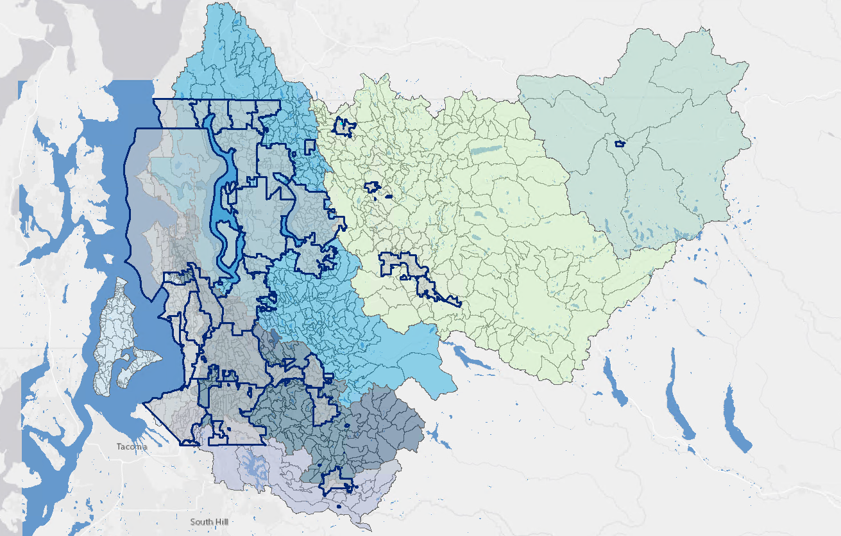

Subbasins

* Outline color: R 104 / G 104 / B 104 (gray 60%)
* Outline width: 0.4 pts
* Fill: R 204 / G 204 / B 204 (Gray 20%) / 80% Transparent

Receiving Waters:

* Outline color: gray 60%
* Outline width: 0.4 pts
* Fill Colors
  + R 158 / G 187 / B 215 (Blue Gray Dust)
  + R 0 / G 76 / B 115 (Steel Blue)
  + R 0 / G 197 / B 255 (Big Sky Blue)
  + R 0 / G 69 / B 230 (Moorea Blue)
  + R 190 / G 232 / B 255 (Sodalite Blue)
  + R 158 / G 215 / B 194 (Turquoise Dust)
  + R 211 / G 255 / B 190 (Tzavorite Green)
  + R 158 / G 170 / B 215 (Violet Dust)

Jurisdictions:

* Outline color: R 0 / G 38 / B 115 (Dark Navy)
* Outline width: 2 pts
* Fill color: R 204 / G 204 / B 204 (Gray 20%) / 40% Transparent

Water Bodies

* Fill: R 102 / G 153 / B 205 (Atlantic Blue)