ADA Compliance Report
San Bernardino County ACA NonProd1 Portal
Client | San Bernardino County (SANBERN_NONPROD)
Portal | Accela Citizen Access (ACA) — NonProd1
Tool | Google Lighthouse 12.8.2 (Desktop, Accessibility only)
Base URL | https://aca-nonprod.accela.com/SANBERN-NONPROD1
Scan Date | 03/18/2026
Report Date | 03/25/2026

1. Executive Summary
A desktop-only Lighthouse 12.8.2 accessibility audit was conducted across 8 primary pages of the SANBERN-NONPROD1 ACA environment. Pages were evaluated in both logged-out and logged-in states, including interactive sub-states discovered during navigation.

# | Page | State | Score | Failing Audits
1 | Default Landing (Logged Out) | Logged Out | 91 | link-name, list
2 | Login Page | Logged Out | 87 | aria-prohibited-attr, link-name, list, target-size
3 | Register Disclaimer | Logged Out | 82 | aria-prohibited-attr, frame-title, link-name, list, target-size
4 | Search For Licenses | Logged In | 85 | aria-prohibited-attr, link-name, list, target-size, document-no-main-landmark
5 | Dashboard | Logged In | 82 | aria-prohibited-attr, color-contrast, link-name, list, target-size
6 | My Records | Logged In | 85 | aria-prohibited-attr, link-name, list, target-size, document-no-main-landmark
7 | Licenses | Logged In | 82 | aria-prohibited-attr, frame-title, link-name, list, target-size
8 | Public Works | Logged In | 81 | aria-prohibited-attr, color-contrast, identical-links-same-purpose

2. Scope
Base URL: https://aca-nonprod.accela.com/SANBERN-NONPROD1
Audited pages:
# | Page | State | Audited URL Path
1 | Default Landing (Logged Out) | Logged Out | /Default.aspx
2 | Login Page | Logged Out | /Login.aspx
3 | Register Disclaimer | Logged Out | /account/RegisterDisclaimer.aspx
4 | Search For Licenses | Logged Out | /GeneralProperty/PropertyLookUp.aspx?isCertBusiness=Y&TabName=Home
5 | Licenses | Logged Out | /Cap/CapHome.aspx?module=Licenses
6 | Publicworks | Logged Out | /Cap/CapHome.aspx?module=Publicworks
7 | Dashboard (Logged In) | Logged In | /Dashboard.aspx
8 | My Records | Logged In | /Cap/CapHome.aspx?TabName=MyRecords

3. Cross-Page Findings Summary
The following audit failures appeared most frequently across the 4 successfully audited pages:
Audit ID | Pages | Description
link-name | 4 | Default Landing, Login, Register Disclaimer, Dashboard
list | 4 | Default Landing, Login, Register Disclaimer, Dashboard
aria-prohibited-attr | 3 | Login, Register Disclaimer, Dashboard
target-size | 3 | Login, Register Disclaimer, Dashboard
color-contrast | 1 | Dashboard (table headers, action buttons)
frame-title | 1 | Register Disclaimer (#DisclaimerFrame)

4. Page-by-Page Results
The following sections detail each failing audit per successfully evaluated page, including the affected element, HTML snippet, and recommended fix.

P1 ——— Default Landing (Logged Out)
URL: https://aca-nonprod.accela.com/SANBERN-NONPROD1/Default.aspx
Accessibility Score: 91 / 100 | State: Logged Out | Failing: 3
Failing Audits: link-name, list, document-no-main-landmark

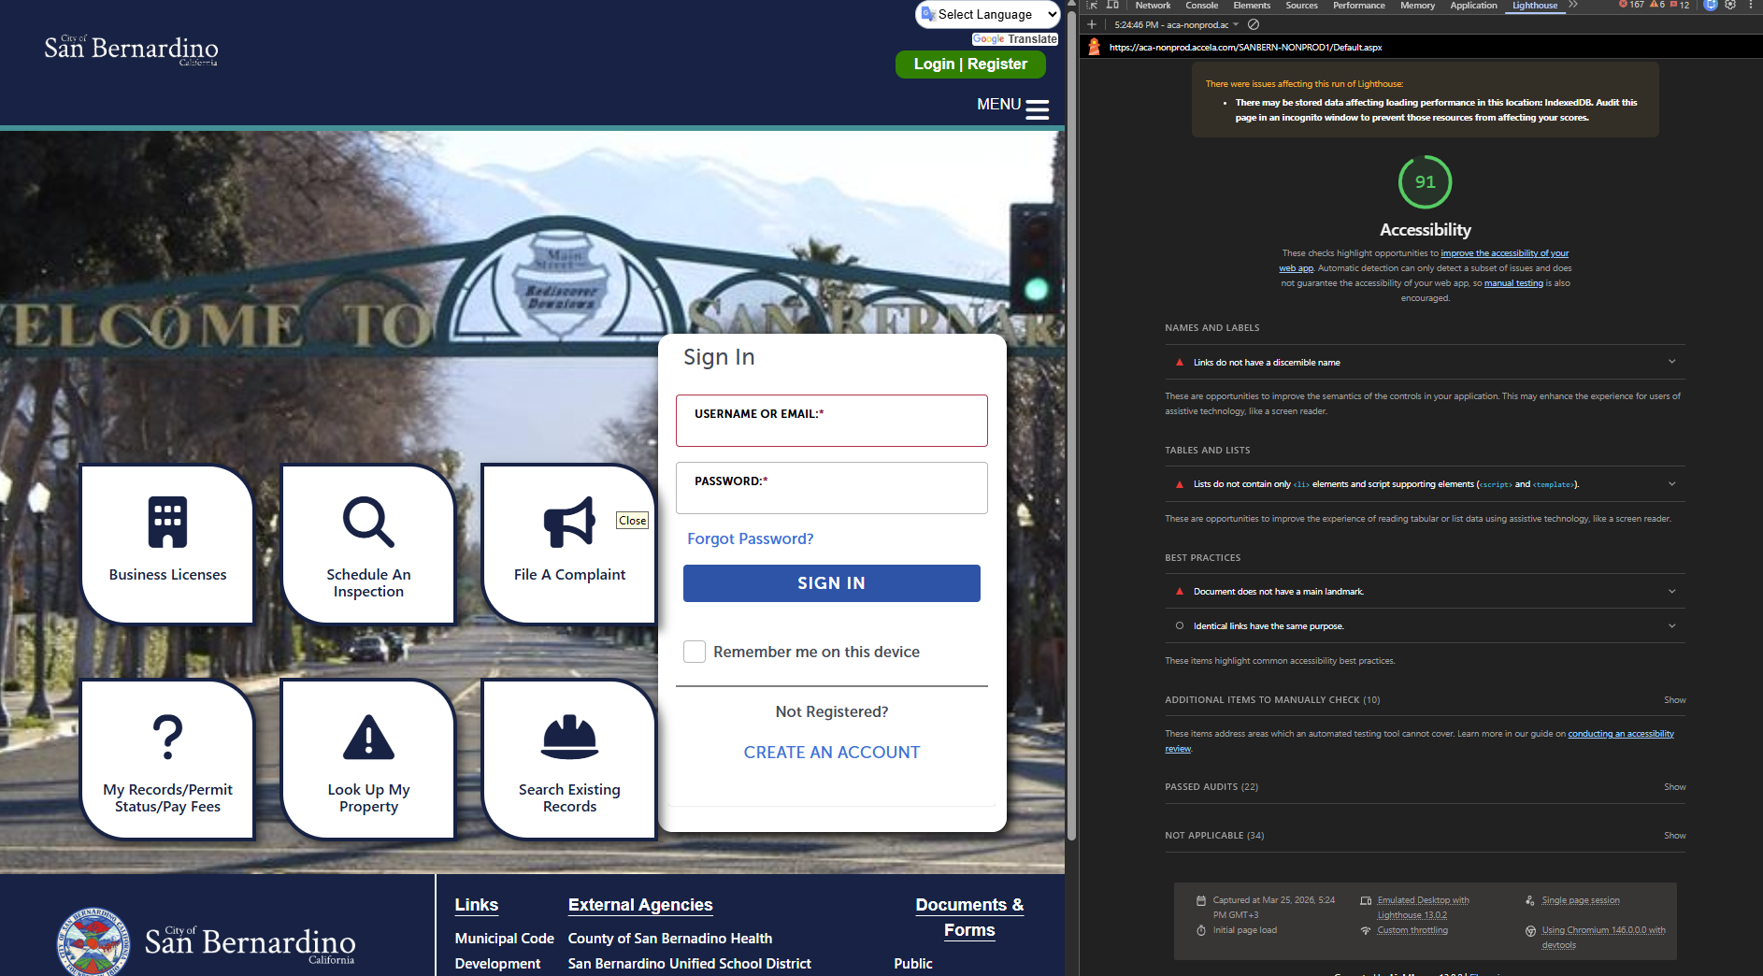

P2 ——— Login Page
URL: https://aca-nonprod.accela.com/SANBERN-NONPROD1/Login.aspx
Accessibility Score: 87 / 100 | State: Logged Out | Failing: 5
Failing Audits: aria-prohibited-attr, link-name, list, target-size, document-no-main-landmark

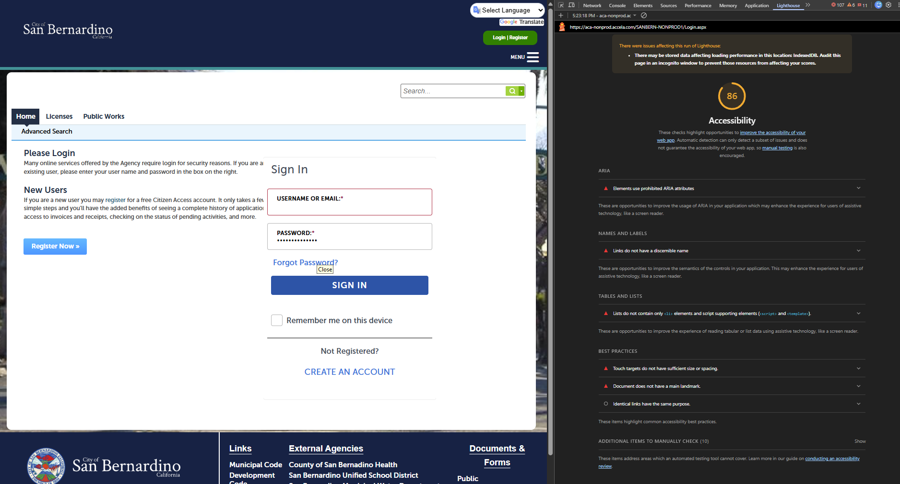

P3 ——— Register Disclaimer
URL: https://aca-nonprod.accela.com/SANBERN-NONPROD1/account/RegisterDisclaimer.aspx
Accessibility Score: 82 / 100 | State: Logged Out | Failing: 6
Failing Audits: aria-prohibited-attr, frame-title, link-name, list, target-size, document-no-main-landmark

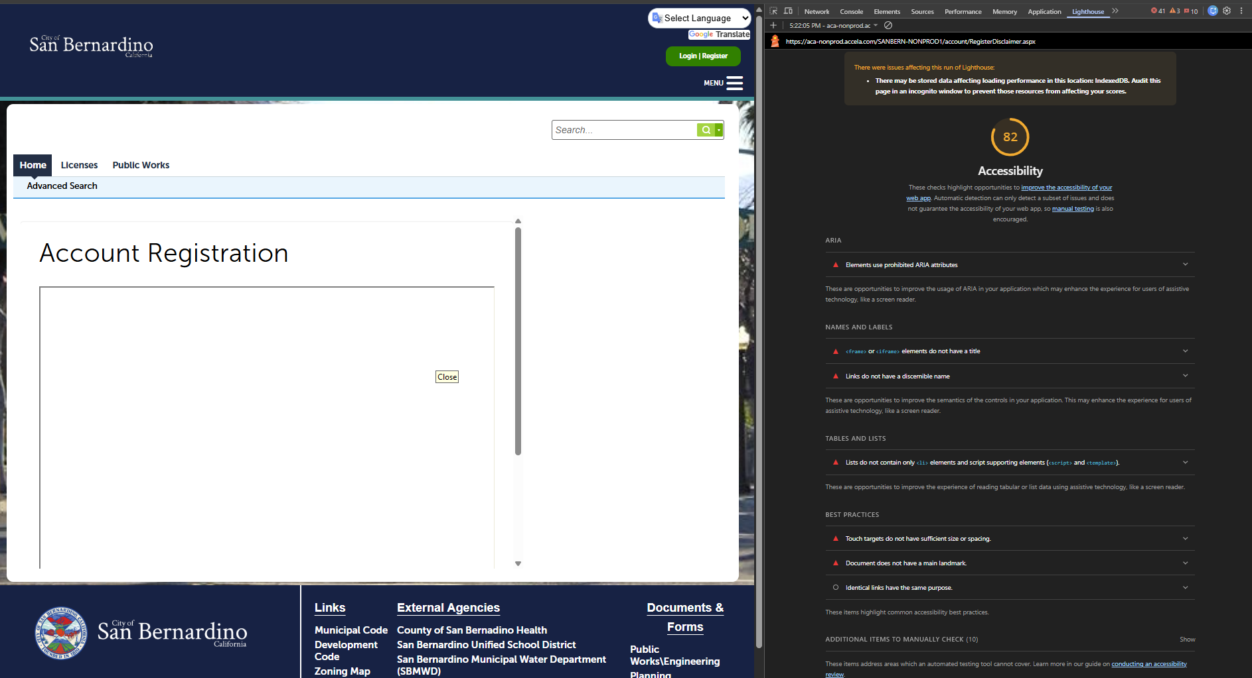

P4 ——— Search For Licenses
URL: https://aca-nonprod.accela.com/SANBERN-NONPROD1/GeneralProperty/PropertyLookUp.aspx?isCertBusiness=Y&TabName=Home
Score: 85 / 100 | State: Logged In | Failing: 5
Failing Audits: aria-prohibited-attr, link-name, list, target-size, document-no-main-landmark

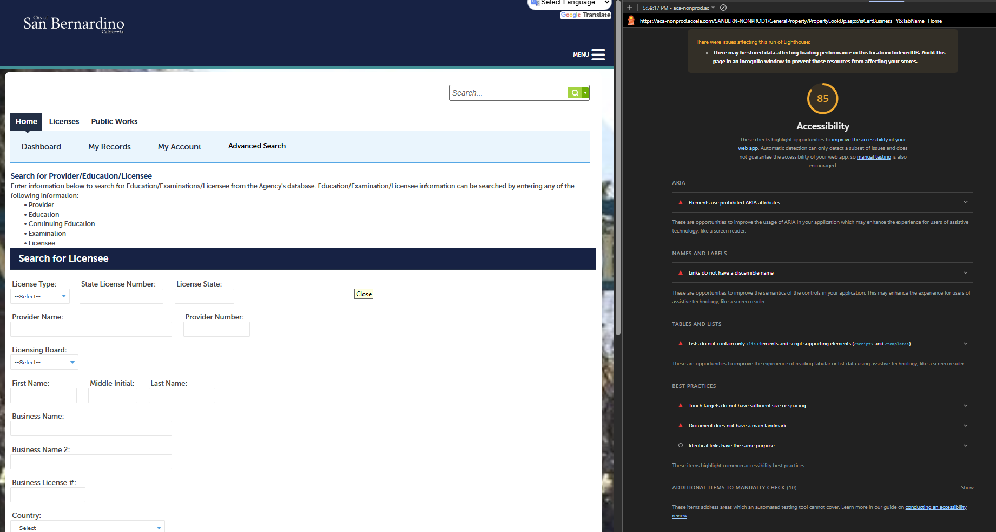

P5 ——— Dashboard (Logged In)
URL: https://aca-nonprod.accela.com/SANBERN-NONPROD1/Dashboard.aspx
Accessibility Score: 82 / 100 | State: Logged In | Failing Audits: 5
Failing Audits: aria-prohibited-attr, color-contrast, link-name, list, target-size
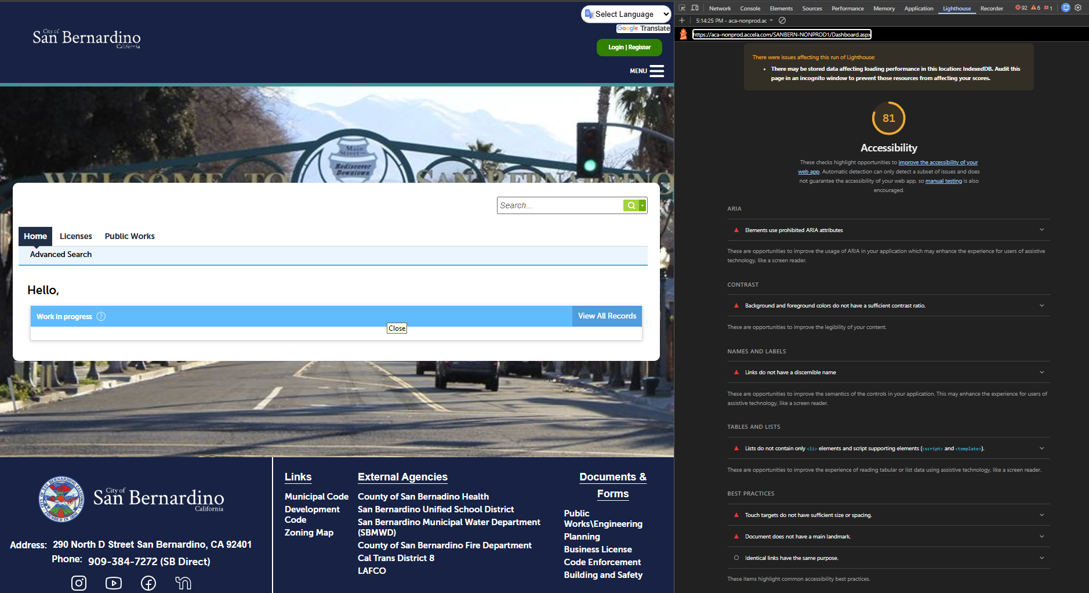

P6 ——— My Records
URL: https://aca-nonprod.accela.com/SANBERN-NONPROD1/Cap/CapHome.aspx?TabName=MyRecords
Accessibility Score: 85 / 100 | State: Logged In | Failing: 5
Failing Audits: aria-prohibited-attr, link-name, list, target-size, document-no-main-landmark

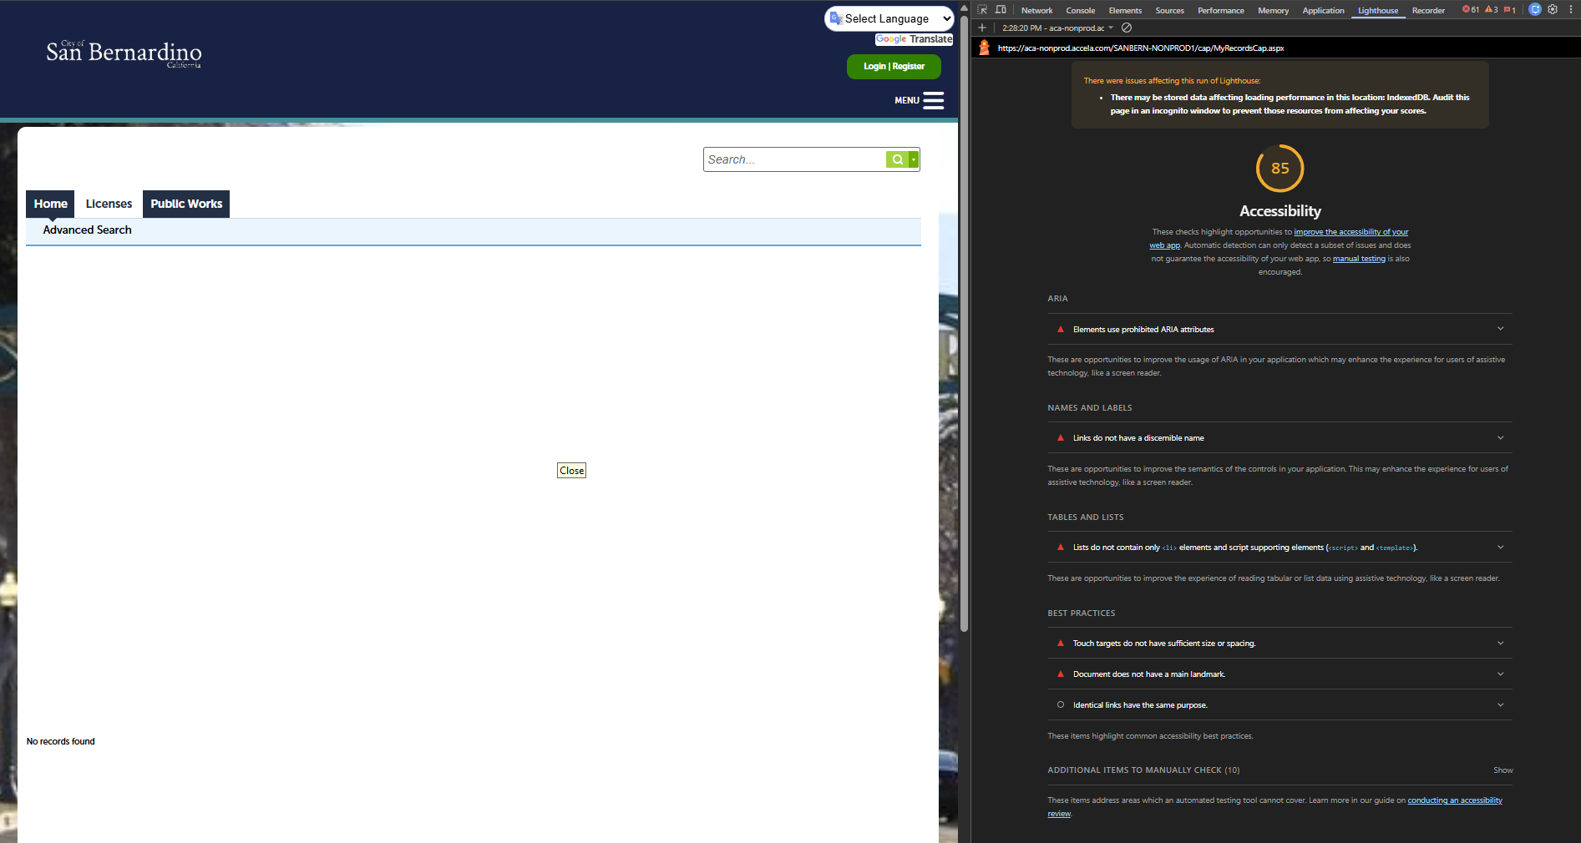

P7 ——— Licenses
URL: https://aca-nonprod.accela.com/SANBERN-NONPROD1/Cap/CapHome.aspx?module=Licenses&TabName=Licenses&TabList=Home%7C0%7CLicenses%7C1%7CPublicWorks%7C2%7CCurrentTabIndex%7C1

Accessibility Score: 82 / 100 | State: Logged Out | Failing: 5
Failing Audits: aria-prohibited-attr, frame-title, link-name, list, target-size

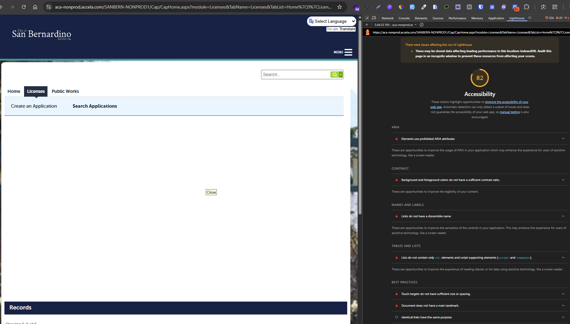

P8 ——— Public Works
URL: https://aca-nonprod.accela.com/SANBERN-NONPROD1/Cap/CapHome.aspx?TabName=MyRecords
Accessibility Score: 81 / 100 | State: Logged In | Failing Audits: aria-prohibited-attr, color-contrast, identical-links-same-purpose
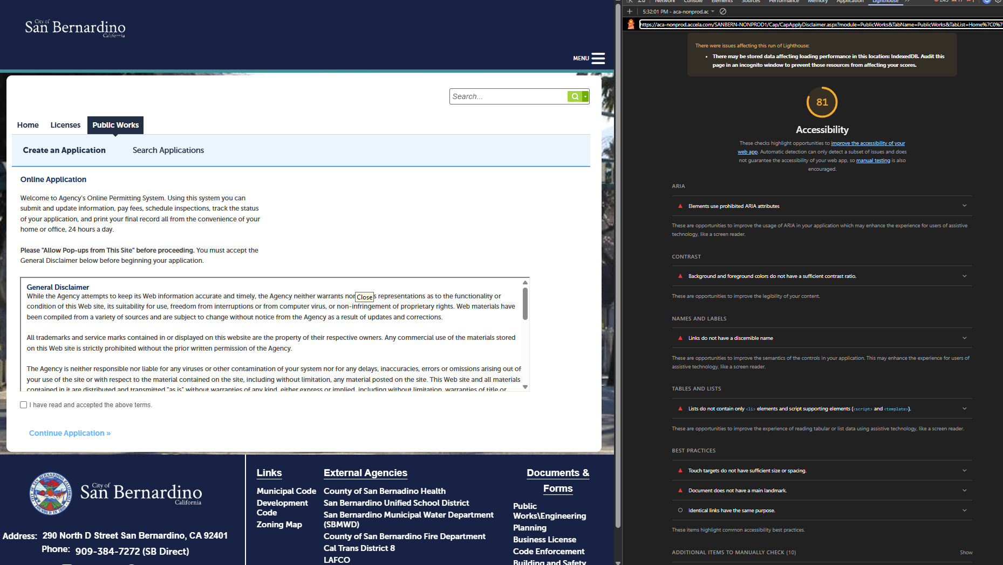

5. Recommendations
The following recommendations are ordered by impact and frequency. Addressing systemic issues (shared templates, global styles, navigation components) will resolve the majority of failures across all pages simultaneously.
1. Fix footer list structure. Replace the nested <ul> structure in the footer with properly nested <ul> > <li> elements. Direct <ul> children of <ul>, and direct <a> or <p> children of <ul> are invalid HTML and confuse screen readers. This single fix resolves the list audit failure on all 4 audited pages.
2. Add accessible names to social media links. All four footer social media links (Instagram, YouTube, Facebook, Nextdoor) have no accessible text. Add aria-label attributes (e.g., aria-label=‘Follow us on Instagram’) to each anchor. Affects all pages sharing the footer template.
3. Fix color contrast on the Dashboard. The Dashboard header uses #22bdff on white (ratio 2.14:1) and #149edf on white (3:1). Table headers use #666666 on #cccccc (3.57:1) — all far below the 4.5:1 WCAG 1.4.3 requirement. Replace with darker accessible colors (e.g., #005A8E for blue, #444444 for grey-on-grey) in the custom CSS theme.
4. Remove prohibited ARIA attributes from skip anchor. The #FirstAnchorInACAMainContent element uses aria-label and aria-labelledby without a valid ARIA role attribute. Either remove these attributes entirely, or add role=‘region’ if the element serves a landmark purpose. Affects Login, Register Disclaimer, Dashboard, and all sub-pages.
5. Add title to DisclaimerFrame iframe. The Register Disclaimer page contains an iframe (#DisclaimerFrame) with no title attribute. Screen reader users cannot determine the iframe purpose. Fix: add title=‘Terms of Use’. Addresses WCAG 4.1.2 (Name, Role, Value).
6. Increase touch target sizes. Multiple interactive elements fall below the 24x24px minimum: search history link (12x20px), search input (partially obscured at 143x15px), and all footer nav links (22px height). Increase to at least 24x24px via CSS min-width, min-height, or padding (WCAG 2.5.8).

6. Notes & Observations
1. Systemic template issues dominate findings. The nonprod environment exhibits the same systemic accessibility defects found in other Accela ACA deployments. The footer HTML structure (improper list nesting, missing social media link labels) and the skip-navigation anchor ARIA misuse both originate in shared ACA template components. Fixing these in the shared codebase will remediate failures across all environments simultaneously.
2. Dashboard color contrast is a custom CSS issue. The Dashboard color contrast failures (header portlet buttons, table header labels) are configuration-level issues applied via a custom CSS theme for San Bernardino County. They can be resolved by updating color values in the site's custom stylesheet without requiring changes to the underlying ACA platform.
3. Audit coverage is significantly limited in nonprod. Four of 8 targeted pages (50%) could not be audited — 3 due to server-side error redirects and 1 due to a navigation timeout. This represents a significant gap. Key workflows including My Records, Helpful Links, Contact Us, and Global Search remain unverified and should be validated once routing is resolved.
4. Interactive sub-states show additional touch target failures. Sub-states discovered during navigation (Business Licenses → Login, Schedule An Inspection → Error, My Records/Permit Status → CapList) scored 85–87 and exhibited the same systemic footer issues plus additional touch target failures from the login redirect components. These are counted in logged-out interactive states, not as separate primary pages.
5. Score colour coding used in this report. Accessibility scores are colour-coded throughout: green (90+) indicates good — only minor issues; amber (85–89) indicates moderate — several failing audits; red (82–84) indicates needs attention — multiple failing audits requiring remediation; grey (N/A) indicates pages that could not be evaluated.

