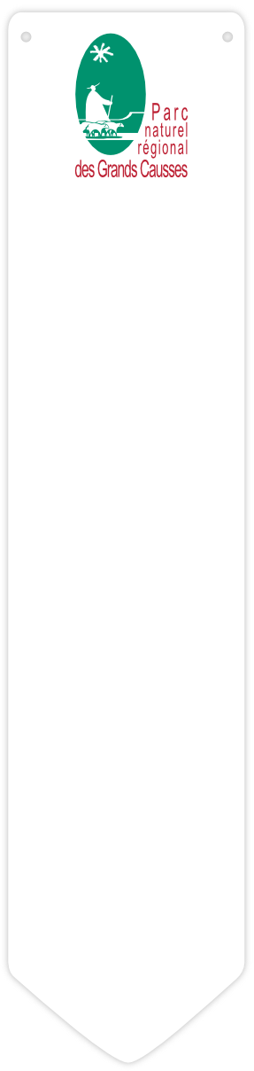
 _('Access')

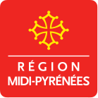 | Ce projet est cofinancé par l’Union européenne. L'Europe s'engage en Midi-Pyrénées avec le Fond européen de développement régional.  _('Powered by http://geotrek.fr')
Credits photo :
object.access
 _('Advised parking')
object.advised_parking
 _('Transport')
object.public_transport

 _('To check the practicability of the hiking paths and to know more about the National park, please visit us or call us at') :

desk.name
desk.description_strip | photo
Tel : desk.phone | photo
desk.website desk.email | photo
desk.street  desk.postal_code desk.municipality | photo
Lat : desk.latitude Long : desk.longitude

_('Other treks')
other.name
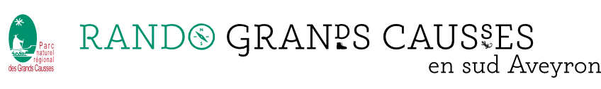
object.name
object.districts_display - object.city_departure
object.description_teaser
_('Duration')  object.duration_pretty  _('Length')  object.length_kilometer km  _('Trek ascent')  object.ascent m  _('Difficulty')  object.difficulty  _('Type')  object.route  _('Usages')  usage.usage  _('Themes')  theme.label | image
 | object.ambiance
_('Trek')
object.description

⚠_('Advice') |  | ♿_('Disabled infrastructures')
object.advice |  | object.disabled_infrastructure
⚠_('Advice')
object.advice
♿_('Disabled infrastructures')
object.disabled_infrastructure

_('Altimetric profile')
 | chart
 | _('Min elevation') : object.min_elevation m | _('Max elevation') : object.max_elevation m

image

_('On the way...')

pic | poi.name 'enumeration[poi.pk]'

logo | object.name  object.districts_display

pic | poi.name 'enumeration[poi.pk]'
ag
poi.description
(_('Attribution'): poi.pictures[0].author)

